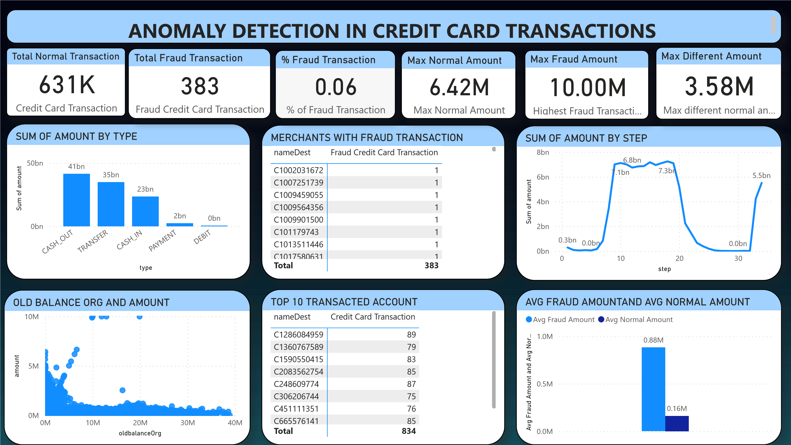

Power BI Desktop

**Anal**

**y**

**sis**

•

The transaction done by credit cards are analyzed and further discovered, there are numerous fraudulent in the

transactions.

•

The total recorded transactions are 631K with 383 fraud transaction. The percentage of fraudulent transaction is

0.06

%.

•

The fraud

transactions happened only in cash-out type and transfer-type payments. Which means these two .

•

There is total 383 Merchants with Fraud transactions.

Conclusion:

This Power BI project aims to provide a robust anomaly detection system for credit card transactions, enabling

users to identify and respond to potential fraud effectively. The combination of visualizations, DAX functions, and

documentation contributes to a comprehensive and user-friendly solution.