**Programming Structures & Algorithms**

**Spring 2022**

**Assignment no: 3**

**Name:** Shivani Madan Chavan

**NUID –** 001582611

**Tasks:**

* Implemented missing portions of UF_HWQUPC.java
* Executed the unit test cases
* Implemented the main method
* Implemented the count() method which takes in value n and prints the number of pairs produced

**Code Screenshots:**

find() method:

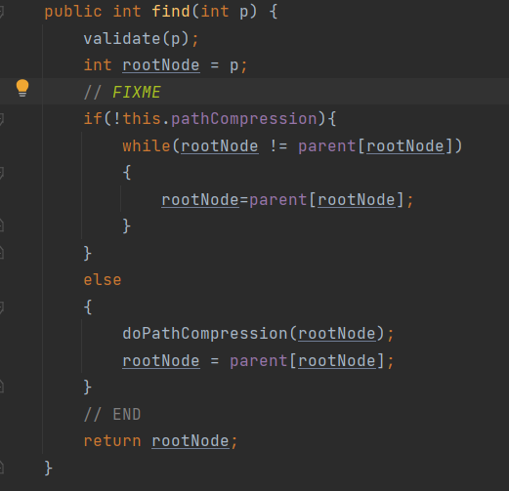

mergeComponents() method:

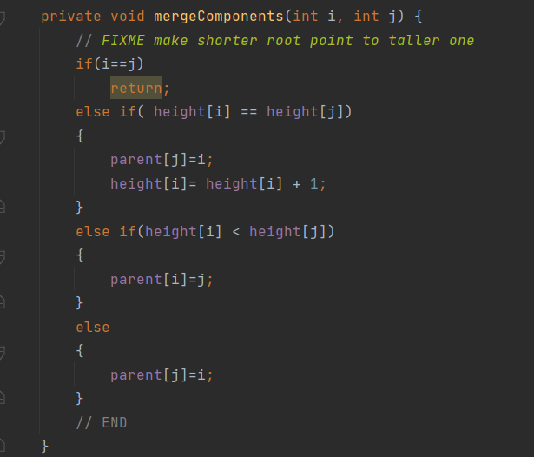

doPathCompression() method:

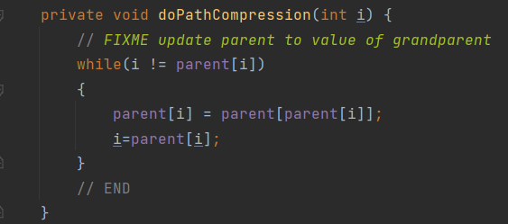

main() method:

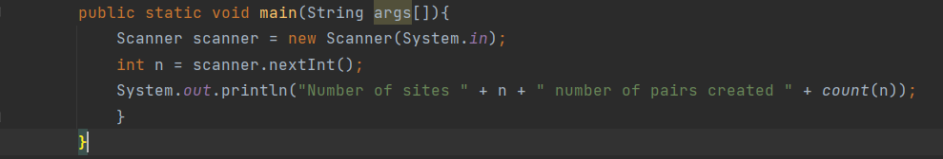

count() method:

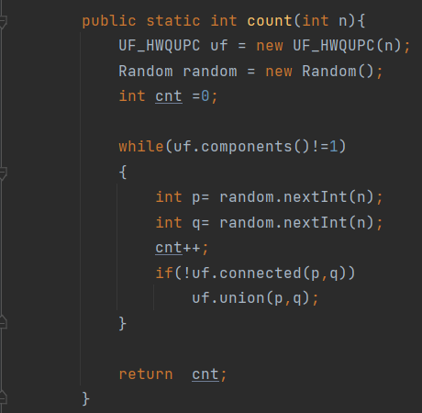

Program Output:

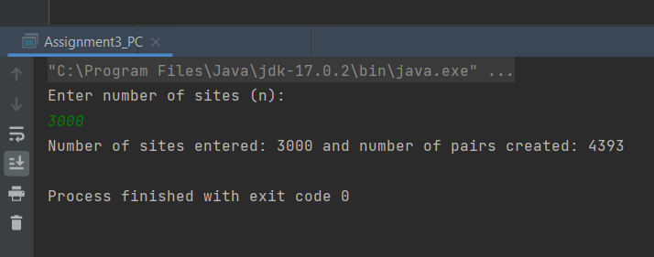

Unit Test Results Screenshot:

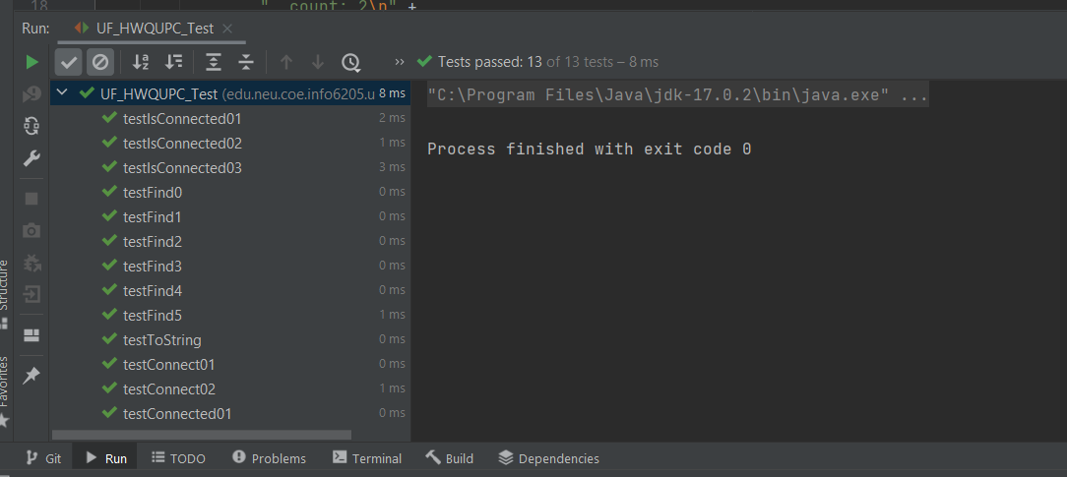

**Analysis:**

|  |  |  |
| --- | --- | --- |
| **No. of sites(N)** | **No. of pairs (M)** | **Slope** |
| 100 | 152 | 1.69 |
| 200 | 321 | 1.035 |
| 400 | 528 | 1.035 |
| 800 | 1386 | 2.145 |
| 1600 | 2328 | 1.1775 |
| 3200 | 5005 | 1.673125 |
| 6400 | 9843 | 1.511875 |
| 12800 | 19827 | 1.56 |
| 25600 | 39138 | 1.508672 |
| 51200 | 79085 | 1.56043 |
| 102400 | 154845 | 1.479688 |
| 204800 | 311850 | 1.533252 |

**Conclusion and reasoning:**

The number of pairs is linearly proportional to the number of sites therefore, as the number of sites increases, the number of pairs will also increase.

Number of pairs created ∝ Number of sites entered

Number of pairs created = c * number of sites

Where **c** is a constant and slope of the line that comes down to approximately 1.5.

**M = cN**

1. The number of ways to generate pair of initial sites is nC2
2. Let P(Connected) be the probability of creating a pair that is already connected and P(notConnected) be the probability of creating a pair that is not connected causing a union.
3. At first, P(Connected) = 0 and P(notConnected) = 1 because we have ‘n’ not connected sites.
4. As time progresses and we build the data structure, P(Connected) increases and P(notConnected) reduces i.e we will come across pairs that are already connected.
5. Therefore, the number of pairs produced is linearly proportional to the number of sites.