Industrial Internship Report on
Industrial Internship Report on
Smart City Traffic Forecasting using Machine Learning
Prepared by
Prepared by
Shivani Singh

Executive Summary
This report presents the work completed during the Industrial Internship organized by upskill Campus and The IoT Academy in collaboration with UniConverge Technologies Pvt. Ltd. (UCT). The internship focused on solving a real-world Machine Learning problem titled "Smart City Traffic Forecasting using Machine Learning."
The objective of this project was to analyze historical traffic data collected from different city junctions and develop a predictive model capable of forecasting future traffic volume. The project involved data preprocessing, feature engineering, exploratory data analysis, and the implementation of multiple machine learning algorithms, including Linear Regression, Decision Tree Regressor, and Random Forest Regressor.
Different models were evaluated using performance metrics such as Mean Absolute Error (MAE), Root Mean Square Error (RMSE), and R² Score. Among all the models, the Random Forest Regressor achieved the best prediction performance and was selected as the final model.
This internship provided practical exposure to real-world data analysis, machine learning model development, and industrial problem-solving techniques. It also enhanced my technical, analytical, and documentation skills while giving me experience in applying theoretical knowledge to practical applications.



TABLE OF CONTENTS
1 Preface 3
2 Introduction 4
2.1 About UniConverge Technologies Pvt Ltd 4
2.2 About upskill Campus 8
2.3 Objective 9
2.4 Reference 9
2.5 Glossary 10
3 Problem Statement 11
4 Existing and Proposed solution 12
5 Proposed Design/ Model 13
5.1 High Level Diagram (if applicable) 13
5.2 Low Level Diagram (if applicable) 13
5.3 Interfaces (if applicable) 13
6 Performance Test 14
6.1 Test Plan/ Test Cases 14
6.2 Test Procedure 14
6.3 Performance Outcome 14
7 My learnings 15
8 Future work scope 16

Preface
Industrial internships play a significant role in bridging the gap between academic learning and real-world industrial applications. They provide students with an opportunity to apply theoretical concepts to practical problems while improving technical and professional skills.
This internship, organized by upskill Campus and UniConverge Technologies Pvt. Ltd. (UCT), provided me with an opportunity to work on a real-world Machine Learning project titled "Smart City Traffic Forecasting using Machine Learning." The project focused on analyzing traffic data collected from different city junctions and developing an intelligent prediction system capable of forecasting future traffic volume.
During the internship, I learned various stages of a complete Machine Learning project, including data preprocessing, feature engineering, exploratory data analysis, model development, performance evaluation, and result interpretation. I also gained experience in using Python libraries such as Pandas, NumPy, Matplotlib, Seaborn, and Scikit-learn for data analysis and predictive modeling.
The internship significantly improved my understanding of Machine Learning concepts, data visualization techniques, problem-solving abilities, and project documentation

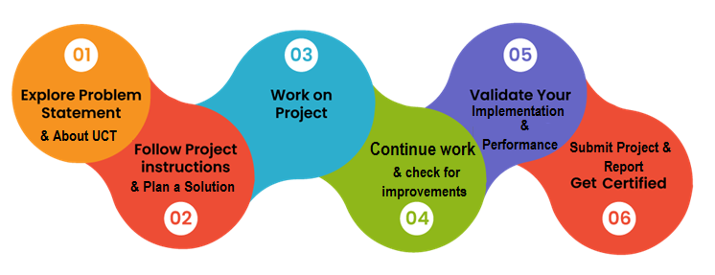
. I sincerely thank UniConverge Technologies Pvt. Ltd. (UCT), upskill Campus, and The IoT Academy for providing this valuable learning opportunity. I also express my gratitude to everyone who supported and guided me throughout the internship.

Introduction

About UniConverge Technologies Pvt Ltd
UniConverge Technologies Pvt. Ltd. (UCT) is a technology-driven company established in 2013, specializing in Digital Transformation and Industry 4.0 solutions. The company develops innovative solutions by leveraging advanced technologies such as the Internet of Things (IoT), Artificial Intelligence (AI), Machine Learning (ML), Cloud Computing, Cyber Security, Data Analytics, and Full Stack Development.
UCT provides industrial solutions in domains including Smart Cities, Smart Manufacturing, Predictive Maintenance, Agriculture, Industrial Automation, and IoT-based monitoring systems. Its platforms enable organizations to collect, monitor, analyze, and visualize real-time data for better decision-making and operational efficiency.
Through its internship programs, UCT provides students with opportunities to work on real-world industrial projects, allowing them to gain practical experience in solving industry-oriented problems using modern technologies.

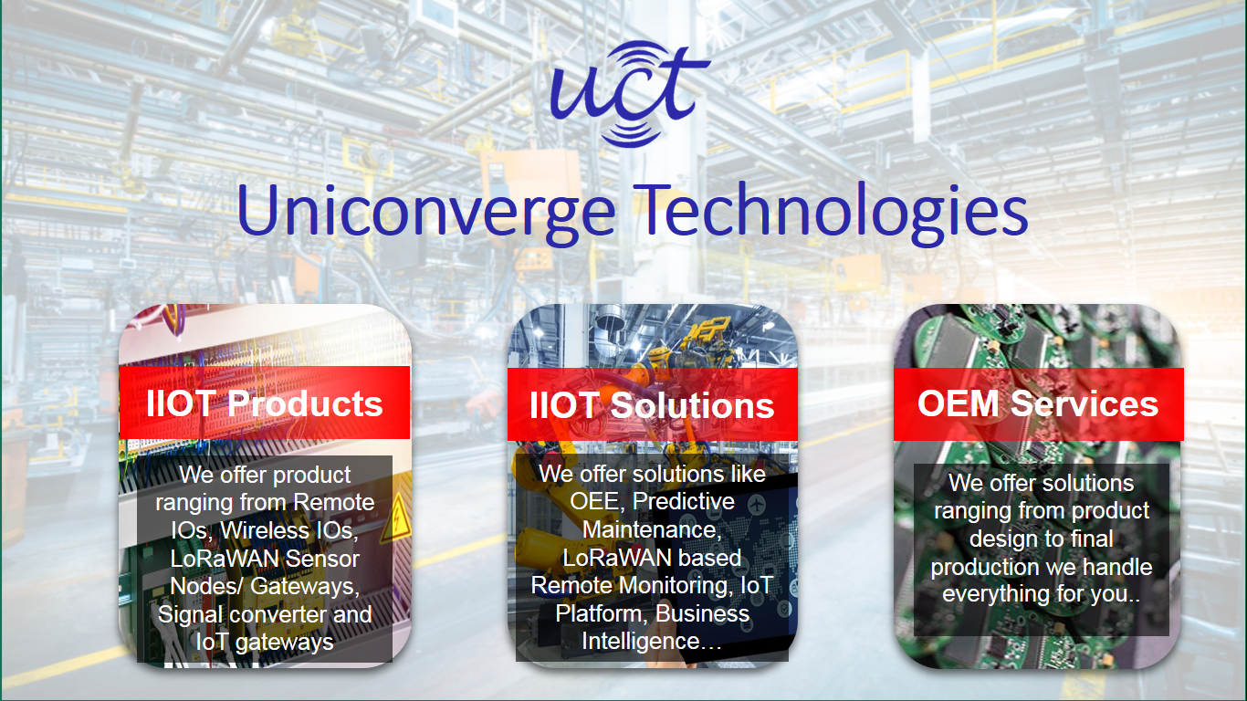
- UCT IoT Platform ()
UCT Insight is an IOT platform designed for quick deployment of IOT applications on the same time providing valuable “insight” for your process/business. It has been built in Java for backend and ReactJS for Front end. It has support for MySQL and various NoSql Databases.
- It enables device connectivity via industry standard IoT protocols - MQTT, CoAP, HTTP, Modbus TCP, OPC UA
- It supports both cloud and on-premises deployments.
It has features to
• Build Your own dashboard
• Analytics and Reporting
• Alert and Notification
• Integration with third party application(Power BI, SAP, ERP)
• Rule Engine

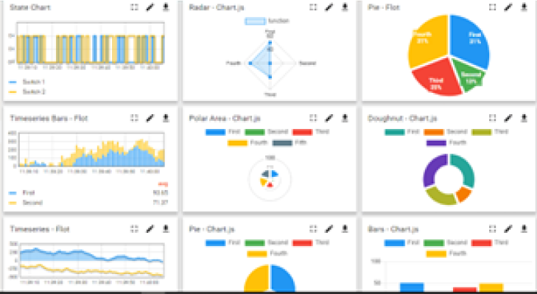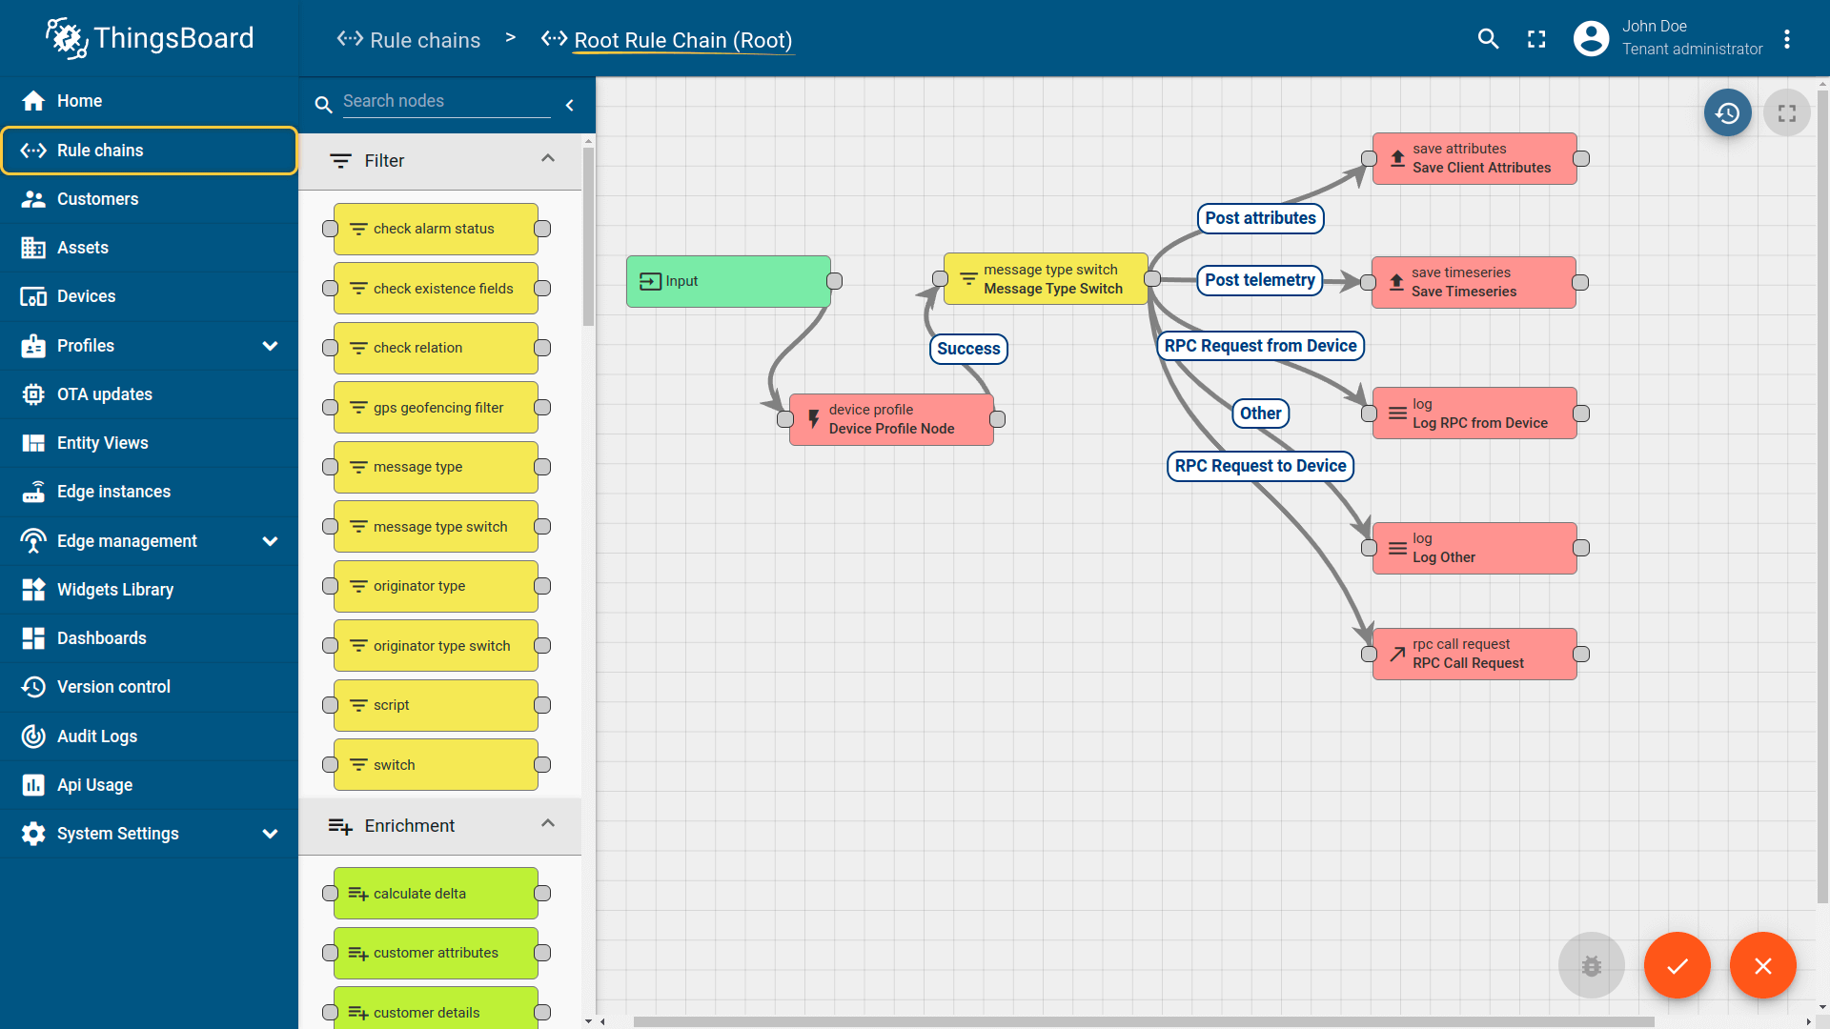

- Smart Factory Platform ()
Factory watch is a platform for smart factory needs.
It provides Users/ Factory
- with a scalable solution for their Production and asset monitoring
- OEE and predictive maintenance solution scaling up to digital twin for your assets.
- to unleased the true potential of the data that their machines are generating and helps to identify the KPIs and also improve them.
- A modular architecture that allows users to choose the service that they what to start and then can scale to more complex solutions as per their demands.
Its unique SaaS model helps users to save time, cost and money.
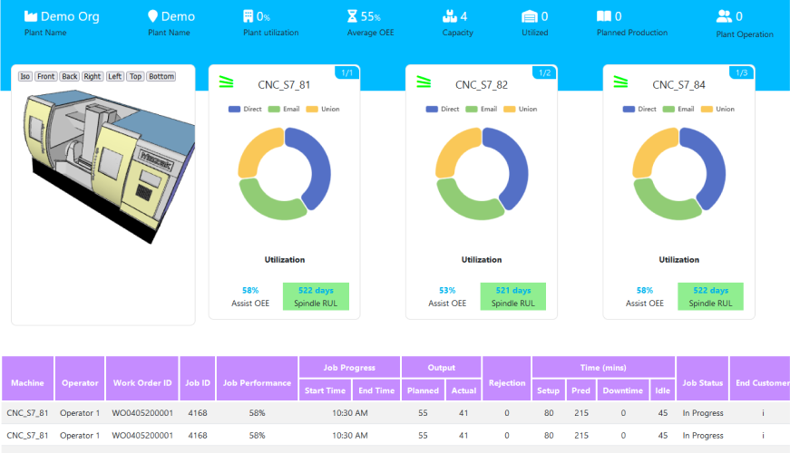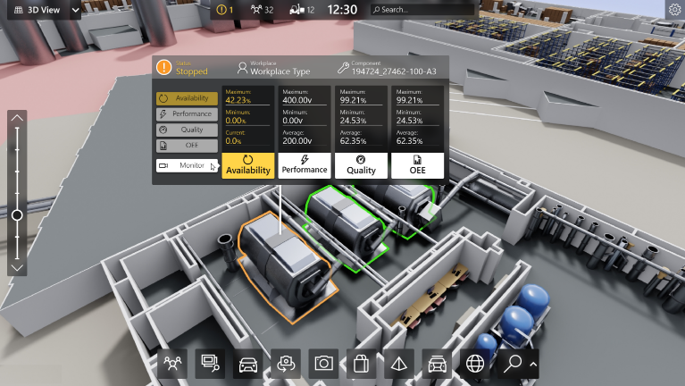

- 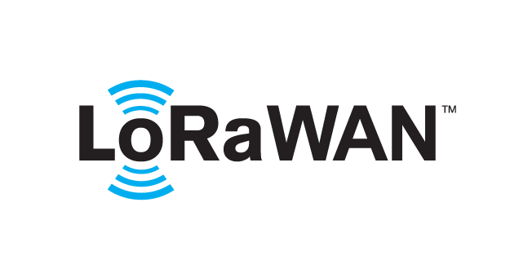 based Solution
UCT is one of the early adopters of LoRAWAN teschnology and providing solution in Agritech, Smart cities, Industrial Monitoring, Smart Street Light, Smart Water/ Gas/ Electricity metering solutions etc.
- Predictive Maintenance
UCT is providing Industrial Machine health monitoring and Predictive maintenance solution leveraging Embedded system, Industrial IoT and Machine Learning Technologies by finding Remaining useful life time of various Machines used in production process.
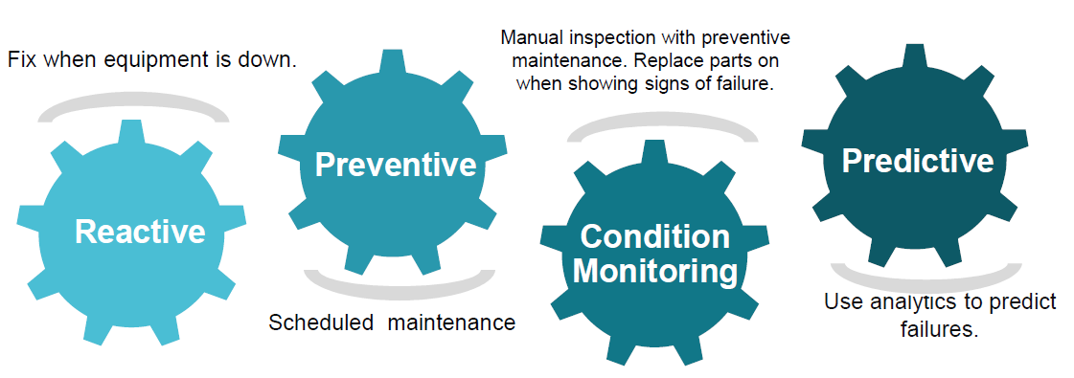

About upskill Campus (USC)
Upskill Campus (USC) is an online career development platform that focuses on enhancing students' technical and professional skills through certification programs, internships, industrial projects, and expert mentorship. The platform collaborates with reputed industries and organizations to provide learners with practical exposure beyond classroom education.
The Industrial Internship Program conducted by Upskill Campus in collaboration with UniConverge Technologies Pvt. Ltd. (UCT) enables students to work on real-world projects, improve problem-solving abilities, and develop industry-ready technical skills required for future career opportunities.




Seeing need of upskilling in self paced manner along-with additional support services e.g. Internship, projects, interaction with Industry experts, Career growth Services
https://www.upskillcampus.com/
upSkill Campus aiming to upskill 1 million learners in next 5 year

The IoT Academy
The IoT academy is EdTech Division of UCT that is running long executive certification programs in collaboration with EICT Academy, IITK, IITR and IITG in multiple domains.

Objectives of this Internship program
The primary objectives of this internship were:
- To understand the complete lifecycle of a Machine Learning project.
- To gain practical experience in handling real-world datasets.
- To perform data preprocessing and exploratory data analysis.
- To implement Machine Learning algorithms for traffic prediction.
- To compare multiple regression models using evaluation metrics.
- To improve programming skills using Python and Scikit-learn.
- To enhance analytical thinking and problem-solving abilities.
- To understand the industrial application of Machine Learning in Smart City traffic management.

Reference
• Scikit-learn Documentation – https://scikit-learn.org
• Pandas Documentation – https://pandas.pydata.org
• NumPy Documentation – https://numpy.org
• Matplotlib Documentation – https://matplotlib.org
• Seaborn Documentation – https://seaborn.pydata.org

Glossary
Terms | Acronym
ML | Machine Learning
AI | Artificial Intelligence
EDA | Exploratory Data Analysis
MAE | Mean Absolute Error
RMSE | Root Mean Square Error
R² Score | Coefficient of Determination
CSV | Comma Separated Values
UCT | UniConverge Technologies Pvt. Ltd.
USC | Upskill Campus

Problem Statement
In the assigned problem statement
traffic congestion has become one of the major challenges in modern smart cities due to the rapid increase in the number of vehicles. Inefficient traffic management leads to longer travel times, fuel wastage, increased air pollution, and road accidents. Therefore, predicting future traffic volume is essential for improving traffic management and city planning.
The objective of this project is to develop a Machine Learning-based traffic forecasting system that predicts the number of vehicles passing through different city junctions using historical traffic data. The dataset contains information such as Date and Time, Junction Number, Vehicle Count, and Unique ID.
The project includes data preprocessing, feature engineering, exploratory data analysis, and implementation of multiple regression models, including Linear Regression, Decision Tree Regressor, and Random Forest Regressor. The models are evaluated using Mean Absolute Error (MAE), Root Mean Square Error (RMSE), and R² Score to identify the most accurate prediction model.
The final developed model helps predict traffic volume efficiently, which can support intelligent traffic signal control, congestion reduction, route optimization, and better decision-making for smart city traffic management.

Existing and Proposed solution

Most traditional traffic management systems rely on fixed traffic signal timings and manual monitoring. These methods are unable to adapt to changing traffic conditions in real time, resulting in traffic congestion, increased travel time, and inefficient road utilization. Although some modern systems use sensors and cameras, many still lack accurate predictive capabilities for future traffic conditions.
The proposed solution is a Machine Learning-based Smart City Traffic Forecasting System that predicts future traffic volume using historical traffic data. The dataset is first preprocessed by converting date and time information into useful features such as Year, Month, Day, Hour, and Day of Week. Exploratory Data Analysis (EDA) is then performed to understand traffic patterns and identify trends.
Three Machine Learning algorithms—Linear Regression, Decision Tree Regressor, and Random Forest Regressor—are trained and evaluated. Based on performance metrics, the Random Forest Regressor is selected as the final model because it provides the highest prediction accuracy and lowest prediction error. The system can assist city authorities in improving traffic signal timing, reducing congestion, and planning transportation infrastructure more effectively.

Code submission (Github link):
https://github.com/Shivani8887/upskillcampus

Report submission (Github link) :
https://github.com/Shivani8887/upskillcampus

Proposed Design/ Model
The proposed Smart City Traffic Forecasting System is designed to predict future traffic volume using historical traffic data and Machine Learning techniques. The complete workflow starts with collecting the traffic dataset and ends with generating traffic predictions for unseen data.
Initially, the traffic dataset is loaded into the Python environment using the Pandas library. Data preprocessing is then performed to convert the DateTime column into meaningful features such as Year, Month, Day, Hour, and Day of Week. Unnecessary columns like ID are removed to improve model performance.
After preprocessing, Exploratory Data Analysis (EDA) is performed to understand traffic patterns, vehicle distribution, junction-wise traffic, hourly traffic trends, and feature correlations. The processed data is then divided into training and testing datasets.
Three Machine Learning algorithms—Linear Regression, Decision Tree Regressor, and Random Forest Regressor—are trained using the prepared dataset. Their performance is evaluated using Mean Absolute Error (MAE), Root Mean Square Error (RMSE), and R² Score. The Random Forest Regressor achieved the best performance and was selected as the final prediction model.
The trained model is then used to predict traffic volume for the test dataset. Finally, the predicted results are saved into a CSV file, which can be used for traffic planning and decision-making in smart city applications.
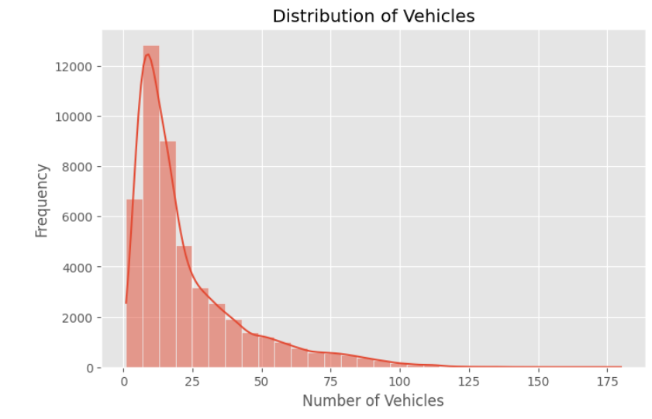
Figure 5.1: Vehicle Distribution

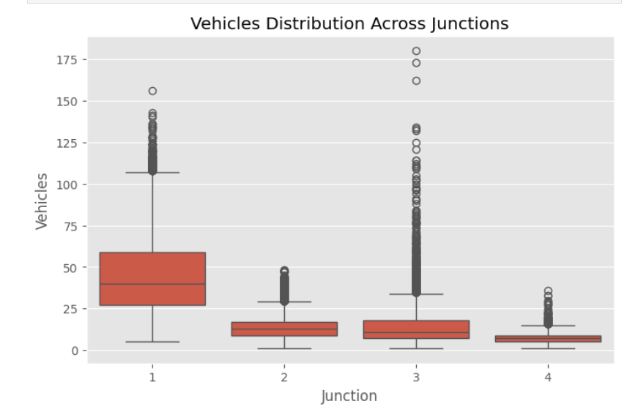
Figure 5.2: Junction-wise Traffic Analysis
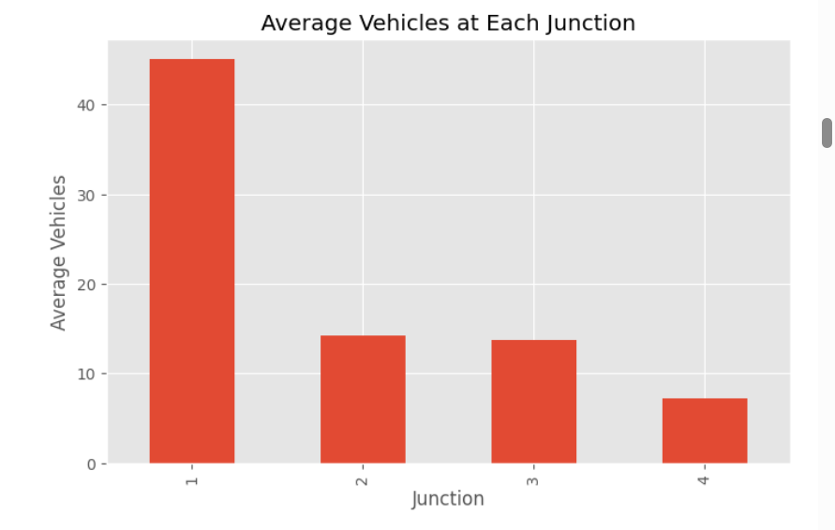
Figure 5.3: Average Traffic at Each Junction
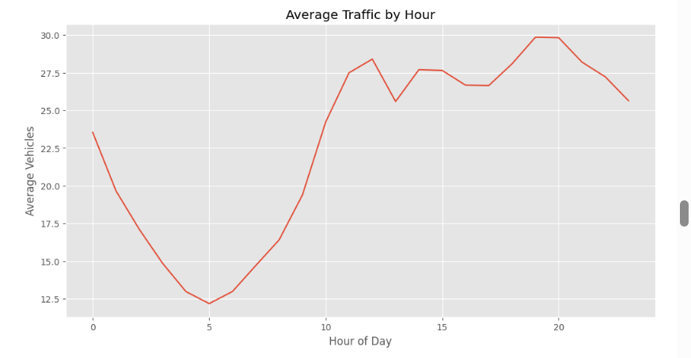
Figure 5.4: Traffic by Hour

High Level Diagram (if applicable)
Traffic Dataset
│
▼
Data Preprocessing
│
▼
Feature Engineering
│
▼
Exploratory Data Analysis
│
▼
Machine Learning Models
│
▼
Model Evaluation
│
▼
Traffic Prediction

Figure 1: HIGH LEVEL DIAGRAM OF THE SYSTEM

Low Level Diagram (if applicable)

CSV Dataset
│
▼
Read using Pandas
│
▼
Convert DateTime Features
│
▼
Train-Test Split
│
▼
Linear Regression
Decision Tree
Random Forest
│
▼
Performance Comparison
│
▼
Best Model Selection
│
▼
Traffic Prediction Output

Interfaces (if applicable)
The Smart City Traffic Forecasting system was developed using Jupyter Notebook as the development environment and Python as the programming language. The traffic dataset in CSV format was imported using the Pandas library. Data preprocessing and feature engineering were performed to prepare the dataset for model training.
The project workflow consists of the following stages:
- Data Collection (CSV Dataset)
- Data Preprocessing
- Feature Engineering
- Exploratory Data Analysis (EDA)
- Model Training
- Model Evaluation
- Traffic Prediction
- Result Export (CSV File)
The visualization of traffic patterns was performed using Matplotlib and Seaborn libraries. Machine Learning models, including Linear Regression, Decision Tree Regressor, and Random Forest Regressor, were implemented using the Scikit-learn library. The final predicted traffic values were stored in a CSV file, which can be further used for traffic management and decision-making.
- Data Flow
Traffic Dataset (CSV)
│
▼
Data Preprocessing
│
▼
Feature Engineering
│
▼
Exploratory Data Analysis
│
▼
Model Training
│
▼
Model Evaluation
│
▼
Traffic Prediction
│
▼
Prediction Output (CSV)

Performance Test

The performance of the developed Machine Learning models was evaluated using three standard evaluation metrics:
- Mean Absolute Error (MAE): Measures the average absolute difference between the actual and predicted traffic values.
- Root Mean Square Error (RMSE): Measures the square root of the average squared prediction error.
- R² Score (Coefficient of Determination): Measures how well the model explains the variance in the data. A value closer to 1 indicates better performance.
Three Machine Learning algorithms were implemented and compared:
- Linear Regression
- Decision Tree Regressor
- Random Forest Regressor
The results obtained from the implementation are shown below.
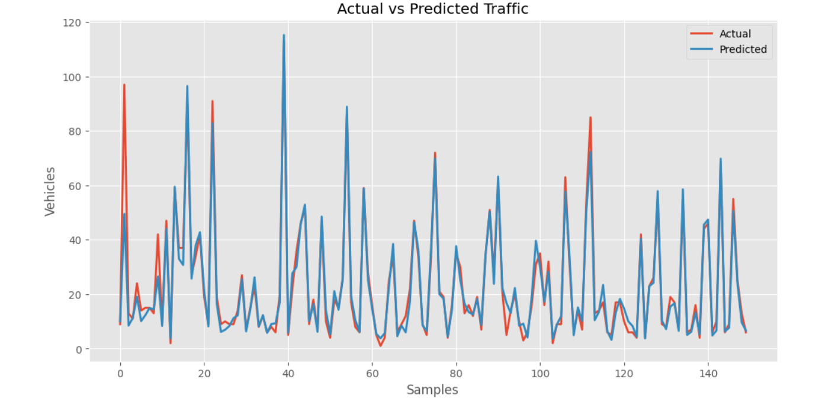

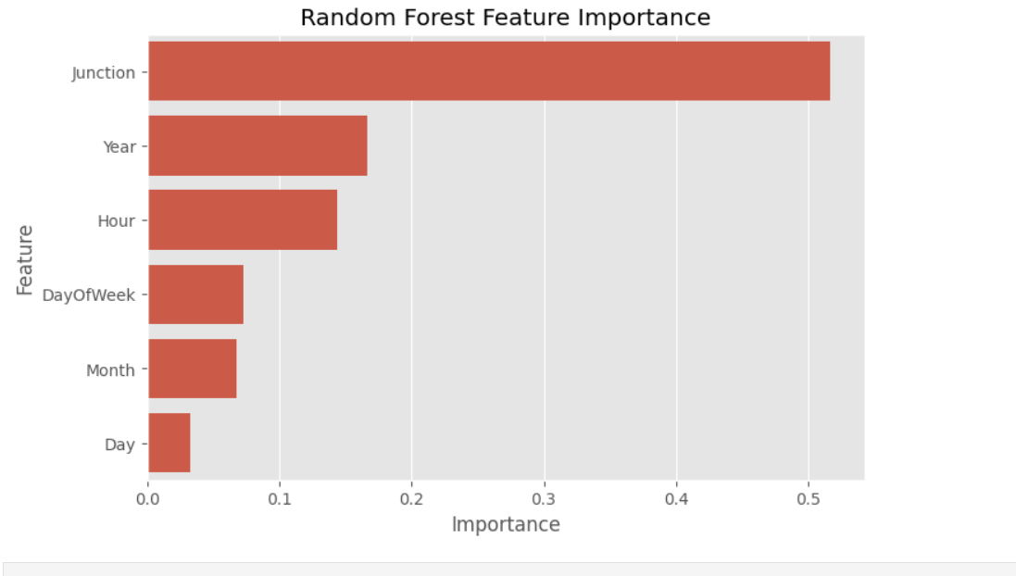

Test Plan/ Test Cases
The testing process was carried out to evaluate the performance and reliability of the developed Smart City Traffic Forecasting System. The following test cases were considered during implementation.
Test Case ID | Test Description | Expected Result | Status
TC-01 | Load training dataset | Dataset loaded successfully | Pass
TC-02 | Check missing values | No critical missing values found | Pass
TC-03 | Convert DateTime into features | New features created successfully | Pass
TC-04 | Train Linear Regression Model | Model trained successfully | Pass
TC-05 | Train Decision Tree Model | Model trained successfully | Pass
TC-06 | Train Random Forest Model | Model trained successfully | Pass
TC-07 | Compare model performance | Best model identified successfully | Pass
TC-08 | Predict traffic on test dataset | Predictions generated successfully | Pass
TC-09 | Export prediction results | CSV file created successfully | Pass

Test Procedure
The project was tested in a step-by-step manner to ensure correct implementation of each phase. Initially, the dataset was loaded into the Jupyter Notebook environment and verified for missing values and inconsistencies. The DateTime column was converted into useful features such as Year, Month, Day, Hour, and Day of Week.
After preprocessing, the dataset was divided into training and testing sets using an 80:20 ratio. Three Machine Learning algorithms—Linear Regression, Decision Tree Regressor, and Random Forest Regressor—were trained using the training dataset.
The trained models were evaluated using MAE, RMSE, and R² Score. Finally, the best-performing model (Random Forest Regressor) was used to predict traffic volume for the test dataset, and the predictions were exported into a CSV file.

Performance Outcome

The developed Smart City Traffic Forecasting system successfully predicted future traffic volume using historical traffic data. Among the implemented algorithms, the Random Forest Regressor achieved the highest prediction accuracy with the best R² Score and the lowest prediction error.
The project demonstrated that Machine Learning techniques can effectively analyze traffic patterns and generate reliable predictions. The developed solution can assist city authorities in improving traffic signal management, reducing congestion, and supporting future transportation planning.

My learnings
During this industrial internship, I gained practical knowledge of the complete Machine Learning project lifecycle, from data collection and preprocessing to model development and evaluation. I learned how to handle real-world datasets, perform feature engineering, visualize data using graphs, and implement regression algorithms using Python and Scikit-learn.
I also improved my programming skills, analytical thinking, and problem-solving abilities while working on a real-world industrial project. This internship enhanced my understanding of Smart City applications and the practical use of Machine Learning in solving traffic-related problems.
The experience strengthened my confidence in working with data-driven projects and prepared me for future opportunities in Data Science, Machine Learning, and Software Development. It also improved my project documentation, GitHub usage, and technical presentation skills.

Future work scope

Although the developed system provides accurate traffic predictions, several improvements can be made in the future.
- Integrate real-time traffic data from IoT sensors and traffic cameras.
- Develop a web-based dashboard for live traffic monitoring.
- Deploy the model using Flask or Django for online access.
- Implement Deep Learning models such as LSTM for time-series forecasting.
- Integrate weather, public events, and road conditions to improve prediction accuracy.
- Develop a mobile application for traffic prediction and route planning.
- Optimize the system for large-scale smart city deployments using cloud computing technologies.

