**MEDICAL PRESCRIPTION RECOGNITION**

J.Alekhya

*Department of Information Technology*

*Faculty of Gokaraju Rangaraju Institute of Engineering and*

*Technology*

Hyderabad, India line 5: email address or ORCID

B.Shivani

*Department of Information Technology*

*Gokaraju Rangaraju Institute of Engineering and Technology*

Hyderabad, India bandishivaniit2021@gmail.com

***Abstract*—The issue of illegible handwritten prescriptions poses a significant challenge in healthcare, often leading to medication misinterpretations and potential patient harm. Our project leverages machine learning, specifically Convolutional Neural Networks (CNN) and Optical Character Recognition (OCR), to convert handwritten prescriptions into readable digital text. Key phases include pre-processing techniques such as image subtraction, noise reduction, and image resizing, followed by CNN classification for feature extraction, and OCR for text decoding. This comprehensive approach effectively handles diverse handwriting styles, improving prescription legibility. Rigorous testing on real-world cases demonstrates reliability, enhancing clarity and accuracy for pharmacists and patients. By minimizing misinterpretation risks, our solution aims to ensure precise medication information communication, significantly improving the overall healthcare experience and patient safety. The integration of advanced machine learning techniques underscores the transformative potential of our project in addressing a critical healthcare challenge.**

***Keywords— image recognition, CNN, image segmentation***

# I. INTRODUCTION

In today's rapidly advancing healthcare landscape, technological innovations are essential for improving patient care, increasing efficiency, and reducing human error. A significant area where technology can make a profound impact is medical prescription handling. The proposed Medical Prescription Optical Character Recognition (OCR) system represents a groundbreaking advancement in this field, addressing critical issues and transforming the management of medical prescriptions. Illegible handwritten prescriptions pose a significant challenge in healthcare, leading to medication errors. Our project leverages Convolutional Neural Networks (CNN) and Optical Character Recognition (OCR) to convert these prescriptions into readable digital text. The system employs pre-processing, CNN feature extraction, and OCR for text decoding, effectively handling diverse handwriting styles. Rigorous testing demonstrates reliability and accuracy, enhancing clarity for pharmacists and patients. This solution aims to ensure precise medication information, improving overall healthcare safety and communication.

T.Archana

*Department of Information Technology*

*Gokaraju Rangaraju Institute of Engineering and Technology*

Hyderabad, India archanathota2003@gmail.com

E.Reena

*Department of Information Technology*

*Gokaraju Rangaraju Institute of Engineering and Technology*

Hyderabad, India reenaerukullaa19@gmail.com

The Medical Prescription OCR Project aims to revolutionize prescription handling using advanced technologies like YOLOv5 for object detection and deep learning models for text recognition.

The main technologies used in this project include:

* OpenCV
* YOLOv5
* TensorFlow
* Python

By minimizing misinterpretation risks, this system ensures patients receive the correct medications and dosages, enhancing overall healthcare efficiency and patient safety.

This project can be divided into multiple crucial phases:

* Image Capture**:** Gathering prescription images from the camera.
* Medicine Detection**:** Using YOLOv5 to identify and locate medicine names on prescriptions.
* Text Recognition**:** Utilizing deep learning models to recognize and convert handwritten text into digital format.
* Data Retrieval**:** Making prescription information easily retrievable and interpretable.
  1. PROBLEM STATEMENT

The issue of illegible handwritten prescriptions often leads to misinterpretation of medication details, posing significant healthcare risks. Our project leverages Convolutional Neural Networks (CNN) and Optical Character Recognition (OCR) to convert handwritten prescriptions into readable digital text. This system employs pre-processing, CNN classification, and OCR for accurate transcription of diverse handwriting styles. Rigorous testing on real-world cases demonstrates its reliability in enhancing prescription legibility. This research aims to minimize misinterpretation risks and improve the overall healthcare experience.

* 1. SYSTEM DESIGN

Pandas:

Pandas is a Python library used for statistical analysis, data cleaning, exploration, and manipulation. Typically, datasets contain both useful and extraneous information. Pandas helps to make this data more readable and relevant.

Matplotlib:

Matplotlib is a Python library for plotting graphs. Built on NumPy arrays, it allows for the creation of a wide range of graph types, from basic plots to bar graphs, histograms, scatter plots, and more.

OpenCV:

An open-source framework for real-time computer vision and image processing is called OpenCV (Open Source Computer Vision Library). It was first created by Intel in 1999 and is compatible with several other programming languages, such as Python, C++, and Java. More than 2,500 well-suited algorithms are available in OpenCV for a range of applications, including motion tracking, picture segmentation, object detection, and facial recognition.

Scikit-learn:

Scikit-learn is a Python library for machine learning. It provides tools for machine learning and statistical modeling, including classification, regression, and clustering.

Convolutional neural networks:

Convolutional neural networks, or CNNs, are a type of deep learning approach designed primarily for processing and analyzing visual input, including images and videos. It is widely used in several fields, including computer vision, photo identification, and natural language processing. CNNs are inspired by the architecture and functions of the human visual cortex.

CNNs are different from traditional neural networks in that they are able to automatically learn hierarchical representations of visual data. They employ a variety of interconnected layers to achieve this, including convolutional, pooling, and completely linked layers. In order to localize important features like as edges, corners, and textures in small portions of the input data, the convolutional layers apply filters.

CNNs are highly effective at tasks like object recognition, picture classification, and image segmentation because they can capture translation invariance and spatial interdependence. They have revolutionized fields like as autonomous driving, medical imaging, and facial recognition. CNN designs such as AlexNet, VGGNet, and ResNet have demonstrated remarkable performance in a number of computer vision challenges, and their techniques have influenced the development of additional deep learning models.  
In general, CNNs are an essential component as, on the whole, they have shown to be a successful technique for extracting meaningful information from visual input.

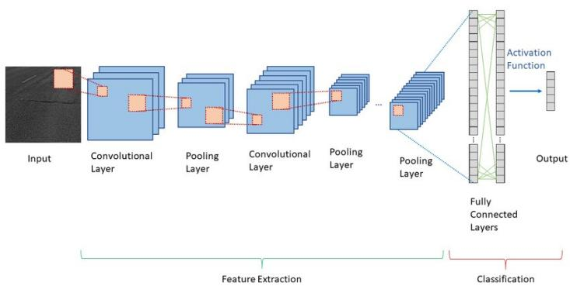

Fig.1. Layers of CNN

Recurrent Neural Network:

RNNs are a type of artificial neural network specifically designed to handle sequential data. Unlike traditional neural networks that process each piece of data independently, RNNs can utilize their internal state (memory) to process information based on preceding elements in the sequence.

How RNN Works:

1. Input & Hidden State: The network receives an input from the sequence and combines it with the current hidden state.
2. Activation Function**:** The combined information is passed through an activation function that determines the output of the current step.
3. Updated Hidden State: The hidden state is updated based on the current input, previous hidden state, and the activation function's output.
4. Sequence Processing**:** These steps (1-3) are repeated for each element in the sequence, allowing the network to learn long-term dependencies.

IV SYSTEM ARCHITECTURE

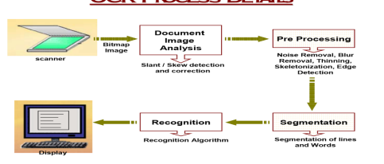

Fig.2. System Architecture

The system architecture for medical prescription recognition involves several steps:

1. Scanning: The prescription is scanned to create a bitmap image.

2. Document Image Analysis: The image undergoes slant/skew detection and correction.

3. Pre-Processing: Noise, blur, and other artifacts are removed. The image is thinned, skeletonized, and edges are detected.

4. Segmentation: The image is segmented into lines and words.

5. Recognition: Recognition algorithms are applied to interpret the text.

6. Display: The recognized text is displayed on a screen.

V. EXPERIMENTAL RESULT

The Medical Prescription OCR system successfully automated prescription interpretation with high accuracy using YOLOv5 and deep learning models.

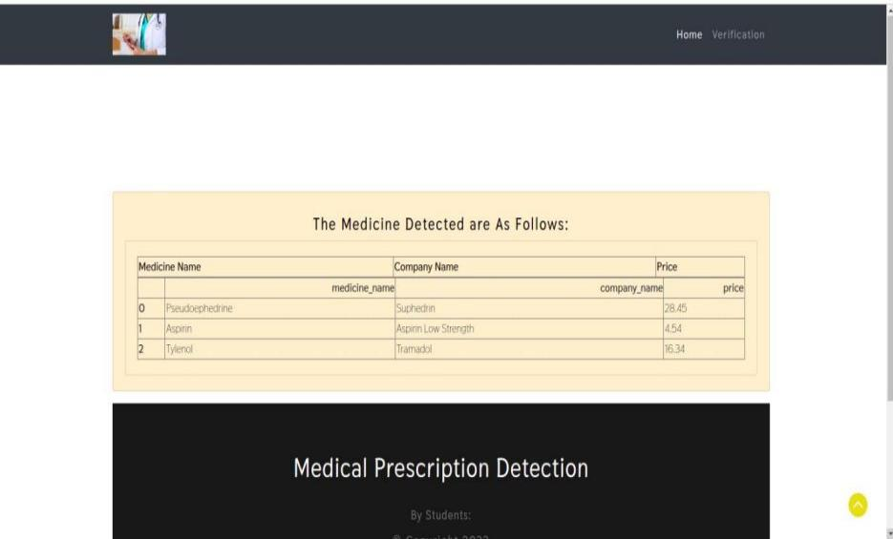

Fig.3. Output

VI. ACCURACY TESTING

Accuracy measures are crucial for evaluating our Medical Prescription OCR system. Key metrics include accuracy, precision, recall, F1 score, and AUC-ROC. Accuracy indicates the proportion of correctly interpreted prescriptions. Precision measures the true positives among predicted positives, while recall assesses the system's ability to identify all relevant medicine names. The F1 score balances precision and recall, and AUC-ROC evaluates the model's class differentiation ability. These metrics ensure the OCR system's effectiveness in accurately interpreting and managing medical prescriptions.

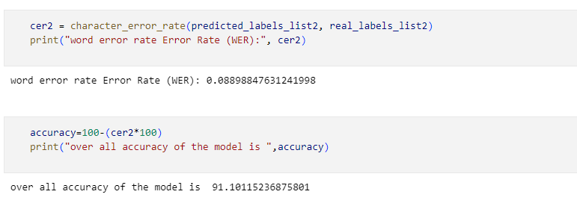

Fig.4. .Accuracy Testing [91%]

# VII. SYSTEM IMPLEMENTATION

The system is implemented in python as the programming language. The major part of the code was done using Jupyter Notebook. Various libraries such as NumPy, OpenCV were used. OpenCV library is used for Image processing. Convolutional Neural Networks (CNN) and Optical Character Recognition (OCR) to convert handwritten prescriptions into digital text. It employs pre-processing techniques like image subtraction and noise reduction, followed by CNN for feature extraction and OCR for text decoding. Trained on diverse handwriting styles, the system ensures accuracy and reliability. This solution enhances prescription legibility and reduces medication errors, improving overall healthcare communication.

# VIII. CHALLENGES

Major Medical prescription recognition faces several challenges, including the wide variability in handwriting styles, which complicates accurate text recognition. Variations in image quality, due to different scanning or photography conditions, further affect the performance of OCR systems. Accurately segmenting prescriptions into relevant sections, such as doctor's name, medications, and dosages, is another significant challenge. The complexity of medical terminology, with numerous abbreviations and similar-looking drug names, requires precise interpretation. Finally, integrating the OCR system seamlessly with existing healthcare infrastructure and electronic health records (EHR) systems is essential for effective implementation.

# IX. CONCLUSIONS AND FUTURE WORK

Finally, this application interface will make it simple for people to access the model and interact with it through the application. Furthermore, this technique allows the majority of users to verify the notes or prescriptions without any prior knowledge in calligraphy analysis. Therefore, this technology will eliminate human mistakes and pave the way for customers to assess it without the assistance of experts. We might improve the accuracy more in the future by supplying more data for training. Furthermore, the method may be tweaked to produce results even faster. Make this programme cross-platform and long-lasting for even the most stringent requirements.

# X. REFERENCES

[1] E. Hassan, H. Tarek, M. Hazem, S. Bahnacy, L. Shaheen and W. H. Elashmwai, "Medical Prescription Recognition using Machine Learning," 2021 IEEE 11th Annual Computing and Communication Workshop and Conference (CCWC), NV, USA, 2021, pp. 0973-0979, doi: 10.1109/CCWC51732.2021.9376141.

[2] W. -J. Chang, L. -B. Chen, C. -H. Hsu, C. -P. Lin and T. -C. Yang, "A Deep Learning-Based Intelligent Medicine Recognition System for Chronic Patients," in IEEE Access, vol. 7, pp. 44441-44458, 2019, doi: 10.1109/ACCESS.2019.2908843.

[3] N. Maitrichit and N. Hnoohom, "Intelligent Medicine Identification System Using a Combination of Image Recognition and Optical Character Recognition," 2020 15th International Joint Symposium on Artificial Intelligence and Natural Language Processing (iSAI-NLP), Bangkok, Thailand, 2020, pp. 1-5, doi: 10.1109/iSAI-NLP51646.2020.9376816.

[4] Y. -Y. Ou, H. -M. Wang, T. -Y. Lee, A. -C. Tsai and J. -F. Wang, "AI Prescription Recognition System," 2021 9th International Conference on Orange Technology (ICOT), Tainan, Taiwan, 2021, pp. 1-4, doi: 10.1109/ICOT54518.2021.9680614.

[5] R. Achkar, K. Ghayad, R. Haidar, S. Saleh and R. Al Hajj, "Medical Handwritten Prescription Recognition Using CRNN," 2019 International Conference on Computer, Information and Telecommunication Systems (CITS), Beijing, China, 2019, pp. 1-5, doi: 10.1109/CITS.2019.8862004.

[6] P. G, S. Padmanabhan, N. Divya, A. V, I. J. P and C. B, "Doctor's Handwritten Prescription Recognition System In Multi-Language Using Deep Learning," 2022 International Conference on Power, Energy, Control and Transmission Systems.