**Mini Project Report on**



**CHAT BOT**



**Submitted in partial fulfillment of the requirement for the award of the degree of**

**BACHELOR OF TECHNOLOGY**

**IN**

**COMPUTER SCIENCE & ENGINEERING**

**Submitted by:**

**Student Name**  **University Roll No.**

**Shivani Sharma 2017027**

***Under the Mentorship of***

**Mr. Vivek Tomar**

**Asst. Prof.**



**Department of Computer Science and Engineering**

**Graphic Era (Deemed to be University)**

**Dehradun, Uttarakhand**

**January 2023**



**CANDIDATE’S DECLARATION**

I hereby certify that the work which is being presented in the project report entitled **“CHAT BOT”** in partial fulfillment of the requirements for the award of the Degree of Bachelor of Technology in Computer Science and Engineeringof the Graphic Era (Deemed to be University), Dehradun shall be carried out by the under the mentorship of **Vivek Tomar, Assistant Professor**, Department of Computer Science and Engineering, Graphic Era (Deemed to be University), Dehradun.

Name University Roll no **signature**

Shivani Sharma 2017027 shivani

**Table of Contents**

|  |  |  |
| --- | --- | --- |
| **Chapter No.** | **Description** | **Page No.** |
| Chapter 1  1.1  1.2  1.3 | INTRODUCTION  Abstract  Introduction  Problem Statement | **1-3** |
| Chapter 2 | LITERATURE SURVEY | **4-5** |
| Chapter 3  3.1  3.2  3.3  3.4  3.5 | METHODOLOGY  Prepare the dependencies  Import Classes  Train the bot  Communicate with Bot  Making Bot Speak | **6-8** |
| Chapter 4 | RESULT AND DISSCUSSION | **9** |
| Chapter 5  5.1  5.2 | CONCLUSION AND FUTUREWORK  Conclusion  Futurework | **10-11** |
|  | References | **12** |

**Chapter 1**

**Introduction**

* 1. **ABSTRACT**

At the most basic level, a chatbot is a computer program that simulates and processes human conversation (either written or spoken), allowing humans to interact with digital devices as if they were communicating with a real person. Chatbots can be as simple as rudimentary programs that answer a simple query with a single-line response, or as sophisticated as digital assistants that learn and evolve to deliver increasing levels of personalization as they gather and process information. Every time the chatbot gets input from the user, it saves input and response which helps chatbot with little initial knowledge to evolve using gathered responses. With increased responses, precision of the chatbot also gets increases.

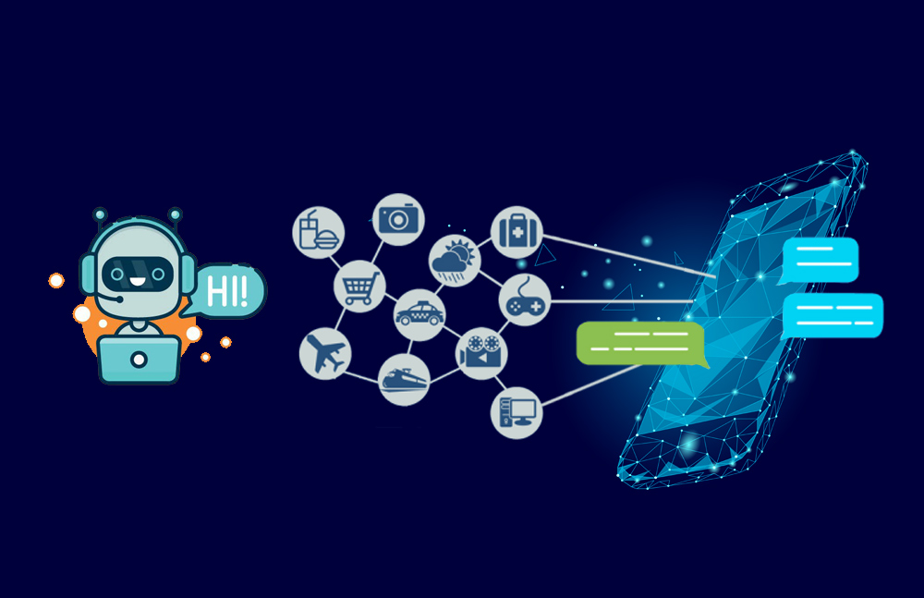

**Fig.1.1.1 chat-bot**

We’ve probably interacted with a [chatbot](https://www.oracle.com/in/chatbots/) whether you know it or not. For example, we’re at your computer researching a product, and a window pops up on your screen asking if you need help. Or perhaps we’re on your way to a concert and use our smartphone to request a ride via chat. Or we might have used voice commands to order a coffee from our neighborhood café and received a response telling us when the order will be ready and what it will cost. These are all examples of scenarios in which you could be encountering a chatbot.

* 1. **INTRODUCTION**

**1.2.1 WHAT IS CHAT-BOT**

A chatbot (conversational interface, AI agent) is a computer program that can understand human language and converse with a user via a website or a messaging app. Chatbots can handle various tasks online — from answering simple questions and scheduling calls to gathering customer feedback. Brands use bots to automate their business processes, speed up customer service, and lower support costs.

There are mainly three types of chatbot: -

1. Simple chatbots

Simple chatbots have limited capabilities, and are usually called rule-based bots. They are task-specific. for example- ordering pizza

1. Smart chatbots

Smart chatbots are designed to simulate near-human interactions with customers. They can have free-flowing conversations and understand intent, language, and sentiment. These chatbots require programming to help it understand the context of interactions. For example – virtual assistants

* Text-based chatbot: In a text-based chatbot, a bot answers the user’s questions via a text interface.
* Voice-based chatbot: In a voice or speech-based chatbot, a bot answers the user’s questions via a human voice interface.

1. Hybrid chatbots.

They are a combination of simple and smart chatbots. Both simple and smart chatbots are extremes in the chatbot spectrum. There will constantly be a need for simple chatbots to be smarter and smart chatbots to be simpler. For example – medical diagnosis.

**1.2.2 APPROACHES**

There are mainly two approaches used to design the chatbots, described as follows:

* In a **Rule-based** approach, a bot answers questions based on some rules on which it is trained on. The rules defined can be very simple to very complex. The bots can handle simple queries but fail to manage complex ones.
* **Self-learning** bots are the ones that use some Machine Learning-based approaches and are definitely more efficient than rule-based bots. These bots can be further classified into two types: Retrieval Based or Generative.

**1.2.3 HOW DO CHATBOTS WORK?**

There are broadly two variants of chatbots.

One follows a set of rules, flows, and triggers to respond to very specific commands. A simple example might be a chatbot that tells you the weather forecast for a location. A user might ask “weather forecast London” and the chatbot would find the answer and respond. This type of chatbot is only as smart as the developers who created it and thought of every eventuality of conversation.

The other variant uses machine learning to try to understand the sentiment and meaning of the language used, to not rely on pre-planned commands. A user might ask “what’s been happening in London lately?” and the chatbot might deliver the latest BBC News headlines for London. This type of chatbot learns from all the conversations it has had to improve accuracy and understanding over time.

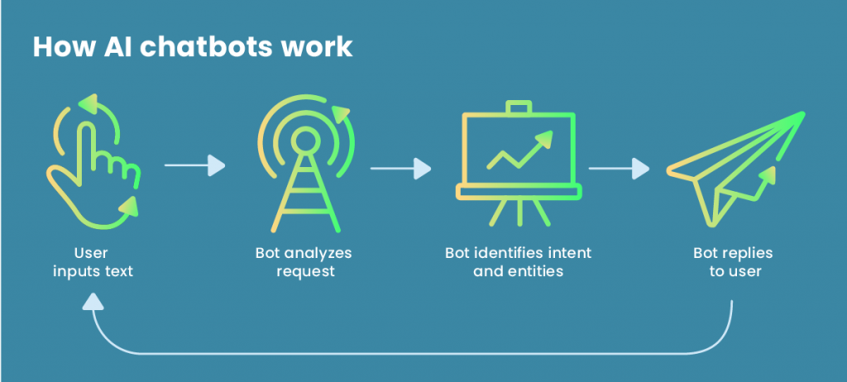

**Fig1.2.3.1 Working of chatbot.**

* 1. **PROBLEM STATEMENT**

Design a chat bot that can greet us and can reply to the questions asked

After greetings, make the chatbot ask about some basic questions like what is the capital of India and then the chatbot makes a comment about your response.

**Chapter 2**

**Literature Survey**

By utilizing the field of Artificial Intelligence, one can develop numerous applications one of that is mentioned in this paper is a chatting chatbot system. In spite of the fact that chatbot can be deployed in various fields like marketing, education, banking, clinical and finance. Research is being done in making the regular rule based chatbots to be informative, responsive and complete the correspondence in a conversational human language. This requires the incorporation of Natural Language Processing (NLP) technologies into the chatbot system. There are various approaches to do as such. Selecting a fitting technique depends on the area of the chatbot, the functionalities it expects to give, the language of correspondence, the end client, and so forth. Some of the approaches are versed in this literature survey.

Michael Maudlin created "Chatter Bot Algorithm" in 1994 and published in the book Julia and was used to answer the queries. Taking this initial idea, further projects were developed to create a chatbot system. The user needs to login to Chat-Bot application. At exactly that point the user is permitted to submit complaints and queries. When user query is submitted to the bot, context of the query is recognized and NLP is applied. WordNet calculation and grammatical forms labeling are utilized to distinguish the feeling of the words. User questions are checked in the knowledge database. If the appropriate response is discovered, at that point that answer is sent to that user. If a particular query isn't found in the database such inquiries are replied by administrator. When the administrator answers the query, at exactly that point the appropriate response is sent to the user. Question alongside answer is put in database so that at whatever point such inquiries will be posed with the intention that they get addressed legitimately from the database. Because of this administrator doesn't have to address same query physically any longer.

Natural Language Tool Kit (NLTK) is a python library which offers assistance for Natural Language Processing (NLP). NLTK has inbuilt tokenizers. The NLTK incorporates a wide scope of tokenizers which are as per the following norm, letters, path, words, keywords, class, N-gram, pattern and so on. The most usually utilized tokenizer is the word-punkt tokenizer which parts the sentences at the blank spaces. The precision, speed and effectiveness of the NLTK tokenizers is exemplary. Administrator signs in to the portal and can perform activities like erase invalid answer or to include explicit answer of a specific inquiry. With the assistance of computerized reasoning, the chatbot application answers the question asked by the users.

Chatbots are currently applied to a variety of different fields and applications, spanning from education to e-commerce, encompassing healthcare and entertainment. Therefore, chatbots can provide both support in different fields as well as entertainment to users ; this is the case for chatbots such as Mitsuku and Jessie Humani, "small talk" oriented chatbots that could provide a sense of social connection . Chatbots appear, in fact, to be more engaging to the user than the static Frequently Asked Questions (FAQ) page of a website. At the same time, chatbots can simultaneously assist multiple users, thus resulting more productive and less expensive compared to human customer supports services. In addition to support and assistance to customers, chatbots can be used for providing entertainment and companionship for the end user. Nonetheless, different levels of embodiment - the way chatbots are human-like and disclosure how and when the nature of the chatbot is revealed to the user - seem to impact users’ engagement with and trust in chatbots

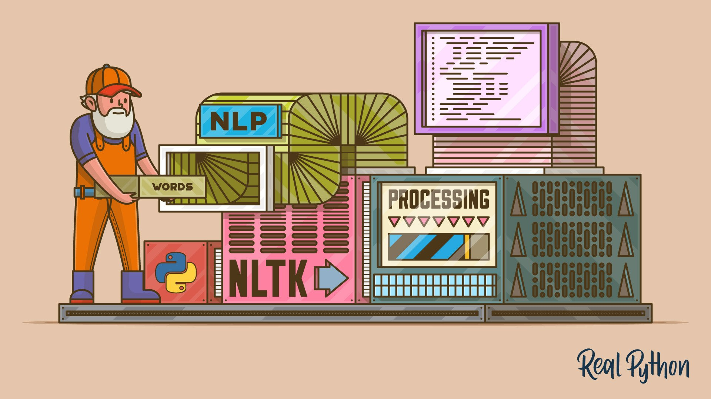

**Fig 2.1 Pictorial Representation**

**Chapter 3**

**Methodology**

**3.1 PREPARE THE DEPENDENCIES**

In this step, you’ll set up a virtual environment and install the necessary dependencies.

To get started with your chatbot project, create and activate a [virtual environment](https://realpython.com/python-virtual-environments-a-primer/), then

**3.1.1 Install chatterbot library**

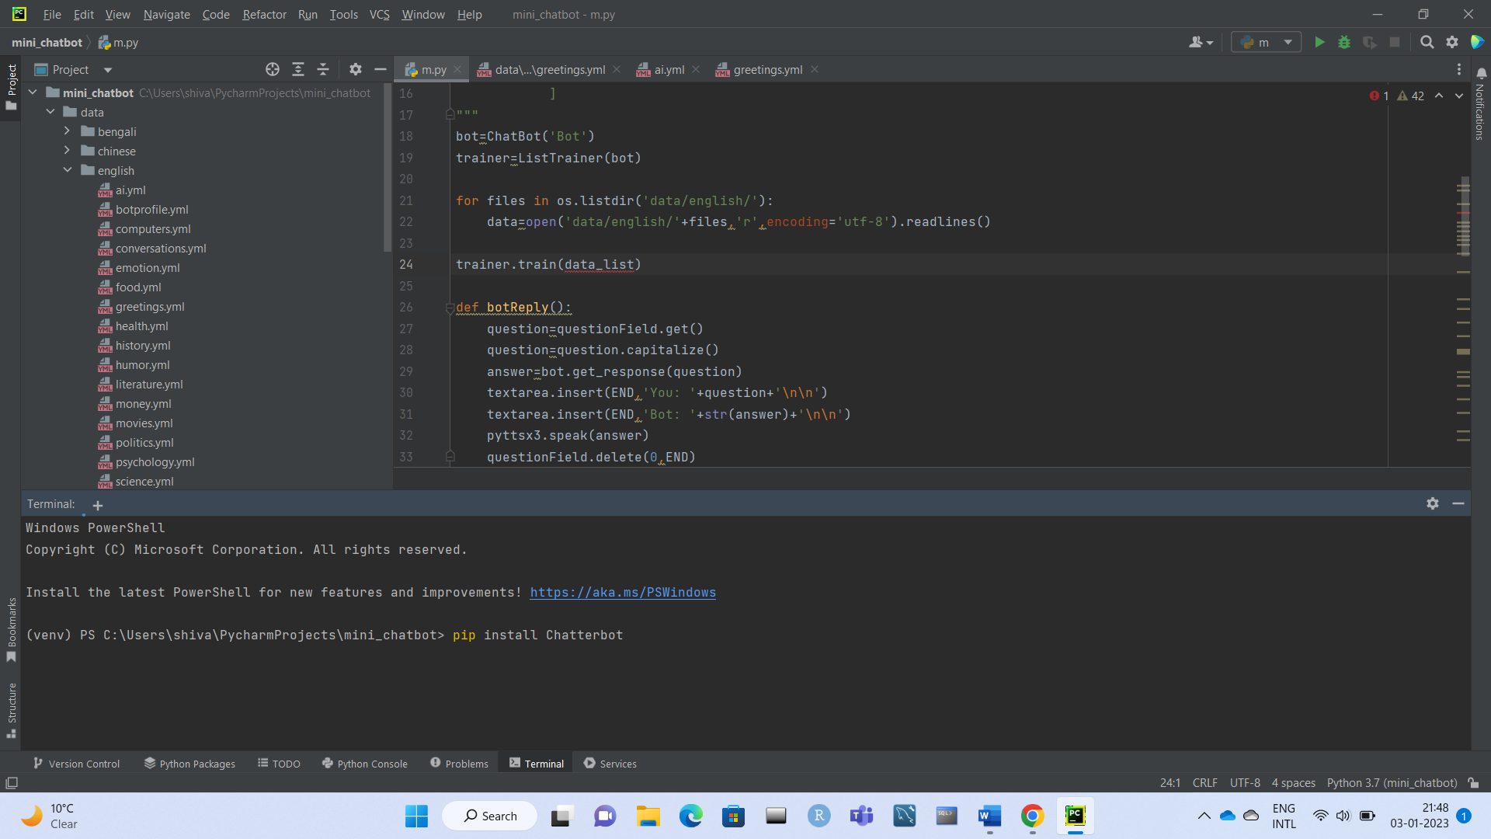

**Fig 3.1.1.1 PowerShell command to install chatterbot library**

ChatterBot is a Python library built based on machine learning with an inbuilt conversational dialog flow and training engine. The bot created using this library will get trained automatically with the response it gets from the user.

**3.1.2 Install spacy version 2.3.3**

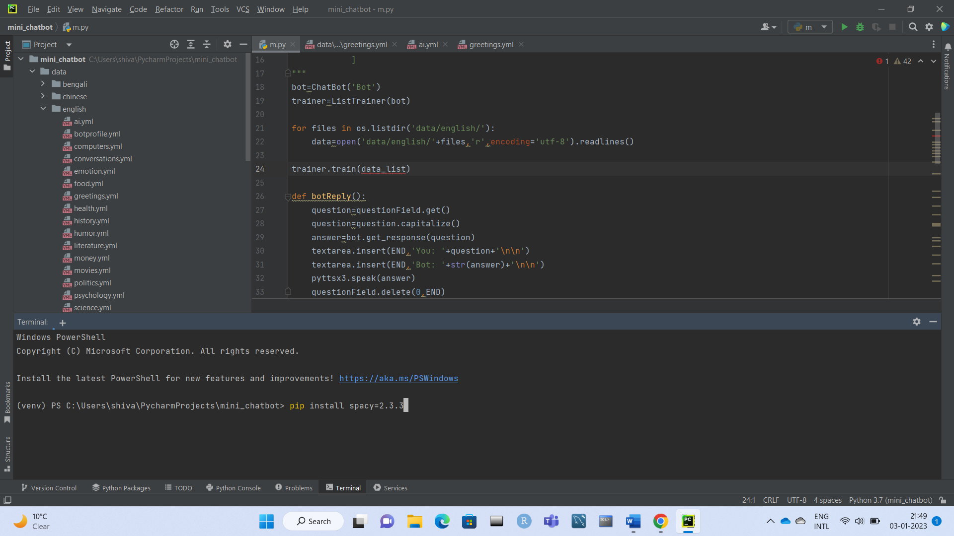

**Fig 3.1.2.1 Power shell command to install spacy library**

Spacy is an open-source software library for advances [natural language processing](https://www.projectpro.io/article/nlp-projects-ideas-/452), and specifically designed for production use and helps to build applications that process understand large volumes of text. Also it can be used for information extraction.

**3.1.3 Install pyttsx3 library**

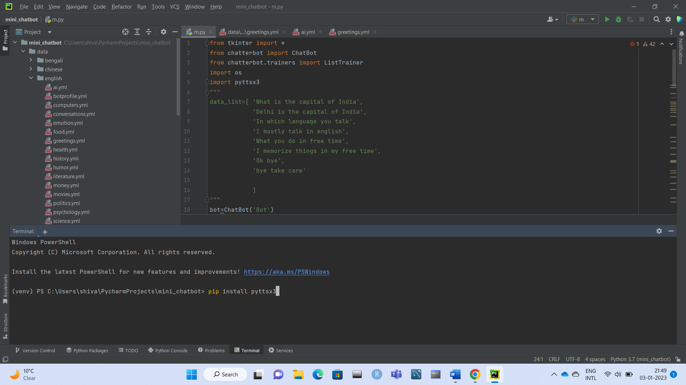

**Fig 3.1.2.1 Powershell command to install pyttsx3 library.**

**pyttsx3** is a text-to-speech conversion library in Python. Unlike alternative libraries, it works offline and is compatible with both Python 2 and 3.

* 1. **IMPORT CLASSES**

Importing classes is the second step in the Python chatbot creation process. All you need to do is import five classes – tkinter, ChatBot from chatterbot, ListTrainer from chatterbot.trainers , pyttsx3 and os . To do this, you can execute the following command:

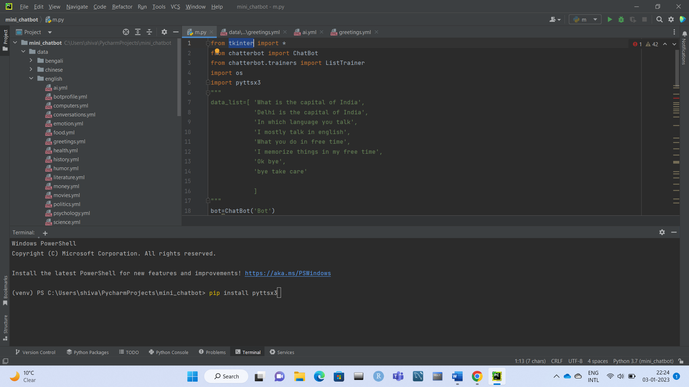

**Fig 3.2.1 Showing how to import libraries.**

* 1. **CREATE AND TRAIN THE CHATTERBOT**

This is the third step on creating chatbot in python. The chatbot we are creating will be an instance of the class “ChatBot.” After creating a new ChatterBot instance, we can train the bot to improve its performance.

Since we have to provide a list of responses, we can do it by specifying the lists of strings that can be later used to train your Python chatbot, and find the best match for each query. Here’s an example of responses we can train your chatbot using python to learn:

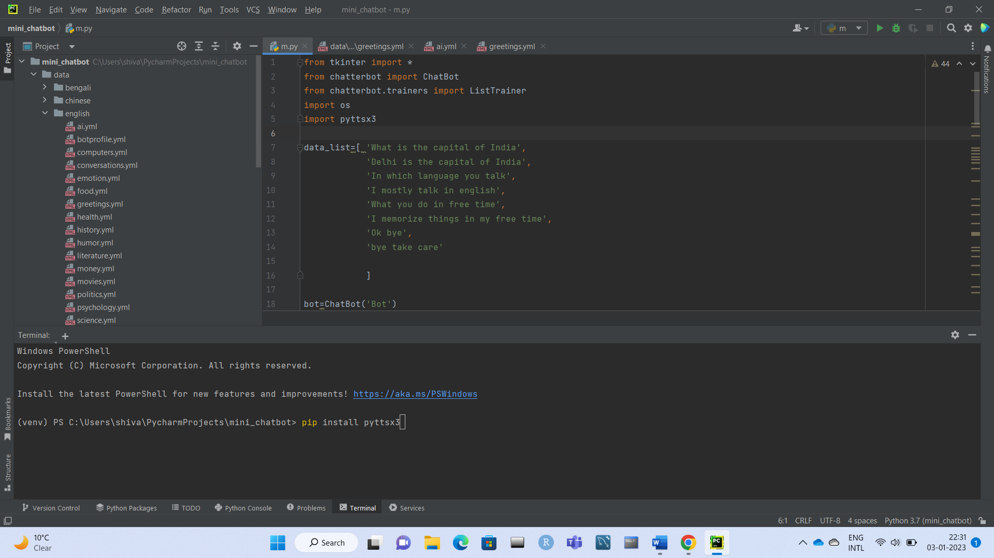

**Fig 3.3.1 Training of chatterbot with the help of responses.**

We can also create and train the bot by writing an instance of “ListTrainer” and supplying it with a list of strings like so:

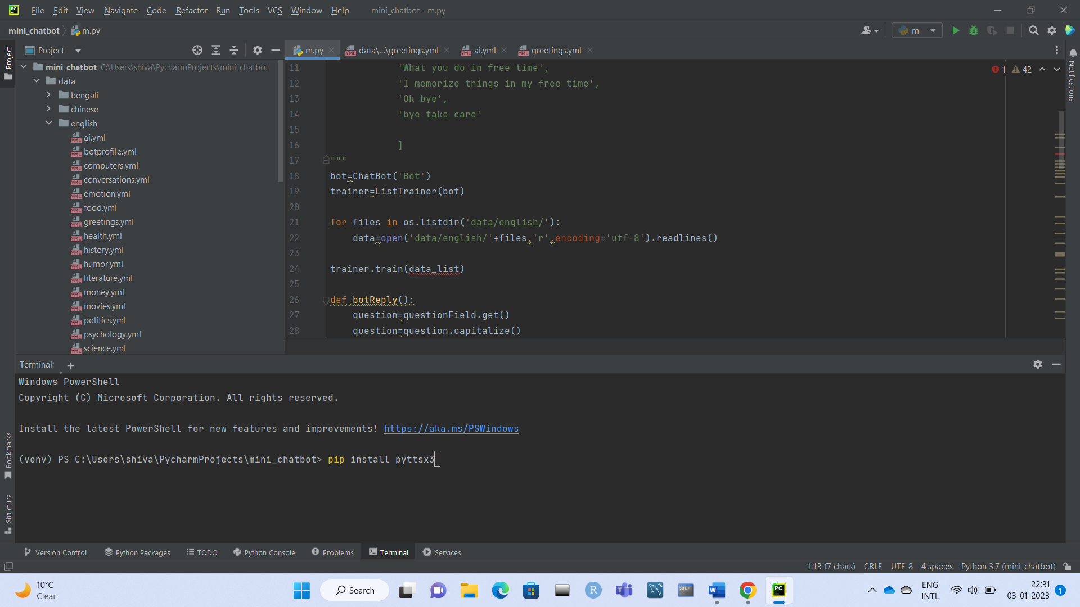

**Fig 3.3.2 Training of chatterbot with the help of instance ListTrainer.**

Now, our Python chatbot is ready to communicate.

* 1. **COMMUNICATE WITH THE PYTHON CHATBOT**

To interact with our Python chatbot, we can use the. Get_response() function.

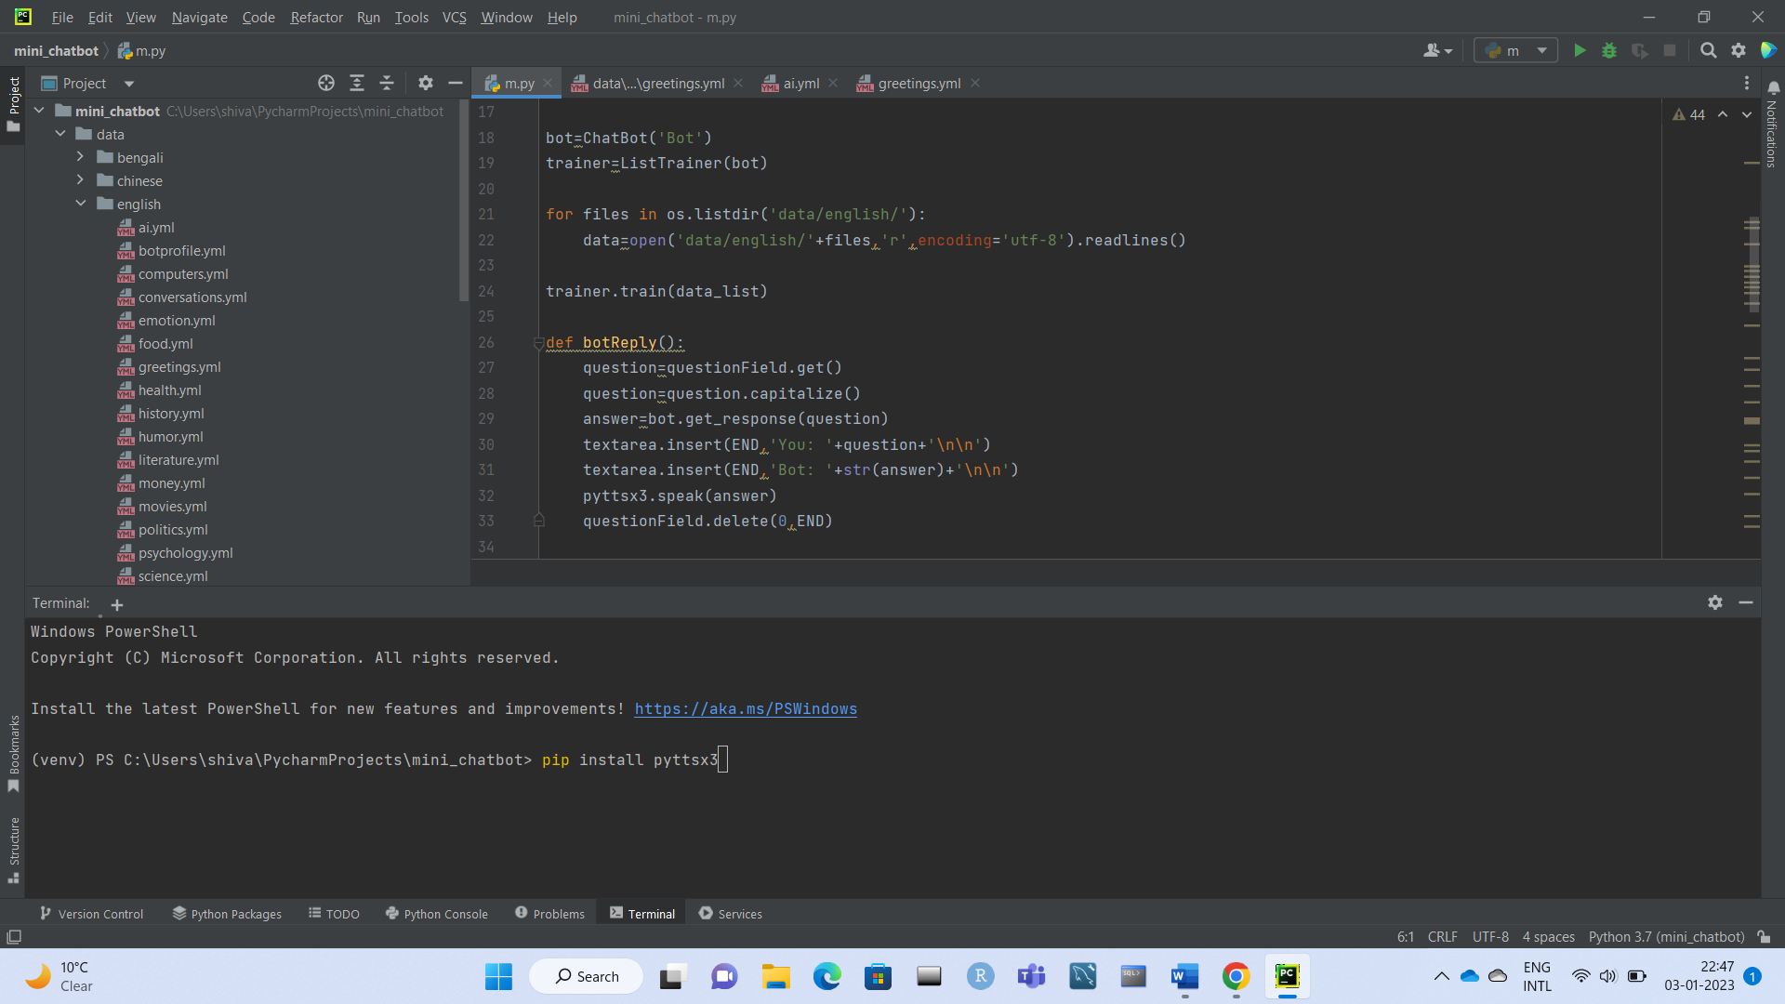

**Fig 3.4.2 Function to interact with your chat bot.**

* 1. **MAKING OUR CHAT BOT SPEAK**

We can make our chatbot speak the answer for the question asked with the help of library pyttsx3 and by using the .speak() method of the library.

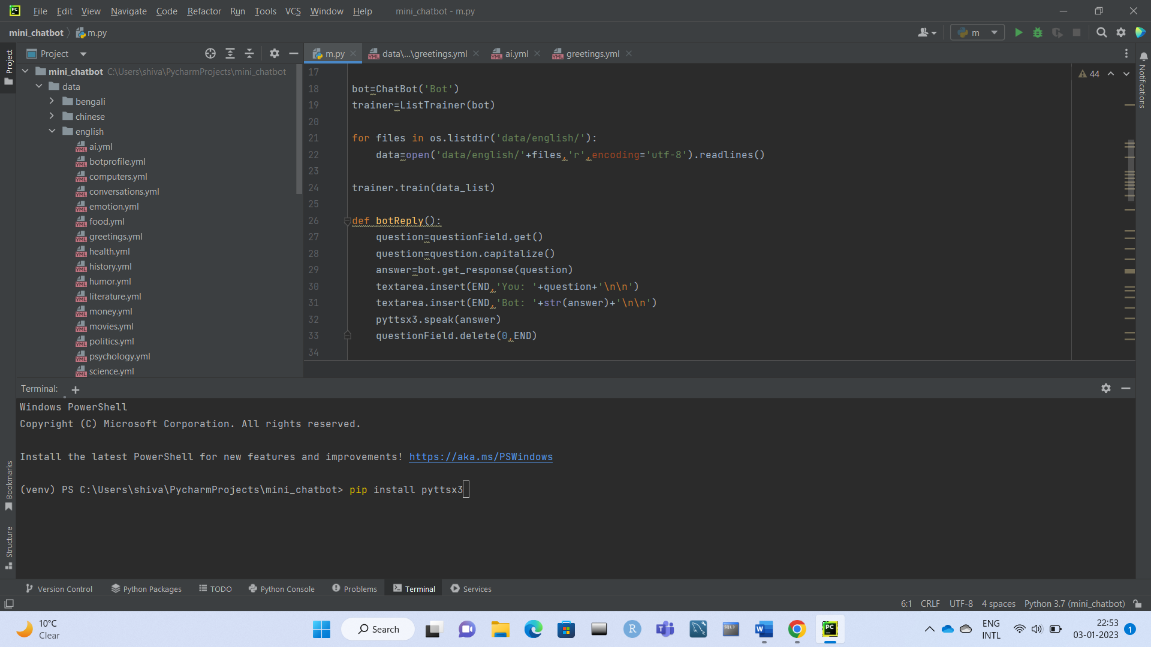

**Fig 3.5.1 Function to make our chatbot speak the response.**

**Chapter 4**

**Result and Discussion**

Chatbot is a great tool for quick interaction with the user. They help us by providing entertainment, saving time and answering the questions that are hard to find. The Chatbot must be simple and conversational. Since there are many designs and approaches for creating a chatbot, it can be at odds with commercial considerations. Researchers need to interact and must agree on a common approach for designing a Chatbot. In this project, we looked into how Chatbots are developed. General purpose Chatbot must be simple, user friendly, must be easily understood and the knowledge base must be compact. Although some of the commercial products have recently emerged, improvements must be made to find a common approach for designing a Chatbot.

Chatbot system is implemented to meet requirements of the users. Simulation or Generating response from a chatbot is a knowledge-based one. Wordnet is responsible for retrieving the responses and in this case, it contains all logics that is triggered whenever the user context is matched. When a user begins asking queries in the chatbot Graphical Use Interface (GUI). The query is searched in the database. If the response is found in the database it is displayed to the user else the system notifies the admin about the missing response in the database and gives a predefined response to the user.

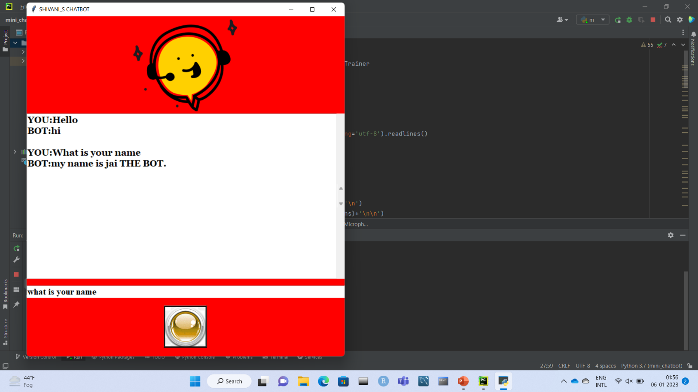

**Fig 4.1 Final Result**

**Chapter 5**

**Conclusion And Future Work**

**5.1 CONCLUSION**

In this project, we have introduced a chatbot that is able to interact with users. This chatbot can answer queries in the textual user input. The chatbot can answer only those questions which he has the answer in its dataset. Simulation or Generating response from a chatbot is a knowledge-based one. Wordnet is responsible for retrieving the responses and in this case, it contains all logics that is triggered whenever the user context is matched. When a user begins asking queries in the chatbot Graphical Use Interface (GUI). The query is searched in the database

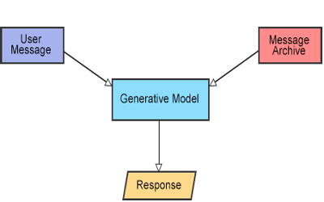

**Fig 5.1.1 Architecture**

**5.2 FUTURE WORK**

Chatbots are also referred to as virtual assistants. It is a rudimentary form of artificial intelligence software that can mimic human conversation. The Chatbots can be analyzed and improved. It can be used in various fields such as education, business, online chatting etc. It can be used in the field of education as a learning tool. The information necessary for education can be stored in the data base and can be retrieved any time by querying the bot. In business field, it can be used to provide business solutions in an efficient way. When the solutions are efficient, the business can be improved and the growth of the organization will be increased. This Chatbot can be used in online chatting for entertainment purpose. People can chat with these bots online when they are bored for the purpose of entertainment. These bots can also be used to learn different kinds of language. The language that has to learnt can be stored in the database and can be learnt by asking questions to the bot. They can also be used in the field of medical to solve health related problems. Chatbots are going to explode and can be really dominating in future. Chatbots can provide a new and flexible way for users. They are giving AI something better to do. Chatbots results in smart conversation and is advancing at an unprecedented rate with each new development. ChatBot usually store contextual data which can be used in the detection of geo location or a state (which data is needed for which step when communicating with a bot?). This could also be a telephone number or other private data, and no one knows whether the data is encrypted before it gets saved to a database. Since Chatbot predicts and provides accurate response to a posed question, it is hard to imagine the future without a Chatbot.

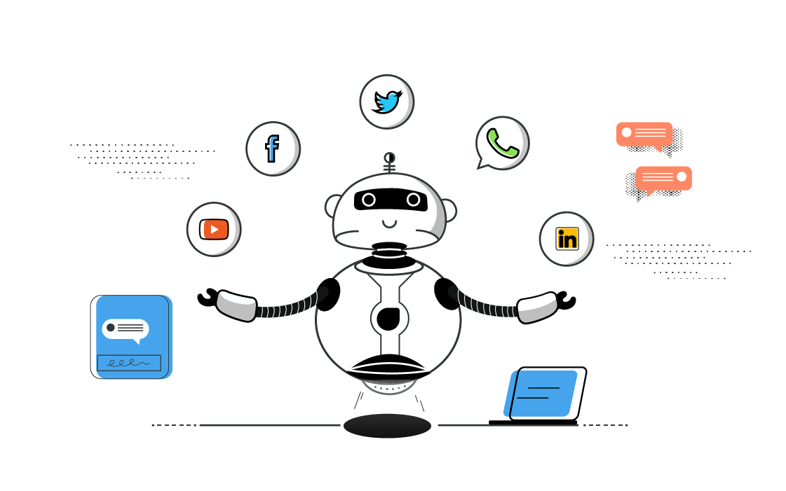

**Fig 5.1.1 Future of chat bot**

**References**

[1} Wikipedia (2019). Chatbot. Retrieved March 9, 2019 from: <https://en.wikipedia.org/Chatbot>

Wikipedia (2019) Retrieved March 9, 2019 from: <https://en.wikipedia.org/SiriFeatures_and_options>

[2] A. Storman, "5 Chatbot Challenges and How to Overcome Them", Chatbots Magazine, 2016. [Online]. Available: <https://chatbotsmagazine.com/5-chatbotchallenges-and-how-to-overcome-them-caccc3a26d7c>.

[3] "Chatbot: What is Chatbot? Why are Chatbots Important? -", Expertsystem.com, 2018. [Online]. Available: [https//www.expertsystem.comchatbot/](https://www.expertsystem.com/chatbot/).

[4] Chatbot Magazine (2019). A Visual History of Chatbots. Retrieved March 9, 2019 from: [https://chatbotsmagazine.com/a-history-of-chatbots-8bf3b31dbfb2](https://www.google.com/url?q=https%3A%2F%2Fchatbotsmagazine.com%2Fa-visual-history-of-chatbots-8bf3b31dbfb2&sa=D&sntz=1&usg=AOvVaw348XQu7kw_PZMselCnkUmo)