Module-3 HTML

**Q-1 Are the HTML tags and elements the same thing?**

**A-1** NO both are differnence.

**HTML Tages:-** HTML Tags are building blocks of HTML Page.

**Example**:-<a>,<br>,<!doctype>,<b>...etc.

<p> Paragraph Tag </p>

<h2> Heading Tag </h2>

<b> Bold Tag </b>

<i> Italic Tag </i>

<u> Underline Tag </u>

**HTML Elements:-**starting tag to ending tag with content is called HTML Elements.

**Example:-<**h1>,<h2>,<text>,<div>

**Q-2 What are tags and attributes in HTML**?

**A-2** HTML Tages:- HTML Tags are building blocks of HTML Page.

**Example:-**

**<**a>,<br>,<!doctype>,<b>...etc.

<p> Paragraph Tag </p>

<h2> Heading Tag </h2>

<b> Bold Tag </b>

<i> Italic Tag </i>

<u> Underline Tag </u>

**HTML Attributes:-**Attributes are specified within the opening tag of an element and consist of a name and a value, separated by an equals sign.

**Example:-** "style=front,size,color"

<element attribute="value">element content</element>.

**Q-3 What are void elements in HTML? With Example?**

**A- 3** The void element is the starting tage is compalsary but end tage is not compalsary(not must be). Self closing tage also calles void tage.

**Example:-** <br> ,<image>,<input>….etc

**Q-4 What are HTML Entities? With Example?**

**A-4** The HTML entites is tage in used symbol & sign yhat called entities. The used converted the code in html entities.

**Example:-** (),<>,{},[],””,& …etc.

**Q-5 What are different types of lists in HTML? With Example.**

**A-5** Unorder list:-

Order List:-

**Unoder list :-**An unordered list starts with the <ul> tag. Each list item starts with the <li>tag.

The list items will be marked with by default:-Bullet property is used to define the style of the list item marker.like circle,squre,disc..

**Ordet list:-**An order list start with <ol>tag. Each list item starts with the <li>tag.

The list items will be marked with by default:-123.

**Example:-**

<!DOCTYPE html>

<html lang=”en”>

<head>

<meta charset=”UFT-8”/>

<meta name=”viewport” content=”width=device-width,initial-scale=1.0”>

<title>Document</title>

</head>

<body>

<ul type=”disk”>

<li>abc</li>

<li>abc</li>

<li>abc</li>

<li>abc</li>

</ul>

<ul type=”circle”>

<li>abc</li>

<li>abc</li>

<li>abc</li>

<li>abc</li>

</ul>

<ol type=”A”>

<li>abc</li>

<li>abc</li>

<li>abc</li>

<li>abc</li>

</ol>

<ol type=”A”>

<li>abc</li>

<li>abc</li>

<li>abc</li>

<li>abc</li>

</ol>

<ol type=”i”>

<li>abc</li>

<li>abc</li>

<li>abc</li>

<li>abc</li>

</ol>

</body>

</html>

**Result:-**

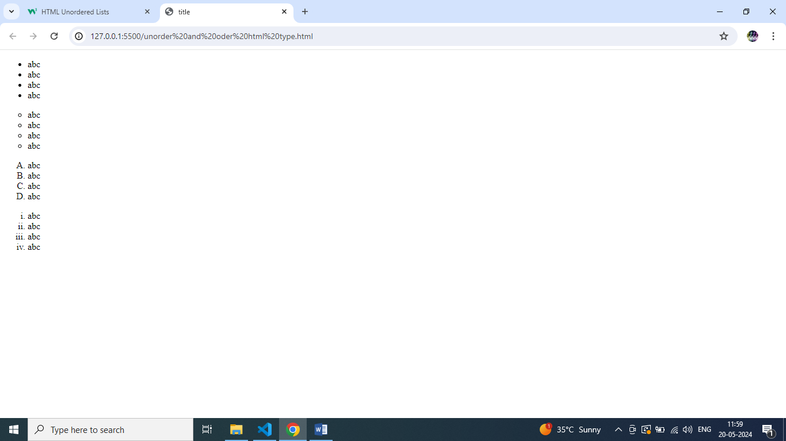

**Q-6 What is the ‘class’ attribute in HTML? With Example.**

**A-6 :-** class attribute is a defile the class in style. Class define as a (.)

The mulitiple class are applied.

**Example:-**

<!DOCTYPE html>

<html lang=”en”>

<head>

<meta charset=”UFT-8”/>

<meta name=”viewport” content=”width=device-width,initial-scale=1.0”>

<title>Document</title>

<style>

.h4{background-color:bisque;}

.b{color:blue;}

.h7{ color:blacks;

background-color:bisque;}

</style>

</head>

<body>

<h1 class=”h4 b”>class tag</h1>

<h2 class=”h7 ”>shivani bhatt</h2>

</body>

</html>

**Result:-**

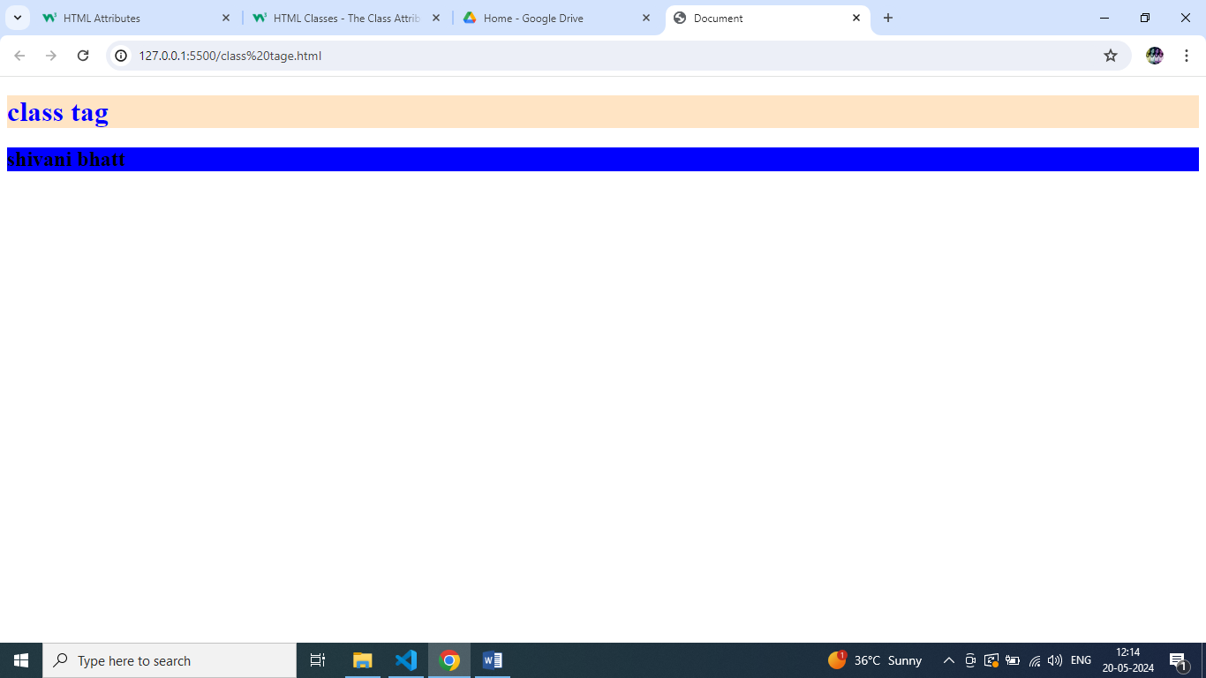

**Q-7 What is the difference between the ‘id’ attribute and the ‘class’ attribute of HTML**

**elements? With Example.**

**A-7** The id attributes is a applied one time in a tag. And the definr as a(#.)

The class attributes is a applied multiple time in a tag. And the define as a(.)

**Example:-** <!DOCTYPE html>

<html lang=”en”>

<head>

<meta charset=”UFT-8”/>

<meta name=”viewport” content=”width=device-width,initial-scale=1.0”>

<title>Document</title>

<style>

.h2,h4{ color:blue;

background-color:aqua;}

#A{color:blue;

background-color:aqua;}

</style>

</head>

<body>

<h1 class=”h2 h4”>class tage</h1>

<h2 id=” A”>hello id</h2>

</body>

</html>

**Result:-**

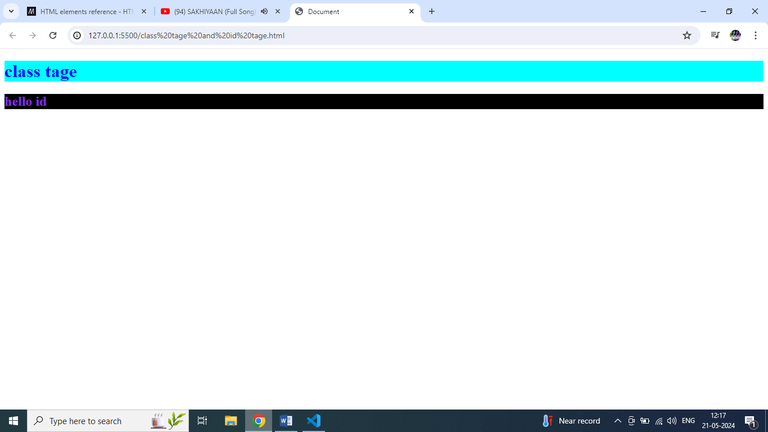

**Q-8 What are the various formatting tags in HTML?**

**A-8** Text formatting in HTML refers to the way text is displayed on a web page. It is the process of applying various styles, colors, fonts-sizes, and other visual enhancements to text content within an HTML document.

**Example:-**

<!DOCTYPE html>

<html lang=”en”>

<head>

<meta charset=”UFT-8”/>

<meta name=”viewport” content=”width=device-width,initial-scale=1.0”>

<title>Document</title>

</head>

<body>

<h1 style=”color: blueviolet;”>Shivani</h1>

<h2 style=”font-size:40px;”>Shivani</h2>

</body>

</html>

**Result:-**

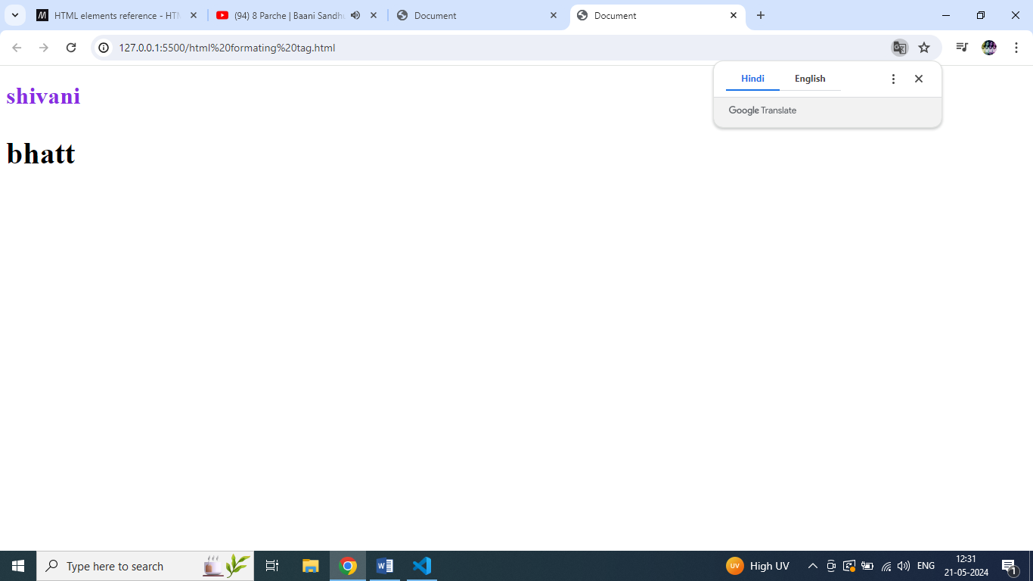

**Q-9 How is Cell Padding different from Cell Spacing? With Example.**

**A-9** **cell padding:-**cell padding is used for create space inside the cell(text area).the subcell inside the space create(cell spacing is used for positioning elements (such as images or text) within that content area).

**cell spacing:-**cell spacing is used for create space in outer side of subcell. and create the space main cell inside.(Cell padding is used to create a border around the content area of a web page).

**Example:-**

Example:- <!DOCTYPE html>

<html lang="en">

<head>

<meta charset="UTF-8">

<meta name="viewport" content="width=, initial-scale=1.0">

<title>Document</title>

</head>

<body>

<table  border="4" cellspacing="10px" cellpadding="20px">

<tr>

<th colspan="4">cell padding & cell spacing</th>

</tr>

<tr>

<td>table 1</td>

<td>table 2</td>

<td>table 3</td>

<td>table 4</td>

</tr>

<tr>

<td>table A</td>

<td>table B</td>

<td>table C</td>

<td>table D</td>

</tr>

</table>

<table border="6" cellSpacing="40px">

<tr>

<th colspan="4">cell spacing</th>

</tr>

<tr>

<td>table 1</td>

<td>table 2</td>

<td>table 3</td>

<td>table 4</td>

</tr>

<tr>

<td>table A</td>

<td>table B</td>

<td>table C</td>

<td>table D</td>

</tr>

</table>

<table border="6" cellpadding="20px">

<tr>

<th colspan="4">cell padding</th>

</tr>

<tr>

<td>table 1</td>

<td>table 2</td>

<td>table 3</td>

<td>table 4</td>

</tr>

<tr>

<td>table A</td>

<td>table B</td>

<td>table C</td>

<td>table D</td>

</tr>

</table>

</body>

</html>

**Result:-**

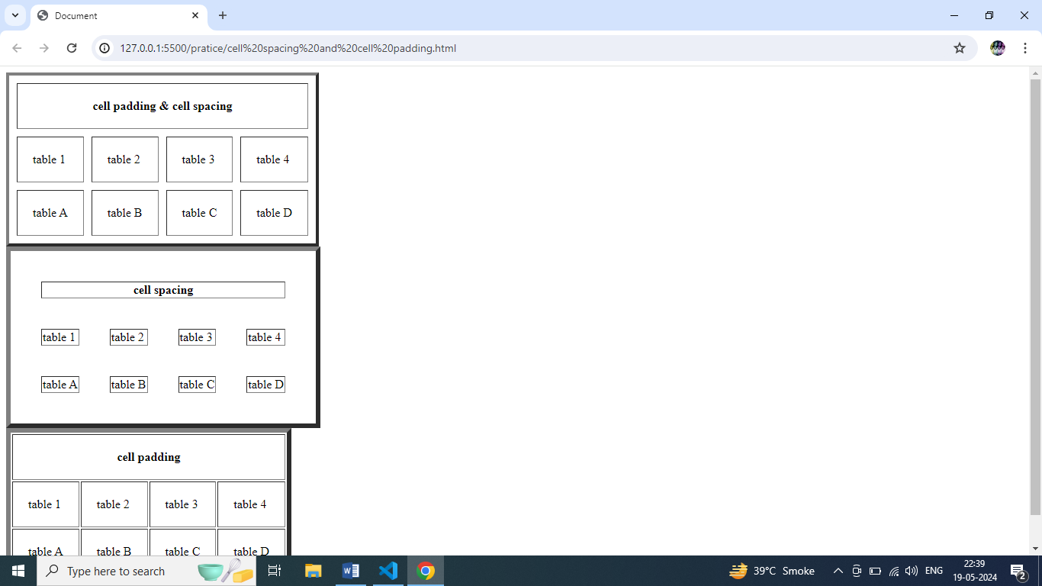

**Q-10 How can we club two or more rows or columns into a single row or column in an HTML table? With Example**.

**A-10:-**The Table in Used table tag inside the applied boder in table then used rowspan,and colspan used.

**Example:-**

<!DOCTYPE html>

<html lang="en"><!DOCTYPE html>

<html lang="en">

<head>

<meta charset="UTF-8">

<meta name="viewport" content="width=device-width, initial-scale=1.0">

<title>Document</title>

</head>

<body>

<table border="3" cellpadding="10px" cellspeacing="20px">

<tr>

<td>hello</td>

<td colspan="2">hello</td>

</tr>

<tr>

<td rowspan="2">hello</td>

<td>hello</td>

<td rowspan="2">hello</td>

</tr>

<tr>

<td>hello</td>

</tr>

<tr>

<td rowspan="2">hello</td>

<td>hello</td>

<td rowspan="2">hello</td>

</tr>

<tr>

<td>hello</td>

</tr>

<tr>

<td>hello</td>

<td colspan="2">hello</td>

</tr>

</table>

</body>

</html>

**Result:-**

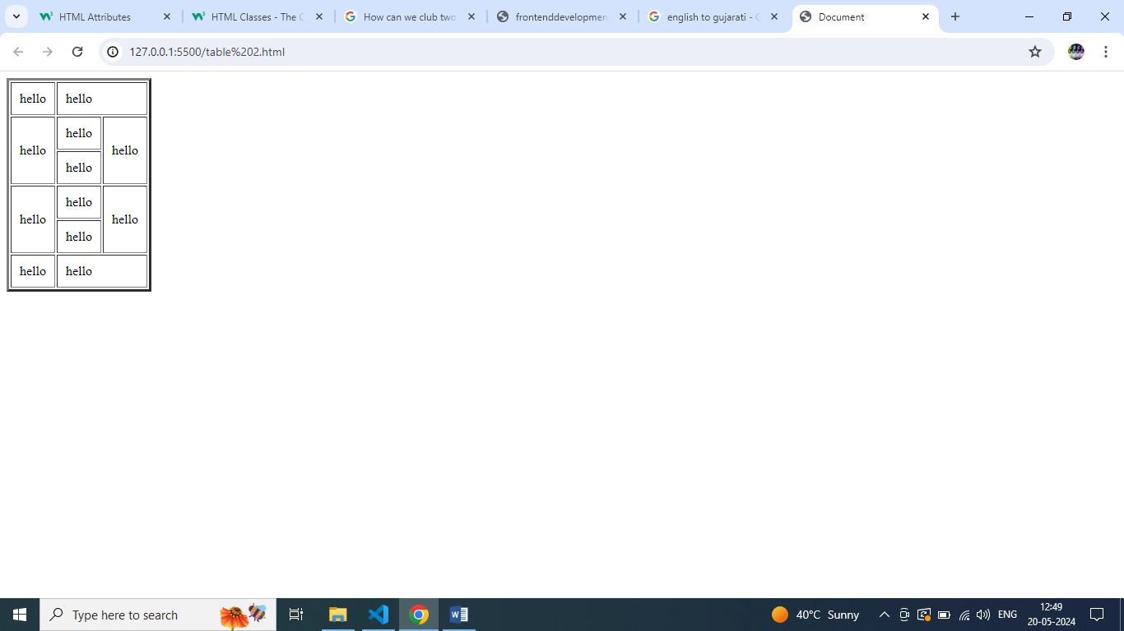

**Q-11:- What is the difference between a block-level element and an inline element?**

**A-11:-** Block level element :-A contain always starts from the new line.Block element is start new line.the block element not necessary width.

**Example:-**

<p>,<div>..etc

Inline element:-The contain is start form the same line. inline element does not start on a new line. An inline element only takes up as much width as necessary. Example:-<a>,<b>, <span>…etc.

**Example:-**

<!DOCTYPE html>

<html lang="en">

<head>

<meta charset="UTF-8">

<meta name="viewport" content="width=p, initial-scale=1.0">

<title>Document</title>

</head>

<body>

<!-- block element -->

<p>shivanibhatt</p>

<div>12th</div>

<!-- inline element -->

<span>abcdefghijklmnop</span>

<a href="">abc</a>

</body>

</html>

**Result:-**

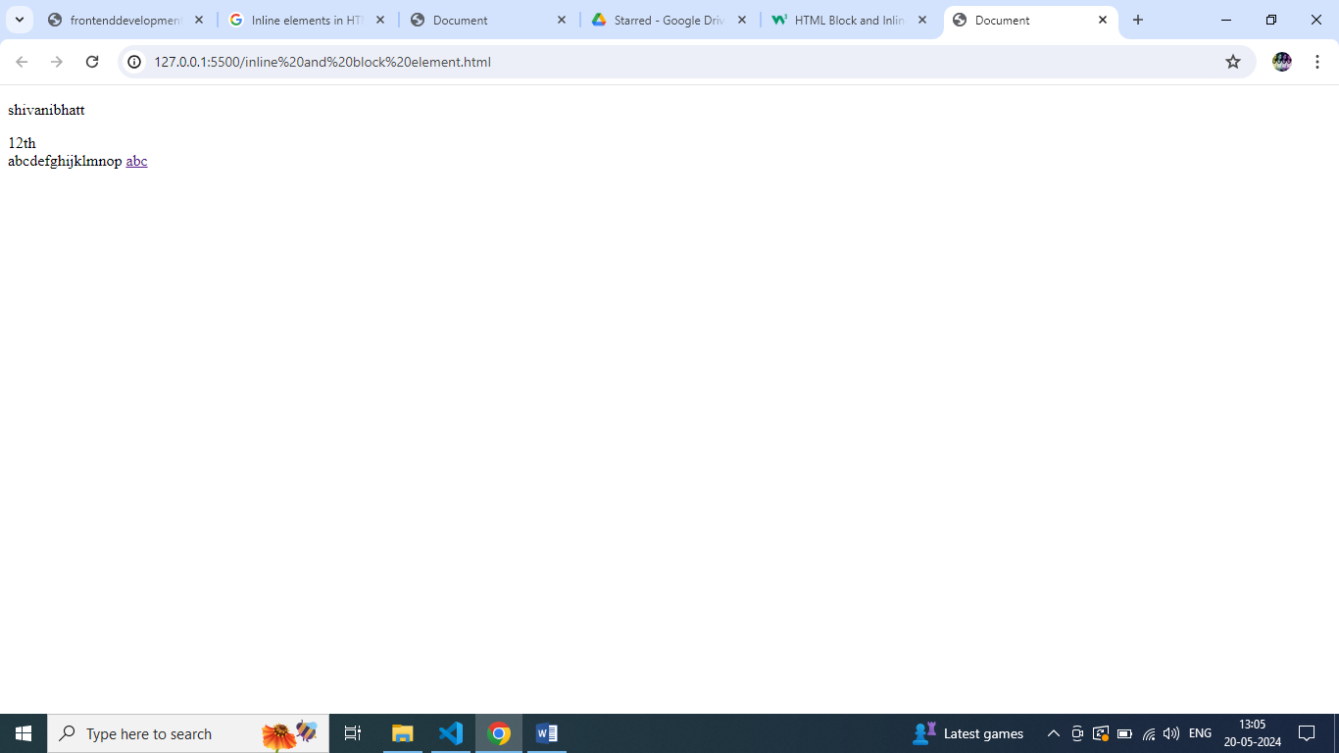

**Q-12 How to create a Hyperlink in HTML? With Example.**

**A-12** the use A elments and use image tage are and provide the path image then provide link a in a tage.

**Example:-**

<!DOCTYPE html>

<html lang="en">

<head>

<meta charset="UTF-8">

<meta name="viewport" content="width=a, initial-scale=1.0">

<title>Document</title>

</head>

<body>

<img src="shivani/nature.jpg" style="width: 100px; height: 100px;"><br>

<a href="https://www.youtube.com/"><img src="shivani/live free.jpg " style="width: 100px; height: 100px;"></a><br>

<a href="https://about.google/">click me</a>

</body>

</html>

**Result:-**

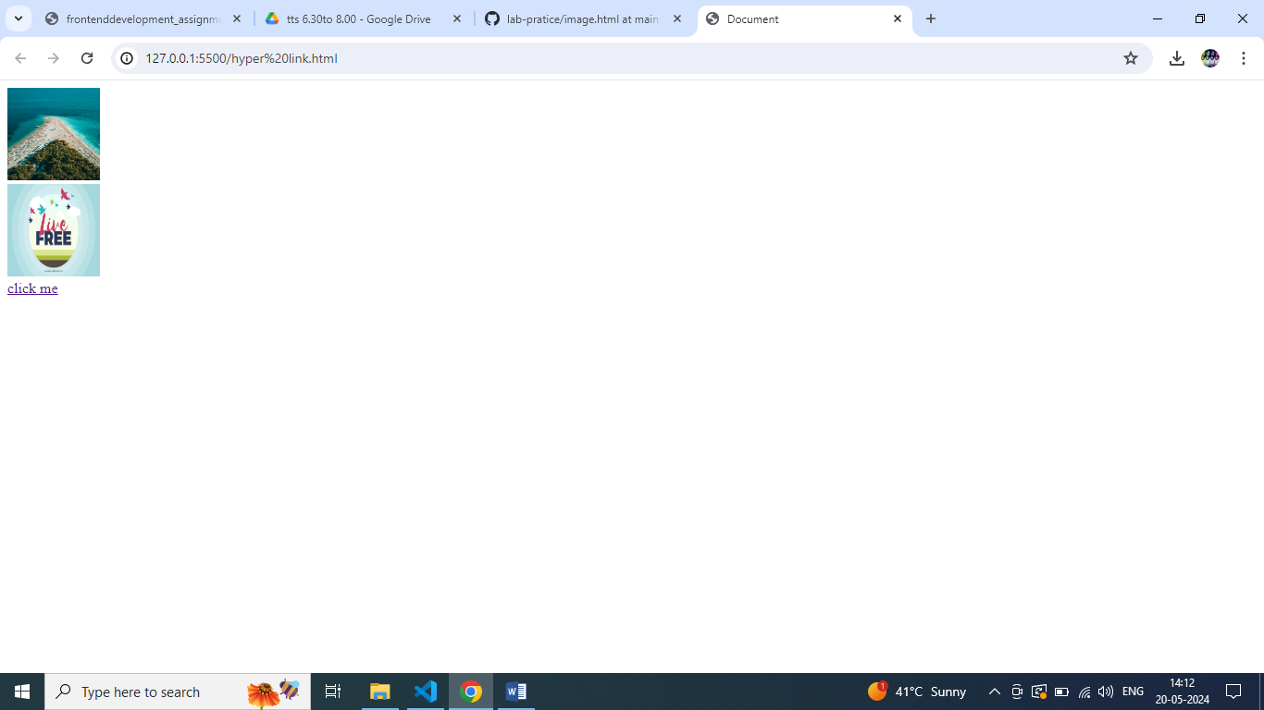

**Q-13 What is the use of an iframe tag? With Example.**

**A-13** Ifram tage is used for the image and video embed code copy then past in ifram image run the tage . ifram is ued google maping,image,video.

**Example:-**

<!DOCTYPE html>

<html lang="en">

<head><meta charset="UFT-8"/>

<meta name="viewport" content="width=device-width,initial-scale=1.0">

<title>Document</title>

</head>

<body>

<iframe width="560" height="315" src="https://www.youtube.com/embed/vP3TRAsjZss?si=m59avetIyYwlwsEF" title="YouTube video player" frameborder="0" allow="accelerometer; autoplay; clipboard-write; encrypted-media; gyroscope; picture-in-picture; web-share" referrerpolicy="strict-origin-when-cross-origin" allowfullscreen></iframe>

</body>

</html>

**Result:-**

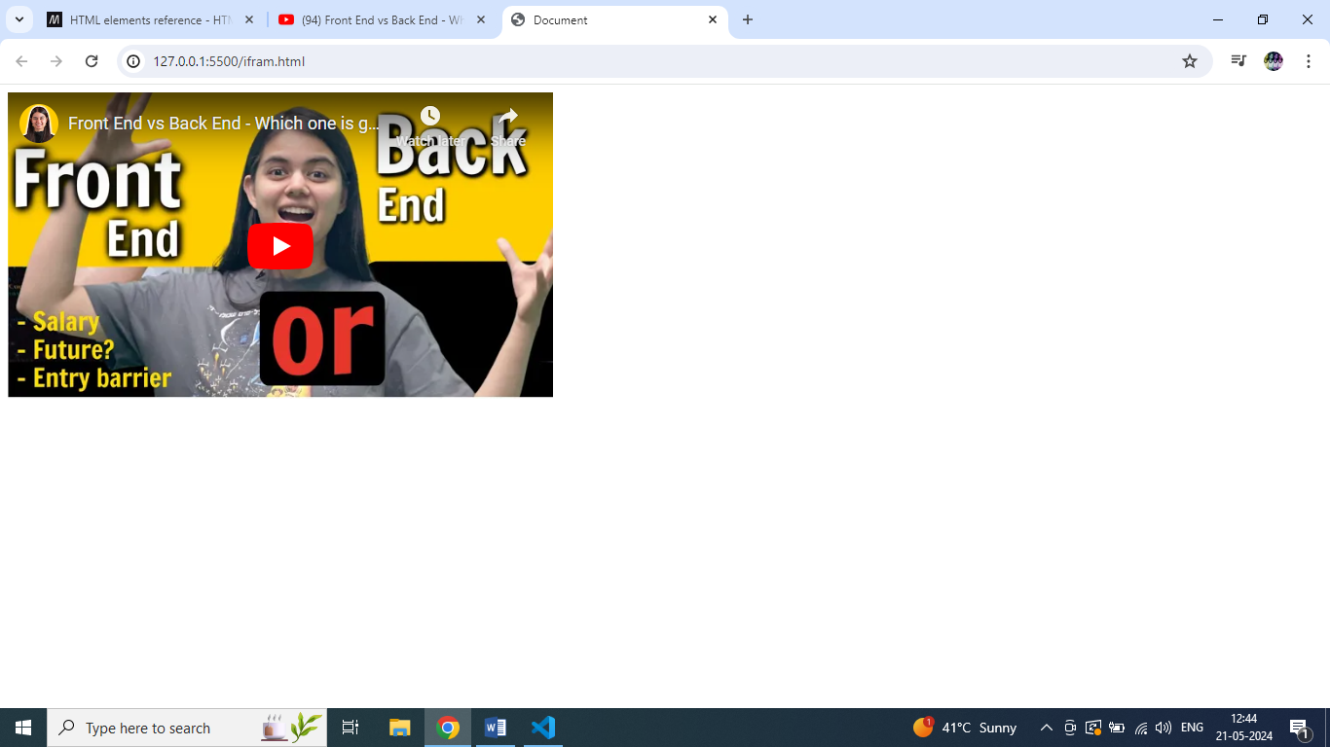

**Q-14 What is the use of a span tag? Explain with example?**

**A-14** span tage is inliner tage .and the tage used for text for style contain.

**Example:-**

<!DOCTYPE html>

<html lang="en">

<head><meta charset="UFT-8"/>

<meta name="viewport" content="width=device-width,initial-scale=1.0">

<title>Document</title>

</head>

<body>

<span style=”color: aqua; background-color:black;”>Lorem ipsu m dolor sit amet,consectrtur <b>adipisicing elit. Deserunt, sint!</span>

</body>

</html>

**Result:-**

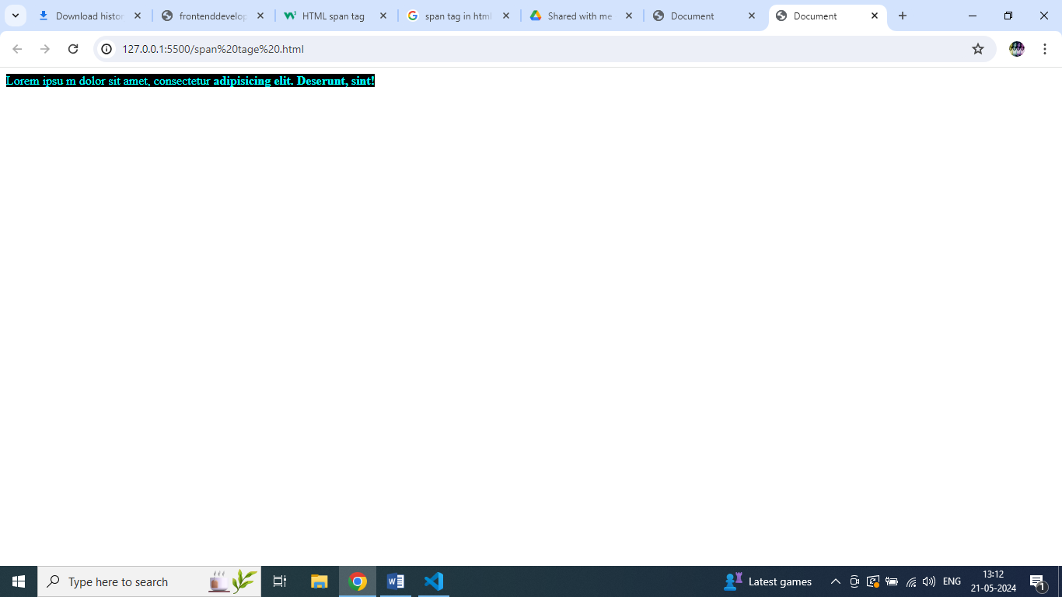

**Q-15 How to insert a picture into a background image of a web page? With Example.**

**A-15** Back ground in image used in use <p>and applied image tage and applied style.

**Example:-**

<!DOCTYPE html>

<html lang="en">

<head><meta charset="UFT-8"/>

<meta name="viewport" content="width=device-width,initial-scale=1.0">

<title>Document</title>

</head>

<body>

<h1 style=”background-color: blue; font-size: 100px;”>Nuture</h1>

<p><img src=”shivani/nature.jpg” alt=”” style=”height: 300px; width:300px;”></p>

</body>

</html>

**Result:-**

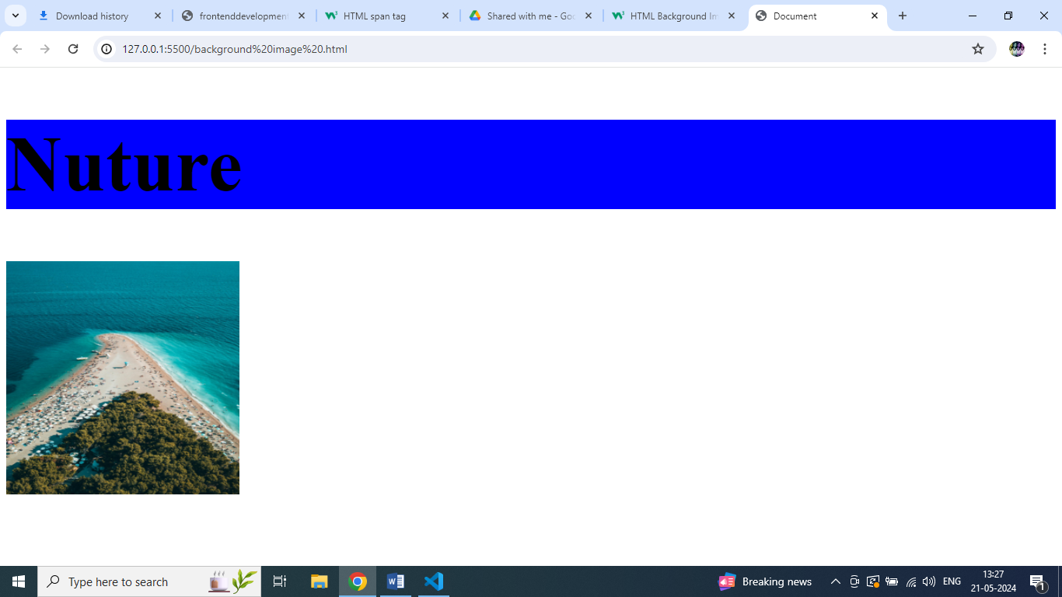

**Q-16 How are active links different from normal links?**

**A-16** Active links is open the another page and normal link is open same page.

The applied the h1 tage and then applied (A) ref used and then applied application link in (A) tag .and then cick application name and link open is another page.

**Example:-**

<!DOCTYPE html>

<html lang="en">

<head><meta charset="UFT-8"/>

<meta name="viewport" content="width=device-width,initial-scale=1.0">

<title>Document</title>

</head>

<body>

<h1>this is a link</h1>

<h2><a href=<https://www.mynrta.com/>>”myntra</h2>

</body>

</html>

**Result:-**

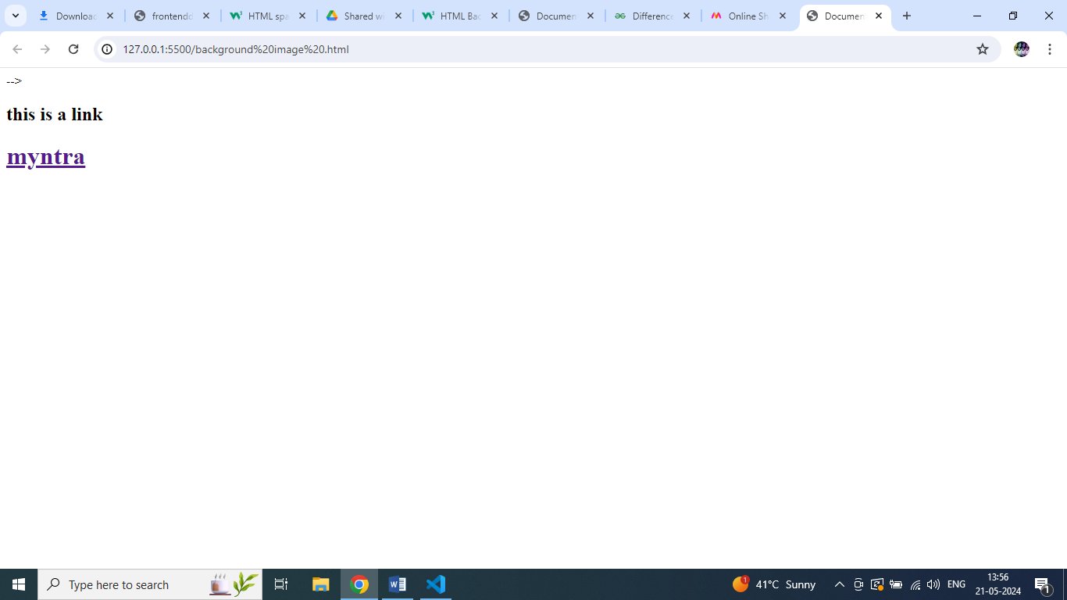

**Q-17 What are the different tags to separate sections of text?**

**A-17** the <br> tage is used for the sepration section of text.

This tage is containg is start from next line

**Example:-**

<!DOCTYPE html>

<html lang="en">

<head><meta charset="UFT-8"/>

<meta name="viewport" content="width=device-width,initial-scale=1.0">

<title>Document</title>

</head>

<body>

<tr>

<td>

L<br>u<br>n<br>c<br>h<br>

</td>

</tr>

</body>

</html>

**Q-18 What is SVG?**

**A-18** Scalable Vector base Graphic. this is 2D creation. In vactor use in three like(x,y,z).the svg used image are zoom that time qulity is not lose.provide the visual appearance to the text.

**Q-19 What is difference between HTML and XHTML?**

**A-19**

**XHTML** stands for EXtensible HyperText Markup Language. XHTML comes with a much stricter error handling.

**HTML** stand for HyperText Markup Language.

HTML more extensible and flexible to work .

**Q-20 What are logical and physical tags in HTML?**

**A-20** The logical tages is describe the Meaning and structure define.

The Physical tage is describe the provide the visual appearance to the text.

**TASK:-**

**Example:-**

<!DOCTYPE html>

<html lang="en">

<head><meta charset="UFT-8"/>

<meta name="viewport" content="width=device-width,initial-scale=1.0">

<title>Document</title>

</head>

<body>

<table border=”1” cellpadding=”5px” cellspacing=”3px”>

<caption>create below example using only HTML tages without css.</caption>

<tr>

<td >Home</td

<td >Above</td>

<td >Contact</td>

<td >Help</td>

<td >Store</td>

<td style=”background-color:red:”>download <br> app </td>

<tr>

<td style=”background-color:red;”>app</td>

</tr>

</td>

</tr>

<tr>

<td colspan=”6”><img srs=’/image/door image.jpg” alt=”” style=”width: 100%:” style=”hight:100%:”></td>

</tr>

<tr>

<td style=”background-color:darkmagenta;” colspan=”6” align=”center”>contact-us-page</td>

</tr>

<tr>

<td colspan=”6”><img src=”/img/contact us.web” alt=”” style=”width: 100%:” style=”hight:100%”;></td>

</tr>

<form action=””>

<tr style=”background-color:aquamarine;” align=”center”>

<td colspan=”3”>

<label for=””>First-name</label>

<input type=”text” placeholder=”Enter your name” align=”center”>

</td>

<td colspan=”3”>>

<label for=””>Last-name</label>

<input type=”text” placeholder=”Enter your name” align=”center”>

</td>

</tr>

<tr style=”background-color:aquamarine;” align=”center”>>

<td colspan=”3”>>

<label for=””>Email-id</label>

<input type=”text” placeholder=”Enter your email id” pattern=”[a-z0-9._%-]+@[ a-z0-9._-]+\.[a-z]{2,3}$” align=”center” required>

</td>

<td colspan=”3”>>

<label for=””>Phone number</label>

<input type=”text” placeholder=”Enter your phone no.” pattern=”[0-9]{9}” align=”center” required>

</td>

</tr>

<tr style=”background-color:aquamarine;” align=”center”>>

<td colspan=”3”>>

<label for=””>city</label>

<select name=”” id=””>

<option value=””>Ahmedabad</option>

<option value=””>Surat</option>

<option value=””>Rajkot</option>

<option value=””>Gandhinagar</option>

</select>

</td>

<td colspan=”3”>>

<label for=””>Gender</label>

<input type=”radio” name=”gender”>Male

<input type=”radio” name=”gender”>Female

<input type=”radio” name=”gender”>Other

</td>

</tr>

</form>

<tr>

<td colspan=”3”>>

<iframe src="https://www.google.com/maps/embed?pb=!1m14!1m12!1m3!1d3670165.028933462!2d73.50226506874995!3d26.061499693138057!2m3!1f0!2f0!3f0!3m2!1i1024!2i768!4f13.1!5e0!3m2!1sgu!2sin!4v1716366712488!5m2!1sgu!2sin" width="100%" height="100%" style="border:0;" allowfullscreen="" loading="lazy" referrerpolicy="no-referrer-when-downgrade" ></iframe>

</td>

<td colspan=”3”>>

<iframe width="100%" height="100%" src="https://www.youtube.com/embed/Y9pgsPW-KIE?si=uSEKcgZ2DmGeTcQO" title="YouTube video player" frameborder="0" allow="accelerometer; autoplay; clipboard-write; encrypted-media; gyroscope; picture-in-picture; web-share" referrerpolicy="strict-origin-when-cross-origin" allowfullscreen></iframe>

</td>

</tr>

</table>

</body>

</html>

**In VSCODE:-**

<!DOCTYPE html>

<html lang="en">

<head>

    <meta charset="UTF-8">

    <meta name="viewport" content="width=device-width, initial-scale=1.0">

    <title>Document</title>

</head>

<body>

    <table border= "1"cellpadding=”5px” cellspacing=”3px”>

        <caption>Create below example using only HTML tags without CSS.</caption>

        <tr>

            <td >Home</td>

            <td >Above</td>

            <td >Contact</td>

            <td >Help</td>

            <td>store</td>

            <td style="background-color: red;">download <br>app </td>

        </tr>

        <tr>

            <td colspan="6"><img src="/image/door image.jpg" alt="" style="width: 100%; height: 100%;"></td>

        </tr>

        <tr>

            <td style="background-color:darkmagenta;" colspan="6" align="center">contact-us-page</td>

        </tr>

<tr>

    <td colspan="6"><img src="/image/contact us.webp" alt="" style="width:100%" height="100%"></td>

</tr>

<form action="" >

    <tr style="background-color: aquamarine;" align="center">

        <td colspan="3">

            <label for="">First- name</label>

            <input type="text" placeholder="Enter Your name" align="center">

        </td>

        <td colspan="3">

            <label for="">Last- name</label>

            <input type="text" placeholder="Enter Your name" align="center">

        </td>

    </tr>

    <tr style="background-color: aquamarine;" align="center">

        <td colspan="3">

            <label for="">Email-id</label>

            <input type="text" placeholder="Enter your email id"pattern="[a-z0-9._%+-]+@[a-z0-9.-]+\.[a-z]{2, 3}$" align="center"required>

        </td>

        <td colspan="3">

            <label for="">Phone number</label>

            <input type="text" placeholder="Enter your phone no." pattern="[0-9]{9}" align="center"required>

        </td>

    </tr>

    <tr style="background-color: aquamarine;" align="center">

        <td colspan="3">

         <label for="">city</label>

            <select name="" id="">

            <option value="">Ahmedabad</option>

            <option value="">surat</option>

            <option value="">Rajkot</option>

            <option value="">Gandhinagr</option>

        </select>

        </td>

        <td colspan="3">

            <label for="">Gender</label>

            <input type="radio" name="gender" >Male

            <input type="radio" name="gender" >Female

            <input type="radio" name="gender" >Other

        </td>

    </tr>

</form>

<tr>

    <td colspan="3">

        <iframe   src="https://www.google.com/maps/embed?pb=!1m14!1m12!1m3!1d3670165.028933462!2d73.50226506874995!3d26.061499693138057!2m3!1f0!2f0!3f0!3m2!1i1024!2i768!4f13.1!5e0!3m2!1sgu!2sin!4v1716366712488!5m2!1sgu!2sin" width="100%" height="100%" style="border:0;" allowfullscreen="" loading="lazy" referrerpolicy="no-referrer-when-downgrade" ></iframe>

    </td>

    <td colspan="3">

        <iframe width="100%" height="100%" src="https://www.youtube.com/embed/Y9pgsPW-KIE?si=uSEKcgZ2DmGeTcQO" title="YouTube video player" frameborder="0" allow="accelerometer; autoplay; clipboard-write; encrypted-media; gyroscope; picture-in-picture; web-share" referrerpolicy="strict-origin-when-cross-origin" allowfullscreen></iframe>

    </td>

</tr>

</table>

</body>

</html>

**Result:-**

