

SQL Project:-



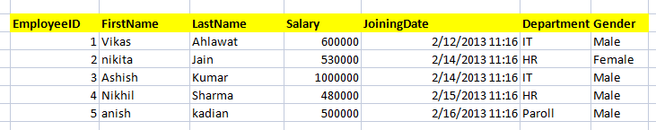

1. Write a query to get all employee detail from "EmployeeDetail" table

ANS : - select * from EmployeeDetail

1. Write a query to get only "FirstName" column from "EmployeeDetail" table

ANS : - select FirstName from EmployeeDetail

1. Write a query to get FirstName in upper case as "First Name".

ANS : - select upper(FirstName) from EmployeeDetail

1. Write a query to get FirstName in upper case as "First Name".

ANS : - select upper(FirstName) from EmployeeDetail

1. Write a query for combine FirstName and LastName and display it as "Name" (also include white space between first name & last name)

ANS : - select concat(FirstName,‘ ‘, LastName) AS‘Name’from EmployeeDetail

1. Select employee detail whose name is "Vikas

ANS : - select * from EmployeeDetail where FirstName = ‘Vikas’

1. Get all employee detail from EmployeeDetail table whose "FirstName" start with latter 'a'.

ANS : - select * from EmployeeDetail where FirstName LIKE‘A%’

1. Get all employee detail from EmployeeDetail table whose "FirstName" start with latter 'a'.

ANS : - select * from EmployeeDetail where FirstName LIKE‘A%’

1. Get all employee details from EmployeeDetail table whose "FirstName" end with 'h'

ANS : - select * from EmployeeDetail where FirstName LIKE‘%H’

1. Get all employee detail from EmployeeDetail table whose "FirstName" start with any single character between 'a-p'

ANS : - select * from EmployeeDetail where FirstName between‘A%’ and‘P%’

1. Get all employee detail from EmployeeDetail table whose "FirstName" not start with any single character between 'a-p'

ANS : - select * from EmployeeDetail where FirstName not between ‘A%’ and ‘P%’

1. Get all employee detail from EmployeeDetail table whose "Gender" end with 'le' and contain 4 letters. The Underscore(_) Wildcard Character represents any single character

ANS : - select * from EmployeeDetail where Gender like ‘__le’

1. Get all employee detail from EmployeeDetail table whose "FirstName" start with 'A' and contain 5 letters

ANS : - select * from EmployeeDetail where FirstName like ‘A____’

1. Get all employee detail from EmployeeDetail table whose "FirstName" containing '%'. ex:-"Vik%as".

ANS : - select * from EmployeeDetail where FirstName like 'Vik%as'

1. Get all unique "Department" from EmployeeDetail table

ANS : - select distinct Department from EmployeeDetail

1. Get the highest "Salary" from EmployeeDetail table.

ANS : - select max(salary) from EmployeeDetail

1. Get the lowest "Salary" from EmployeeDetail table

ANS : - select min(salary) from EmployeeDetail

1. Show "JoiningDate" in "dd mmm yyyy" format, ex- "15 Feb 2013

ANS : -

1. Show "JoiningDate" in "yyyy/mm/dd" format, ex- "2013/02/15"

ANS : -

1. Show only time part of the "JoiningDate"

ANS : -

1. Get only Year part of "JoiningDate"

ANS : - select datepart (Year, JoiningDate) from EmployeeDetail

1. Get only Month part of "JoiningDate”

ANS : - select datepart (Month, JoiningDate) from EmployeeDetail

1. Get system date

ANS : - select getdate()

1. Get UTC date.
   1. Get the first name, current date, joiningdate and diff between current date and joining date in months.
2. Get the first name, current date, joiningdate and diff between current date and joining date in days.

ANS : -

1. Get all employee details from EmployeeDetail table whose joining year is 2013

ANS : - select * from EmployeeDetail where DATEPART(Year, JoiningDate) = '2013'

1. Get all employee details from EmployeeDetail table whose joining month is Jan(1)

ANS : - select * from EmployeeDetail where DATEPART (MONTH,JoiningDate) = 01

1. Get all employee details from EmployeeDetail table whose joining month is Jan(1)

ANS : - select * from EmployeeDetail where DATEPART (MONTH,JoiningDate) = 01

1. Get how many employee exist in "EmployeeDetail" table

ANS : - select count(EmployeeID) from EmployeeDetail

1. Select only one/top 1 record from "EmployeeDetail" table

ANS : - select top 1 * from EmployeeDetail

1. Select all employee detail with First name "Vikas","Ashish", and "Nikhil".

ANS : - select * from EmployeeDetail where FirstName in (‘Vikas’, ‘Ashish’, ‘Nikhil’)

1. Select all employee detail with First name not in "Vikas","Ashish", and "Nikhil"

ANS : - select * from EmployeeDetail where FirstName not in (‘Vikas’, ‘Ashish’, ‘Nikhil’)

1. Select first name from "EmployeeDetail" table after removing white spaces from right side

ANS : - select rtrim(‘FirstName’) from EmployeeDetail

1. Select first name from "EmployeeDetail" table after removing white spaces from left side

ANS : - select ltrim(‘FirstName’) from EmployeeDetail

1. Display first name and Gender as M/F.(if male then M, if Female then F)

ANS : - select firstname,

Case

When Gender = 'Male' Then 'M'

when Gender = 'Female' Then 'F'

End as Gender

From EmployeeDetail

1. Select first name from "EmployeeDetail" table prifixed with "Hello

ANS : - select ‘Hello’+ ‘’+ FirstName from EmployeeDetail

1. Get employee details from "EmployeeDetail" table whose Salary greater than 600000

ANS : - select * from EmployeeDetail where Salary > 600000

1. Get employee details from "EmployeeDetail" table whose Salary less than 700000

ANS : - select * from EmployeeDetail where Salary < 700000

1. Get employee details from "EmployeeDetail" table whose Salary between 500000 than 600000



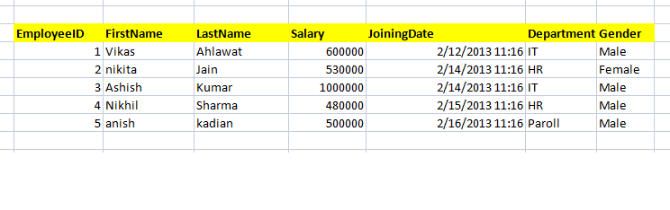

ANS : - select * from EmployeeDetail where Salary between 500000 and 600000

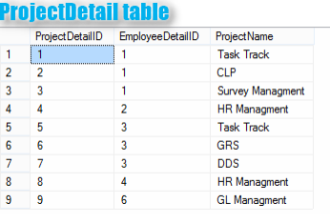

1. Give records of ProjectDetail table

ANS : - select * from ProjectDetail

1. Write the query to get the department and department wise total(sum) salary from "EmployeeDetail" table.

ANS : - select Department, sum(Salary) from EmployeeDetail Group by Department

1. Write the query to get the department and department wise total(sum) salary, display it in ascending order according to salary.

ANS : - select Department, sum(Salary) from EmployeeDetail Group by Department order by sum(Salary) ASC

1. Write the query to get the department and department wise total(sum) salary, display it in descending order according to salary

ANS : - select Department, sum(Salary) from EmployeeDetail Group by Department order by sum(Salary) DESC

no.

1. Write the query to get the department, total of departments, total(sum) salary with respect to department from "EmployeeDetail" table.

ANS : - select count(distinct Department) as totaldepartment, sum(Salary) as totalsalary from EmployeeDetail Group by Department

1. Get department wise average salary from "EmployeeDetail" table order by salary ascending

ANS : - select Department, Avg(Salary) from EmployeeDetail Group by Department order by Avg(Salary) ASC

47 . Get department wise maximum salary from "EmployeeDetail" table order by salary ascending

ANS : - select Department, Max(Salary) from EmployeeDetail Group by Department order by Max(Salary) ASC

48.Get department wise minimum salary from "EmployeeDetail" table order by salary ascending.

ANS : - select Department, Min(Salary) from EmployeeDetail Group by Department order by Min(Salary) ASC

1. Get department wise minimum salary from "EmployeeDetail" table order by salary ascending

ANS : - select Department, Min(Salary) from EmployeeDetail Group by Department order by Min(Salary) ASC

1. Join both the table that is Employee and ProjectDetail based on some common paramter

ANS : - select EmployeeDetail.EmployeeID from EmployeeDetail Inner join ProjectDetail on EmployeeDetail.EmployeeID=ProjectDetail.EmployeeDetailID

1. Get employee name, project name order by firstname from "EmployeeDetail" and "ProjectDetail" for those employee which have assigned project already.

ANS: - select FirstName, ProjectName from EmployeeDetail Inner join ProjectDetail on EmployeeDetail.EmployeeID=ProjectDetail.ProjectDetailID order by Firstname

1. Get employee name, project name order by firstname from "EmployeeDetail" and "ProjectDetail" for all employee even they have not assigned project.

ANS : - select EmployeeDetail.FirstName, ProjectDetail.ProjectName from EmployeeDetail left join ProjectDetail on EmployeeDetail.EmployeeID=ProjectDetail.EmployeeDetailID order by Firstname

1. Get employee name, project name order by firstname from "EmployeeDetail" and "ProjectDetail" for all employee if project is not assigned then display "-No Project Assigned"

ANS: - select Firstname, ISNULL (Projectname, 'No Project Assigned') from EmployeeDetail left outer join ProjectDetail on EmployeeDetail.EmployeeID=ProjectDetail.EmployeeDetailID

order by FirstName

54.Get all project name even they have not matching any employeeid, in left table, order by firstname from "EmployeeDetail" and "ProjectDetail

ANS : - select EmployeeDetail. Firstname, ProjectDetail.ProjectName from EmployeeDetail right outer join ProjectDetail on EmployeeDetail.EmployeeID=ProjectDetail.EmployeeDetailID

order by FirstName

1. Get complete record (employeename, project name) from both tables ([EmployeeDetail],[ProjectDetail]), if no match found in any table then show NULL

ANS: - select EmployeeDetail.EmployeeID, EmployeeDetail.FistName, ProjectDetail.ProjectName from EmployeeDetail left join ProjectDetail on EmployeeDetail.EmployeeID=ProjectDetail.EmployeeDetailID

1. Get complete record (EmployeeName, project name) from both tables ([EmployeeDetail],[ProjectDetail]), if no match found in any table then show NULL

ANS: - select EmployeeDetail.EmployeeID, EmployeeDetail.FistName, ProjectDetail.ProjectName from EmployeeDetail left join ProjectDetail on EmployeeDetail.EmployeeID=ProjectDetail.EmployeeDetailID

57.Get complete record (EmployeeName, project name) from both tables ([EmployeeDetail], [ProjectDetail]), if no match found in any table, then show NULL

ANS: - select EmployeeDetail.EmployeeID, EmployeeDetail.FistName, ProjectDetail.ProjectName from EmployeeDetail left join ProjectDetail on EmployeeDetail.EmployeeID=ProjectDetail.EmployeeDetailID

58.Write down the query to fetch EmployeeName & Project who has assign more than one project

ANS: - Select EmployeeID, FirstName, ProjectName from EmployeeDetail INNER JOIN ProjectDetail ON EmployeeDetail.EmployeeID = ProjectDetail.EmployeeDetailID

WHERE EmployeeID IN (SELECT EmployeeDetailID FROM ProjectDetail GROUP BY EmployeeDetailID HAVING COUNT (*) >1)

1. Write down the query to fetch ProjectName on which more than one employee are working along with EmployeeName

ANS: - Select ProjectDetail.ProjectName, EmployeeDetail.FistName from ProjectDetail INNER JOIN EmployeeDetail on ProjectDetail.EmployeeDetailID = EmployeeDetail.EmployeeID

where ProjectDetail.ProjectName in (select ProjectName from ProjectDetail group by ProjectName having COUNT (1)>1)

1. Apply Cross Join in Both the tables

ANS: - select * from EmployeeDetail cross join ProjectDetail where EmployeeDetail.EmployeeID=ProjectDetail.EmployeeDetailID