**OUTPUT :**

**1.**When we Run this Project First then Following Screen (W**elcome Screen)** is Shown :

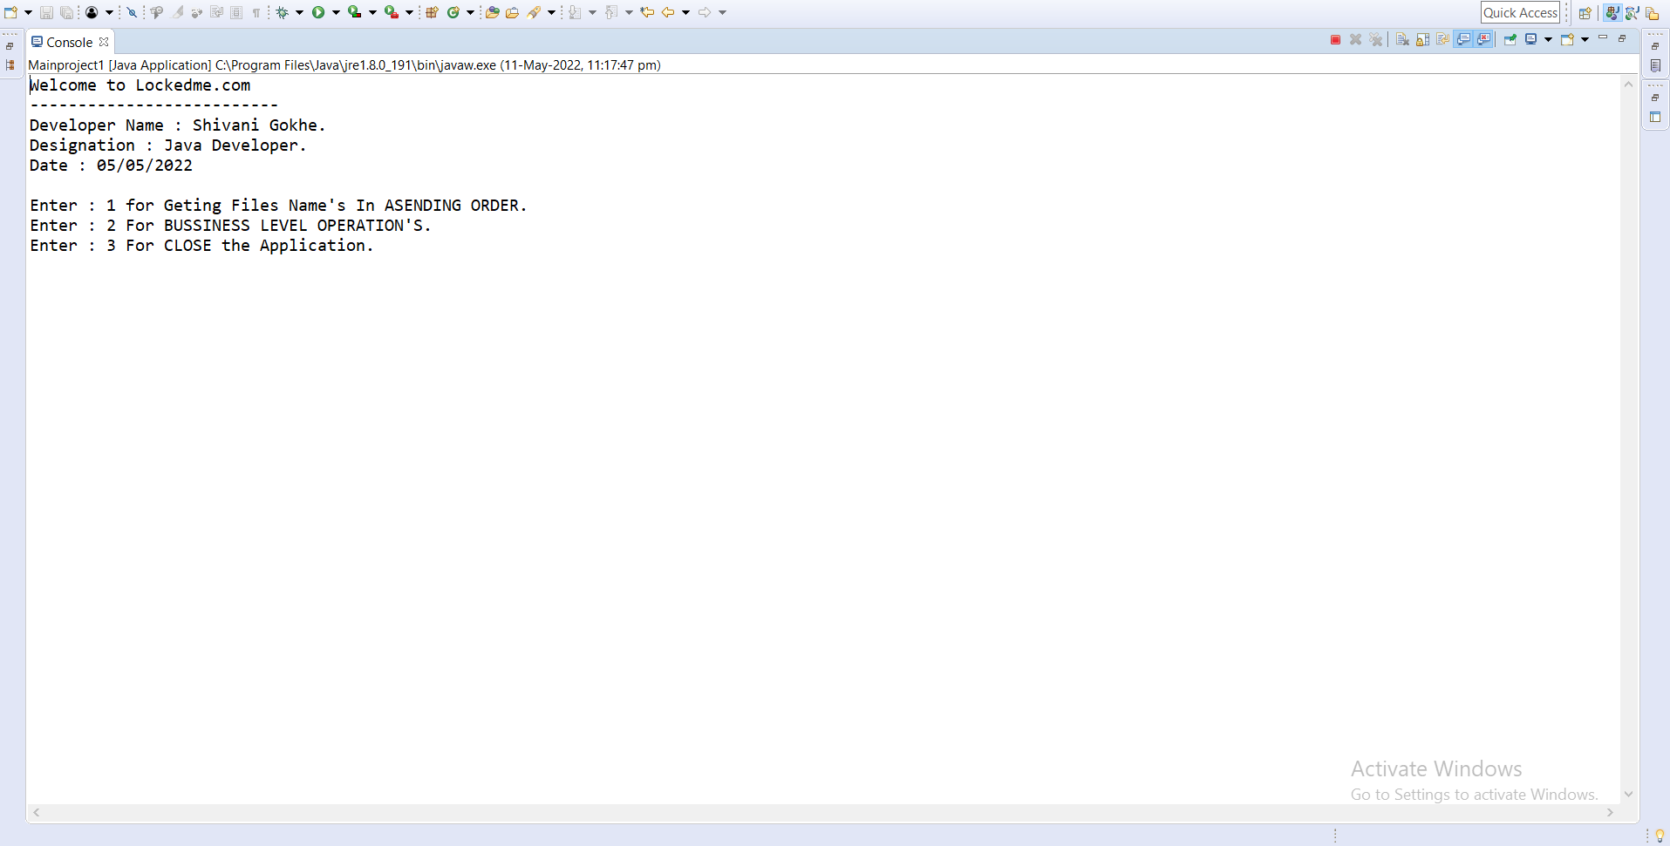

**2.**In first Option, First Option Return the File Names in Ascending order.

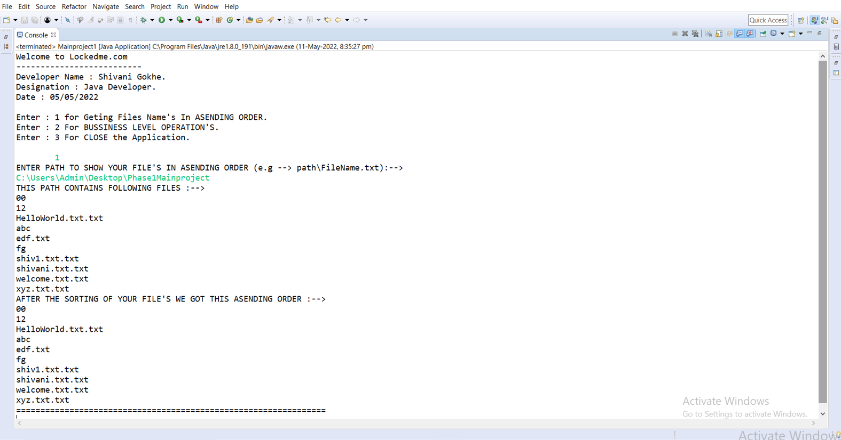

**3.** After we Gives input ‘2’ then some option are Shown Like following Screen :

And When we want to create file then we Give’s input ‘a’, then System will automatically create a file.

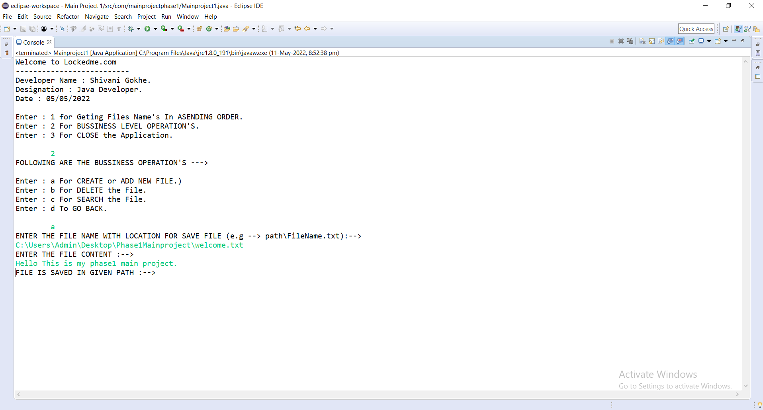

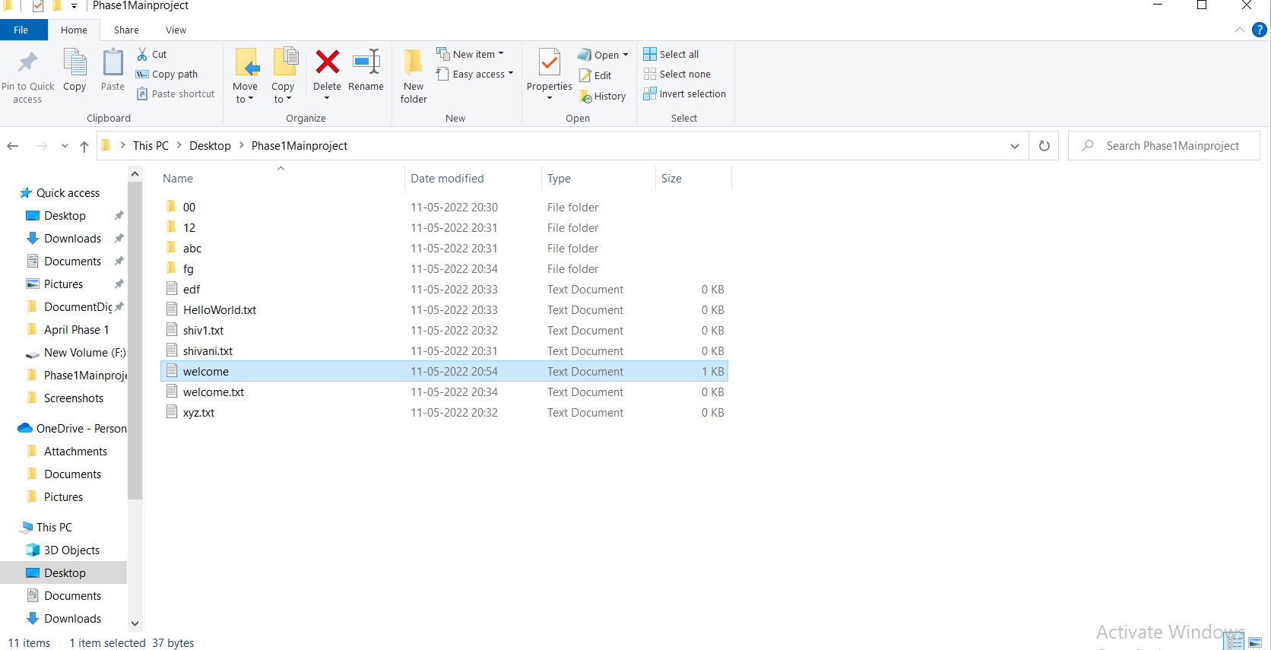

**4.** When we want to Delete file then we Gives input ‘b’, then system will Delete this file provided by user.

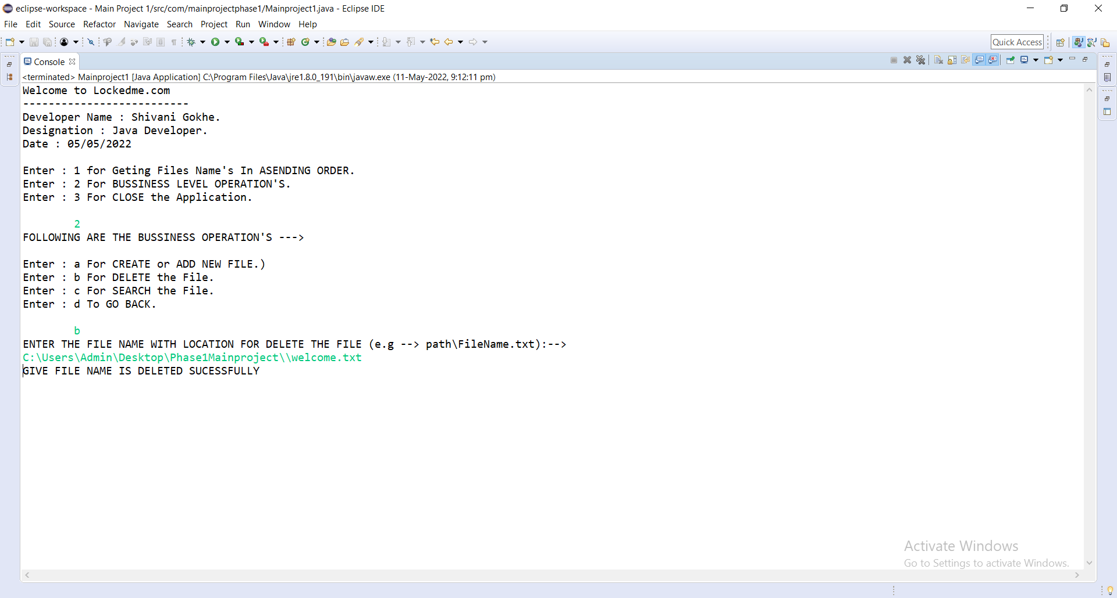

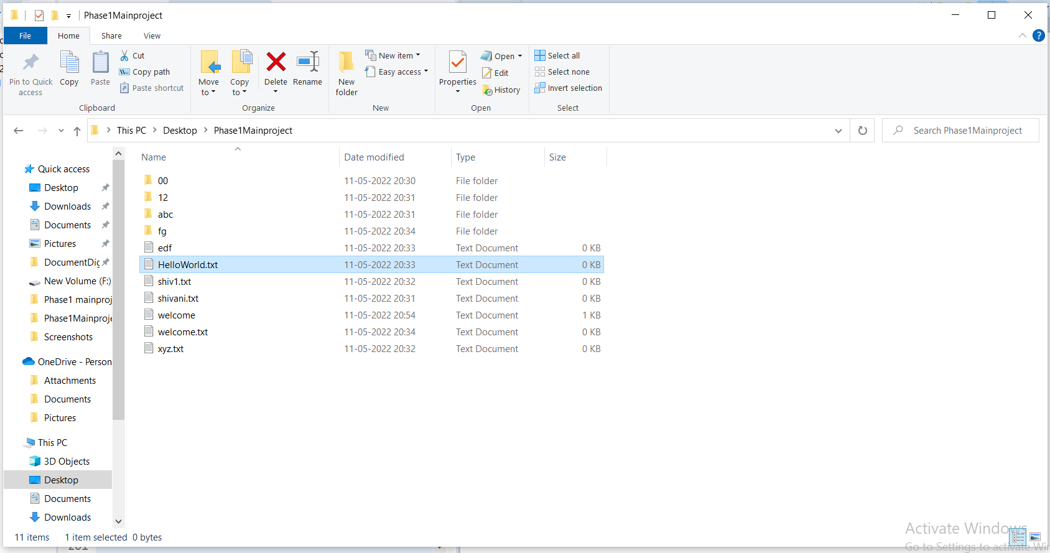

**Before Deleting the File**

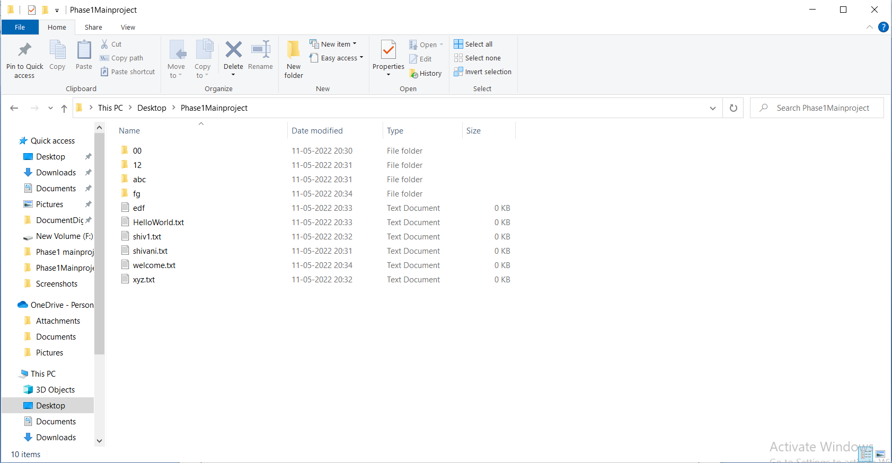

**After the delete the file “welcome”**

**5.** When we want to search some file then we give input ‘c’, then system will search this file on given Path.

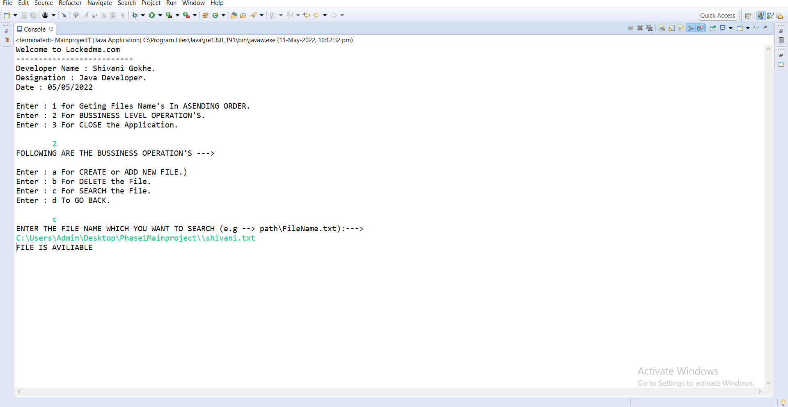

But when we search some file but not present in given path then system will show *“THIS FILE IS NOT HERE!!!! SORRY”*

**6.** When we want to close this application then we gives input ‘3’, then we goes Out From Application.

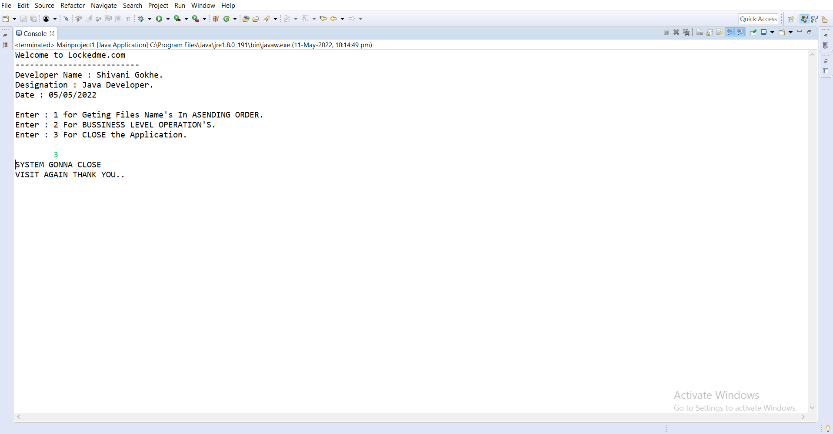

***THANK YOU***