# Error1

A total of 11 requests have been failed for Clip Bundle due to “500 – InternalServerError”

Please find the error below.

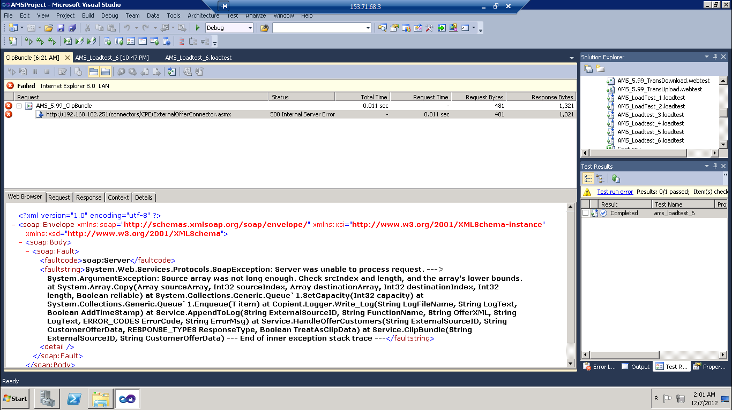

**Error2:** A total of 2 requests have been failed for IPL-RD.aspx connector due to Request Timed Out.

**Error3:** Issuance script has been failed completely as it has not received ACK message in response for the requests.