

AMS Performance Test Report

Last Template update
January 4th, 2013
Confidential

Table of Contents
Table of Contents 2
Revision history 2
1. Introduction 3
1.1 Purpose of this document 3
2.1 Hardware infrastructure details 4
2.2 Network setup information 5
3. Test information and scenarios 6
3.1 Current tests 6
3.2 Test Mix 7
4. Test information and scenarios 8
4.1 Current test information 8
4.2 Database Load during test 8
4.3 Overall Test Results 8
4.4 Test Results 9
4.5 Test Errors 9
4.6 System Behavior [Database Servers] 10
4.7 System Behavior [Application Server] 14
4.8 System Behavior [Web Servers] 15

Revision history

April 26, 2011 | Original revision.
January 4, 2013 | Template update.

1. Introduction

1.1 Purpose of this document
This document details the results of a performance test of the AMS product. The report will detail what tests are in place, results of those tests and test parameters.

Sections 1 through 3 detail the environment and test setup and section 4 details the current test results.
2. Environment Information

2.1 Hardware infrastructure details
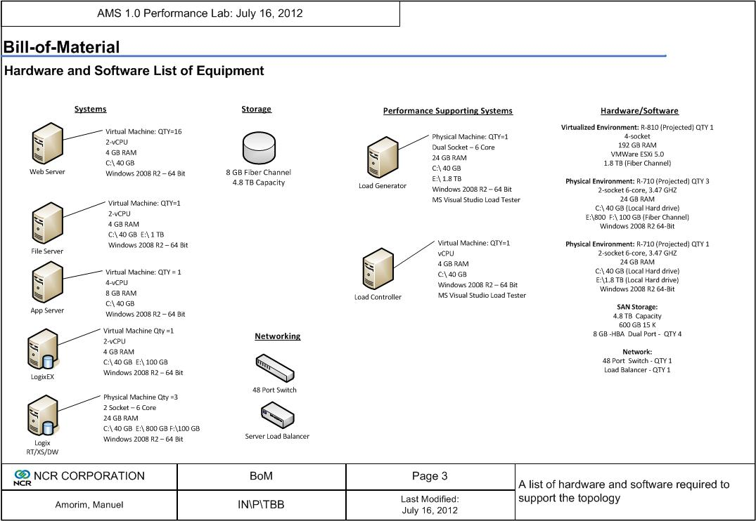

2.2 Network setup information
The load balancer is setup to round robin between 16 web servers in the virtual machine fabric.
The load controller launches the tests and controls the test infrastructure and the Load Generator runs the test scripts against the environment.

Internal network between all machines is gigabit links.

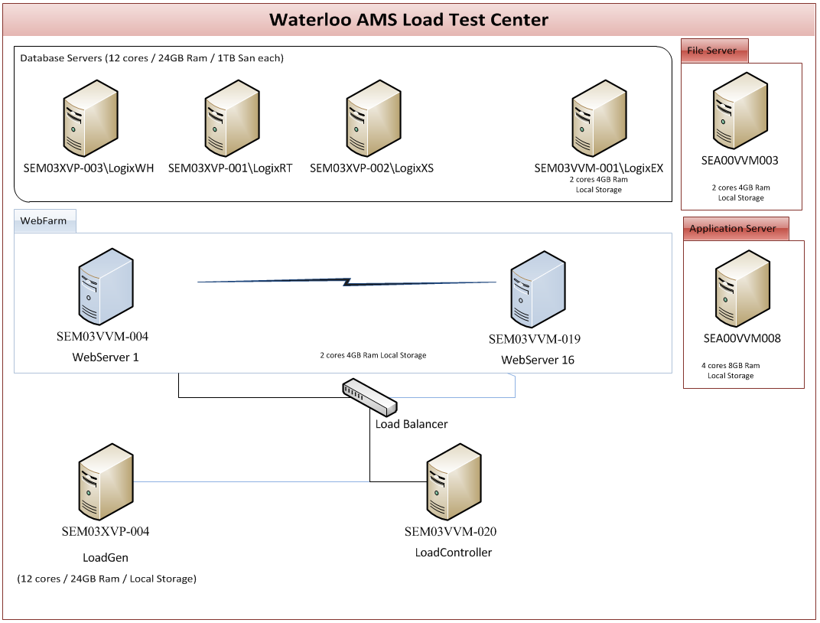

3. Test information and scenarios

3.1 Current tests
AMS Logix test environment currently consists of the following tests. These tests are launched with a mix based on current recommended scheduling of the communications in a live environment.

No | Functions
1 | IncentiveFetch
2 | TransDownload
3 | TransUpload
4 | ReportingUpload - transredemption
5 | ReportingUpload - newtranshist
6 | ReportingUpload - impressions
7 | Issuance
8 | PhoneHome
9 | IPL process ~11 per day
10 | EOC AddOffer ~ 5000 per day
11 | EOC ClipBundle ~ 5 million per day

3.2 Test Mix
No | Functions | Schedule (Times per hour) per store | # of Stores | Connections Per hour enterprise | Avg Txn duration from Prod (Mins) | 125 %Work Load
1 | IncentiveFetch | 1 | 1800 | 1800 | 1.12 | 42.00
2 | TransDownload | 1 | 1800 | 1800 | 1.00 | 37.50
3 | TransUpload | 6 | 1800 | 10800 | 1.00 | 225.00
4 | ReportingUpload - transredemption | 1 | 1800 | 1800 | 1.00 | 37.50
5 | ReportingUpload - newtranshist | 1 | 1800 | 1800 | 1.00 | 37.50
6 | ReportingUpload - impressions | 1 | 1800 | 1800 | 1.00 | 37.50
7 | Issuance | 1 | 1800 | 1800 | 1.25 | 46.88
8 | PhoneHome | 7 | 1800 | 12600 | 1.00 | 262.50
9 | IPL process ~11 per day | 0.5 | 1800 | 900 | 1.00 | 18.75
10 | EOC AddOffer ~ 5000 per day | 417 | 1 | 417 | 0.10 | 0.87
11 | EOC ClipBundle ~ 5 million per day | 416667 | 1 | 416667 | 0.10 | 868.06
 | Total Concurrent Users |  |  |  |  | 1614

4. Test information and scenarios

4.1 Current test information

Test Run Information
Load test name | LiveLoadTest_2
Description
Start time | 04-01-2013 03:12
End time | 04-01-2013 04:12
Warm-up duration | 00:02:00
Duration | 01:00:00
Controller | SEM03VVM-020
Number of agents | 1
Run settings used | Run Settings1

4.2 Database Load during test

LogixRT

-- STORES
set @TotalNumberOfStores = 2000;

-- OFFERS
set @TotalNumberOfActiveOffers = 100000;
set @PrctOffersLimitOver1 = .05;
set @PrctOffersIssuanceEnabled = .15;
set @PrctOffersAccumulation = .10;
set @PrctOffersSVReward = .01;
set @PrctOffersPointsReward = .05;
set @PrctOffersGMReward = 0;
set @PrctOffersFrankingReward = 0;
set @PrctOffersTargeted = .75

LogixXS

-- CUSTOMERS
set @TotalNumberOfCustomers = 35000000;
set @AvgNumIDsPerCust = 2;
set @StoresPerCustomer = 3;
set @PercentInHH = .60;
set @CustomersPerHH = 3;
set @PercentPayVantageAttribute = 0;
set @PercentUSAMAttribute = .01;

-- OFFERS
set @AvgNumCustsPerTargetedOffer = 10000;
set @TotalNumberOfActiveOffers = 100000;
set @PrctOffersTargeted = .75
set @PrctOffersGMReward = 0;
set @PrctOffersLimitOver1 = .15;
set @PrctOffersAccumulation = 0;
set @PrctOffersFrankingReward = 0;

-- Preload customer balance data
set @PreloadPointsNumRecs=500000;
set @PreloadPointsHistoryNumRecs=5000000;
set @NumPointsPrograms=10000;
set @PreloadStoredValueNumRecs=0;
set @PreloadStoreValueHistoryNumRecs=0;
set @NumStoredValuePrograms=0;
set @PreloadRewardDistributionNumRecs=5000000;
set @PreloadStoredFrankingNumRecs=0;
set @PreloadRewardAccumulationNumRecs=0;

LogixWH

-- CUSTOMERS
set @StartCustPK = 1;
set @EndCustPK = 35000000;

-- Preload customer balance data
set @TotalNumberOfActiveOffers=100000;
set @PreloadTransHistoryNumRecs=500000;
set @PreloadTransRedemptionNumRecs=500000;

4.3 Overall Test Results

Overall Results
Max User Load | 1,616
Tests/Sec | 121
Tests Failed | 1,564
Avg. Test Time (sec) | 0.63
Transactions/Sec | 123
Avg. Transaction Time (sec) | 0.61
Pages/Sec | 123
Avg. Page Time (sec) | 0.45
Requests/Sec | 123
Requests Failed | 1,564
Requests Cached Percentage | 0
Avg. Response Time (sec) | 0.45
Avg. Content Length (bytes) | 1,339

4.4 Test Results
Test Results
Name | Scenario | Total Tests | Failed Tests (% of total) | Avg. Test Time (sec)
AMS_5.99_All_Connectors_IPLprocess | IPL | 582 | 2 (0.34) | 99.7
AMS_5.99_Issuance | Issuance | 1,551 | 1,551 (100) | 45.4
AMS_5.99_IncentiveFetch | IncentiveFetch | 1,799 | 0 (0) | 22.1
AMS_5.99_TransDownload | TranDownload | 1,799 | 0 (0) | 17.1
AMS_5.99_EOC_AddOffer | Addoffer | 68 | 0 (0) | 2.38
AMS_5.99_TransUpload | TransUpload | 10,798 | 0 (0) | 0.71
AMS_5.99_ReportingUpload_NewTransHist | Reporting_TransHist | 1,799 | 0 (0) | 0.47
AMS_5.99_ReportingUpload_TnsRdmptn | Reporting_TransRedemptn | 1,799 | 0 (0) | 0.28
AMS_5.99_ReportingUpload_Impressions | Reporting_Impressions | 1,799 | 0 (0) | 0.25
ClipBundle | ClipBundle | 3,99,988 | 11 (0.0028) | 0.16
AMS_5.99_PhoneHome | Phonehome | 12,598 | 0 (0) | 0.092

4.5 Test Errors

500—InternalServerError for Clip Bundle

Error1: A total of 11 requests have been failed due to 500 – InternalServerError

Reason:

- <soap:Fault>
<faultcode>soap:Server</faultcode>
<faultstring>System.Web.Services.Protocols.SoapException: Server was unable to process request. ---> System.ArgumentException: Source array was not long enough. Check srcIndex and length, and the array's lower bounds. at System.Array.Copy(Array sourceArray, Int32 sourceIndex, Array destinationArray, Int32 destinationIndex, Int32 length, Boolean reliable) at System.Collections.Generic.Queue`1.SetCapacity(Int32capacity)atsystem.Collections.Generic.Queue`1.Enqueue(T item) at Copient.Logger.Write_Log(String LogFileName, String LogText, Boolean AddTimeStamp) at Service.AppendToLog(String ExternalSourceID, String FunctionName, String OfferXML, String LogText, ERROR_CODES ErrorCode, String ErrorMsg) at Service.HandleOfferCustomers(String ExternalSourceID, String CustomerOfferData, RESPONSE_TYPES ResponseType, Boolean TreatAsClipData) at Service.ClipBundle(String ExternalSourceID, String CustomerOfferData) --- End of inner exception stack trace ---</faultstring>
<detail />
</soap:Fault>

Error2: A total of 2 requests have been failed for IPL-RD.aspx connector due to Request Timed Out.

Error3: Issuance script has been failed completely as it has not received ACK message in response for the requests.

4.6 System Behavior [Database Servers]

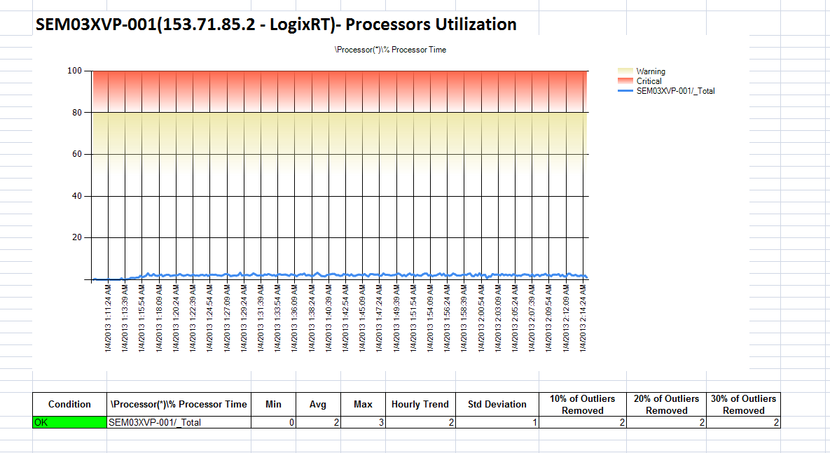

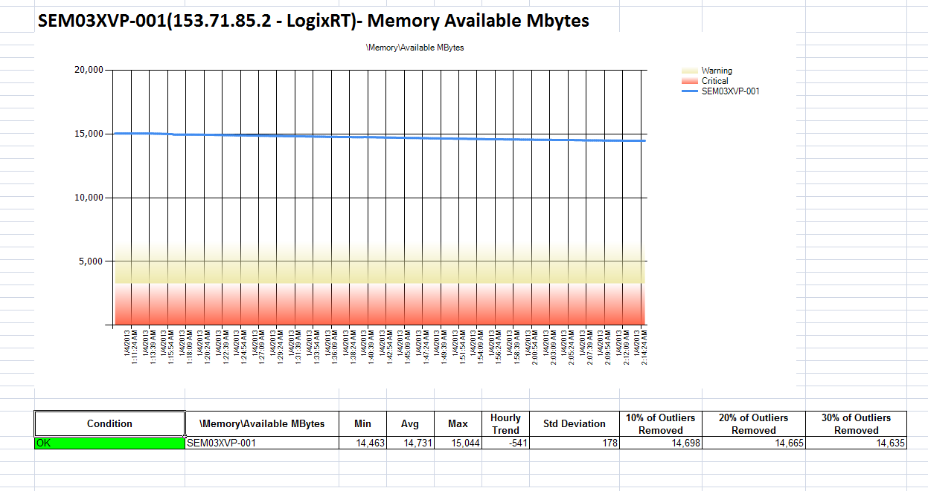

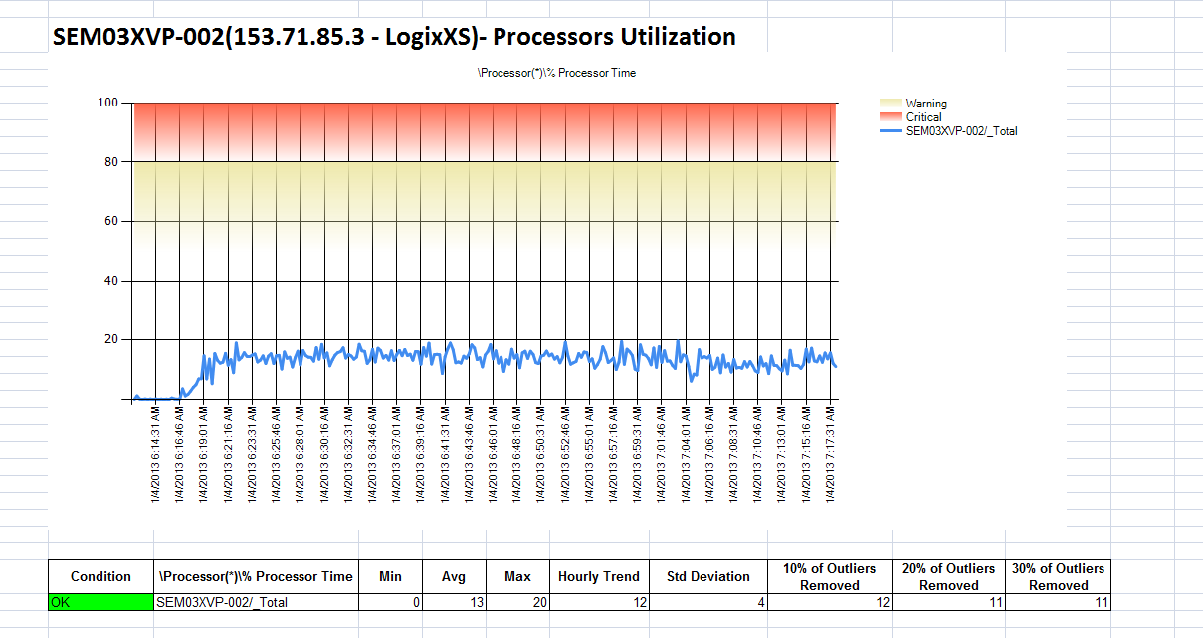

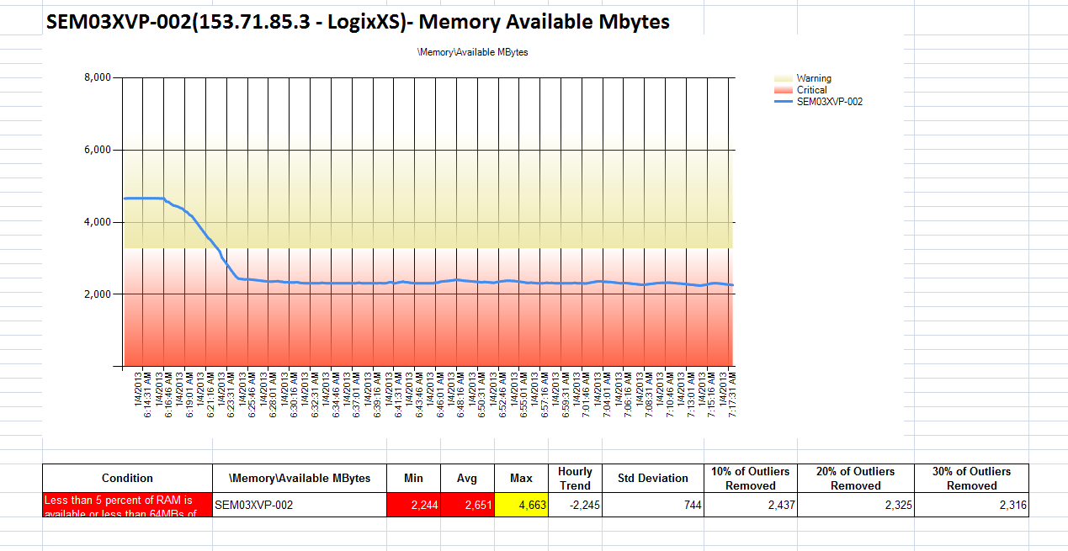

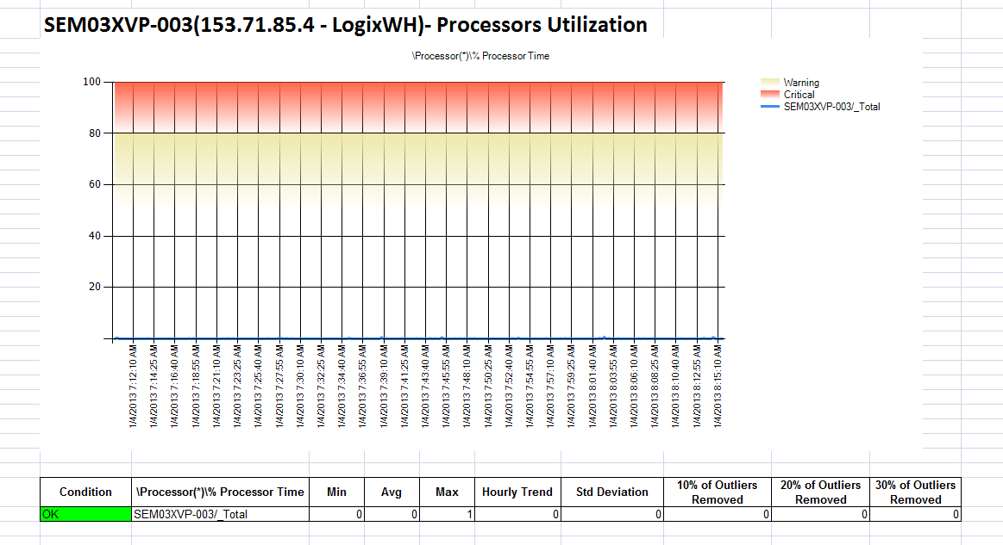

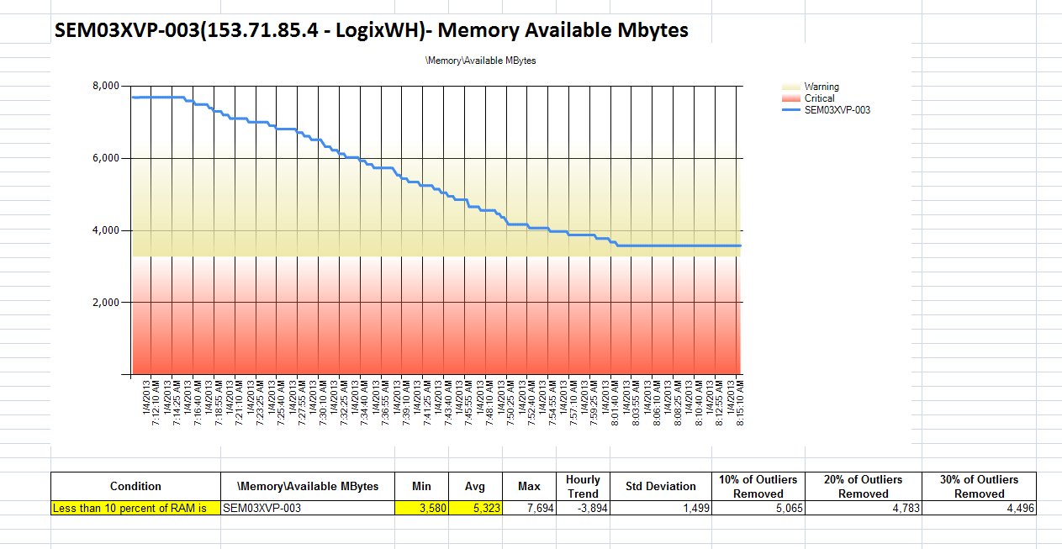

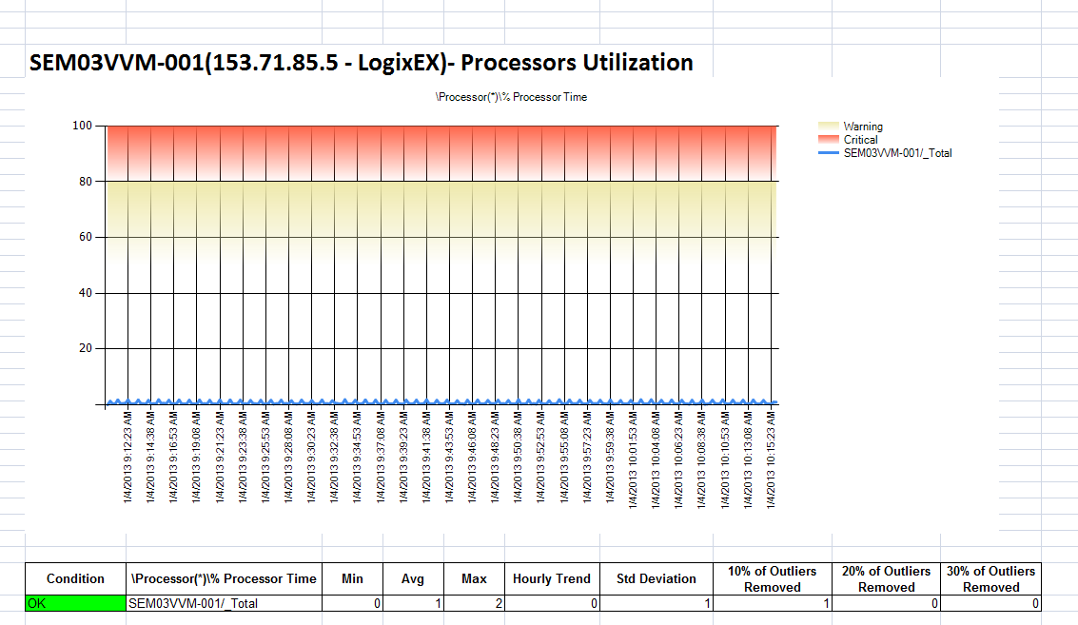

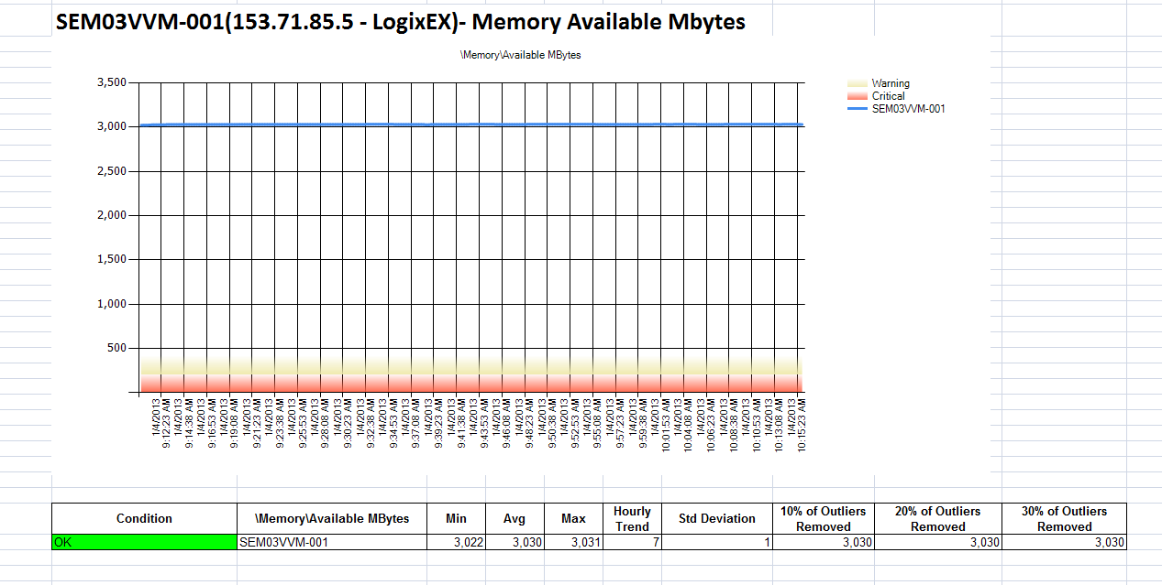

4.7 System Behavior [Application Server]

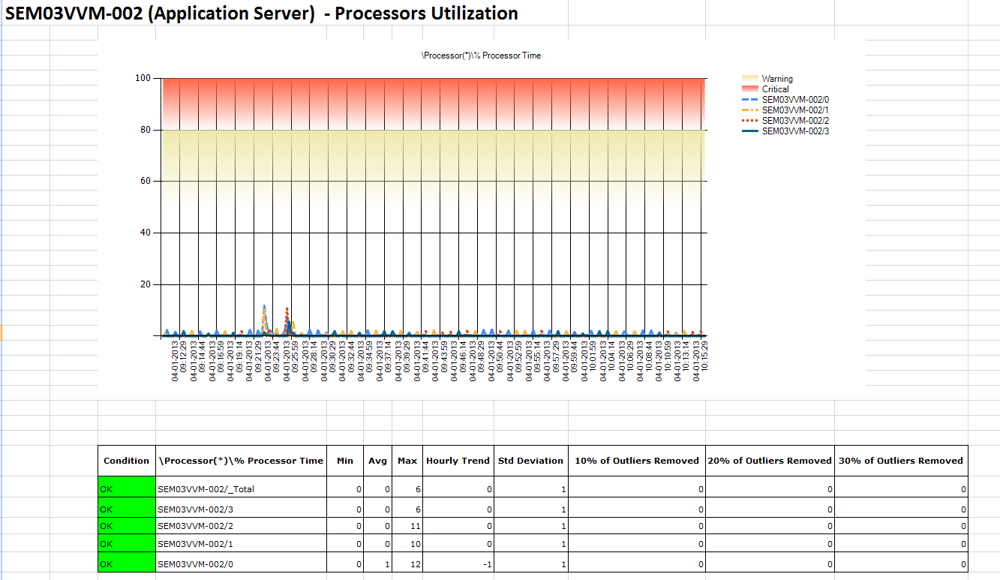

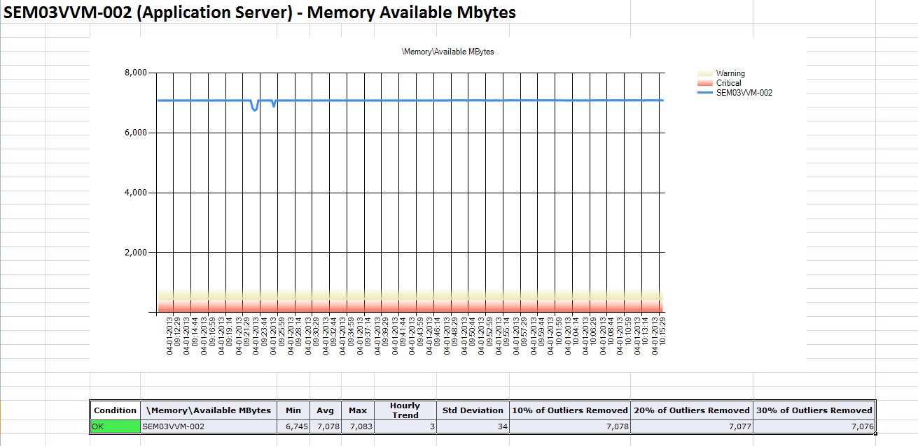

4.8 System Behavior [Web Servers]

