**Software Design**

**Specification**

**for**

**Crop Disease and Severity**

**Detection and Prediction of Pesticides**

**Version 1.0**

**Prepared by:**

**Anuj Jain (BE/25036/13)**

**Yash Tongia (BE/25030/13)**

**Mentor:**

**Dr. Madhavi Sinha**

**Birla Institute of Technology, Mesra, Jaipur Campus**

**October 12,2017**

**1. Introduction**

**1.1 Purpose of this document**

This document will outline in detail the software architecture and design for the Crop Disease and Severity Detection and Prediction of Pesticides System.This document will provide several views of the system's design in order to facilitate communication and understanding of the system.

**1.2 Scope of the development project**

This document provides the architecture and design of Release 1.0 of the Crop Disease and Severity Detection and Prediction of Pesticides System. It will show how the design will accomplish the functional and non-functional requirements enlisted in the Software Requirements Specification (SRS) document.

**1.3 Definitions, acronyms, and abbreviations**

KNN - K Nearest Neighbor

SVM - Support Vector Machine

SRS - Software Requirement Specification

SDS - Software Design Specification

**1.4 References**

* Crop Disease and Severity Detection and Prediction of Pesticides System Software Requirement Specification(SRS).

.

**1.5 Overview of document**

* The first section describes the introduction of document.
* The second section describes the system architecture, in this section we mention the modules of this project and their structures.
* The third section consists of detailed description of the modules described in the previous section modules.
* The fourth section states how our project can be reused and its relationship to other products.
* The fifth section gives the complete idea about design decision and tradeoffs which we had to do in order to simplify the design.
* The sixth section consists of pseudocodes for the components.

**2. Structured Chart**

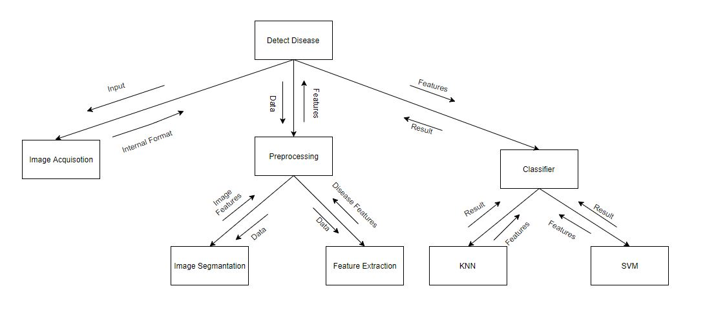

**3.1 E-R Diagram**

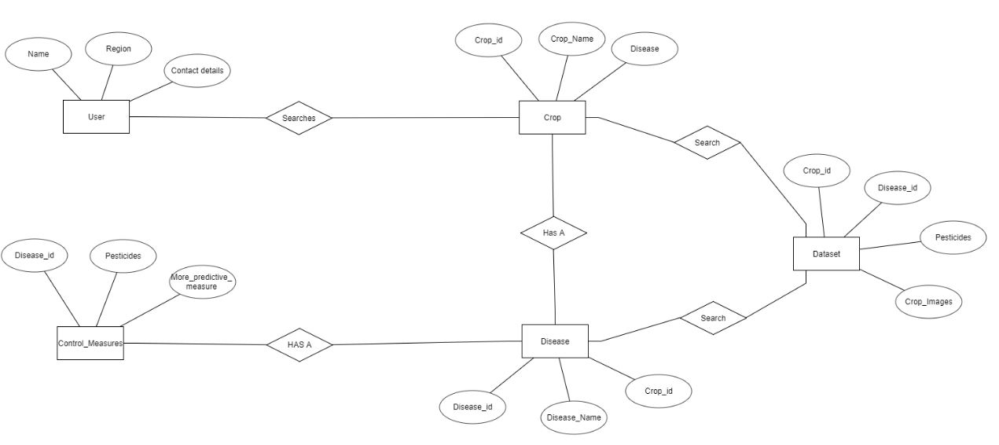

**3.2 Data Processing Diagram**

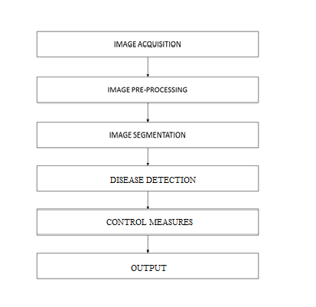

**4. System architecture description**

This section is the main focus of the first version of SDS, the high level design. This should give a good view of exact organization of the system as per the requirements.

**4.1 Overview of Modules**

1. **Image Acquisition**

It is the initial step in which image is upload in the system for detecting the Disease segment in the image. The image can be uploaded in any format like jpeg, png, etc.

1. **Image Segmentation**

The image segmentation means to segment each pixel of the image. A matrix will be formed in which the value of each pixel of image will be stored in form of RGB (Red, Green, Blue) value. All pixel will be assigned a value by the image segmentation.

1. **Image Classification**

In this we will use three classifiers for classification of image. The classifiers are KNN, SVM, Bayesian classifier. These classifiers are used to classify the image. We will get output for each classifier and we will compare the result of each classifier and decide which will give the most optimum result.

**4.2 Structure and relationships**

The functionalities available to the user will be based on the type of login details entered, we have two types of user a general user and the other one the administrator. The user can use the functionalities such as details submission, disease detection and disease enquiring. On the other hand, the administrator can add on new features such as modifying the dataset used and providing other utilities.

**4.3 User interface issues**

The GUI can be divided into 2 parts. One is for the user, and the other is for the Administrator of the system. The user side interface will be optimized to provide the user with an easy to use interface.

**5. Detailed description of components**

**5.1 Image Acquisition**

|  |  |
| --- | --- |
| Identification | Input Image |
| Type | Module |
| Input | An image in which we have to detect the disease segments. |
| Function | The main function of this module is to allow the user to upload the image in the system. |
| Output | The image provided by the user. |

**5.2 Image Pre-Processing and Segmentation**

|  |  |
| --- | --- |
| Identification | Preprocessing |
| Type | Module |
| Input | The input is the image provided by the user. |
| Function | The main function of this module is to pre-process the given input image. A matrix will be formed in which the value of each pixel of image will be stored in form of RGB (Red, Green, Blue) value. |
| Dependencies | The pixel value will be dependent on the image format. |
| Processing | An input image will be provided by the user. The image segmentation will be performed and the image is segmented into pixels and the value of each pixel (in form of RGB) will be stored in form of matrix. |
| Output | The output is the matrix in which the value of each pixel will be stored. |

**5.3 Feature Extraction**

|  |  |
| --- | --- |
| Identification | Feature Extraction |
| Type | Module |
| Input | The input is the segmented image provided by the previous module which is the processed form of the image obtained from the user. |
| Function | The main function of this module is to extract feature of the given input image. A matrix will be formed in which the features to be judged are stored which will be compared to the pre-stored values. |
| Dependencies | This unit depends on the segmented image. |
| Processing | The image is obtained from the user is segmented and given to this unit for feature extraction. The various parameters are calculated and stored to represent the color changes and textures. |
| Output | The output is the matrix in which the values associated with image are stored. |

**5.4 Image Classification**

|  |  |
| --- | --- |
| Identification | Classification |
| Type | Module |
| Input | The features extracted from the segemented image. |
| Purpose | To obtain the disease affected. |
| Function | The main function of this module is apply the classification algorithms on the extracted features and use predefined dataset to detect the disease with which the plant is affected. |
| Resources | The dataset is required for this process. |
| Output | The output from this unit is the integrated output from the various classifier algorithms. |

**5.5 Output**

|  |  |
| --- | --- |
| Identification | Output |
| Type | Module |
| Purpose | The purpose of this module is to provide the output which are the pesticides associated with the disease. |
| Processing | Depending upon the disease detected the pesticides associated and their amount is calculated according to the intensity of the disease detected. |
| Output | The output is pesticide type and quantity according to the disease detected. |

**6.0 Reuse and relationships to other products**

This project has very high scope of reuse. This project can be further extended for more crops as per the requirement. Even for preserving crops it can be used to give suitable advise about the type of pesticides to be used. This project will be running locally, it can be extended to the run on the internet.

**7.0 Design decisions and tradeoffs**

System is designed in a simple and elegant way, so as to make it easy for everyone to use it. It is designed in a responsive manner so that each and every device will have the interface according to its resolution.

**8.0 References**

* **www.catalog.data.gov/dataset?tags=plant+disease**
* [**www.reddit.com/r/datasets/comments/5uljlp/plant_leaf_disease_datasets**](http://www.reddit.com/r/datasets/comments/5uljlp/plant_leaf_disease_datasets)[**/**](https://www.reddit.com/r/datasets/comments/5uljlp/plant_leaf_disease_datasets/)
* [**www.sciencedirect.com/science/article/pii/S2214317316300154**](http://www.sciencedirect.com/science/article/pii/S2214317316300154)
* [**https://pdfs.semanticscholar.org/0a10/96ca51b4b8067865211b42c0bec4c9969f34.pdf**](https://pdfs.semanticscholar.org/0a10/96ca51b4b8067865211b42c0bec4c9969f34.pdf)