**Software Requirements Specification**

**For**

**Crop Disease and Severity Detection and Prediction of Pesticides**

**Version 1.0**

**Prepared by:**

**Anuj Jain (BE/25036/14)**

**Yash Tongia (BE/25030/14)**

**Supervised by:**

**Dr. Madhavi Sinha**

**Birla Institute of Technology, Mesra, Jaipur Campus**

**October 5,2017**

**Table of Contents**

**Table of Contents…………………………………………………………………………….2**

**Revision History……………………………………………………………………………...2**

**1.Introduction……………………………………………………………………………...…3**

1.1 Purpose………………………………………………………………………………………….3

1.2 Intended Audience and Reading Suggestions…………………………………………………..3

1.3 Scope of a project...……………………………………………………………………………..3

**2. Overall Description……………………….……………………………………………….4**

2.1 Product Perspective……………………………………………………………………………..4

2.2 Product Functions……………………………………………………………………………….4

2.3 Operating Environment………………………………………………………………………....5

2.4 Design and Implementation Constraints………………………………………………………..5

2.5 Assumptions and Dependencies………………………………………………………………...5

**3.System Interaction...……………..…….…………………………………………………..5**

3.1 Data Flow Diagram..…………..………………………………………………………………..6

3.2 Entity Diagram …………………..……………………………………………………………..6

3.3 Hardware Interfaces…………….…..…………………………………………………………..6

3.4 Software Interfaces…………….……..………………………………………………………...7

3.5 Communications Interfaces….………..………………………………………………………..7

**4.Functional Requirements………………………………………………………………....7**

4.1 User Interface…………………...……………………………………………………………....7

4.2 System Interface………………………………………………………………………………...7

4.3 Sentiment Analysis……………………………………………………………………………...8

**5.Other Nonfunctional Requirements……….……………………………………………...8**

5.1 Performance……………………………………………………………………………………..8

5.2 Availability……………………………………………………………………………………...8

5.3 Security………………………………………………………………………………………….8

5.4 Maintainability…………………………………………………………………………………..8

5.5 Scalability……………………………………………………………………………………….8

**6. References…………………………………………………………………………………….8**

**Revision History**

|  |  |  |  |
| --- | --- | --- | --- |
| **Name** | **Date** | **Reason for changes** | **Version** |
|  |  |  |  |
|  |  |  |  |

# 

# **1. Introduction**

## **1.1 Purpose**

The purpose of this Software Requirement Specification for Crop Disease and Severity Detection and Prediction of Pesticides is to state the functional and non-functional requirements of this project. The document provides an insight to the environment in which the software tool is expected to operate, capabilities provided by the system and requirements both functional and non-functional.

The SRS is expected to deliver the outlines upon which the system has to be built thus this document is to be used by system designers to develop the project. The client for which the product is being designed is expected to review the document. The SRS serves as the written agreement between client and development team that pertains to the functionality provided by the system. This document is designed for project maintainers also who will refer to it for clarity about system’s features.

**1.2 Intended Audience and Reading Suggestions**

The intended audience for this document is anyone who is interested in development and gaining knowledge about crop diseases, their detection and classification, preventive measures in successful crop production management. Mainly, this software is designed for farmers and agriculturists.

Moreover, this document also provides measures to evaluate the model’s design and features.

## **1.3 Scope of a Project**

The disease detection model in plants will help users to identify disease present in plant and will suggest the user amount and the type of fertilizer a user must add to cope up with the disease present in a particular type of plant.

Given a large set of data set, disease detection in plants is done by comparing different information of plant with that of given plant in data set, disease is detected on the basis amount and type of difference between data set values and actual values**.**

This software will be using image segmentation and various classifier algorithms to

* Detect a healthy plant/crop.
* In case of diseased crop then the system classifies the disease.
* Suggesting the control measures that are economically and environment friendly.
* Providing a simple user interface.

The Interface should be as simple as possible as the end users of the product are not only non- technical people but are less educated so as to understand a software tool.

# **2. Overall Description**

## **2.1 Product Perspective**

Each year, plant viruses and fungal attacks lead to crop losses of up to 30 percent and moreover excess usage of pesticides leads to spreading of fatal diseases such as cancer, autism and asthma. The farmers in India are less educated to understand the vulnerability and severe consequences of the diseases. They either ignore or recklessly use pesticides to get rid of the problem. This not only leads to spreading of fatal diseases and soil contamination but is also not economically beneficial for them. Thus, it is very important for them to know the disease and their proper treatment for better crop production and environmental balance.

The current system involves monitoring from naked eyes which requires time, effort and presence of specialist to detect any crop failure. Thus, this tool which processes an image and detects the diseases associated with it is of utmost importance. This project will make use of the trained data set and will compare the received information.

**2.2 Product Functions**

The main feature of this system is to analyze the disease with which the crop is affected. Therefore, to achieve this we need data for various crops for which the software is designed. This dataset includes the images and information about the healthy and unhealthy crops. The information received whether in text/image format is pre-processed as per requirement and then given for the extraction of the features of the received information. This processed data is compared and the disease is classified using various classification algorithms such as KNN, SVM. Finally, after the classification of the disease the control measures are listed.

Data flow diagram of recommendation system:

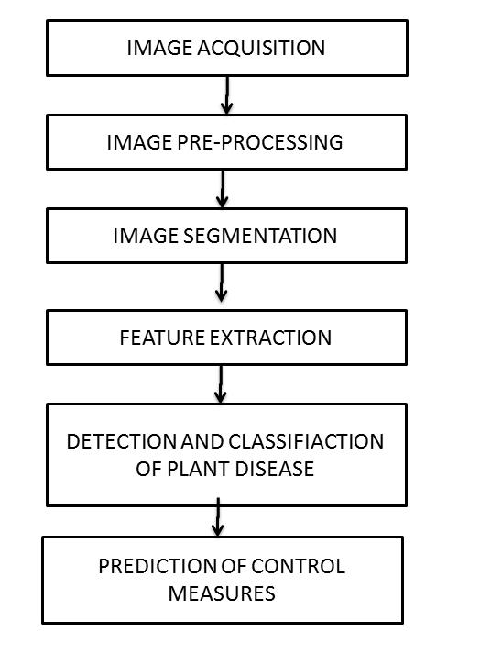

## **2.3 Operating Environment**

The model would operate on Windows 32 bit and 64 bit machines. It would also be able to

operate on Linux OS.

## **2.4 Design and Implementation Constraints**

## In this project, we will be using Image processing unit of MATLAB/Python. The project is implemented for the disease associated with 2 crops which includes citrus crops and sugarcane, which can be further expanded to various other crops.

## **2.5 Assumptions and Dependencies**

The input to the software toolkit is assumed to be the image of a leaf. Irrelevant images will be processed but not detected. The toolkit only predicts the disease but to get 100% surety the user should take expert’s advice.

The user should possess basic knowledge of using a computer/mobile.

# **3. System Interaction**

# **3.1 Data Flow Diagram**

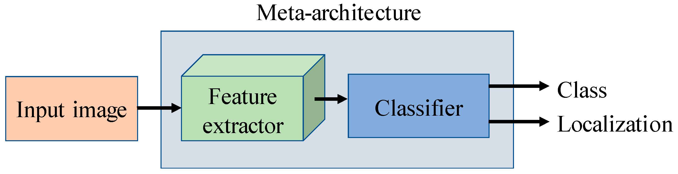

Level 0

Level 1

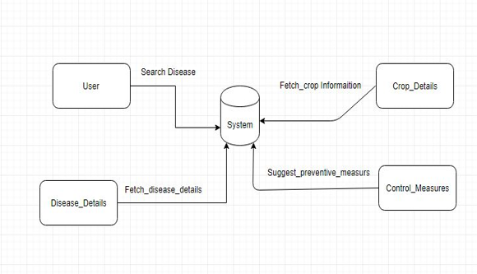

Level 1

## 

Level 2

## **3.3 E-R Diagram**

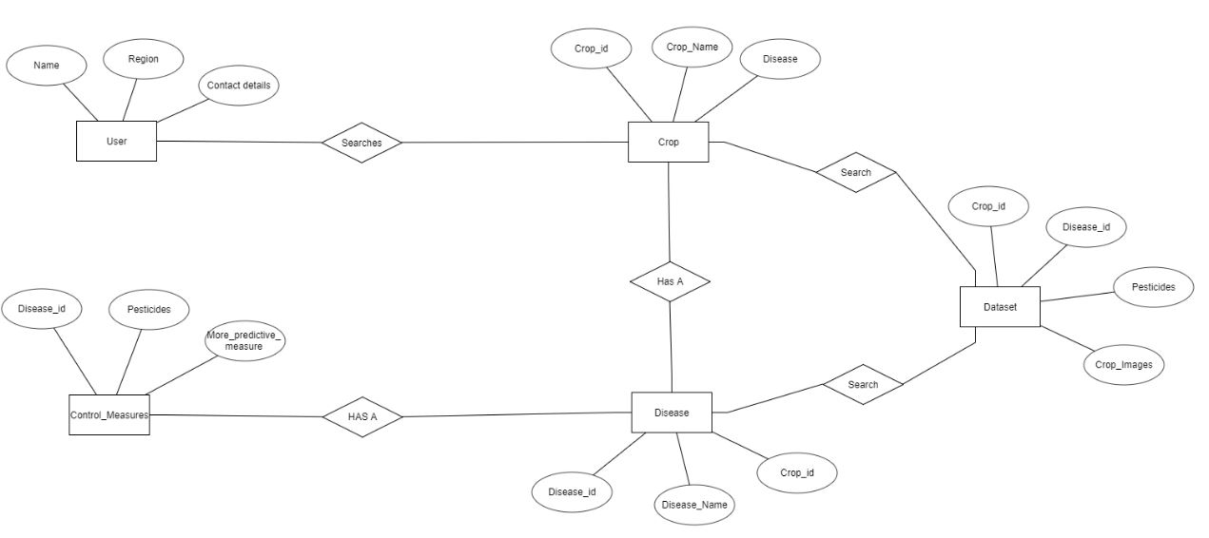

## **3.4 Hardware Interfaces**

* 32/64-bit machine.
* RAM size of 2GB and above.
* Hard disk capacity of 20GB and above.
* Processor Intel i3(min).

**3.5 Software Interfaces**

* Windows /Linux
* MATLAB/Python
* MySQL

**4. Functional Requirements**

**4.1 User Interface**

User can use his username and password to log onto the system. If the user is new then he/she can register after specifying the required details.

User gives the input in the form of an image which is to be processed (image can be obtained by using either upload option or from camera of the device) for detection of disease. User can also search information about a particular crop and the diseases associated with it.

**4.2 System Interface**

The system will provide user name and id and also maintain user session logs.

For a new user, the system will display images of diseased and healthy leaves of some crops user may select the crop type from the given images. For existing user, the system will display crops previously searched or as detailed in the sign-up form.

There will also be a logout button to redirect back to the login/signup page.

## **4.3 Disease Detection**

Disease detection of plant will take place based on information provided by the user and information present in the database by making comparison between the two-information based on several algorithms. This information about the plant in the database will be gained using dataset from different websites.

# **5. Other Nonfunctional Requirements**

## **5.1 Performance**

The system should return correct result with very less percentage from displaying other

Data. Also, the web crawling should be done properly to extract all possible information about a given crop.

## **5.2 Availability**

For the system to be available to users all the time, online server is must which provide 24

hour service daily.

## **5.3 Security**

The password of all the users should be stored properly and not exposed to anyone.

## **5.4 Maintainability**

The code will be well documented. Particular care will be taken to design the software

modularly to ensure that maintenance is easy.

## **5.5 Scalability**

The system will detect the presence of disease in the crop, with the type of disease that exists and if so will also recommend type and amount of pesticides to be used to make crop disease free.

## **6. References**

## **[1]www.catalog.data.gov/dataset?tags=plant+disease**

**[2]**[**www.reddit.com/r/datasets/comments/5uljlp/plant_leaf_disease_datasets**](http://www.reddit.com/r/datasets/comments/5uljlp/plant_leaf_disease_datasets)[**/**](https://www.reddit.com/r/datasets/comments/5uljlp/plant_leaf_disease_datasets/)

[3][**www.sciencedirect.com/science/article/pii/S2214317316300154**](http://www.sciencedirect.com/science/article/pii/S2214317316300154)

**[4]**[**https://pdfs.semanticscholar.org/0a10/96ca51b4b8067865211b42c0bec4c9969f34.pdf**](https://pdfs.semanticscholar.org/0a10/96ca51b4b8067865211b42c0bec4c9969f34.pdf)

**Signatures:**

1. Dr. Madhavi Sinha (Mentor) ____________________________
2. Mr. Santosh Sharma _____________________________