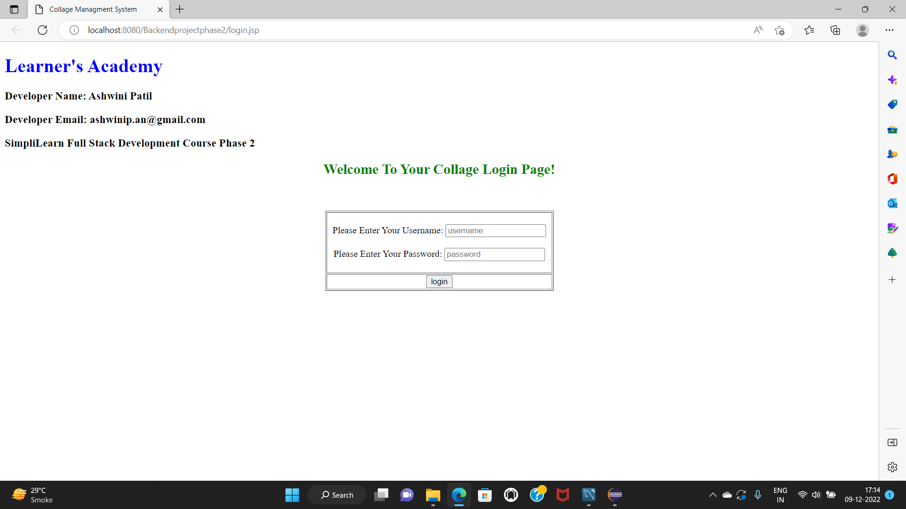

|  |  |  |  |
| --- | --- | --- | --- |
| **Class ID** | **Class Name** | **Edit Action** | **Delete Action** |
| 12 | BE comp | Edit Class | Delete Class |
| 13 | BE IT | Edit Class | Delete Class |
| 14 | BE E&TC | Edit Class | Delete Class |
| 15 | mech | Edit Class | Delete Class |

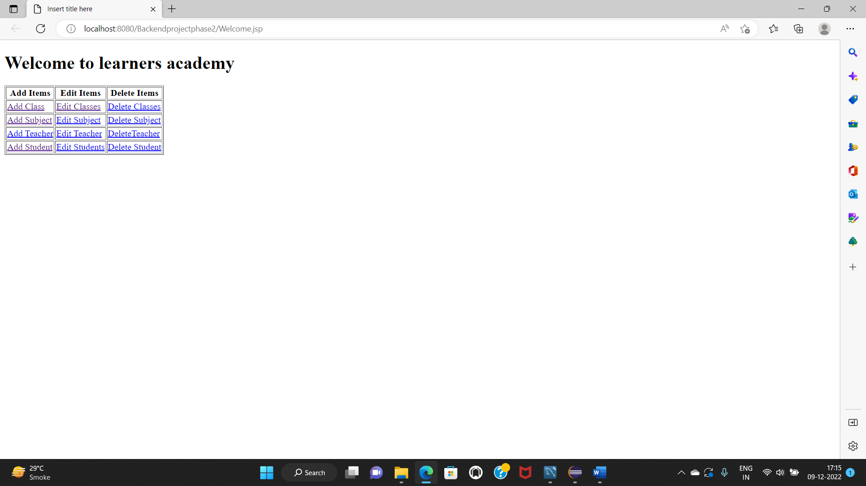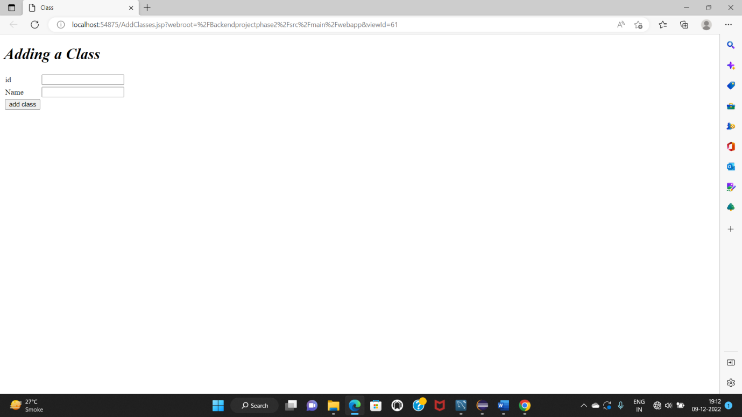

**Add Class**

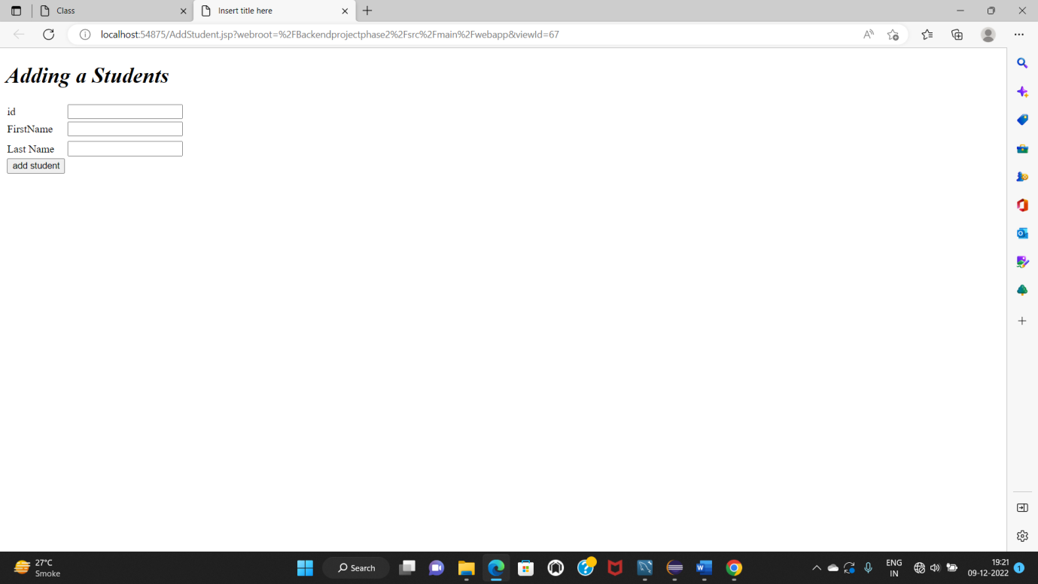

**Add Student**

|  |  |  |  |  |  |  |
| --- | --- | --- | --- | --- | --- | --- |
| **Student ID** | **Student First Name** | **Student Last Name** | **Phone no** | **ClassName** | **Edit Action** | **Delete Action** |
| 1 | Ashwini | patil | 9137275705 | BE com | Edit Student | Delete Student |
| 2 | Ishanvi | borse | 9637275708 | BE IT | Edit Student | Delete Student |

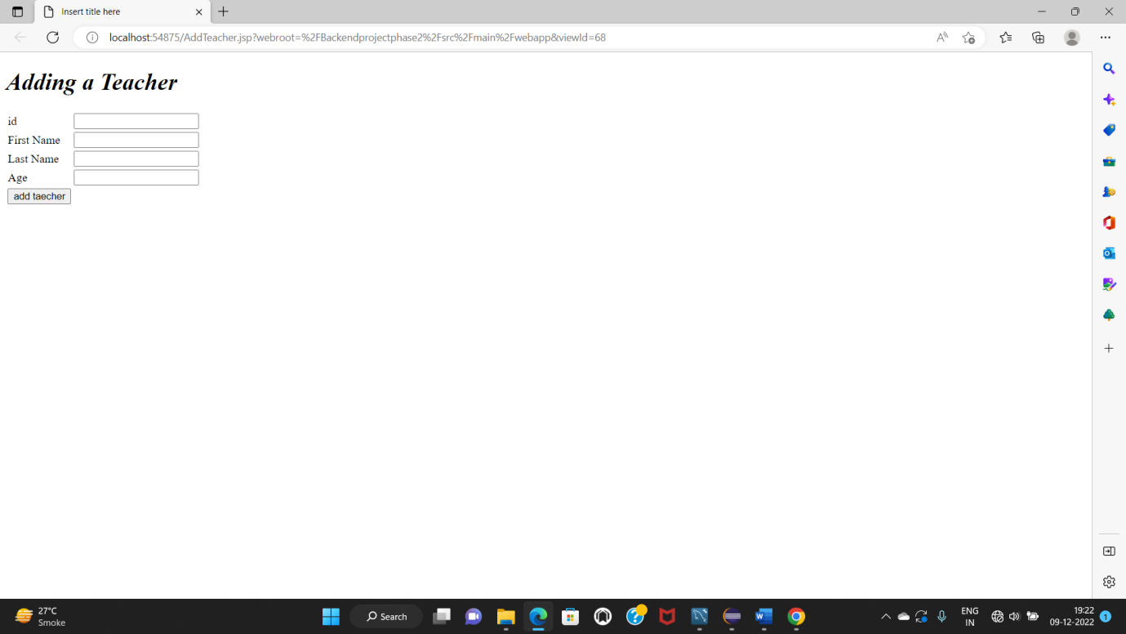

**Add Teacher**

|  |  |  |  |  |  |
| --- | --- | --- | --- | --- | --- |
| **Teacher Id** | **Teacher First Name** | **Teacher Last Name** | **Age** | **Edit Action** | **Delete Action** |
| 43 | Miss. Jospin | Mishra | 45 | Edit Teacher | Delete Teacher |
| 65 | Mr. Suresh | Shaha | 54 | Edit Teacher | Delete Teacher |

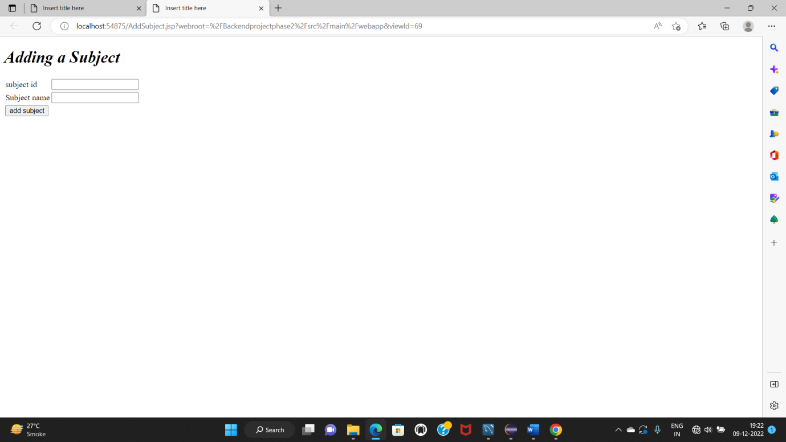

**Add Subject**

|  |  |  |  |
| --- | --- | --- | --- |
| **Subject Id** | **Subject Name** | **Edit Action** | **Delete Action** |
| 123 | java | Edit Subject | Delete Subject |
| 321 | html | Edit Subject | Delete Subject |

