# Administrative-portal-for-Learner-s-Academy

**Project' Details**

This project aims to design and develop a back-end administrative portal for the Learner’s Academy using Java EE technologies. I developed it as a project of phase 2 for the Become a back-end expert course. The goal of this project is to apply servlet, jsp and JDBC, MSSQL concepts.

**Product Backlog:**

1. Create database and tables.
2. Connect the database to the project.
3. Create bean classes.
4. Create a database dao package to insert ,update ,delete and retrieve data.
5. Create login page.
6. Create JSP files for all pages of the project.
7. Create a servlet to get requests and send responses to the JSP files.
8. Create Dbutil class for database connection
9. Create a CSS file to format the contents.
10. Debug and Test the project.

**Technologies and tools Used**

• Servlet: to do the business logic and works a controller for the project.

• JSP: to handle the presentation view.

• MSSQL: to create and manage the database.

• JDBC: to make operations on the database for the project.

• Eclipse: to write and run the code.

• Tomcat: to run and deploy servlet application.

## Flowcharts of The Application

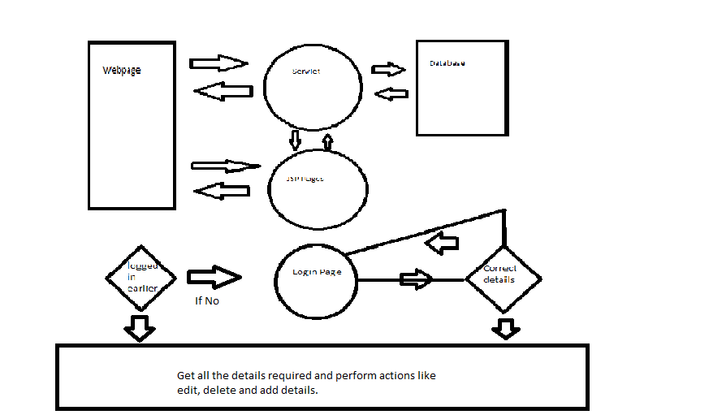

## Core concepts used in the project.

• Object-Oriented: used to create and model objects for users and their credentials.

• Databases: used to store and retrieve data.

• Data Sources: used to define a set of properties required to identify and access the database.

• Collections: used some collections such arraylist to store collection of data.

* **GitHub:-**
* Initiate command

**git init**

* Commit the adding using the following command:

**git add .**

* Commit the changes using the following command:

**git commit -m <commit message>**

* Push the files to the folder you initially created using the following command:

**git push -u origin master**