Documentation for Assignment 3 Project

Shivani Kumar

Operating Systems

11/13/2021

Started the assignment by reading over all files and understanding what is being done. Created a plan/deadline on when to work on each step:

Step 1: 11/13 - 11/16

Step 2: 11/17 - 11/20

Step 3: 11/21 - 11/24

Step 4: 11/25 - 11/28

Step 5 (attempt): 11/29 - 12/01

Step 1 - 11/15/21

Since for step 1, all I have to do is terminate threads at day 370 for Santa, reindeers, and elves, I added a return if statement to terminate the threads at day 370 and added this statement to the Santa, Reindeer, and Elf files. I also added a public int called ‘day’ into the SantaScenario class. Doing this, keeps the days printing but it no longer updates the days after the thread termination happens.

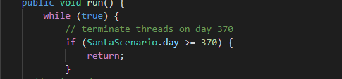

Step 2 - 11/17/21

There are 4 separate steps here and I’ve split them below.

1. No reindeer present

Since no reindeers are present for this part of the project, I commented out all reindeer information for now.

1. Elf runs into problem -> go to Santa’s door

For this problem, the solution was simply to set the elf’s state to ‘AT_SANTAS_DOOR’

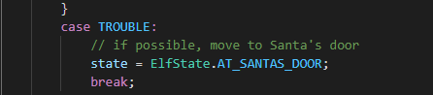

1. Elf is at Santa’s door & Santa is sleeping -> wake up Santa

Once they are at Santa’s door, we have to set Santa's state to ‘WOKEN_UP_BY_ELVES’. In order to do that, I added a setState as well as a scenario.

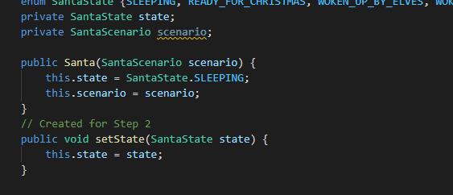

Step 2 continued - 11/18/21

1. If Santa is woken up -> Santa solves problems for all elves at the door

This can be done by iterating through the list of elves and their state then checking which ones are at Santa’s door and need to be helped. Once those elves are found, they can be changed to working and then Santa can go back to sleep.

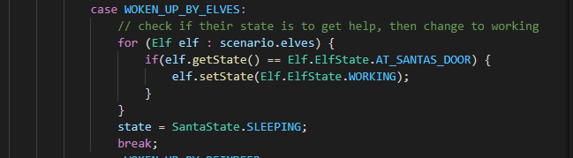

Step 3 - 11/21/21

5 different steps here:

1. There is no reindeer present

Since no reindeers are present for this part of the project, I commented out all reindeer information for now. Same from steps before.

1. Three elves have to be in trouble before going to santa’s door
2. Other elves have to stay in trouble and wait for previous elves to come back

To make sure that there are three elves before they go to Santa’s door, I created a for loop that counts the number of elves and then an if statement that sends those elves to Santa’s door. This was a challenge since I wasn’t sure where to count the troubled elves.

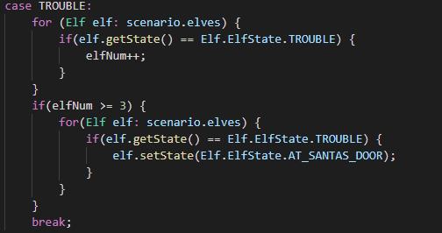

1. Elf is at santa’s door & Santa is sleeping -> wake Santa up
2. If woken up -> Santa solves the problems of the three elves

Both steps have been done and are the same from step 2.

Step 4 - 11/24/21

Using semaphores, I had to figure out a way that the threads of the Elves are waiting in the acquire() function of a semaphore when they are in the TROUBLE mode.

I’m stuck on starting this section. I spent the day trying to learn as much as possible and gather research on how semaphores work in a way that I understood clearly.

Step 4 continued - 11/26/21

I started this step by creating a semaphore in the SantaScenario.java file with 3 permits so it only allows 3 elves to go to Santa’s door.



After that, I added acquire() to make sure that the elves are getting acquired every time there is an elf in trouble. This should make sure to get 3 elves when they are in trouble and acquire them and send them to santa.

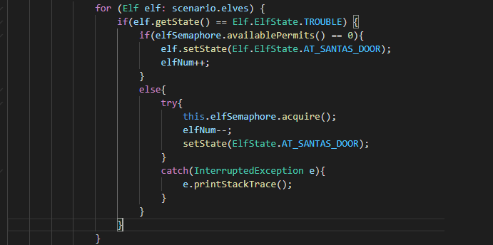

Then we go to Santa.java file to make sure that Santa only helps the elves when there are 3 permits only. In order to do that, we need to add this line in the case of WOKEN_UP_BY_ELVES.

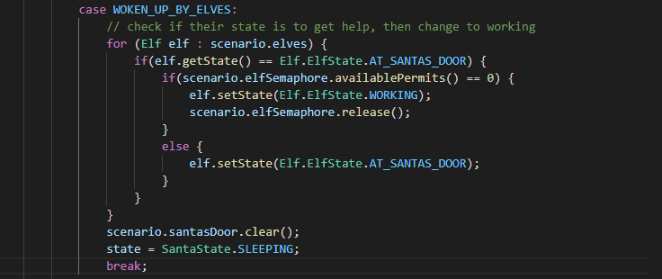

We also need to make sure we release the elves that are in the semaphore so the next 3 elves can be helped by Santa.

Step 5 - 11/28/21

The four things needed to do here are:

1. First 8 reindeers to come back from BEACH stay at WARMING_SHED
2. Reindeers in WARMING_SHED wait in acquire()
3. Last reindeer wakes up santa
4. Santa hooks up reindeers to SLEIGH and wakes their thread

First we create an int to keep track of the number of reindeers and we also add some semaphore stuff into reindeer just like we did for elves such as: getting state, setting state, and reindeerSemaphore.

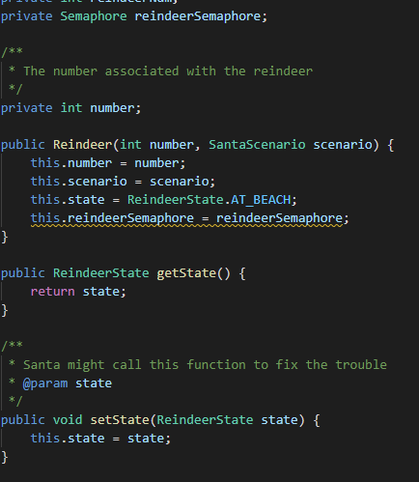

Step 5 continued - 11/29/21

Now I’m going to add the semaphores into the reindeer file. So we make sure that the reindeers wait in acquire() until the last one comes and wakes up santa. Santa updates as well and gets ready for christmas!

