(परीक्षार्थी द्वारा भरा जाए)

(**To be filled by the Candidate**)

**Semester Practical Examination (2021-22), May 2022**

परीक्षा का नाम **(Name of Examination) B.Tech CSE VI Semester**

अनुक्रमांक अंकों में**(In figures) ………1913097……………………………….............**

अनुक्रमांक(शब्दों में)**(Roll No. in Words) ……………………………………………**

नामांकन संख्या **(Enrollment No.) ……2019/906…………………………………............**

ई-मेलआई.डी. **(E-mail ID.)** **…btbtc19246_saumya@banasthali.in……………......**

विषय**(Subject) ………Computer Science………………………………………............**

प्रश्न पत्र कोडसहित**(Paper with Code) …………ELE 306L Microprocessors and Microcontrollers Lab……………………………………**

परीक्षा दिवस और दिनांक **(Day and Date of Examination) ……Wednesday, 04-05-2022……………………**

Total Number of Pages excluding this page:____8________

| Group ID. | Question Paper Set | Question Serial No. |
| --- | --- | --- |
| C1 |  | 7 |
|  | 15 |

Signature of the Student

Question.7)Design an ALP to add two series of five 8-bit numbers and show their corresponding sum in

the other array and carry in other.

A=[ 08 H 05 H 03 H 0A H 07 H]

B=[ 02 H 01 H 08 H 0A H 06 H]

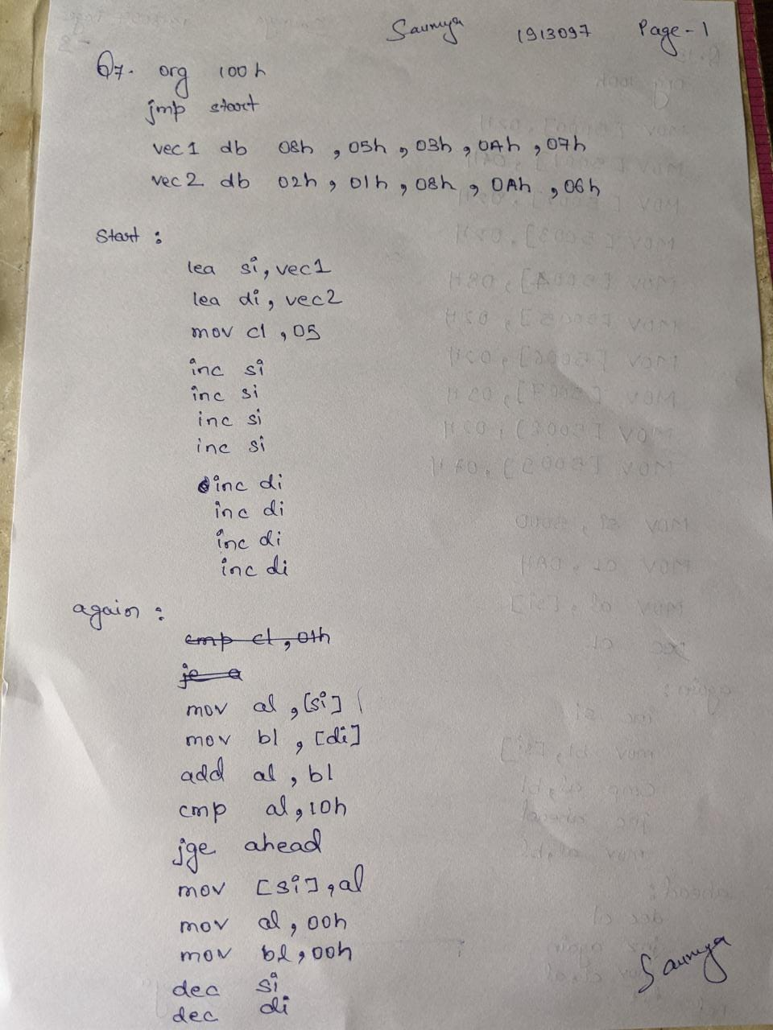

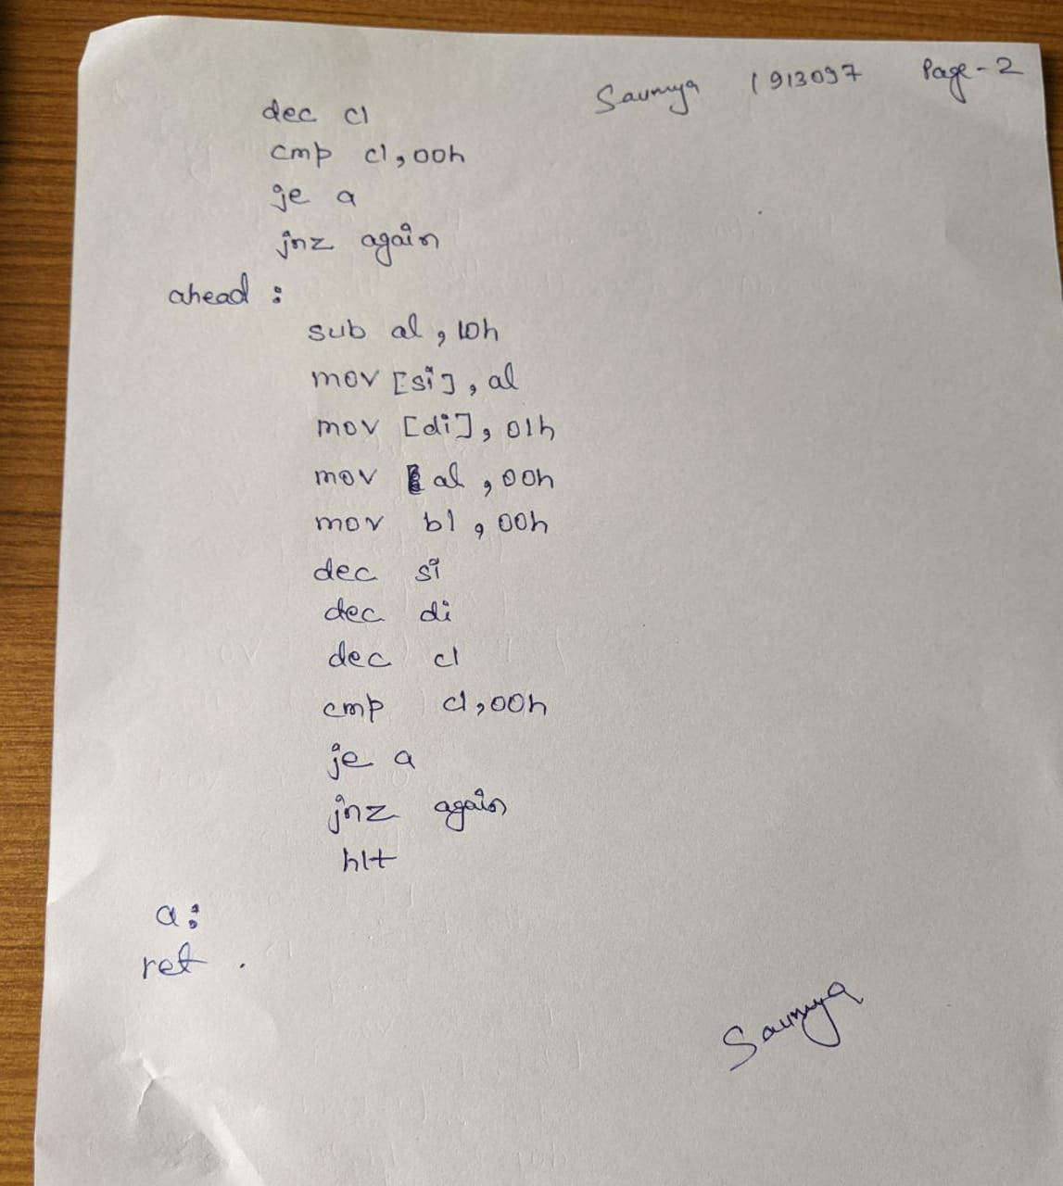

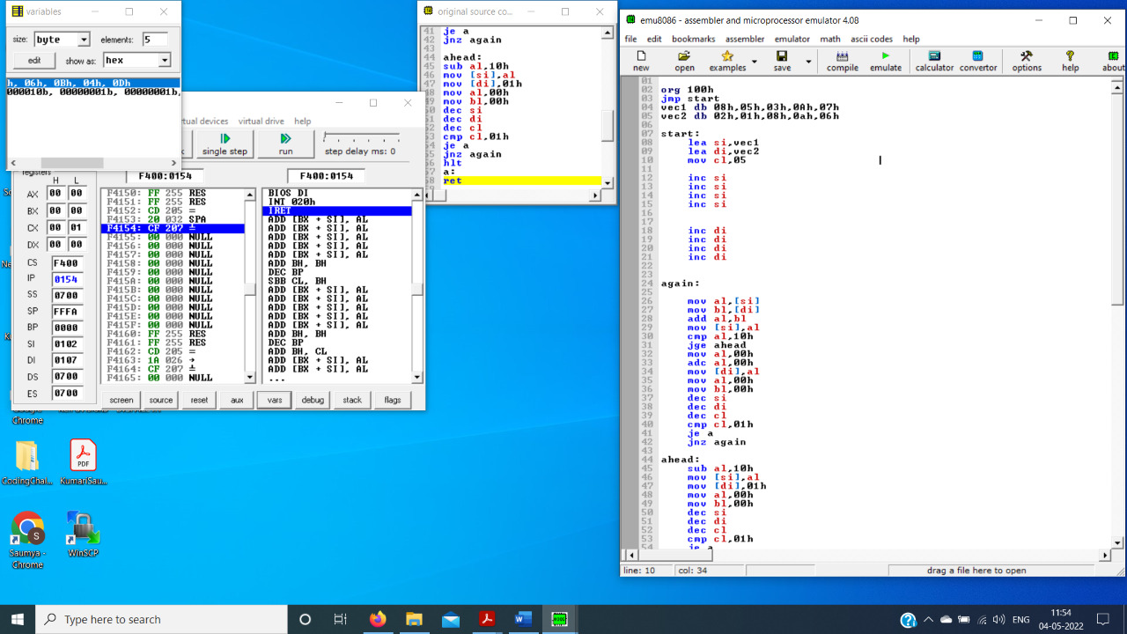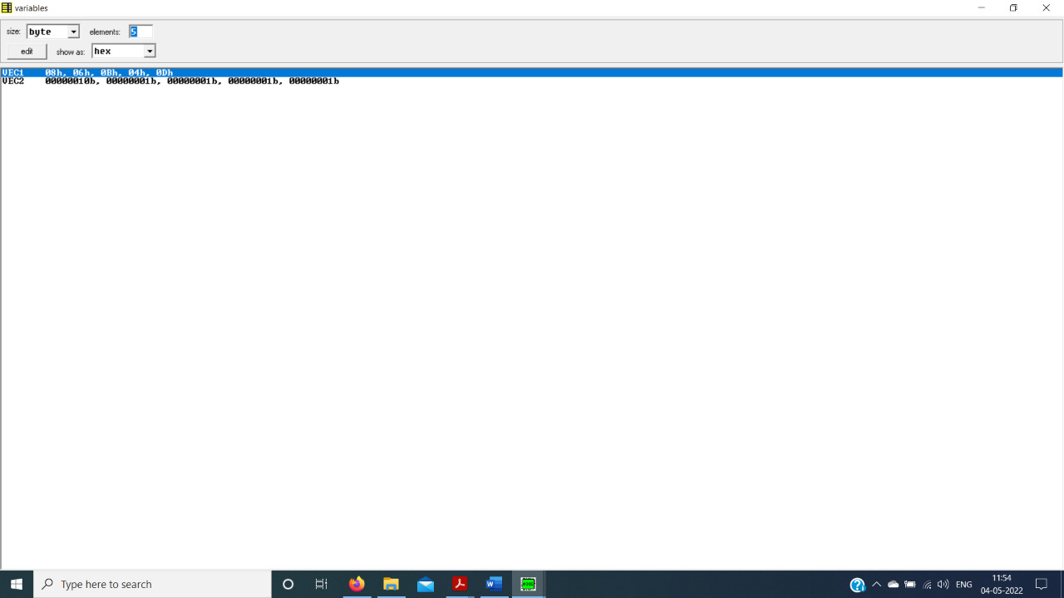

Question.15.Design an ALP to find the maximum number from an array of 10 numbers stored in memory

at 5000 H.