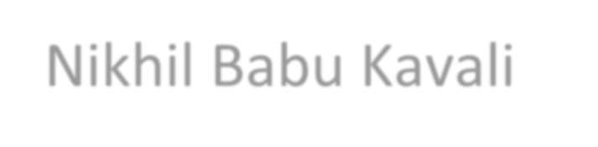

Nikhil Babu Kavali

# Education Qualifications:

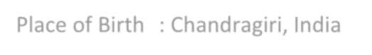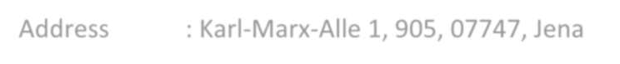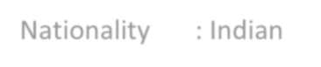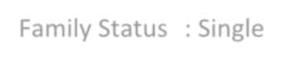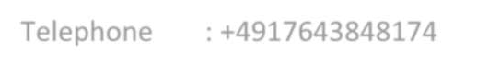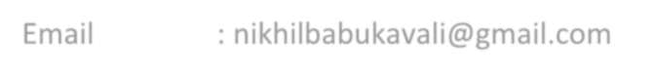

Date of Birth : 17.01.1997

Place of Birth : Chandragiri, India

Address : Karl-Marx-Alle 1, 905, 07747, Jena Nationality : Indian

Family Status : Single

Telephone : +4917643848174

Email : [nikhilbabukavali@gmail.com](mailto:nikhilbabukavali@gmail.com)

**10/2019** **– Present** **Master** **of** **Science** **in** **Scientific** **Instrumentation** **GPA:** **2.8** **Ernst** **Abbe** **Hochschule** **Jena**

**Majors:** Finite Element Methods & Simulations, Advanced 3D Design, Materials for Sensors and Actuators, Precision Instrumentation

**06/2014** **– 05/2018** **Bachelors** **of** **Technology** **in** **Mechanical** **Engineering** **GPA:** **2.3** **Jawaharlal** **Nehru** **Technological** **University** **Anantapur,** **India**

**Majors:** Manufacturing, Mechanics and Strength of Materials, Industrial Engineering, Supply chain Management, Design Engineering, Dynamics & Kinematics of Machines

# Work Experiences:

**01/2022** **– Present** **Master** **internship** **– Design** **&** **Simulation**

**Institut** **für** **Textiltechnik** **der** **RWTH** **Aachen** **University**

* Research and familiarized with carbon tape fibre reinforced composites and Abaqus FE modelling models.
* Created a concept for the development of a simulation model for FRP components made of carbon tapes.
* Implemented the concept for example models and validate the models for carbon tapes.

**06/2020** **– 08/2020** **Advanced** **3D** **Design**

**Ernst** **Abbe** **Hochschule** **Jena**

**-** Design of a mechanical setup for tilt compensation using Autodesk Inventor considering its manufacturability.

**05/2020** **– 07/2020** **FEM** **and** **Simulation**

**Ernst** **Abbe** **Hochschule** **Jena**

* Optimisation of Truss using ANSYS Workbench to maximise the load carrying capacity with regards to force.

**08/2018** **– 03/2019** **Product** **Designer**

**Lakshmi** **Pipe** **Industries,** **Tirupati** **(India)**

* Designed Tee-Angle elevation, weldolet angle elevation, spool define, flanges and triod setting for the water tubes.
* Internal pipe flow simulation through Solid works.
* Carry out quality assurance tests to discover errors.

**Bachelor** **Thesis** ***“****Experimental* *Investigation* *on* *The* *Effect* *Of* *Aluminium* *&Titanium* *on* *The* *Mechanical* *Properties* *of* *Sisal-Epoxy* *Composites".*

**05/2018** **– 06/2018** **Bachelor** **Internship** **-** **Design**

**SVS** **Hydraulics** **Private** **Limited,** **India**

* Responsible for the design and analysis of hydraulic scissor lift control using SolidWorks and ANSYS Workbench.
* Conducted static analysis and compared the theoretical hand calculations with simulation results**.**

**02/2017** **– 03/2017** **Research** **Assistant**

**S.V.** **College** **of** **Engineering** **and** **Technology,** **Chittoor** **-** **India**

* Design of IC Engine parts using Solid works and Autodesk inventor

software.

* Responsible for the design process from the concept to the draft.
* Designed piston, connecting rod and crank shaft for IC engine.

# Technical Skills:

AutoCAD Expert Catia V5 Expert

Office 365 Expert ANSYS Good

Autodesk Inventor Expert ABAQUS Good

# Language Skills:

**Telugu** Mother Tongue

**English** Business Fluency

**German** Communicative (Level A2)

# Hobbies:

Cricket, Cooking, Wandering, Trekking, Travelling



**Nikhil** **Babu,** **Kavali** **Jena,** **09.08.2022**