EXAM GUIDE PREP

PROJECT REPORT
Submitted by

BOGGULA CHANDRA (B192511)

VEMPATI MEGHANA (B191177)

SIRIPURAM SHIVANI (B191017)

of

Bachelor of Technology
in
Computer Science and Engineering

Under the Guidence of

Ms.SINDHUJA
Asst.Prof.CSE,RGUKT BASAR



DEPARTMENT OF COMPUTER SCIENCE AND ENGINEERING

RAJIV GANDHI UNIVERSITY OF KNOWLEDGE TECHNOLOGIES

BASAR,NIRMAL(DIST.),

TELANGANA-504107

EXAM GUIDE PREP

Project Report submitted to

RAJIV GANDHI UNIBERSITY OF KNOWLEDGE TECHNOLOGIES, Basar
for the partial fulfillment of the requirements
for the award of the degree of

Bachelor of Technology
in
Computer Science and Engineering
by

BOGGULA CHANDRA(B192511)
VEMPATI MEGHANA(B191177)
SIRIPURAM SHIVANI(B191017)

Under the Guidence of

Ms.SINDHUJA
Asst.Prof.CSE,RGUKT BASAR

DEPARTMENT OF COMPUTER SCIENCE AND ENGINEERING

RAJIV GANDHI UNIVERSITY OF KNOWLEDGE TECHNOLOGIES

BASAR,NIRMAL(DIST.),

TELANGANA-504107

i

DEPARTMENT OF COMPUTER SCIENCE AND ENGINEERING
RAJIV GANDHI UNIVERSITY OF KNOWLEDGE TECHNOLOGIES,
BASAR.

CERTIFICATE

This is to certify that the Project Report entitled ‘EXAM GUIDE PREP’ submitted by Boggula Chandra – B192511, Vempati Meghana – B191177, Siripuram Shivani – B191017, Department of Computer Science and Engineering,Rajiv Gandhi University of Knowledge Technologies, Basar, for partial fulfillment of the requirements for the degree of Bachelor of Technology in Computer Science and Engineering is a bonafide record of the work and investigations carried out by them under my supervision and guidance.

PROJECT SUPERVISOR : HEAD OF DEPARTMENT :

Ms.SINDHUJA Mr.REVYA NAIK
Assitant Professor Assistant Professor

PROJECT COORDINATOR : EXTERNAL EXAMINER :

Mr.B VENKAT RAMAN
Assitant Professor

ii

DEPARTMENT OF COMPUTER SCIENCE AND ENGINEERING
RAJIV GANDHI UNIVERSITY OF KNOWLEDGE TECHNOLOGIES,
BASAR.

DECLARATION

We hereby declare that the work which is being presented in this project entitled, “

EXAM GUIDE PREP ” submitted to RAJI GANDHI UNIVERSITY OD KNOWLEDGE

TECHNOLOGIES, BASAR in the partial fulfillment of the requirements for the award of the

degree of BACHELOR OF TECHNOLOGY in COMPUTER SCIENCE AND

ENGINEERING, is an authentic record of oue own work carried out under the supervision of
“Ms.SINDHUJA” , Assistant Professor in Department of Computer Science and Engineering

RGUKT,Basar.

The matter embodied in this project report has not been submitted by us for the award of any other degree.

Place:Basar BOGGULA CHANDRA(B192511)
Date:19-06-2024 VEMPATI MEGHANA(B191177)
SIRIPURAM SHIVANI(B191017)

iii

ACKNOWLEDGEMENT

We would like to express our deep gratitude to our project guide Ms.SINDHUJA,Assistant Professor,Department of Computer Science and Engineering,RGUKT Basar,for her guidance with unsurpassed knowledge and immense encouragement.

We are grateful to Mr.REVYA NAIK,Head of the Department,Computer Science and Engineering,for providing us with the required facilities for the completion of the project work.

We are very much thankful to the Director and Administration,RGUKT Basar for their encouragement and cooperation to carry out this work.

We express our thanks to all teaching staff of Department of CSE,whose suggestions during reviews helped us in accomplishment of our project.

We would like to thank all non-teaching staff of the Department of CSE,RGUKT Basar for providing great assistance in accomplishment of our project.

We would like to thank our parents,friends and classmates for their encouragement throughout our project period.Atlast, we thank everyone for supporting us directly or indirectly in completing this project successfully.

PROJECT STUDENTS :

BOGGULA CHANDRA(B192511)

VEMPATI MEGHANA(B191177)

SIRIPURAM SHIVANI(B191017)

iv

ABSTRACT

The EXAM GUIDE PREP is a website aims to simplify the process of preparing for Government jobs and Competive exma like UPSC,GATE,JEE,etc by providing students with easy access to such essential portals.Traditionally collecting the description of such competitive ones are challenging,This portal centralizes all such necessary information inluding the list of exams,exams description,exam pattern,exam strategy and resources for exam.Users can create accounts and access to portal at any time,ensuring they are well-prepared for competitive exams.

v

LIST OF CONTENTS

Certificate........................................................................................................ii
Declaration......................................................................................................iii
Acknowledgement............................................................................................iv
Abstarct.............................................................................................................v
CHAPTER- 1....................................................................................................1
1.1 Project Ojective...................................................................................1
1.2 Aims and Objective............................................................................2
1.3 Algorithm............................................................................................3
CHAPTER – 2.....................................................................................................5
2.1 Introduction to webdevelopment.........................................................5
2.2 Core Components of Webdevelopment...............................................5
2.3 Webdevelopment tools and Frameworks.............................................6
2.4 WebDevelopment Prpcess...................................................................6
2.5 Emerging trends in webDevelopment..................................................6
2.6 Web Development Carriers and Skills.................................................7
2.7 Resources for WebDevelopment.........................................................7
CHAPTER – 3.....................................................................................................9
3.1 Code Implementation..........................................................................9
3.2 Output Images....................................................................................18
CHAPTER – 4....................................................................................................20
4.1 Introduction........................................................................................20
4.2 Work Breakdown Structure................................................................20
CHAPTER – 5....................................................................................................21
Conclusion................................................................................................21

vi

CHAPTER – 1

INTRODUCTION

1.1 PROJECT OBJECTIVE:

Welcome to EXAM GUIDE PREP: Your Ultimate Exam Guide Prep Resource

Welcome to EXAM GUIDE PREP, your go-to destination for mastering exam preparation strategies and achieving academic excellence. Whether you're a student gearing up for school exams, a professional pursuing certifications, or anyone facing a crucial test, we are here to empower you with the knowledge and tools to succeed.

At EXAM GUIDE PREP, we understand the challenges and pressures that come with exam season. Our mission is to provide you with comprehensive guidance and resources that will not only boost your confidence but also enhance your performance on exam day. From study tips and time management techniques to practice tests and stress-relief strategies, we cover everything you need to excel.

What You'll Find Here:

1. Expert Advice and Insights:
Benefit from expert tips and insights on how to approach different types of exams and maximize your study efforts.

2. Comprehensive Study Guides:
Access detailed study guides tailored to various exams, ensuring you cover all essential topics effectively.

3. Interactive Practice Resources:
Engage with interactive quizzes, practice tests, and exercises designed to reinforce your learning and assess your progress.

4. Community Support:
Connect with a community of learners and educators who share valuable advice and encouragement, creating a supportive environment for your exam preparation journey.

Whether you're preparing for standardized tests, university entrance exams, professional certifications, or any other academic challenge, EXAM GUIDE PREP is here to guide you every step of the way. Let’s embark on this journey together towards academic success and achievement!
1

1.2 Aims and Objective

At EXAM GUIDE PREP , our primary aim is to empower students and professionals alike with the tools and knowledge necessary to excel in their exams. Our objectives include:

1. Comprehensive Exam Preparation:
Provide comprehensive resources and study guides that cover a wide range of exams, including standardized tests, university entrance exams, professional certifications, and more.

2. Effective Study Techniques:
Offer proven study techniques and strategies that enhance learning retention and comprehension, ensuring students can study smarter, not just harder.

3. Practical Advice and Tips:
Provide practical advice from experts and educators on exam preparation, time management, stress reduction, and test-taking strategies to boost confidence and performance.

4. Interactive Learning Resources:
Offer interactive quizzes, practice tests, and exercises that simulate exam conditions and allow users to assess their knowledge and progress.

5. Community and Support:
Foster a supportive community where users can connect with peers, share experiences, and receive encouragement and guidance throughout their exam preparation journey.

6. Current and Updated Content:
Ensure all content is current, relevant, and updated regularly to reflect changes in exam formats, syllabi, and best practices in exam preparation.

7. Accessibility and User-Friendly Interface:
Design a user-friendly website interface that makes navigation easy and provides seamless access to resources across different devices.

8. Continuous Improvement:
Regularly gather feedback from users to improve the website's content, features, and user experience, ensuring it remains a valuable and trusted resource.
By achieving these aims and objectives, EXAM GUIDE PREP aims to be the

2
ultimate destination for anyone looking to prepare effectively and confidently for
their exams, ultimately leading to academic and professional success.

1.3 Algorithm

1. Identify Exam Details
- Determine the specific exam you are preparing for (e.g., GRE, GATE, JEE, etc.) and understand its format, content, and timing.

2. Set Clear Goals
- Define achievable goals for your preparation, such as target scores or areas of improvement.

3. Gather Study Materials
- Collect all necessary study materials, including textbooks, notes, online resources, and practice exams.

4. Create a Study Schedule
- Develop a realistic study schedule based on the time available before the exam. Allocate specific time slots for each subject or topic.

5. Prioritize Topics
- Identify and prioritize topics based on their weightage in the exam and your current level of understanding.

6. Understand Key Concepts
- Study each topic thoroughly, focusing on understanding key concepts, formulas, definitions, and theories.

7. Practice Problems
- Solve practice problems and questions related to each topic to reinforce understanding and improve problem-solving skills.

8. Review Regularly
- Continuously review and revise previously studied material to reinforce retention and identify areas needing further improvement.

9. Take Mock Exams
- Take simulated or mock exams under timed conditions to simulate the exam environment and assess your readiness.

3
10. Evaluate Performance
- Analyze your performance in mock exams and practice tests. Identify weak areas and adjust your study plan accordingly.

11. Seek Clarifications
- Clarify doubts and seek help from teachers, tutors, or online forums for topics or concepts you find challenging.

12. Manage Stress
- Practice stress management techniques such as deep breathing, exercise, and adequate sleep to stay focused and calm during the exam period.

13. Stay Healthy
- Maintain a balanced diet, stay hydrated, and get regular exercise to ensure physical and mental well-being during preparation.

14. Final Review
- Conduct a final comprehensive review of all topics and notes a few days before the exam to reinforce learning and boost confidence.

15. Exam Day Preparation
- Prepare everything you need for the exam day in advance, such as identification documents, stationery, and directions to the exam venue.

16. Stay Confident
- Approach the exam with confidence, knowing that you have prepared thoroughly and effectively.

4

CHAPTER-2

WEB DEVELOPMENT

Web development encompasses a broad range of topics and skills involved in creating and maintaining websites and web applications. Here’s a comprehensive overview covering various aspects of web development:

2.1 Introduction to Web Development

Web development refers to the process of building and maintaining websites and web applications. It involves various disciplines, including programming, design, content creation, client-side scripting, server-side scripting, network security configuration, and more.

2.2 Core Components of Web Development

Front-End Development:
This focuses on the client-side of web development, involving the design, structure, and behavior of everything users interact with in their browser.
i.HTML (Hypertext Markup Language):
Used for structuring web content.
ii.CSS (Cascading Style Sheets):
Used for styling HTML elements.
iii.JavaScript:
Programming language used for interactive elements, animations, and dynamic updates.

Back-End Development:
This focuses on server-side operations, handling databases, server configuration, and ensuring the application works smoothly behind the scenes.
i.Server-Side Languages:
Examples include PHP, Python, Ruby, Java, Node.js.
ii.Databases:
MySQL, PostgreSQL, MongoDB, etc., for storing and retrieving data.
iii.Server Management:
Configuring servers, handling security, and managing APIs.

Full-Stack Development:
Involves proficiency in both front-end and back-end development, enabling developers to work on all layers of the application stack.
5
2.3 Web Development Tools and Frameworks

Development Environments:
Editors like Visual Studio Code, Sublime Text, and IDEs like IntelliJ IDEA, Eclipse.

Version Control:
Git and platforms like GitHub for managing code changes and collaboration.

Front-End Frameworks:
React, Angular, Vue.js for building interactive user interfaces.

Back-End Frameworks:
Express.js (Node.js), Django (Python), Ruby on Rails (Ruby), Laravel (PHP), etc.

2.4 Web Development Process

Planning and Analysis:
Understanding project requirements, target audience, and defining project scope.

Design:
Creating wireframes, mockups, and user interfaces (UI/UX design).

Development:
Writing code, integrating front-end and back-end components, and testing functionality.

Testing:
Debugging, performance testing, usability testing to ensure the website/application works as intended.

Deployment:
Moving the application from development to production environment.

Maintenance and Updates:
Monitoring, troubleshooting issues, updating content, and ensuring security patches.

2.5 Emerging Trends in Web Development

Responsive Web Design:
Ensuring websites work well on various devices and screen sizes.

6
Progressive Web Apps (PWAs):
Websites that feel like native mobile apps, providing offline access and push notifications.

Single Page Applications (SPAs):
Web apps that load a single HTML page and dynamically update as the user interacts.

Serverless Architecture:
Using cloud services to handle server-side logic, reducing infrastructure management.

Artificial Intelligence (AI) and Machine Learning:
Integrating AI-driven features like chatbots, personalized content recommendations.

2.6 Web Development Careers and Skills

Front-End Developer:
Proficient in HTML, CSS, JavaScript, and frameworks like React, Angular, or Vue.js.

Back-End Developer:
Skills in server-side programming languages, databases, and frameworks.

Full-Stack Developer:
Competence in both front-end and back-end development.

UI/UX Designer:
Focuses on user interface design and user experience.

Web Developer Tools:
Knowledge of development tools, version control systems, and debugging techniques.

2.7 Resources for Learning Web Development

Online Courses and Tutorials:
Platforms like Coursera, edX, Udemy, and free resources like MDN Web Docs, W3Schools.
Books:
Recommended titles include "Eloquent JavaScript" by Marijn Haverbeke and "Learning Web Design" by Jennifer Robbins.

7
Communities and Forums:
Engage with communities like Stack Overflow, GitHub, and attend local meetups or conferences.

8
CHAPTER – 3

CODE IMPLEMENTATION AND ANALYSIS

3.1 Code Implementation

All our code is written using HTML and CSS.First here is our project directory structure and files.

Pattern:

- main.html
- main_style.css
- login
login.html
login_style.css
- when?
when.html
when_style.css
- why?
why.html
why_style.css

3.1.1 main.html

<!DOCTYPE html>
<html lang="en">
<head>
<meta charset="UTF-8">
<meta name="viewport" content="width=device-width, initial-scale=1.0">
<title>EXAM_GUIDE_PREP</title>
<link rel="stylesheet" href="style.css">
</head>
<body>
<div><h1 id="heading1"><marquee>WELCOME TO EXAM GUIDE PREP</marquee></h1></div>
<header>
<div id="navbar">
<a herf="#">eguide.in</a>
<a href="/why/why.html">WHY?</a>
<a href="/when/when.html">WHEN?</a>
<a href="/login/login.html">LOGIN</a>
<input type="text" placeholder="search eguide.in">
<button>search</button>
</div>
9

</header><br>
<div id="UPSC">
<h3><a href="https://byjus.com/civil-services-exam/">Union Public Service Commision(UPSC-CSE)</a></h3>
<p>UPSC is a constitutional body of INDIA that conducts direct recrutiment of officers to the All India Services and the Central Civil Services(Group A and B) through examinations and appoints officers in various services under Government of India.It is a best carrier option for serving country in different fields such as EDUCATION,HEALTH,WOMEN WELFARE etc. </p>
</div>
<div id="box1"></div><br><br>
<div id="CAT">
<h3><a href="https://byjus.com/cat/exam-info/">Common Admission Test(CAT-MBA)</a></h3>
<p>CAT exam is a National level Exam for admission into management sector or other definition is doing MBA.It si purpose for doing PG.It is offere by various prestigious bussiness schools and management institutes in INDIA.</p>
</div>
<div id="box2"></div><br><br>
<div id="GATE">
<h3><a href="https://byjus.com/gate/gate-exam/">Graduate Aptitude Test in Engineering(GATE-M.Tech)</a></h3>
<p>GATE exam is an entrance examination conducted in INDIA that primarily tests the comprehensive understanding of undergraduate subjects in engineering and sciences for admission into postgraduate programs.</p>
</div>
<div id="box3"></div><br><br>
<div id="JEE">
<h3><a href="https://byjus.com/jee/jee-main/">Joint Entrance Exam(JEE-B.Tech)</a></h3>
<p>JEE exam is for joing engineering and sciences background as undergraduate subjects.It all has tough competition overall india after completion of 12th standard.It takes admission as follows IIT,NIT,IIIT,etc.</p>
</div>
<div id="box4"></div><br><br>
<div id="NEET">
<h3><a href="https://byjus.com/neet/neet-exam-pattern/">National Eligibility cum Entrance Test(NEET-MBBS)</a></h3>
<p>NEET exam is for admission into sciences background like Medical courses.It is also one of the toughest exam conducted in India.It takes eligibilty as after completion of 12th standard in any board all over the India.</p>
</div>
<div id="box5"></div><br><br>
<div id="NDA">
<h3><a href="https://www.shiksha.com/sarkari-exams/articles/nda-eligibility-criteria-blogId-22425">National Defence Academy(NDA)</a></h3>
<p>NDA exam is for joing the defence services through out the country India.It is a exam which conducted for only boys after completion of 12th standard in any of the state or central board exams.</p>
</div>
10
<div id="box6"></div><br><br>
<div id="CDS">
<h3><a href="https://www.shiksha.com/sarkari-exams/articles/cds-eligibility-blogId-24737">Combined Defence Service(CDS)</a></h3>
<p>CDS exam is for selecting the candidates for training under Indian Military Academy(IMA),Indian Naval Academy(INA),Air Force Academy(AFA),and Officers Training Academy(OTA).This is a written exam eligible only after graduation and both male & female can attend for this exam.</p>
</div>
<div id="box7"></div><br><br>
<div id="CGL">
<h3><a href="https://www.shiksha.com/exams/ssc-cgl-exam">Staff Selection Commission-Combined Graduate Level(SSC-CGL)</a></h3>
<p>SSC CGL tests are administered by the staff selection commission(ssc) to choose the most qualified applicants for Group B and Group C positions.The SSC CGL Exam is conducted anually to fill Grade B and C openings in Government,Ministries,and Deapartment positions.</p>
</div>
<div id="box8"></div><br><br>
<div id="TSPSC">
<h3><a href="https://telanganatoday.com/all-about-tspsc-group-exams">Telangana State Public Service Commission(TSPSC)</a></h3>
<p>TSPSC exams also well known as groups exams.This exam to conduct various recrutiment exams and select eligible candidates for various civil services positions in the state government of Telangana.This exam is well conducted for selecting the candidates group 1 and 2 positions mostly as civil services.And through all over India every state conducts their own PSC.</p>
</div>
<div id="box9"></div><br><br>
<div id="LAW">
<h3><a href="https://www.shiksha.com/law/ailet-exam">All India Law Entrance Test(AILET)</a></h3>
<p>AILET is a exam conducted all over India and conducted by National Law University,Delhi for admission to its Bachelor of Arts-Bachelor of Laws-BALLB(Hons),Master of Laws-LLM and PhD courses in LAW.</p>
</div>
<div id="box10"></div><br><br>
<footer>
made with &hearts; by examguide <br>
&#169; copy right of examguide
<div> +91 123456789 Contact Us</div>
<div>examguide@gmail.com</div>
</footer>
</body>
</html>

11

3.1.2 main_style.css

body{
background-color: rgb(142, 205, 247);
}
#heading1{
background-color:rgb(2, 32, 54);
color:white;
}
a{
margin-right: 200px;
text-decoration: none;
color:white;
}
p{
color:white;
}
h2{
color:white;
}
#navbar{
background-color:rgb(2, 32, 54);
color:aliceblue;
}
footer{
background-color: rgb(2, 32, 54);
color:white;
text-align:center;
}
#UPSC{
display:inline-block;
color:white;
background-color:rgb(2, 32, 54);
height:100px;
width:1200px;
}
#box1{
display:inline-block;
height:100px;
width:130px;
background-image: url("upsc.jpg");
background-size: cover;
}
#CAT{
display:inline-block;
height:100px;
width:1200px;
color:white;
12
background-color:rgb(2, 32, 54);
}
#box2{
display:inline-block;
height:100px;
width:130px;
background-image: url("cat.jpg");
background-size: cover;
}
#GATE{
display:inline-block;
height:100px;
width:1200px;
color:white;
background-color:rgb(2, 32, 54);;
}
#box3{
display:inline-block;
height:100px;
width:130px;
background-image: url("gate.jpg");
background-size: cover;
}
#JEE{
display:inline-block;
height:100px;
width:1200px;
color:white;
background-color:rgb(2, 32, 54);
}
#box4{
display:inline-block;
height:100px;
width:130px;
background-image: url("jee.jpg");
background-size: cover;
}
#NEET{
display:inline-block;
height:100px;
width:1200px;
color:white;
background-color:rgb(2, 32, 54);
}
#box5{
display:inline-block;
height:100px;
width:130px;
background-image: url("neet.jpg");
background-size: cover;
13
}
#NDA{
display:inline-block;
height:100px;
width:1200px;
color:white;
background-color:rgb(2, 32, 54);
}
#box6{
display:inline-block;
height:100px;
width:130px;
background-image: url("nda.jpg");
background-size: cover;
}
#CDS{
display:inline-block;
height:100px;
width:1200px;
color:white;
background-color:rgb(2, 32, 54);
}
#box7{
display:inline-block;
height:100px;
width:130px;
background-image: url("cds.jpg");
background-size: cover;
}
#CGL{
display:inline-block;
height:100px;
width:1200px;
color:white;
background-color:rgb(2, 32, 54);
}
#box8{
display:inline-block;
height:100px;
width:130px;
background-image: url("ssc.jpg");
background-size: cover;
}
#TSPSC{
display:inline-block;
height:100px;
width:1200px;
color:white;
background-color:rgb(2, 32, 54);
}
14
#box9{
display:inline-block;
height:100px;
width:130px;
background-image: url("tspsc.jpg");
background-size: cover;
}
#LAW{
display:inline-block;
height:100px;
width:1200px;
color:white;
background-color:rgb(2, 32, 54);
}
#box10{
display:inline-block;
height:100px;
width:130px;
background-image: url("law.jpg");
background-size: cover;
}

3.1.3 Login.html

<html lang="en">
<head>
<meta charset="UTF-8">
<meta name="viewport" content="width=device-width, initial-scale=1.0">
<title>Login_Page</title>
<link rel="stylesheet" href="style3.css">
<link href="https://fontawesome.com/icons/user-lock" rel="stylesheet">
</head>
<body>
<div class="wrapper">
<form action="">
<h1>Login</h1>
<div class="input-box">
<input type="text" placeholder="Username" required>
<i class="fa-solid fa-user"></i>
</div>
<div class="input-box">
<input type="Password" placeholder="Password" required>
<i class="fa-solid fa-lock"></i>
</div>
<div class="remember-forgot">
<label><input type="checkbox">Remember me</label>
<a href="#">Forgot password?</a>
</div>
<button type="submit" class="btn">Login</button>
15
<div class="register-link">
<p>Don't have an account? <a href="#">Register</a></p>
</div>
</form>
</div>
</body>
</html>

3.1.4 login_style.css

body{
display:flex;
justify-content: center;
align-items: center;
min-height: 100vh;
background: rgb(142, 205, 247);
}
.wrapper{
width:420px;
background: rgb(2, 32, 54);
color:#fff;
border-radius:10px;
padding:30px 40px;
}
.wrapper h1{
font-size:36px;
text-align:center;
}
.wrapper .input-box{
position:relative;
width:100%;
height:50px;
margin:30px 0;
}
.input-box input{
width:100%;
height:100%;
/* back-ground:transparent;*/
border:none;
outline:none;
border:2px solid rgba(255,255,255,.2);
border-radius:40px;
font-size:16px;
color: rgb(2, 32, 54);
}
.input-box input::placeholder{
color:rgb(2, 32, 54);
}
.input-box i{
position:absolute;
16
right:20px;
top:50%;
transform:translateY(-50%);
font-size:20px;

}

.wrapper .remember-forgot{
display:flex;
justify-content: space-between;
font-size:14.5px;
margin:-15px 0 15px;
}
.rememeber-forgot label input{
accent-color: #fff;
margin-right:3px;
}
.remember-forgot a{
color:#fff;
text-decoration:none;
}
.remember-forgot a:hover{
text-decoration:underline;
}
.wrapper .btn{
width:100%;
height:45px;
background:#fff;
border:none;
outline:none;
border-radius:40px;
box-shadow:0 0 10px rgba(0,0,0,.1);
cursor:pointer;
font-size:16px;
color:#333;
font-weight:600;
}

.wrapper .register-link{
font-size:14.5px;
text-align:center;
margin:20px 0 15px;
}
.register-link p a{
color:#fff;
text-decoration:none;
font-weight:600;
}

17
3.2 OUTPUT IMAGES

main_page:

Here,the code is written using VSCode and extensions like Live Server and Prettier extensions.After excecuting the code the output console window will be shown on Web Browser.
The mail layout shows us the first page of web page which gives us starting layout of the web page.

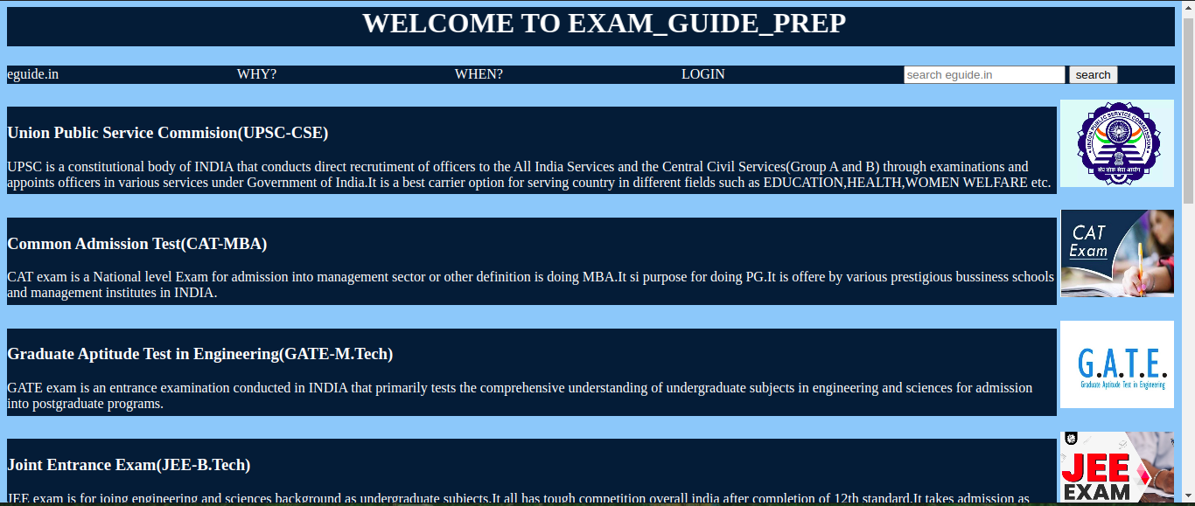

login_page:

Login page creates the register credentials and login credentials.One can register and use the website.After registering one can login after that and use.

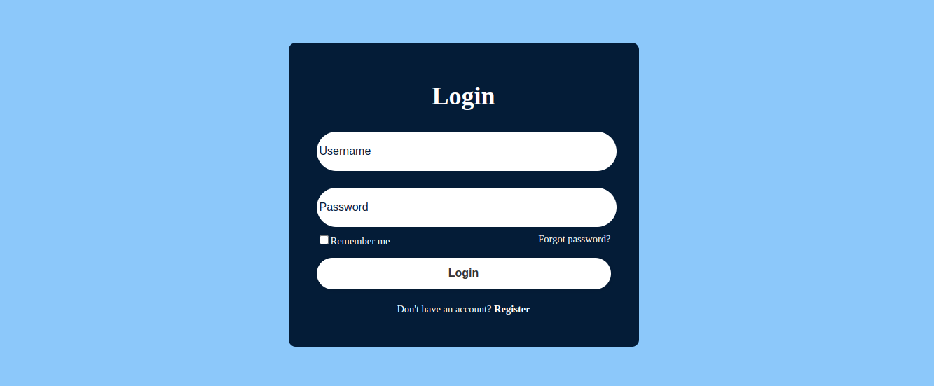

18
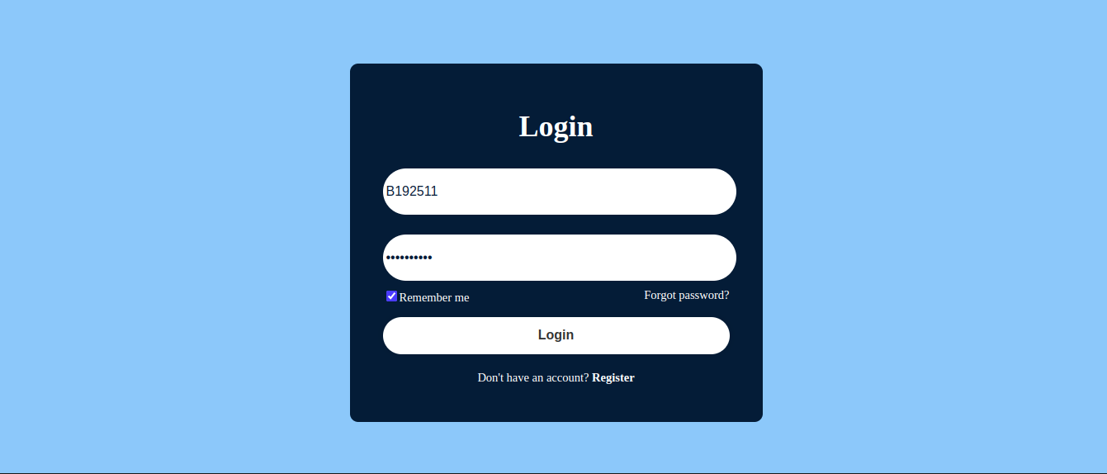

Why_Page:

This page shows us the purpose of the website.

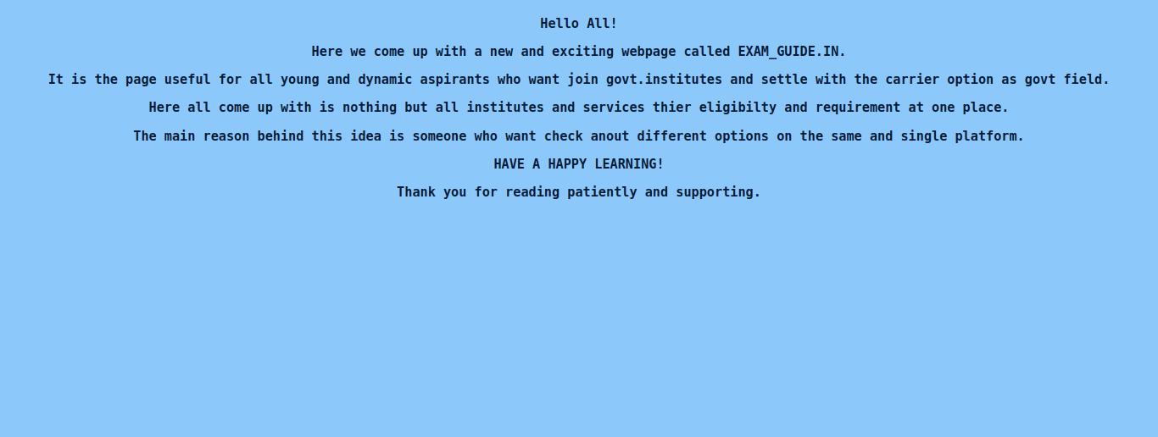

When Page:This shows us the sequence of exams.
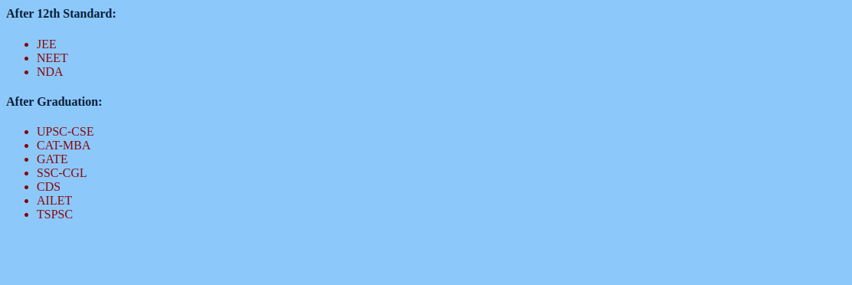
19

CHAPTER-4

WORK PLAN

4.1 Introduction

A project work plan allows you to outline the requirements of a

project,project planning steps,goals,and team members involved in the

project.Within each goal,you’re going to outline the necessary Key Action Steps

in project planning,the requirements,and who’s invovled in each action step.

4.2 Work Breakdown Structure

In order to develop this system,we gave enormous importance
to scheduling because we believed if we want to provide the best of
quality in a given period of time then we must give due importance
to scheduling which also helped us to achieve a better results.We
observe the entire work structure, meaning how the scheduling was
maintained throughout the developmental phase.We shall also see
the financial foundation of this project and further more the
feasibility study should be also discussed.

Month | Activity | Status
February | Selection of project and Study of related works. | Completed
March | Study on Software Implementation works,Web development requirements like HTML and CSS,etc. | Completed
April-May | Study of packages/tools and installation of extensions and implementation of working platform.  Implementation of code and User Interface Design. | Completed

20

CHAPTER-5

CONCLUSION

At EXAM GUIDE PREP, we are dedicated to empowering you on your journey to exam success. Our comprehensive resources, expert advice, and supportive community are designed to equip you with the tools and confidence needed to excel in your exams.

From understanding exam formats to mastering effective study techniques, our goal is to provide you with everything you need to achieve your academic and professional goals. Whether you're preparing for standardized tests, university entrance exams, professional certifications, or any other crucial exam, we are here to guide you every step of the way.

Take advantage of our interactive quizzes, detailed study guides, and insightful tips from experienced educators. Engage with our community to share experiences, seek advice, and stay motivated throughout your preparation.

Remember, preparation is key. By investing time and effort in your studies and utilizing the resources available on EXAM GUIDE PREP, you can approach your exams with confidence and achieve the results you deserve.

Start your journey to exam success today with EXAM GUIDE PREP . Together, let's turn your aspirations into achievements.

21

