**Pharmacy Claims Analysis**

* Shivani Vellanki

**Introduction:**

Given, a dataset of “Pharmacy Claims.” With 21 different columns, the above is the description of the dataset.

**PART – 1:**



Answer: After understanding the data, converted into fact table as shown as below,

copay – This is an additive fact.

insurancepaid – This is an additive fact.

fill_date - This is a non-additive fact.



Answer: In my fact table, each grain in the table represents pharmacy claim or the billing details.

member_id – ID of the patient,

drug_ndc – drug code of the patient prescribed by the doctor,

fill_date1,2,3 – dates on which the patient filled the medication details.

copay1,2,3 – amount paid by the patient on that fill_date.

Insurancepaid – amount paid by the insurance company on that fill_date.

Hence, the fact table grain which can be described in one sentence could be,

Each row represents patient’s medication claim on ***what date*** they filled their prescription for the first time, second time and the most recent time, ***how much amount*** did the patient’s pay and ***how much amount*** the insurance company paid.

**PART – 2:**

After importing the CSV files in the MySQL workbench by creating a new database named ‘final_project’ I have designated primary keys and foreign keys for both fact and dimension tables.



**Answer:**

|  |  |  |  |
| --- | --- | --- | --- |
| TABLE | PRIMARY KEY | NATRUAL KEY | SURROGATE KEY |
| fact_pharmacyclaims | claim_id |  | Yes |
| dim_memberdetails | member_id | Yes |  |
| dim_drugdetails | drug_ndc | Yes |  |



**Answer:**

|  |  |  |
| --- | --- | --- |
| TABLE | FOREIGN KEY | REFERENCED TO TABLE |
| fact_pharmacyclaims | member_id | dim_memberdetails |
| fact_pharmacyclaims | drug_ndc | dim_drugdetails |

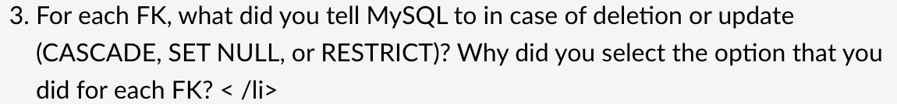

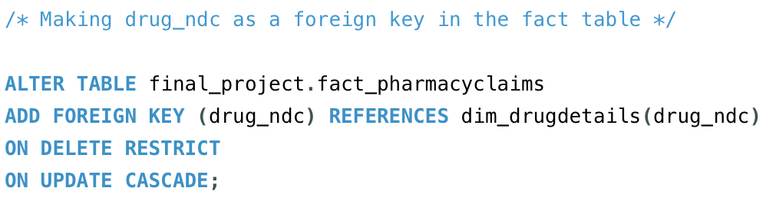

**Why ON DELETE RESTRICT AND ON UPDATE CASCADE?**

* I have used on delete restrict and on update cascade operations on both the foreign keys because, in three tables, pharmacy claim table, member details and drug details table.
* Considering member_id, it is the primary key in the member details table and foreign key in the pharmacy claim table, if in case a member detail row is deleted in the member_details table for any reason, it is important to not lose the data of this patient who have claimed before, for that reason on delete restrict is chosen.
* If the member_id, by any chance is updated in the member details table, then it is crucial in the pharmacy claims to get updated automatically.
* Considering drug_ndc, it is the primary key in the drug details table and foreign key in the pharmacy claim table, if in case a drug_ndc id is deleted, it is important to not lose the data of this patient who have claimed before because drug details and the claim details are entirely independent, for that reason on delete restrict is chosen.
* If the drug_ndc, by any chance is updated in the drug details table, then it is crucial in the pharmacy claims drug_ndc column value to get updated automatically.

**PART – 3:**

**ERD Diagram:**

**PART – 4:**

**Output:**

* ***For the drug Ambien, 2 prescriptions were filled.***

**Output:**

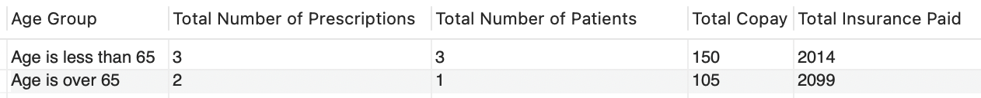

* ***Only one member is over 65 years of age.***
* ***The patient who is over 65 years of age has filled 2 prescriptions.***

**Output:**

* ***Ambien is the drug name that is listed for the member ID ‘10003’on their most recent fill date.***
* ***For the member ID ‘10003’, their insurance paid 322$.***