**PUBLIC TRADED COMPANIES 2023 – 2024 ANALYSIS**

SHIVANI VELLANKI

**Introduction:**

An analysis on 5 selected companies out of the top 500 publicly traded companies. We will be a making dashboard to show the analysis and give suggestions to the president of these companies on whether they should be splitting the stock or not.

Stock Split: Stock split happens when a company’s stock price is high. So, by splitting the stock prices, the company can ensure the stock price is accessible for many more investors. This does not make the company more valuable; it will still have the same value, but it can attract more investors.

**Broadcom Inc.:**

* From the above charts, we can see that for Broadcom Inc. the current stock price is very

high at 1,122 $.

* If we zoom in to the month of December to January where we see a very high increase of stock price and a high fluctuation in volume of stocks traded we get the below chart .
* We can see that when the stock price has been at the highest the volume of stocks traded have decreased significantly.

* Therefore, we can suggest the president of Broadcom Inc. to consider splitting the stocks

to attract more investors.

**Chipotle Mexican Grill Inc.:**

* Similar to Broadcom Inc. for Chipotle Mexican Grill Inc. the stock price is at its highest at 2,271$ per stock.
* When we see the stock price to volume of stocks ratio we see that in the recent times from November to now, there has been a decrease in the volume of stocks traded because the stock price is very high.
* Hence, we can suggest the president of Chipotle Mexican Grill Inc. to consider splitting

the stock prices.

**Costco Wholesale Corporation:**

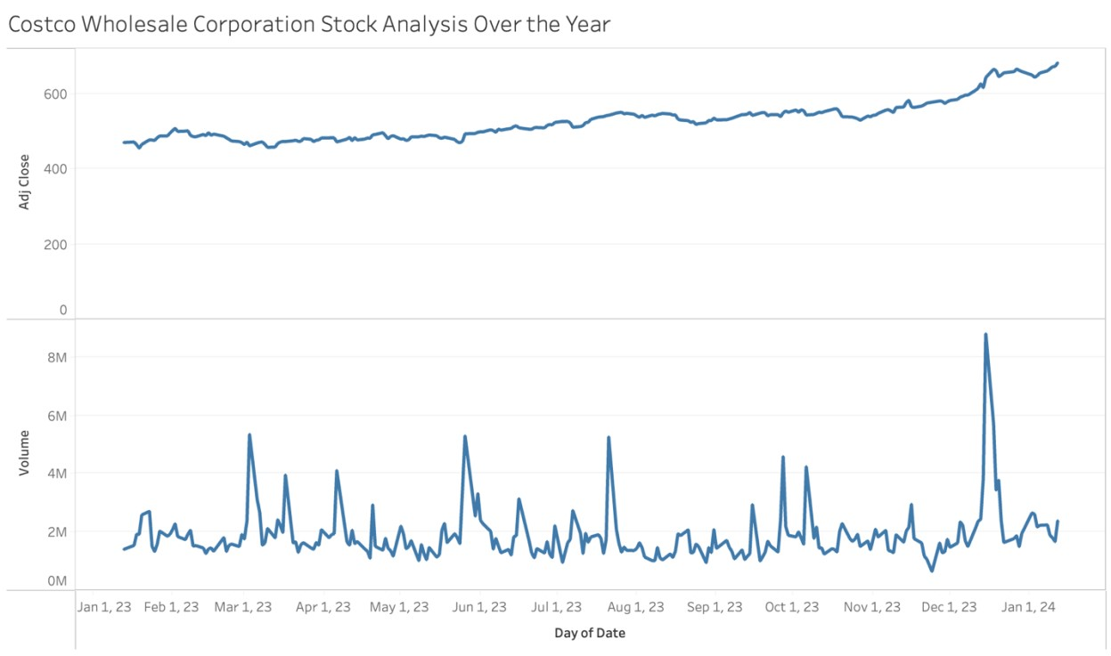

* Similar to the above two stocks, we can see that the stock price of Costco Wholesale Corporation is at its highest at around 683$.
* Since the last one month there has been a high fluctuation in the volume of stocks traded.
* If the stock price would reduce by splitting, then we can expect a huge rise in this volume. - Hence, we can suggest the president of Costco Wholesale Corporation to split the stocks.

**Apple Inc.:**

* Unlike the previous company’s stocks, Appel Inc. stock price has risen a little and there has not been a big rise or fall of stock price.
* Even the volume of stocks traded has been fluctuated but there is no significant evidence to say that splitting the stock price can give a good result.
* Hence, we can suggest president of Apple Inc. not to split the stock.

**Tesla Inc.:**

* Similar to Apple Inc. for Tesla Inc. there has been an increase and decrease pattern in both stock prices and volume of stocks traded.
* There is no significant evidence to say that splitting the stock can be beneficial for the company.
* Hence, we can suggest the president of Tesla Inc. not to split the stock.

**Conclusion:**

From the above analysis, we can suggest the presidents of Broadcom Inc, Chipotle Mexican Grill Inc and Costco Wholesale Corporation to split the stock prices to see an increase in the volume of stocks traded. For the other companies i.e. Apple Inc and Tesla Inc we can suggest the presidents not to split the stock now as there is no significant changes in the stock prices.

# References

Ghasemaghaei, M. (2019). *Decision Support Systems*. Retrieved from Does data analytics use improve firm decision making quality? The role of knowledge sharing and data analytics competency. : https://doi.org/10.1016/j.dss.2019.03.004

Singer, M. (2023, September 19). *Market Business News*. Retrieved from 11 Expert digital marketing tips for small businesses: https://marketbusinessnews.com/11-expert-digitalmarketing-tips-for-small-businesses/347768/amp/

Strack, F. B. (2014, August 1). *The Surprising Economics of a “People Business”*. Retrieved from Harvard Business Review: https://hbr.org/2005/06/the-surprising-economics-of-apeople-business

Yahoo Finance. (n.d.). In Yahoo Finance. Retrieved January 13, 2024, from https://finance.yahoo.com/