 Introduction:

The IPUMS NHIS (National Health Interview Survey) dataset provides comprehensive data about individual health, access to medical care, and health-related behaviours in the United States. This dataset encompasses a wide array of information, including self-reported overall medical conditions, the prevalence of both acute and chronic illnesses, functional limitations, trends in healthcare utilisation, health behaviours such as physical activity and dietary habits, health insurance coverage, and demographic variables such as age, gender, race, educational level, and household composition. It also contains critical data on immunisation rates, mental health indicators, prescription drug usage, reproductive wellness, dietary practices, profiles of healthcare spending, environmental and occupational exposures, and challenges encountered while seeking medical attention.

The dataset presents numerous opportunities for utilising this valuable information. It can be employed to analyse issues such as disparities in health among different racial and ethnic groups, the evolution of diseases over time, the reasons underlying difficulties in accessing healthcare, the impact of diet and exercise on health, and key topics like mental health and vaccination rates. Additionally, this data can be used to assess how health insurance policies influence individuals, quantify healthcare expenditures, and evaluate the effectiveness of public health initiatives. Moreover, we can examine the methods by which people obtain health insurance, such as through their employers or government schemes, and whether any individuals lack coverage. Additionally, this data reveals how frequently people communicate with physicians, require admission to hospitals, or use the emergency room.

Furthermore, it provides information on the different kinds of healthcare professionals that consumers see, which aids in our understanding of the healthcare system.

**Dataset Selected:** Falls (Injury) Data from 2010-2017 (Customized Data Extract)

<https://nhis.ipums.org/nhis/>

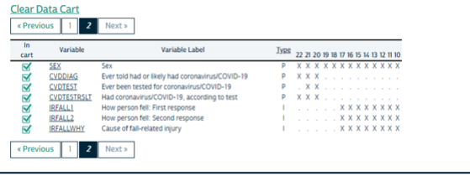

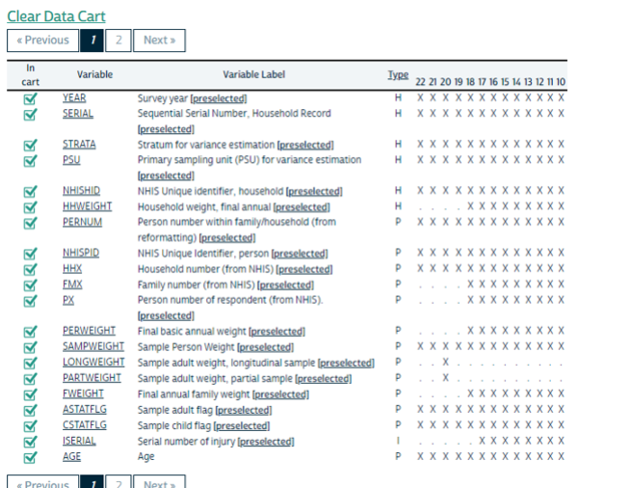

**Deliverable:** Analysis of Falls (How the person fell and reason for fall) for the following age groups: 55-64; 65-84 and 84+.

Major **codes** used throughout the analysis.

1. **YEAR** (Survey year)
2. **AGE** (Age)
3. **SEX** (Sex) – 1: Male, 2: Female
4. **HHWEIGHT** (Household weight, final annual)
5. **IRFALL1** (How person fell: First response)
6. **IRFALLWHY** (Cause of fall-related injury)
7. **Age Category**: "Under 18", "18-29", "30-44", "45-54", "55-64", "65-84", "84+"

IRFALLWHY Labels

|  |  |
| --- | --- |
| **Label** | **Value** |
| 01 | Slipping, tripping, or stumbling |
| 02 | Jumping or diving |
| 03 | Collision with/pushing, shoving by another person |
| 04 | Bumping into an object or another person |
| 05 | Being shoved or pushed by another person |
| 06 | Loss of balance/dizziness/fainting/seizure |
| 07 | Something else |
| 97 | Refused |
| 98 | Not ascertained |
| 99 | Don't know |

IRFALL1 Labels

|  |  |
| --- | --- |
| **Label** | **Value** |
| 01 | Escalator |
| 02 | Floor/level ground |
| 03 | Curb, including sidewalk |
| 04 | Ladder or scaffolding |
| 05 | Playground equipment |
| 06 | Building or other structure |
| 07 | Chair, bed, sofa, other furniture |
| 08 | Tree |
| 09 | Bathtub, shower, toilet, commode |
| 10 | Swimming pool |
| 11 | Hole or other opening |
| 12 | Sports field, court, or rink |
| 13 | Other |
| 97 | Refused |
| 98 | Not ascertained |
| 99 | Don't know |

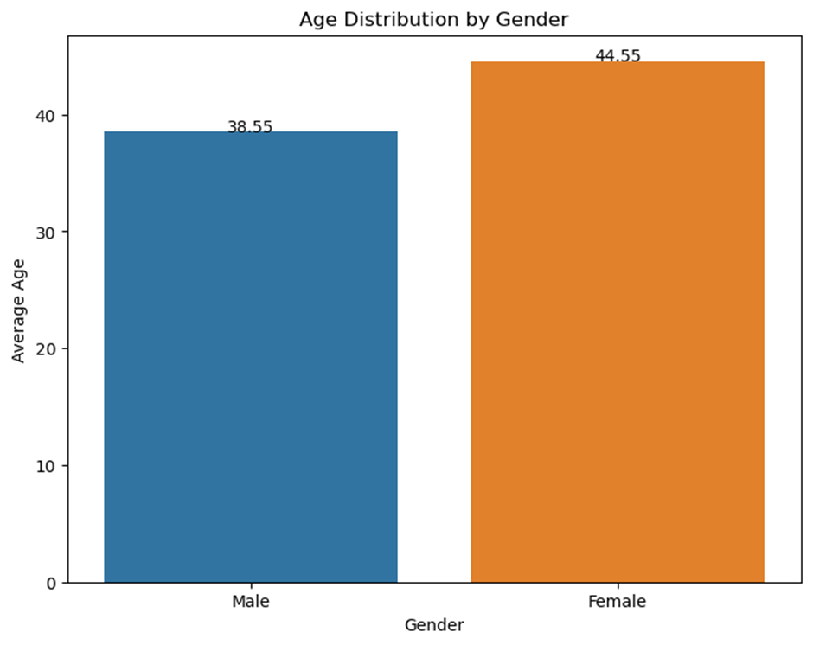

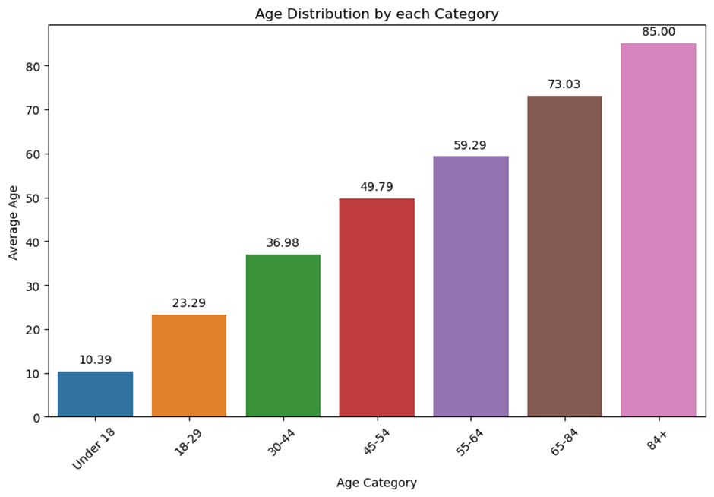

**Places where falls occur frequently.**

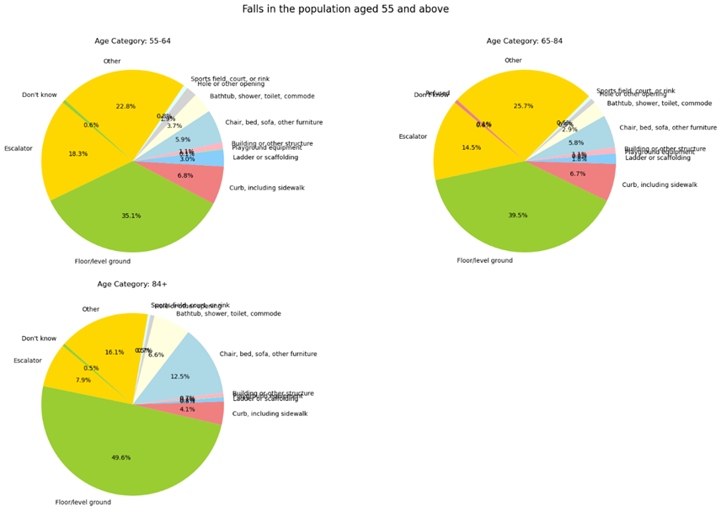

* People over the age of 55 fell or were injured on the floor or an escalator.

**Causes associated with Falls.**

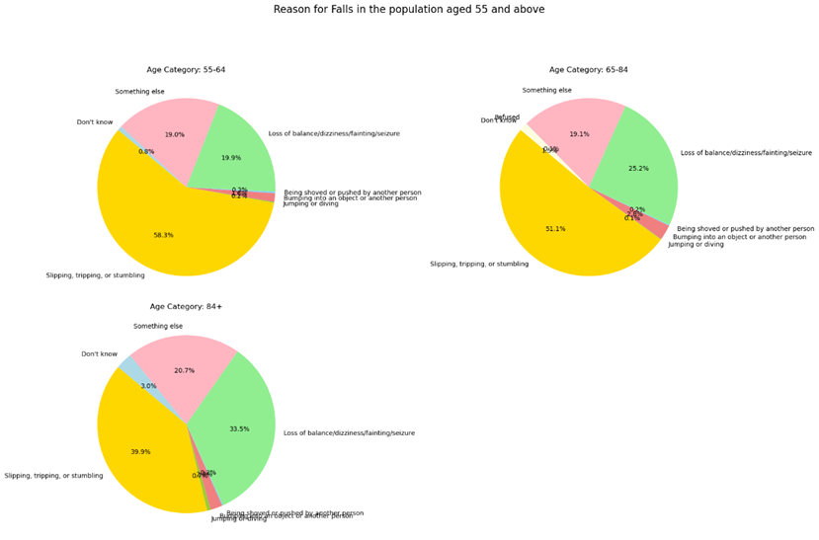

* Slipping, tripping and loss of balance are the most common causes of falls or injuries in people over the age of 55.

**Trend of causes of falls over the years.**

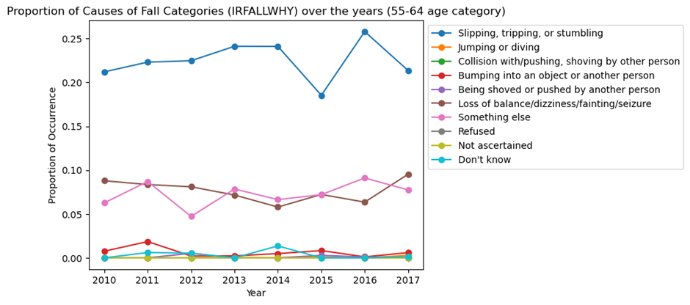

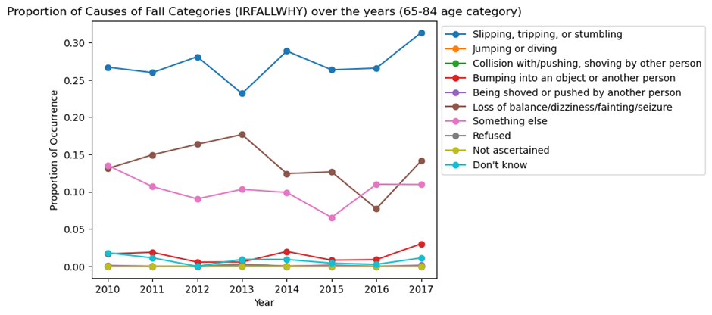

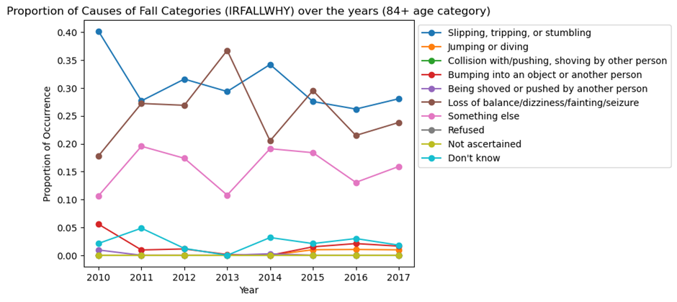

* For all senior age groups, loss of balance and tripping/slipping were consistently the top reasons over the years. This highlights that improving balance and stability should be a primary focus for reducing falls in the senior population.

**Trend of occurrence of falls over the years.**

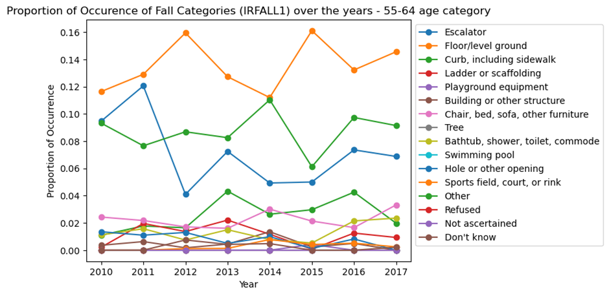

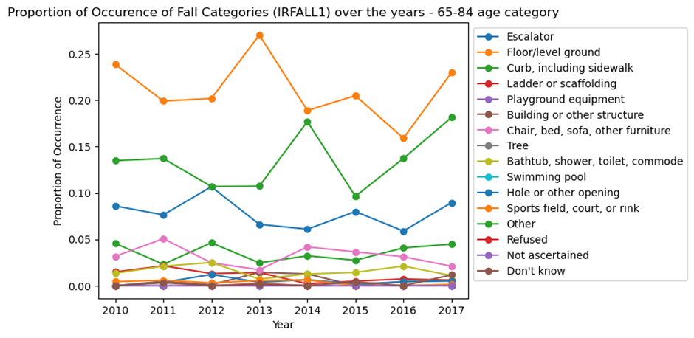

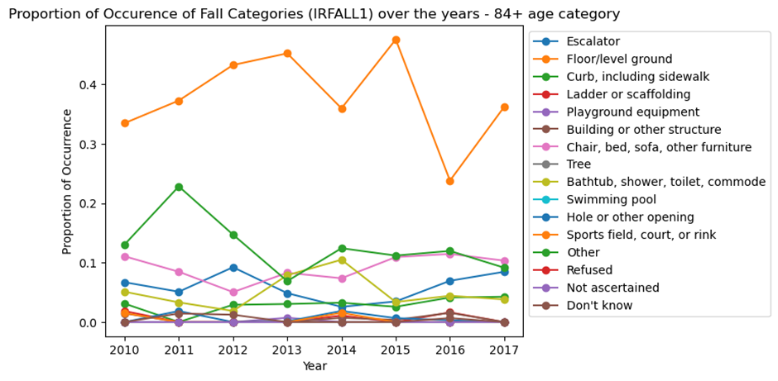

* Falls caused by furniture and the ground/floor have increased in people aged 55 to 64. This shows that a greater emphasis on furniture safety and decreasing tripping hazards on floors could be beneficial.
* Ground/floor falls consistently accounted for the largest proportion of falls among those aged 65-84 and 84+. This highlights the importance of ground and floor surfaces in adult fall prevention.

**Rate of falls per person.**

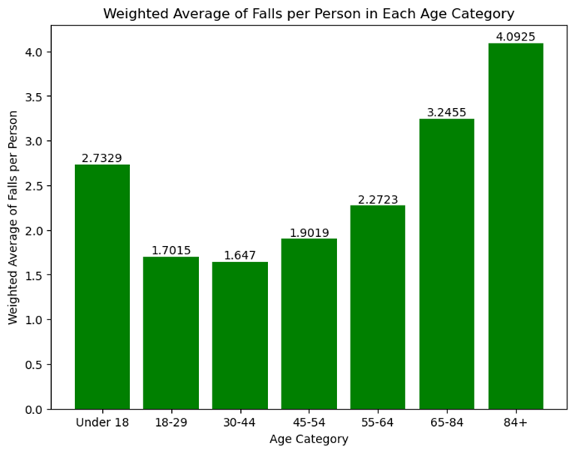

* the rate of falls per person increases with age.
* "65-84" and "84+"-higher rates of falls per person
* elders are more susceptible to falls.