**Shivani Akunoori**

# MIMS Degree College , Mancherial district, Telangana State , BSc (M.St.Cs) 2022

▪

Pursuing Certification Course Of Junior Full stack Java Developer by Tata STRIVE

Hyderabad

[shivaniakunoori.ts04@gmail.com](mailto:shivaniakunoori.ts04@gmail.com) –

PROFILE:

TECHNICAL PROFICIENCY PERSONAL INTEREST

* High school – Board of Secondary Education Telangana State , INDIA



**JFSJD**

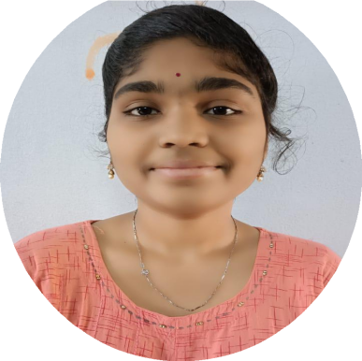

2016-2017 7.8

* Intermediate- 2017-2019 779
* BSc M.St.Cs – (2019-2022) CGPA- 8.14

LANGUAGE:

* English
* Hindi
* Telugu
  + JAVA Language
  + Basics of SQL

## ASPIRATION

Hardworking fresher seeking for an opportunity to work in challenging environment to prove my skill and knowledge.

**3**

* Java full Stack Developer

## PROJECT WORK DONE

* + colmar project
  + Portfolio project
  + Bus reservation System , ATM machine(by using Getters &Setters method) .

