1. Use case Diagram for online cake shop

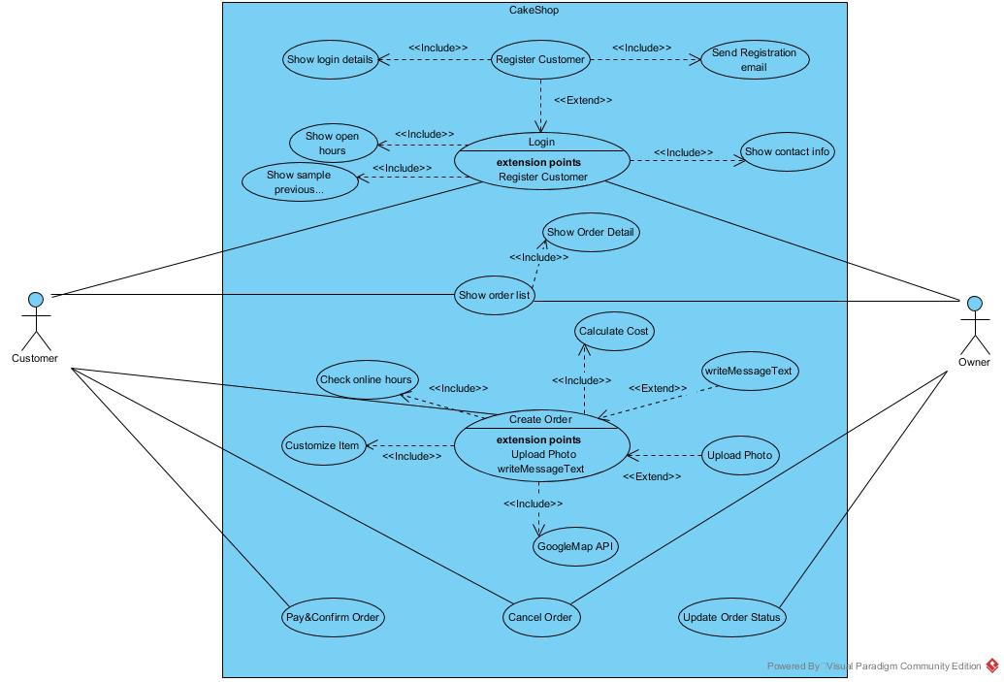

1. Activity Diagram for online cake shop

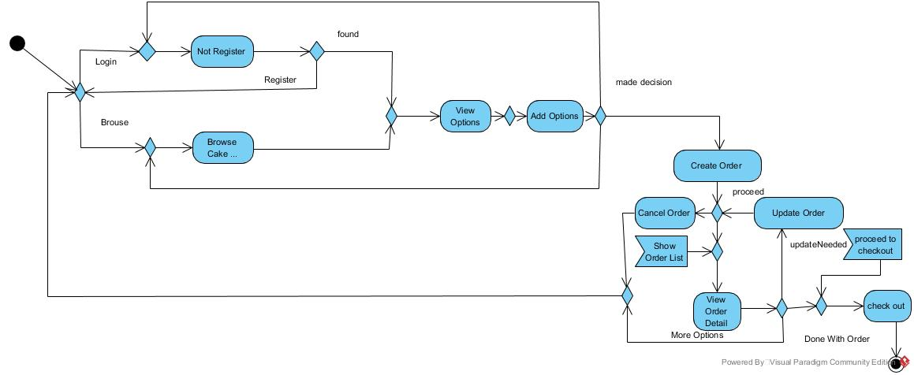

(3) Sequence Diagram for online cake shop

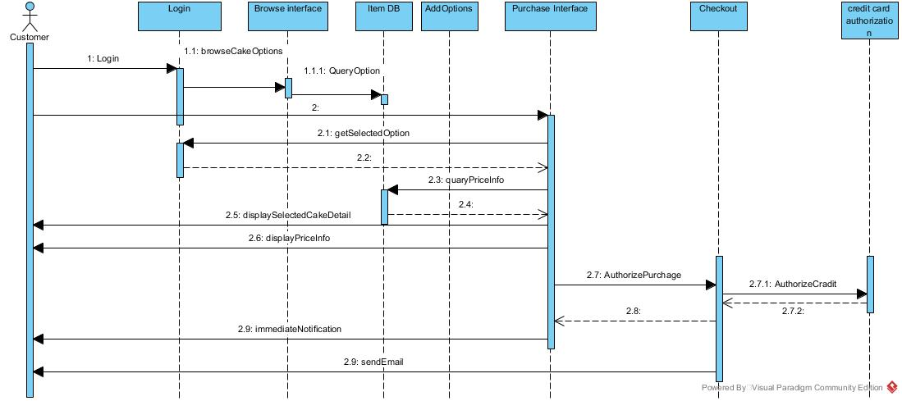

(4) Class Diagram for online cake shop

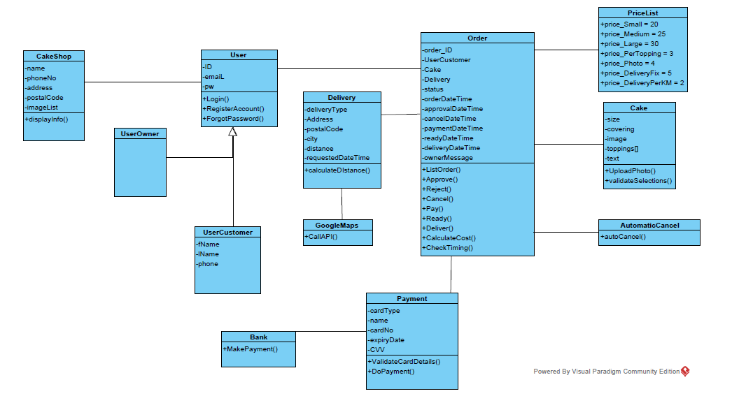

(5) State Diagram for online cake shop

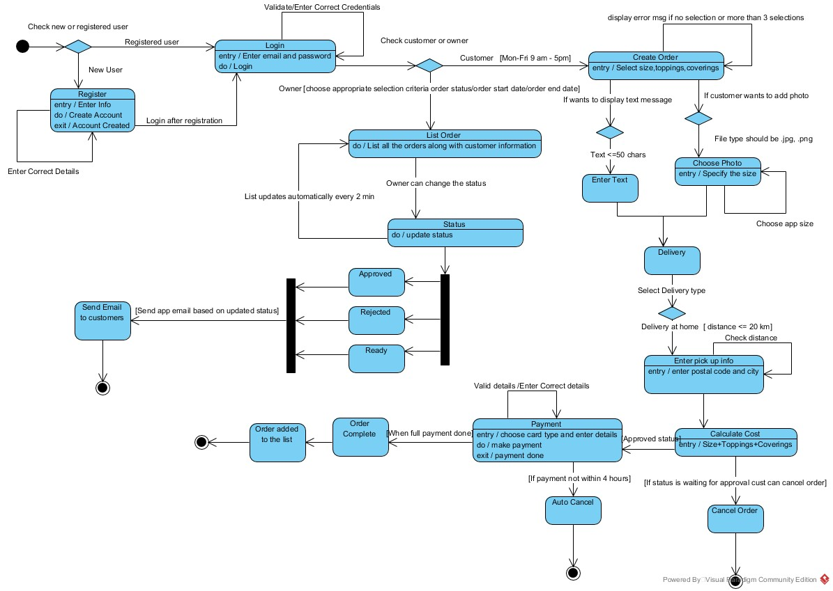

(6) Object Diagram for online cake shop

