File Sharing System using Django-REST



INTRODUCTION

File Sharing System using Django-REST

INTRODUCTION

System References
File Sharing – Swift Share allows to share documents, files from one device to another over the internet. Both uploading and downloading are essential processes for file sharing, as they enable users to transfer files between devices and locations.
File sharing was often done through peer-to-peer (P2P) networks or through email attachments. However, these methods were often slow, unreliable, and insecure. Additionally, P2P file sharing often raised legal concerns related to copyright infringement and piracy. File sharing websites address many of these issues by providing a centralized platform for users to share files with others. They offer features such as cloud storage, collaboration tools, and secure sharing links, making it easier for users to work together and share files in a secure and efficient manner. Currently the system used for storing and again retrieving the data is very costly and used at a large scale. No matters, the systems provide many operations along with data storage and team collaborations but they are paid systems and are used by the premium users only i.e., paid users.
We have developed Web-based application,Swift Share in order to demonstrate the payment signature with proper security. Instead of relying on physical storage devices, one can simply upload files to the website and share a link with others, allowing them to access the files from anywhere with an internet connection.
An assistive chatbot interface is also provided for the users to know the information about this website and to solve the queries of the users. This chatbot is implemented using Diaglogflow and that model is being trained for real-time users.

Overall Description:

What is File Sharing:
File sharing is the practice of distributing or providing access to digital media, such as computer programs, multimedia (audio,images and video), documents. Popular payment gateways include BitTorrent, Dropbox, and pCloud.

File Sharing system using Django-REST

Steps to implement Payment Gateway:
- Encryption: For Security reasons, the data fetched from user should be encrypted into cipher text to ensure the privacy of the user
- Request: The authorization request occurs when a payment processor gets approval from a credit card company or financial institution to proceed with the transaction.

- Fulfilment:
When the payment gateway has the authorization, it allows the website and interface to proceed to the next action.

Razorpay provides payment-gateway services used by more than 30,000 merchants. Razorpay is the only converged payments solution company in India that allows your business to accept, process, and disburse payments via its product suite. With Razorpay, you have access to all payment modes, including credit and debit cards, UPI, and popular mobile wallets.
Razorpay provides two keys for integration; private key and public key for integration.

What is Django?

Django is Web Framework, which follows MVT (Model View Template) architecture.
Django is a high-level Python web framework that enables rapid development of secure and maintainable websites. Built by experienced developers, Django takes care of much of the hassle of web development, so you can focus on writing your app without needing to reinvent the wheel.
Django is an open-source framework for back end web applications based on Python.
This framework provides the front-end and back-end and built-in database (SQLite). Also, Django supports multi language such as HTML, JavaScript for UI designing.

File Sharing System using Django-REST

What is REST API?
A REST API (also known as RESTful API) is an application programming interface(API or web API) that conforms to the constraints of REST architectural style and allows for interaction with RESTful web services. REST stands for representational state transfer.
API is a mediator between the users or clients and the resources or web services they want to get. It’s also a way for an organization to share resources and information while maintaining security, control, and authentication—determining who gets access to what.
When a client request is made via a RESTful API, it transfers a representation of the state of the resource to the requester or endpoint. This information, or representation, is delivered in one of several formats via HTTP: JSON (Javascript Object Notation), HTML, XLT, Python, PHP, or plain text.

What Django and Razorpay Integration do for us:
Integrating Razorpay to Django provides a payment gateway for various transactions such as for donation marketing, stores, etc.
- Provides proper authentication for login before using this website.
- Sends authentication tokens and links for resetting password and changing password.
- Provides email alerts whenever transaction is succeeded.
- Provides real-time chatbot for solving the queries of user.
- Provides various payment methods.
- Provides payment signature and capture.
- Provides appropriate security policy.
- Provides acknowledgement letter.

File Sharing System using Django-REST

Software Project Constraints

An Application Programming Interface (API) is an interface that facilitates communication and connectivity between two or more software applications.
API Integration refers to this seamless connectivity that allows organizations to automate business processes, and enhance the sharing and embedding of data between various applications and systems.

API integration is the connection between two or more applications via their APIs (application programming interfaces) that allow systems to exchange data sources. API integrations power processes throughout many sectors and layers of an organization to keep data in sync, enhance productivity and drive revenue.

API is an interface and is part and parcel of almost everything in the digital world. No matter the business and the size of the enterprise, APIs enable seamless operation and performance of applications and web systems.

Benefits of API Integration:
- Automation

- Scalability

- Streamlined Visibility

- Increases productivity

- Enhances Customer Experiences

File Sharing System using Django-REST



PROJECT SCHEDULE

File Sharing System using Django-REST

PROJECT SCHEDULE
Software Engineering is an establishment of computer engineering principles in order to obtain economical software that is reliable and works efficiently on real machine.
We have used classic life cycle paradigm also called “Water fall model”. For software engineering which is sequential approach to software development that begins at the system level and progress through analysis, design, coding, testing and maintenance. We had completed system engineering and analysis by the end of September 2021 which encompasses requirement gathering at the system level in the small amount of top-level design analysis.
We had completed software requirement analysis by the mid of October 2022 which encompasses both system and software requirement gathering. By the end of October 2021, we had completed the project planning and design. On the basis of design prepared in the previous stage by the end of March 2023 we completed coding stage.
After completion of coding page, the important part of the software development is carried out, which is the testing phase by the mid of April 2023. Various criteria of testing were taken in account has unit testing, integration testing, validation testing and system testing. First, each and every module of the project was tested under the unit testing. After unit testing, integration testing was carried out by integrating all module tested in unit testing. After unit testing the module prepared was cross checked with the design. At last, the whole module was tested over the system and desired result was obtained.

File Sharing System using Django-REST

Sept
System Engineering

Oct
Requirement Analysis
Nov
Dec
Design
Jan
Feb
Coding
Mar
Apr
May
Testing

File Sharing System using Django-REST



REQUIREMENTS ANALYSIS

File Sharing System using Django-REST

REQUIREMENTS ANALYSIS

Software Requirements Specification:

- Problem Statement -

To develop secure and user friendly website using Django REST framework.

Objectives

This web application consist senders(upload files) and receivers(download files). However, the major objectives are:

- Develop user friendly interface.
- Utilize Python Django and REST framework.
- Ensure data security.

Software Requirements

Operating System Support-

As far as operating systems are concerned Swift Share is compatible with :
- All 64 bit versions of Microsoft Windows
- All 32 bit Microsoft Windows (95/98/NT/2000/XP/Vista)
- All versions of Linux OS

It is obvious that Swift Share is independent from the operating system of the computer on which it runs. This software is web based and can be viewed by any web browser, i.e., Mozilla, Internet explorer, Netscape,Opera

Programming Language -
This project is mainly Desktop based so, we chose Python-Django for backend and HTML, CSS, JavaScript for Front End UI.

File Sharing System using Django-REST

Constraints-

The concept of File Sharing has become an essential component of how we work and collaborate, allowing individuals and organizations to easily share files with colleagues, clients and partners. Both uploading and downloading are essential processes for file sharing, as they enable users to transfer files between devices and locations. .
This application is basically a Desktop application system targeted for society from where many people can send and receive files securely an fast
The main constraints of our project are the user can easily upload and download files. In this way user can maintain the end-to-end reliability using the internet.

Performance Analysis
Whenever user uploads a file either drag and drop or select from local directory a url of that file is generated. The user can copy the url and send the link to the receiver.

Technical Analysis

As the project is based on desktop application Python-Django is used for back end language and HTML, CSS, JavaScript is used for front-end and SQLite is used for storing the data.

As Python is easy to use, supports multi-platform development and multi-paradigm, we can also parse data from one language to another. Django is a framework of Python which provides excellent security
And built-in database.

Dialogflow is a natural language understanding platform that makes it easy to design and integrate a conversational user interface into your mobile app, web application, device, bot, interactive voice response system.
Training the bot from intents and responses, this chatbot is being implemented to solve the queries of the user.

File Sharing system using Django-REST



DESIGN

File Sharing System using Django-REST

Analysis Modeling – System Design Calls:

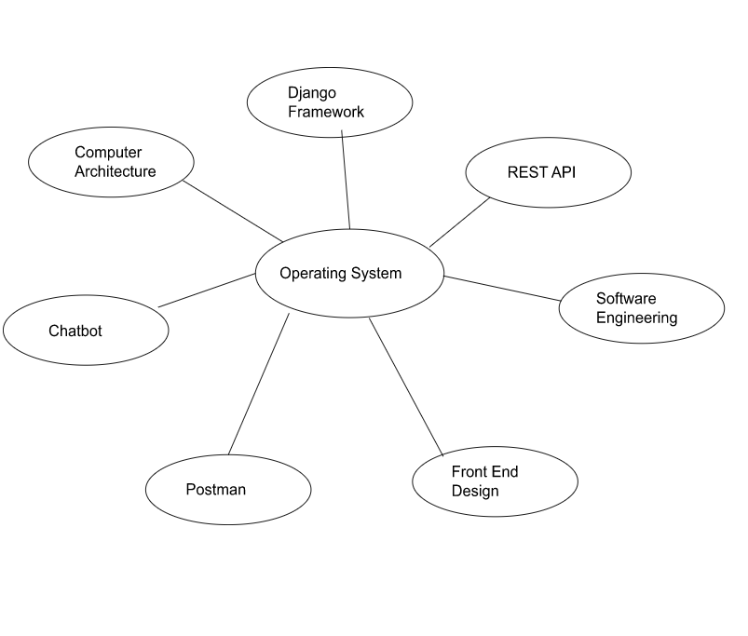

File Sharing System using Django REST

Working Design Cycle:

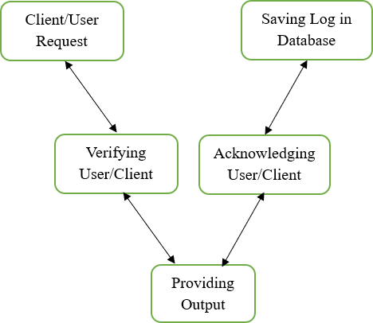

Fig 1.2

File Sharing System using Django-REST

Characteristics of Django Framework
- Excellent Documentation
If we compare Django with other open-source technologies, it offers the best documentation in the market.

Python Web-framework
Python is also one of the main reasons people started learning Django. It is that one tool which can solve all your problems and in any kind of operation out there, we can use it. It’s very simple and easy to use.

SEO Optimised
This is a special feature of Django due to which it has edge over others. SEO is Search Engine Optimization as from the name it means that adding your website to the search engine such that it appears in the top results.

High Scalability
A lot of MNCs on a worldwide scale uses Django and it gets implement there without any defects or errors. It is the best example of Django being scalable.

Versatile in Nature
Django is very versatile in its own Django way. The logical project structure and MVT architecture of Django sometimes seem very limiting. But, that’s just opposite because by giving us the files it is providing us with a solid foundation which can then be used to make whichever application we want to create.

Python-Django Payment Integration using Razorpay

Functional Partitioning:
- Upload File

- File Sharing

- File Download

- Security and Privacy

Functional Description:
  - Upload File Input:
Either drag and drop or browse files

Output:
File Uploaded

Specification:
This module handles the file upload and storage functions, including file compression and temporary storage on the server.

File Sharing

Input:
Copy the link to clipboard

Output:
Link copied (url)

Specification:
This module handles the file sharing functions, such as generating a shareable url link and ensure authorized users will get the link .In this case it helps user to copy the link to the clipboard and share it to the respective receiver.

File Sharing System using Django-REST

File Download

Input:
Click on Download Button.

Output:
Zip File will be downloaded

Specification:
This module handles the file download functions, including downloading files from the server to the user’s local system as a compressed zip file.

Security and Privacy Input:
Boolean value which is obtained after verification of data.

Output:
Payment is successful or failed

Specification:
This module handles the security and privacy functions, including implementing encryption and secure transfer protocols to protect files by implementing CSRF token mechanism to prevent unauthorized requests from being made on behalf of a user.

File Sharing System using Django-REST

BEHAVIORAL MODELING

Block Diagram:

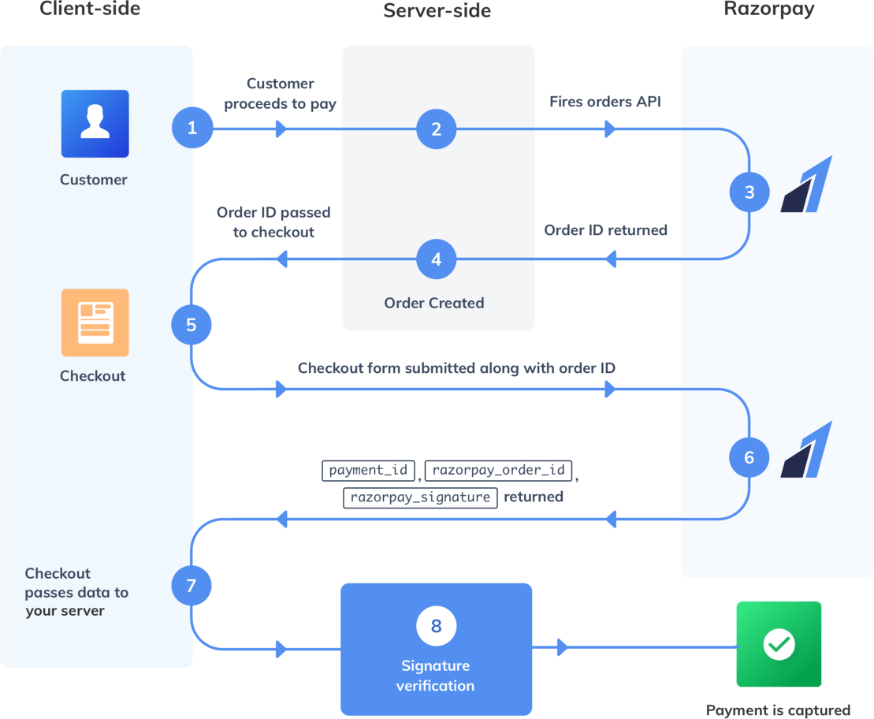

fig1.3

File Sharing System using Django-REST

Deployment Diagram-

Razorpay Dashboard
SQLite Database
<<select donation and proceed for payment>>
User
<<Run Server on Mobile IP>>
Using Internet
Fig1.4

File Sharing System using Django-REST



IMPLEMENTATION

`

File Sharing System using Django-REST

IMPLEMENTATION

- Proposed Architecture:

Language:
This project is based on the Desktop application, so we choose Python-Django, Django REST framework, JavaScript and Bootstrap to develop our project.

Tools used:
- Google cloud (Dialog flow)

Software requirements
- Visual Studio Code- JavaScript, Python-Django

- SQLite

- Client OS - Microsoft Windows XP, Linux Mint, android

Overall Description
Django is a high-level Python web framework that encourages rapid development and clean, pragmatic design. Built by experienced developers, it takes care of much of the hassle of web development, so you can focus on writing your app without needing to reinvent the wheel. It’s free and open source.
Swift Share is intended for individuals, organizations, educational institutes, and businesses that need to share files for various reasons quickly and safely.
For this purpose, a special framework of python “Django” is used. As Django follows the principle of “Model-View-Template” architecture, it is possible to demonstrate the 3-layer architecture in file sharing.While the Django REST framework is an extension to Django that makes it easy to build RESTful APIs and also scalable and robust web applications can be built with clean and maintainable code. The main focus it to use open source efficiently.

Python-Django Payment Integration using Razorpay

Initially the user selects the file that they want to share with others. This could be a document,photo,video,or any other type of file that the user wants to make available to others. Once the user has selected the file they upload it.
For managing file uploads and storage, File Field model field, File System Storage class where used from django-storages library
Once the file has been uploaded, the website generates a unique link that can be used to access the shared file. In Django, a unique ID is created using a model field called `UUIDField`. UUID [Universally Unique Identifier] .When a file is uploaded to the website, a UUID is automatically generated by the Django framework and assigned to the file. This UUID is used to retrieve the file from the server when requested by a user
Once a unique ID is generated for a file, the next step is to construct the link that will allow users to share that file. This is typically done using JavaScript running in the user's browser. The JavaScript takes the unique ID and concatenates it with the server URL in a specific format to create the shareable link.
The link is essential for others to be able to access the shared file. The link can be copied and pasted into emails,messaging apps or social media platforms for sharing with others.
When others receive the link, they can click it to be directed to the Swift Share. From there, they can download the shared file in a compressed ZIP format to reduce download times and improve the overall user experience. By compressing the file, it also reduces the risk of data corruption during transfer. This way, the file can be easily downloaded and saved to recipient’s device.
To ensure privacy and security, the file sharing website may employ security measures such as encryption, the use of unique access codes or passwords, and the implementation of CSRF (Cross-Site Request Forgery) protection. CSRF protection involves the use of a CSRF token, which is a unique value generated by the website that is included in each request made by the user.

By generating unique IDs that are difficult to guess, it's less likely that unauthorized users will be able to access the files. Additionally, by requiring a specific link to access the files, it's easier to control who has access to them and to track who has downloaded them.
Also, a navigation bar is also provided which includes the information about the project, members and the feedback option.
The Chatbot is also integrated with this website using Diaglogflow which solves the queries of real time users.
The basic process includes handling user data, processing data and providing the resulted output are organized differently in different development process. The team is will be divided to work on each module of project. All the members of our team will play separate roles in each part of the projects and roles assigned to them is carried out accordingly.

File Sharing System using Django-REST



TESTING REPORT

File Sharing System using Django-REST

TESTING REPORTS

Unit Testing

Unit testing focuses each module individually, ensuring that if function properly as unit. In this testing we have tested of our software to ensure maximum error detection. It helps to remove bugs from sub modules & prevent arrival of huge bugs after words.

Functional Partitioning:

Upload File

File Sharing

File Download

Security and Privacy

Functional Description:
  - Upload File :

Input:
Drag and Drop or Browse File

Output:
File Uploaded and stored on the server

Specification:
This module handles the file upload and storage functions, including file compression and temporary storage on the server.
  - File Sharing:

Input:
Copy the link and send to the receiver
Output:
Link has been copied successfully

Specification:
This module handles the file sharing functions, such as generating link or access code for shared files and allow user to copy link to the clipboard

File Sharing System using Django-REST

  - Security and Privacy :
Input:
Valid csrf token
Output:
Allow only valid csrf token and block the request if it is a fake request

Specification:
This module checks whether csrf token is valid or not.

Integration Testing:

Integration testing is a systematic technique for constructing the program structure while at the same time conducting tests to uncover errors associated with interfacing. The objective is to take unit tested components and build a program structure that has been dictated by the design.
We prefer the Top-down integration testing as a testing approach for our project. The Top-down integration testing is an incremental approach to construction of program structure. Modules are integrated by moving downward through the control hierarchy, beginning with the main control module
Modules subordinate to the main module are incorporated into the structure in depth-first order. Depth-first integration would integrate all components on a major control path of a structure. Selection of a major path is somewhat arbitrary and depends on application-specific characteristics.

Validation testing

The purpose of validation testing is to ensure that all expectations of the customer have been satisfied. The testing is done by the project group members by inspecting the requirements and validating each requirement.
We prefer the alpha testing technique for the validation purpose. In which case the group of students is called on to test the services of Swift Share.

File Sharing System using Django-REST

The group members will present at the place and observing the working and collecting the bugs occuring at the site and changes are made accordingly and testing done again.

4. System Testing
In the system testing system undergoes various exercises to fulfill the system requirements.
These tests include:
- Security Tests: these are designed to ensure no user can access the other documents which are none of his business,
- Performance Tests: The tests are conducted to check the performance of the system.

File Sharing System using Django_REST




PERFORMANCE ANALYSIS

File Sharing System using Django-REST

PERFORMANCE ANALYSIS

  - Figure below shows the details of performance analysis of Razorpay.com
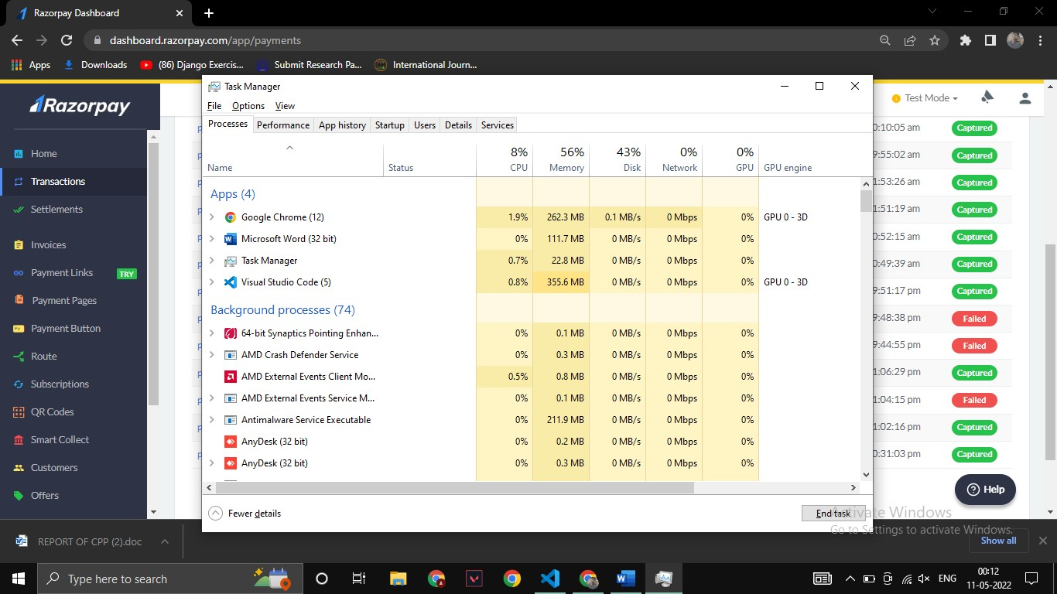

File Sharing System using Django-REST



INSTALLATION GUIDE

File Sharing System using Django-REST

INSTALLATION GUIDE

- Operating System: Microsoft windows or android or linux
- Python interpreter needed
- Virtual Environment for dependencies.
.

Install Procedure for Client

- Browse for www.swiftshare.com, enter the valid username and password and login into dashboard.
- Hit Run server Command and Open Localhost.
- Upload the file and share the link

File Sharing System using Django-REST



USER MANUAL

File Sharing System using Django-REST

USER MANUAL

Step 1: Click the upload button
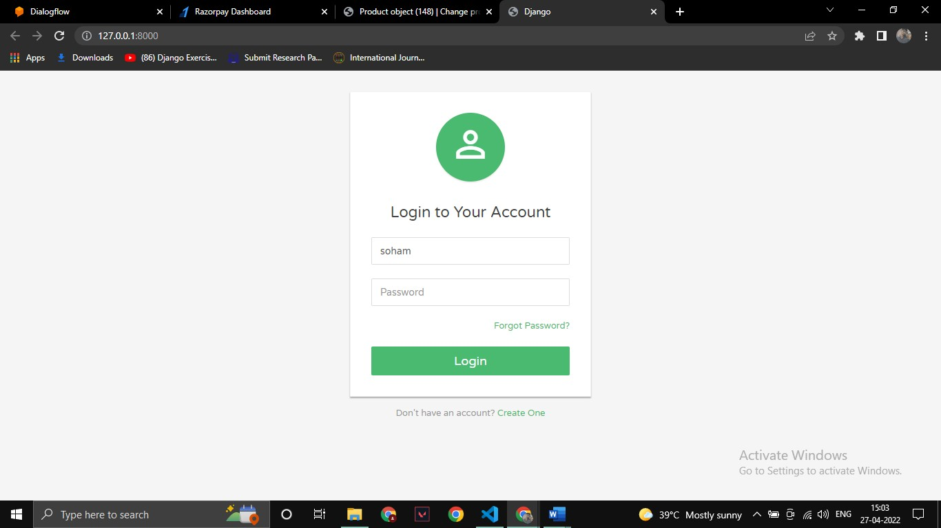

Step 2: Select the file you want to upload
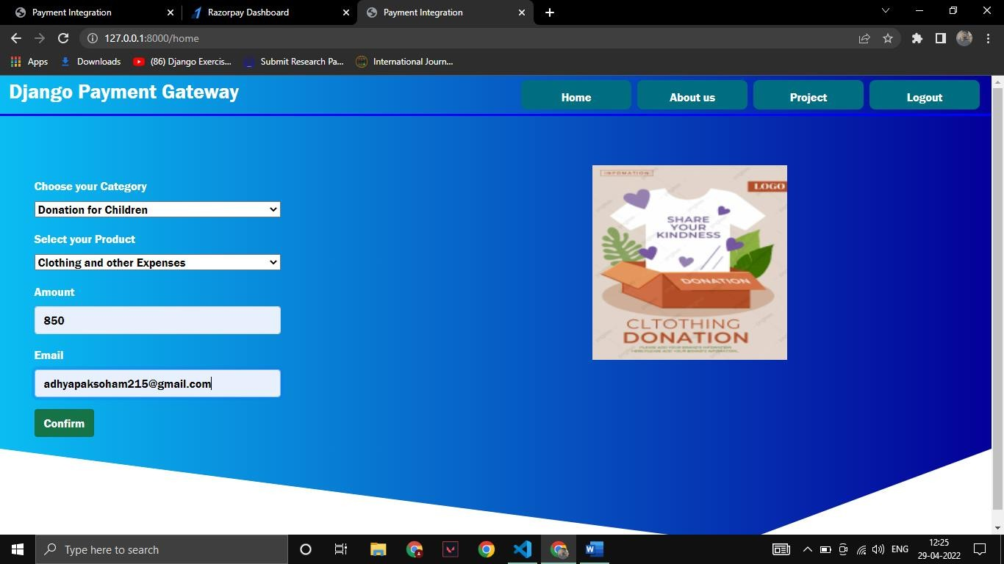

Python-Django Payment Integration using Razorpay

Step 3: Copy the link

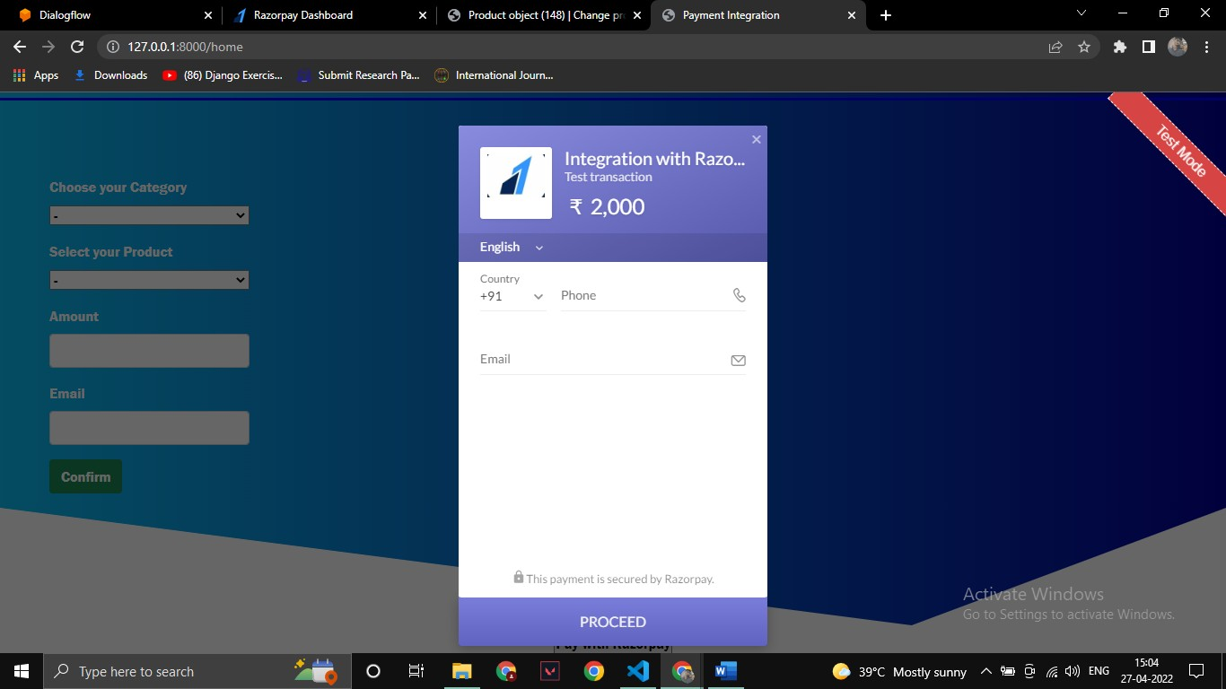

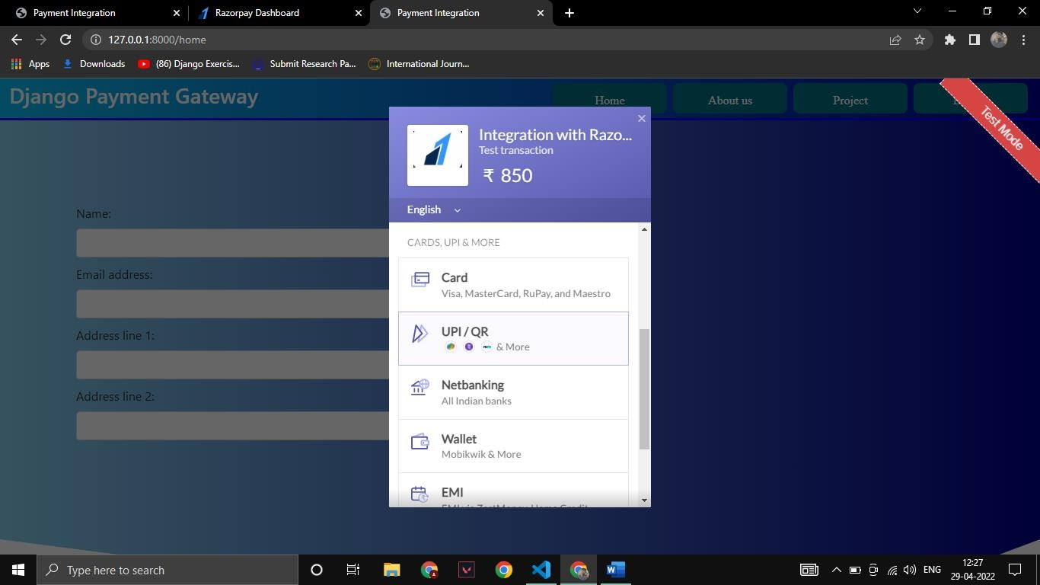

Python-Django Payment Integration using Razorpay

Step 4: Click Download button to download the file
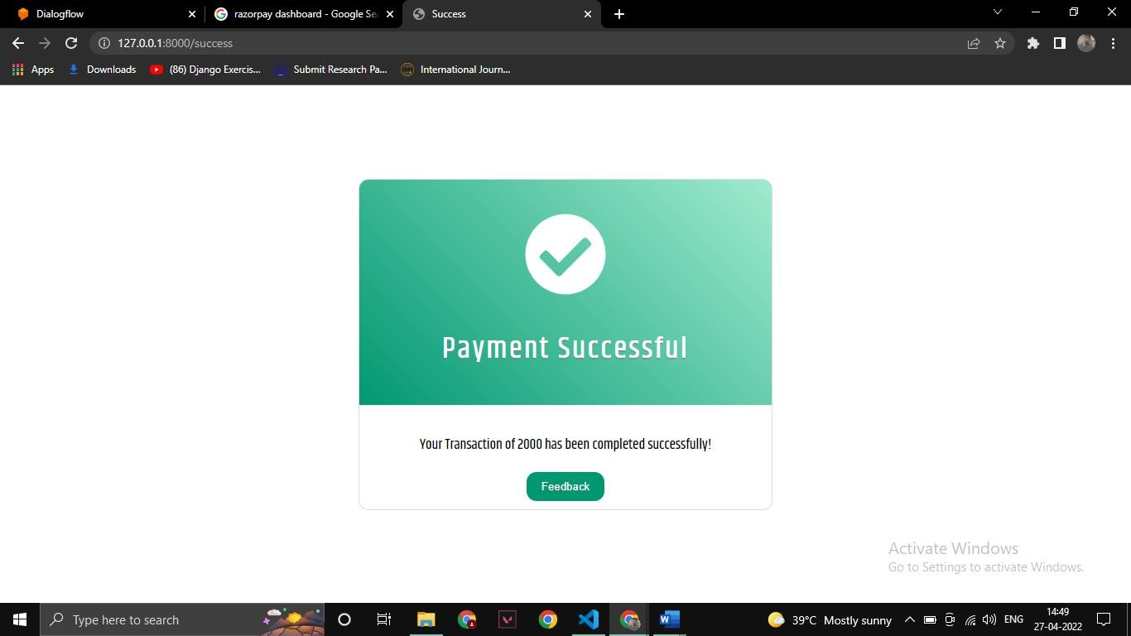

Step 5: Save the zip file to your local system
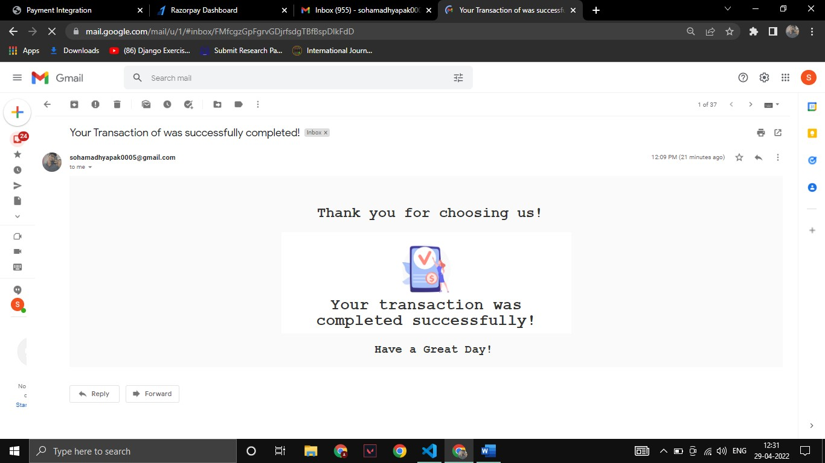

File Sharing System using Django-REST



RESULT

Python-Django Payment Integration using Razorpay

Functional Partitioning:

- Database
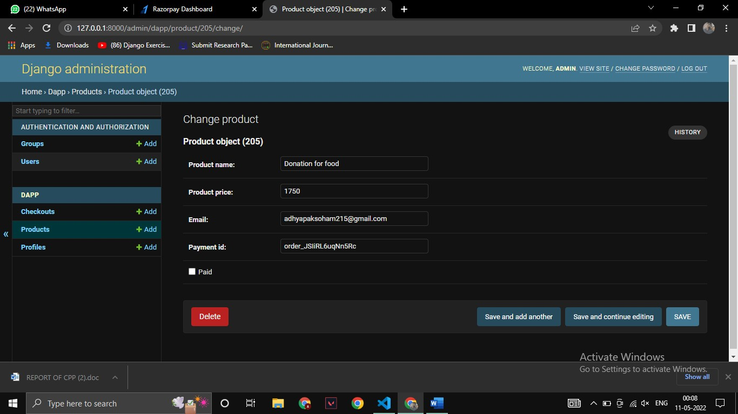
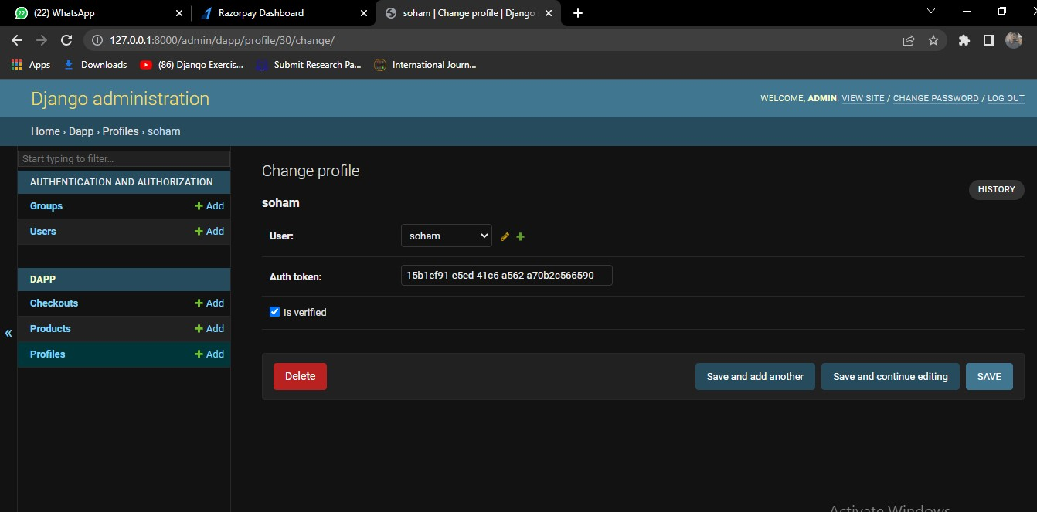

Python-Django Payment Integration using Razorpay

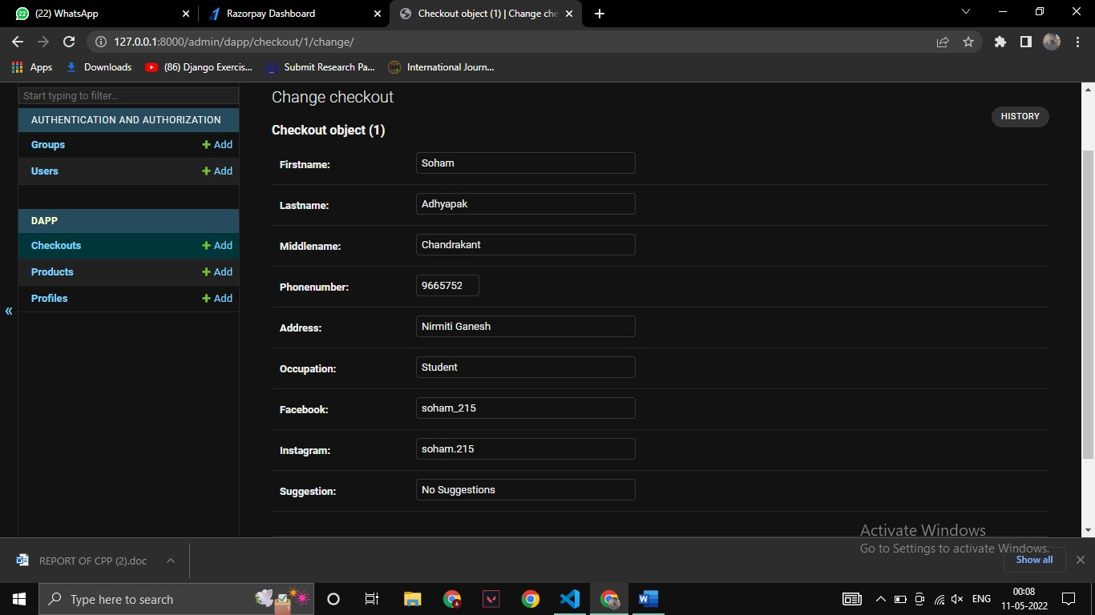

- Razorpay Dashboard
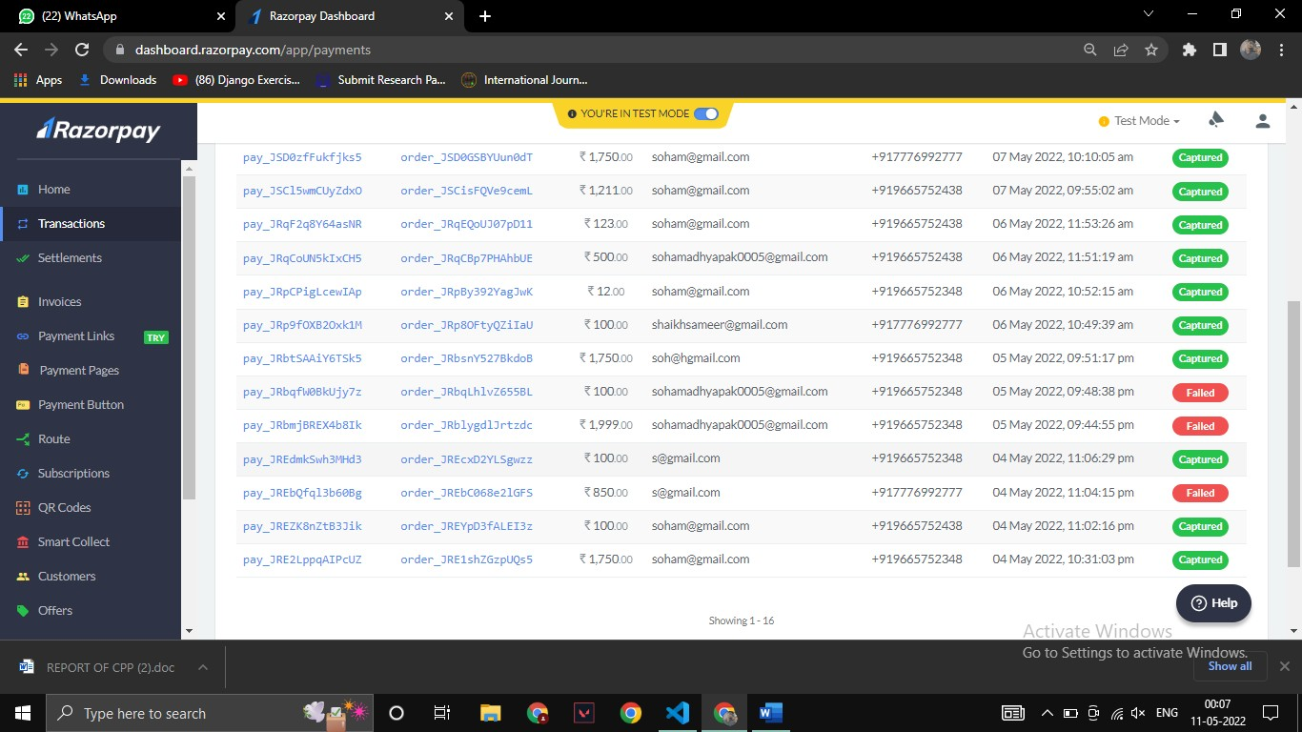

File Sharing System using Django-REST




APPLICATION

File Sharing System using Django-REST

APPLICATIONS

This project can be modified and used in following areas:
  - Business
  - Education
  - Personal Use
  - Creative Industries

File Sharing System using Django-REST



BIBLIOGRAPHY

File Sharing System using Django-REST

BIBLIOGRAPHY

TEXT BOOKS REFFERED

- Django 1.2 Jesse Legg Packt Publishing.
- Django unleashed.

WEBSITES

- www.swiftshare.com
- www.docs.djangoproject.com
- www.realpython.com
- www.developer.mozilla.org

