**Bansilal Ramnath Agarwal Charitable Trust’s**

**Vishwakarma Institute of Technology, Pune-37**

*(An Autonomous Institute of Savitribai Phule Pune University)*



**Department of AIDS**

|  |  |
| --- | --- |
| **Division** | A |
| **Roll Number** | 79 |
| **PRN Number** | 12320097 |
| **Name** | Sanket Kulkarni |

**Title:-**

Implement the following programs in JavaScript

1. Continuous Subarray Sum: Given an unsorted array of non-negative integers and a target sum, find a continuous subarray that sums up to the target sum and return the left and right indices (1-based indexing) of that subarray.

<https://www.geeksforgeeks.org/problems/subarray-with-given-sum-1587115621/1>

1. Missing Number: Given an array of size N-1 containing distinct integers in the range of 1 to N, find the missing element.

<https://www.geeksforgeeks.org/problems/missing-number-in-array1416/1>

1. Maximum Subarray Sum: Given an integer array, find the contiguous subarray (containing at least one number) with the largest sum and return its sum.

<https://leetcode.com/problems/maximum-subarray/description/>

1. Longest Consecutive Sequence: Given an unsorted array of integers, find the length of the longest consecutive elements sequence.

<https://leetcode.com/problems/longest-consecutive-sequence/description/>

It's specified that these problems should be solved using JavaScript and the solutions should be submitted as a Word file containing code and screenshots of the successful submissions on either LeetCode or GeeksforGeeks.

**a)** Continuous Subarray Sum: Given an unsorted array of non-negative integers and a target sum, find a continuous subarray that sums up to the target sum and return the left and right indices (1-based indexing) of that subarray.

<https://www.geeksforgeeks.org/problems/subarray-with-given-sum-1587115621/1>

**Code:-**

class Solution

{

//Function to find a continuous sub-array which adds up to a given number.

subarraySum(arr, n, s)

{

//your code here

let result = [];

let found = false;

let st = 0, end = 0;

let sum = 0;

for (let i = 0; i < n; i++) {

sum += arr[i];

if (sum >= s) {

end = i;

while (s < sum && st < end) {

sum -= arr[st++];

}

}

if (sum === s) {

result.push(st + 1);

result.push(end + 1);

found = true;

break;

}

}

if (!found)

result.push(-1);

return result;

}

}

**Output:-**

**b)** Missing Number: Given an array of size N-1 containing distinct integers in the range of 1 to N, find the missing element.

**Code:-**

class Solution{

missingNumber(a,N){

let xor1 = 0;

let xor2 = 0;

for (let i = 0; i < N - 1; i++) {

xor2 = xor2 ^ a[i];

xor1 = xor1 ^ (i + 1);

}

xor1 = xor1 ^ N; // XOR up to [1...N]

return xor1 ^ xor2;

}

}

**Output:-**

**c)**Maximum Subarray Sum: Given an integer array, find the contiguous subarray (containing at least one number) with the largest sum and return its sum.

**Code:-**

**/\*\***

* @param {number[]} nums

* @return {number}

*/

var maxSubArray = function(nums) {

let sum = 0;

let maxi = Number.MIN_SAFE_INTEGER;

for (let i of nums) {

sum += i;

maxi = Math.max(sum, maxi);

if (sum < 0) sum = 0;

}

return maxi;

};

**Output:-**

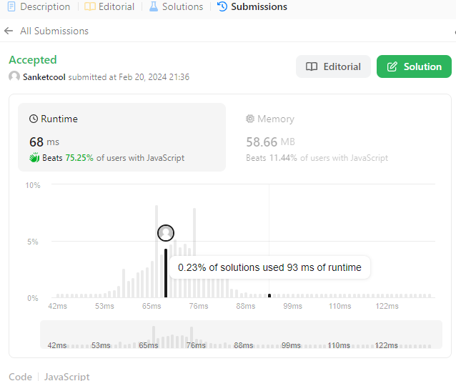

**d)**Longest Consecutive Sequence: Given an unsorted array of integers, find the length of the longest consecutive elements sequence.

**Code:-**

/**

* @param {number[]} nums

* @return {number}

*/

var longestConsecutive = function(arr) {

let n = arr.length;

if (n === 0) return 0;

// sort the array:

arr.sort((a, b) => a - b);

let lastSmaller = -Infinity;

let cnt = 0;

let longest = 1;

// find longest sequence:

for (let i = 0; i < n; i++) {

if (arr[i] - 1 === lastSmaller) {

// arr[i] is the next element of the

// current sequence.

cnt += 1;

lastSmaller = arr[i];

} else if (arr[i] !== lastSmaller) {

cnt = 1;

lastSmaller = arr[i];

}

longest = Math.max(longest, cnt);

}

return longest;

};

**Output**

