Forge
Complete Technical Reference — as built
Agent Platform Capstone · Data Sense · 18 September 2026. Every step, every rule, every table, and how they connect — with real figures taken from this platform's own live testing, not placeholders. Every file path below exists in the repository.
Companion files: README.md (run it), docs/ARCHITECTURE.md (plain language), docs/DESIGN.md (HLD/LLD with diagrams), docs/BACKEND.md (code walkthrough), docs/VERIFY.md (what each screen writes to the database).

1. What This Platform Is
Forge is a multi-tenant platform where a person describes an agent in plain English, the platform builds it from that person's own registry of real MCP tool servers, runs it with human approval on every risky action, scores it on two independent numbers, and — once it clears a hard gate — lets the platform admin publish it to a marketplace that other companies install from, using their own credentials.
The one idea everything hangs off: an agent is a JSON document (AgentConfig, backend/app/builder/schema.py), not generated code. The builder writes the document; one runtime (backend/app/runtime/compiler.py::compile_agent) reads it and assembles a LangGraph graph. Nothing is generated. That is why the platform — not the agent — decides where a run stops for approval, why the document can be scored and sanitized, and why it can be copied to another company.
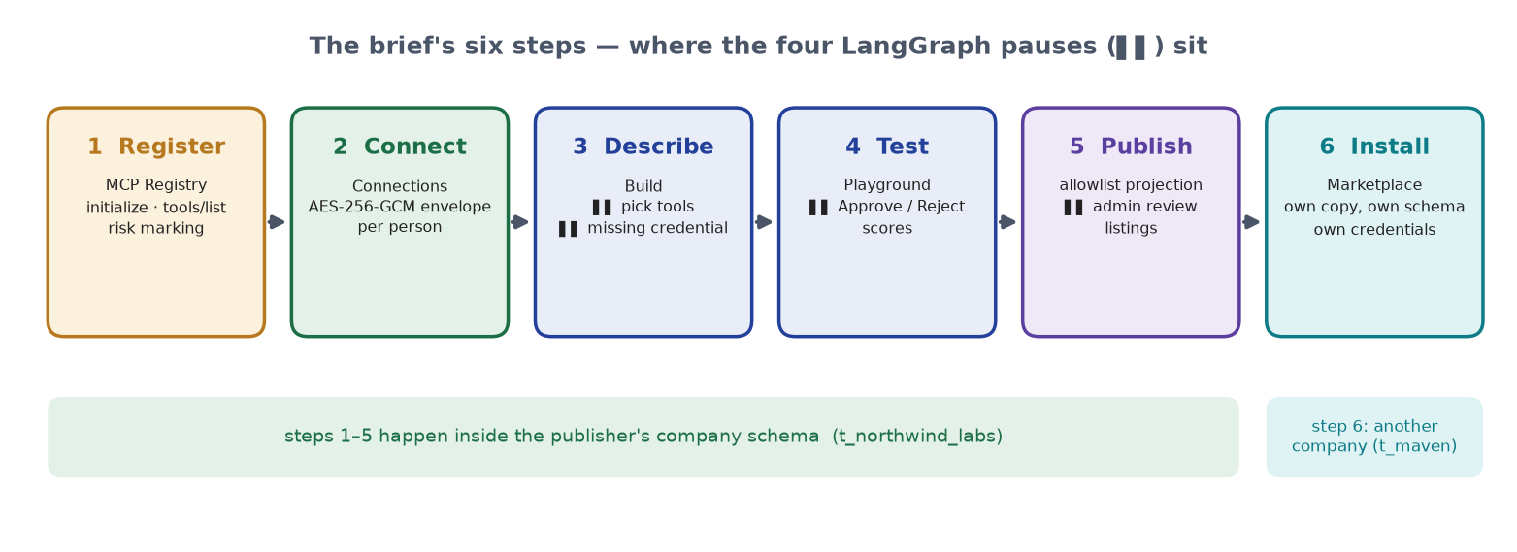
Figure 1 — The brief's six steps and where the four LangGraph pauses sit.
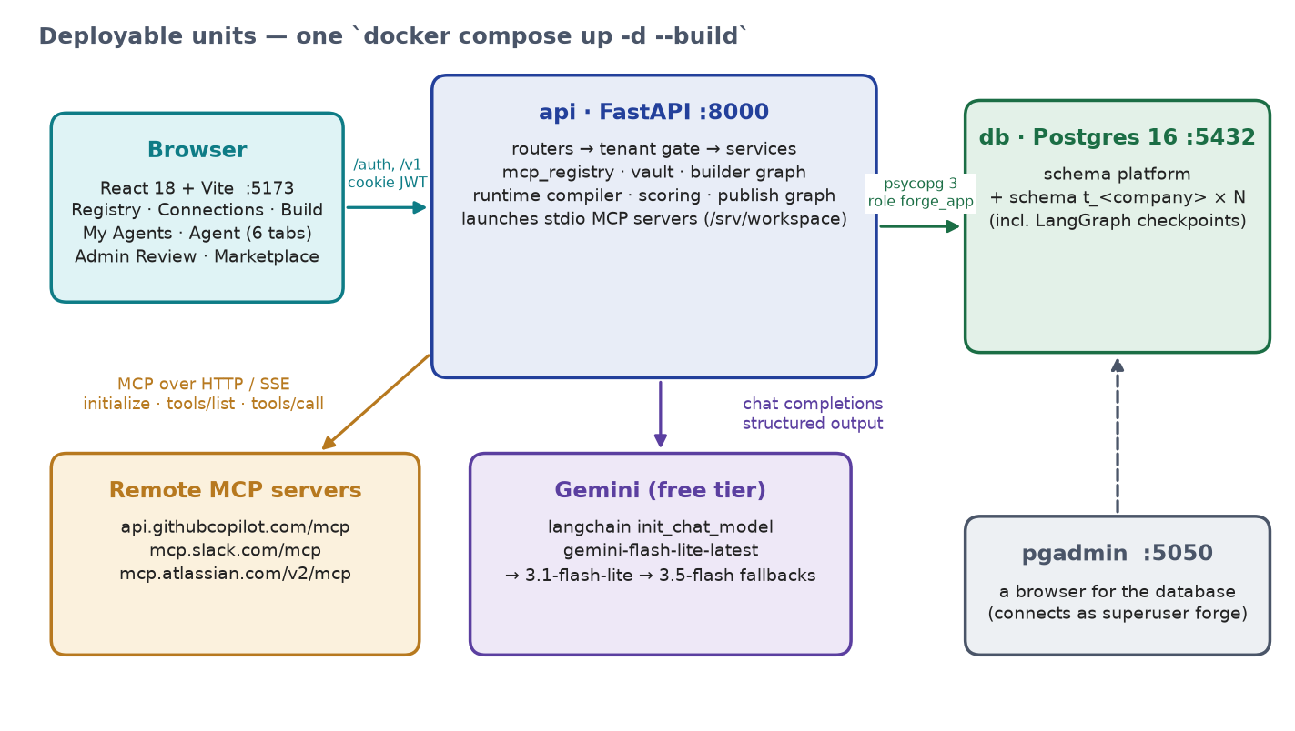
Figure 2 — Deployable units: browser, api, db, pgadmin, and the external MCP servers and model.
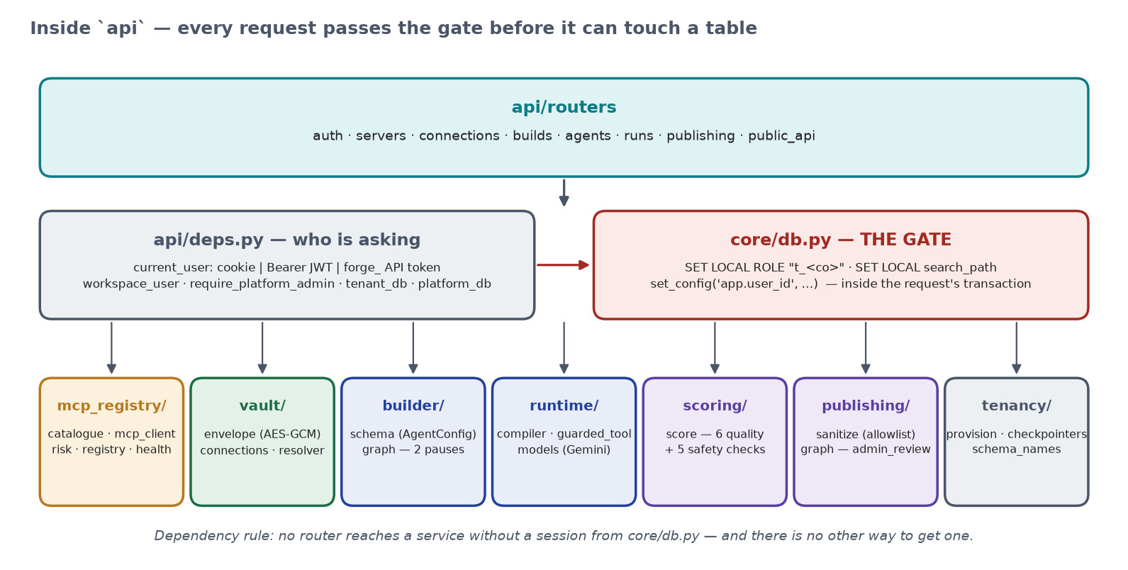
Figure 3 — Inside the api container: routers → identity → the gate → services.

1.1 The Six-Step Flow, at a Glance
Step | What happens | Where it is implemented
1. Register a server | Connect to a real MCP server, call tools/list, store exactly what it said, mark each tool read / write / destructive | api/routers/servers.py · mcp_registry/registry.py · mcp_client.py · risk.py
2. Connect once | Encrypt one person's credential for one server; the plaintext is never stored or returned | vault/envelope.py · vault/connections.py · api/routers/connections.py
3. Describe an agent | A model designs from THIS person's registry; two LangGraph pauses (pick tools, missing credential); the document is written | builder/graph.py · builder/schema.py · api/routers/builds.py
4. Test it | Compile the document, run it live over SSE; a write tool pauses for Approve / Reject; thumbs feed the score | runtime/compiler.py · runtime/guarded_tool.py · api/routers/runs.py · public_api.py · scoring/score.py
5. Publish it | Score gate, allowlist projection, a second graph parked on admin_review in the author's schema | publishing/sanitize.py · publishing/graph.py · api/routers/publishing.py
6. Someone else installs it | The sanitized design becomes a new agent in the installer's schema; they connect their own credentials | api/routers/publishing.py (listings, install)

2. Multi-Tenancy — How Isolation Actually Works
The brief's own test: “we delete your application-level check and try again.” So there is no application-level check. Isolation is set on the database connection by one function, core/db.py::_point_at, and consists of two locks:
SET LOCAL ROLE "t_northwind_labs"; -- lock 1: the company
SET LOCAL search_path TO "t_northwind_labs", platform;
SELECT set_config('app.user_id', '<uuid of the person>', true); -- lock 2: the person
Approach | How it works | Isolation strength
Shared table + tenant_id column | Every query must remember WHERE tenant_id = … | Weak — one forgotten filter is a data breach
Schema-per-company + a Postgres role per company (this project, lock 1) | Each company gets its own schema; the request runs as a role that can USE only that schema | Strong — an unqualified table name can only resolve inside the company; naming another company's schema is permission denied
Row-level security per person (this project, lock 2) | FORCE ROW LEVEL SECURITY with policy owner_id = current_setting('app.user_id') | Strong — two colleagues share a schema and see only their own rows; a session that names nobody sees zero rows

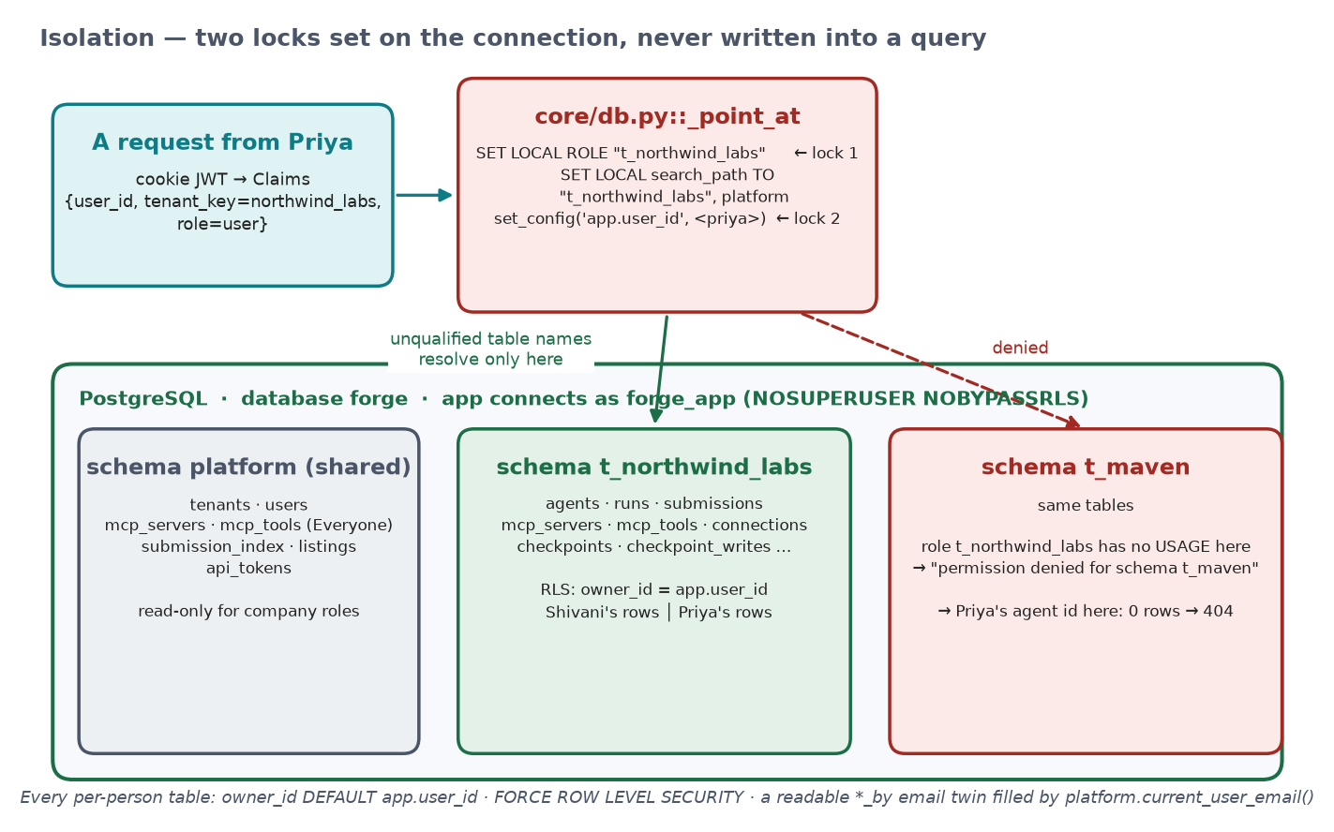
Figure 4 — One request, two locks: the company role + search_path, and the person's app.user_id for row-level security.

2.1 Person-level isolation, made structural
- Tables under RLS: agents, runs, submissions, connections, mcp_servers (policy adds OR visibility = 'company'), and mcp_tools through its server.
- owner_id DEFAULTs to the session variable, so no handler passes an owner and WITH CHECK refuses a row claiming someone else's id.
- A readable twin next to every owner_id — created_by, run_by, submitted_by, registered_by, added_by — is filled by Postgres from platform.current_user_email(), so a row in pgAdmin says who without a join.
- LangGraph checkpoint tables have no owner column, so the owner is put into the key: <user_id>/build-…, <user_id>/run-…, <user_id>/pub-<submission>. A colleague pasting your thread id addresses a thread that does not exist.

Proven live, at the SQL level
Connected with psql as the application's own role forge_app (not a superuser), SET ROLE to the company, and ran a query with no WHERE clause at all:
app.user_id | SELECT count(*) FROM agents
not set | 0 rows — RLS fails closed
Shivani's id | exactly Shivani's agents
Priya's id | exactly Priya's agents
SELECT count(*) FROM t_maven.agents | ERROR: permission denied for schema t_maven

A real bug this uncovered
The database user the official postgres image creates (forge) is a SUPERUSER, and superusers bypass row-level security unconditionally — even with FORCE ROW LEVEL SECURITY. Every RLS test passed for the wrong reason. Fixed with a dedicated role forge_app (NOSUPERUSER NOBYPASSRLS CREATEROLE) created by docker/db/init.sql, with DATABASE_URL pointed at it. pgAdmin still connects as the superuser, which is why it sees everyone's rows and the app never can.

2.2 People, companies, roles
Role | How you get it | What it can do
platform_admin | Created at startup from config (PLATFORM_ADMIN_EMAIL / PASSWORD; default admin@forge.dev). Exactly one. Sign-up can never create it. | Share servers with Everyone; review marketplace submissions. No company, no workspace — Build / My Agents / Connections answer 404.
admin | Sign up → Create a new company. The first person IS the admin. | Everything a user can, plus share a server with the whole company (and take it back).
user | Sign up → Join an existing company (the name must match; otherwise 404 no_such_company). | Register servers for themselves, connect, build, test, publish, install.

“Company”, “workspace” and “tenant” are one thing: a schema. Known gap, deliberate for the capstone: joining needs only the company name; the production answer is an admin invite link. Nothing in the isolation above depends on it.

3. MCP Registry and Connections
MCP (Model Context Protocol) is the standard way for the platform to ask a tool server “what can you do?” and receive a structured answer. Nobody ever types a tool name: registry.register() opens a real session (mcp_registry/mcp_client.py — stdio subprocess, streamable HTTP, or SSE), sends initialize, calls tools/list, and stores exactly the names, descriptions and input schemas that came back. A server that does not answer is not saved. A background sweep re-checks every server every 300 seconds and flips health to down.
Layer of the registry | Who put it there | Where it lives | Who sees it
Everyone | platform admin | platform.mcp_servers | every person in every company
Whole company | the company admin (“share with company” on a card they registered) | t_<co>.mcp_servers, visibility = company | everyone in that company
Just me | anyone | t_<co>.mcp_servers, visibility = private, owner_id = me | only me

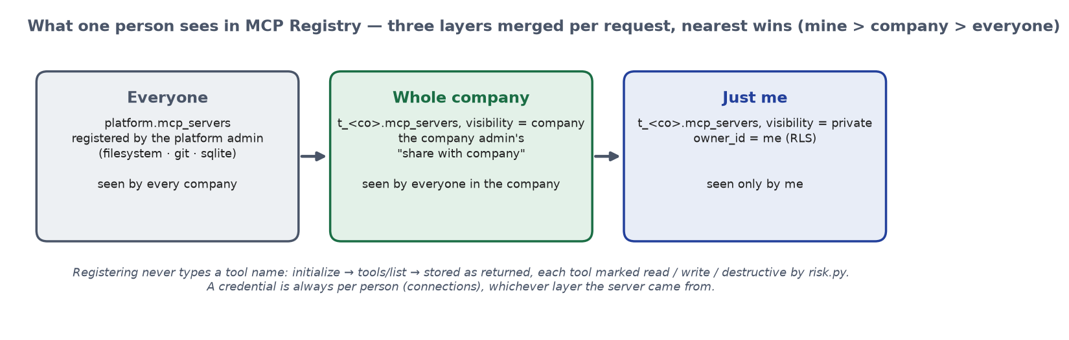
Figure 5 — The three registry layers a person sees, merged per request.

3.1 Risk Classification
Every discovered tool is classified by mcp_registry/risk.py from its own name and description — deterministic, never a model, never trusted from a human: a destructive verb anywhere → destructive; a read verb as the first word → read (list_commits lists, it does not commit); a write verb anywhere → write; otherwise read. That marking is what forces approval = ask on the tool at build time (Rule 4).

3.2 Connections Are Per-Person
Rule 2 is worded per person — “my connections … mine” — so two colleagues each bring their own token for the same server. vault/envelope.py seals each with AES-256-GCM under a fresh per-row data key, wraps that key under FORGE_MASTER_KEY, and binds the ciphertext to company:user:server as AAD, so a row copied to another schema or another person will not decrypt. The plaintext exists in one function, vault/connections.py::use(), and is deleted after the tool call. ConnectionOut.secret is a constant string of dots — the API has nowhere to put a value.

3.3 Real Worked Example
The vendors' own servers, registered through the form and discovered live (counts are what tools/list returned):
Server | Endpoint | Transport / auth | Tools | read / write / destructive
github | https://api.githubcopilot.com/mcp/ | http · api_key (PAT) | 45 | 28 / 16 / 1
slack | https://mcp.slack.com/mcp | http · oauth (xoxp- user token) | 14 | 8 / 6 / 0
filesystem | npx -y @modelcontextprotocol/server-filesystem /srv/workspace | stdio · none | 14 | 10 / 4 / 0
git | uvx mcp-server-git --repository /srv/workspace | stdio · none | 12 | 7 / 4 / 1 (git_reset)
sqlite | uvx --with mcp<2 mcp-server-sqlite --db-path /srv/var/forge.sqlite | stdio · none | 6 | 3 / 3 / 0

GitHub and Slack answer 401 to an anonymous tools/list, so the form asks for a credential, discovers with it, and — for a company user — saves it encrypted as their connection in the same click (401 auth_required without one; 401 credential_rejected with the server's own reason, e.g. Slack's invalid_token for a bot xoxb- token). An address that does not answer gets 422 unreachable and nothing is saved.

4. The Build Flow — Describing an Agent
builder/graph.py is a LangGraph StateGraph, checkpointed with a per-company AsyncPostgresSaver. The two pauses are LangGraph interrupt() calls — the brief's “centre of this project”.
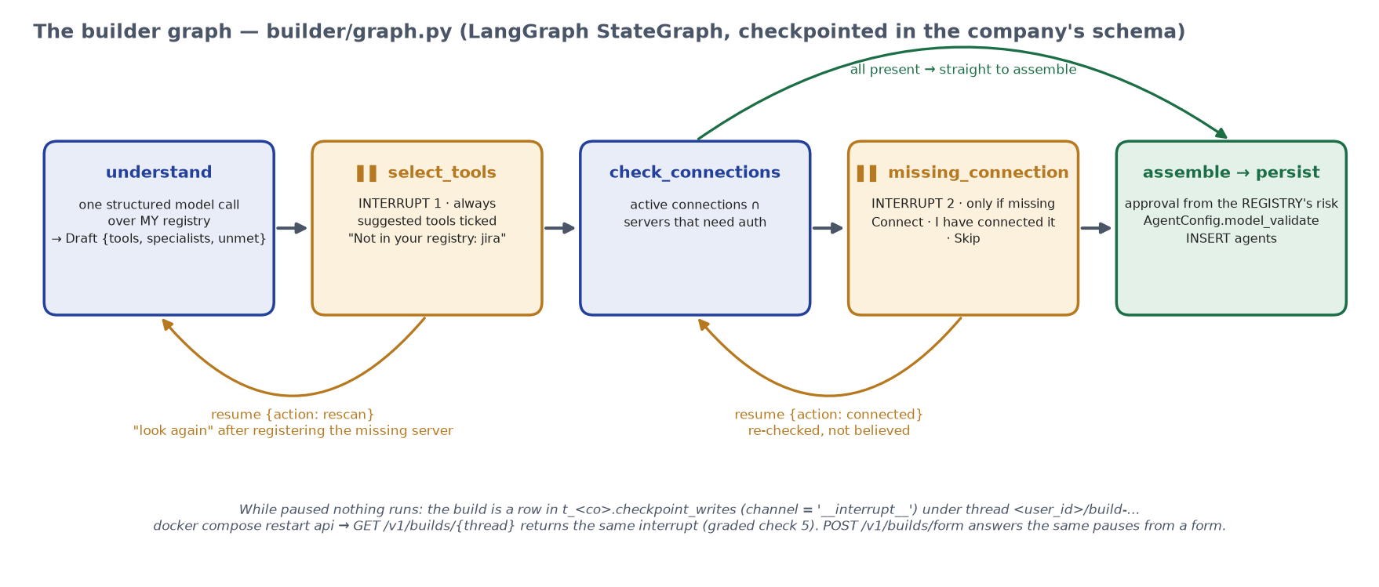
Figure 6 — The builder graph with its two interrupts and the "look again" loop.
understand → search_registry ⏸ select_tools → check_connections → ask_for_connection ⏸ missing_connection → assemble → persist
▲ │
└── "look again" ──┘ resume {"action": "rescan"} after registering a server the design needed
- understand — one structured model call. The catalogue it may choose from is THIS person's registry, loaded from the database first; any ref not in it is dropped. It returns name, description, the minimum tools, specialists, and unmet — parts of the request no registered server can do. A job that reads and then writes is always coordinator + collector + poster, so the worker holding the write tool holds nothing else.
- ⏸ select_tools — always. If something was unmet the card says so — “Not in your registry: jira → Register it → look again” — instead of quietly building a smaller agent.
- check_connections — active connections ∩ servers that need a credential. ⏸ missing_connection fires only when one is missing: Connect / I have connected it (re-checked, not believed) / Skip.
- assemble — risk and approval come from the registry rows, never from the model or the user; the document is validated by AgentConfig. persist — INSERT INTO agents; Postgres stamps owner_id and created_by.
While paused nothing runs: the build is a checkpoint_writes row with channel = '__interrupt__'. docker compose restart api, reload the URL, the same question is on screen (graded check 5). POST /v1/builds/form drives the same graph with the answers pre-seeded — the builder is not written twice.

4.1 Real Worked Example — the brief's sentence, as Priya
Priya is a plain user with a GitHub connection and no Slack connection; Slack is visible to her because her company admin shared it.
POST /v1/builds {"prompt": "I want an agent that reads my open GitHub issues every morning and posts a summary to Slack."}
→ 202 waiting · interrupt select_tools
log: Understood: GitHub Issue Summariser - coordinator + gatherer, poster. The job requires gathering issues
from GitHub and writing messages to Slack, so it uses GitHub list tools and Slack send tools split across specialists.
suggested: github.list_issues, slack.slack_send_message
specialists: gatherer [github.list_issues] · poster [slack.slack_send_message]
(docker compose restart api · GET /v1/builds/<thread> → the same interrupt)
POST /v1/builds/<thread>/resume {"selected": [...both...]}
→ 202 waiting · interrupt missing_connection · missing: [slack] · required: [github, slack]
t_northwind_labs.checkpoint_writes: thread 56274702-…/build-efa0d9ae24bf, channel __interrupt__

4.2 Real Worked Example — an honest refusal
prompt: "Every Monday, read my open GitHub issues and create a Jira ticket for each one labelled bug."
suggested: github.list_issues
unmet: [{"need": "jira", "why": "to create Jira tickets for each bug"}]
→ resume {"action": "rescan"} re-runs understand against the registry; Jira still absent → the same honest pause
The assembled document — note the write tool's approval is forced to ask, and the config names a server kind, never a credential:
{"ref": "github.list_issues", "risk": "read", "approval": "auto", "requires_connection": "github"}
{"ref": "slack.slack_send_message", "risk": "write", "approval": "ask", "requires_connection": "slack"}
"requires_connections": ["github", "slack"] · "topology": {"type": "supervisor", "specialists": [gatherer, poster]}

5. The Playground — Actually Running an Agent
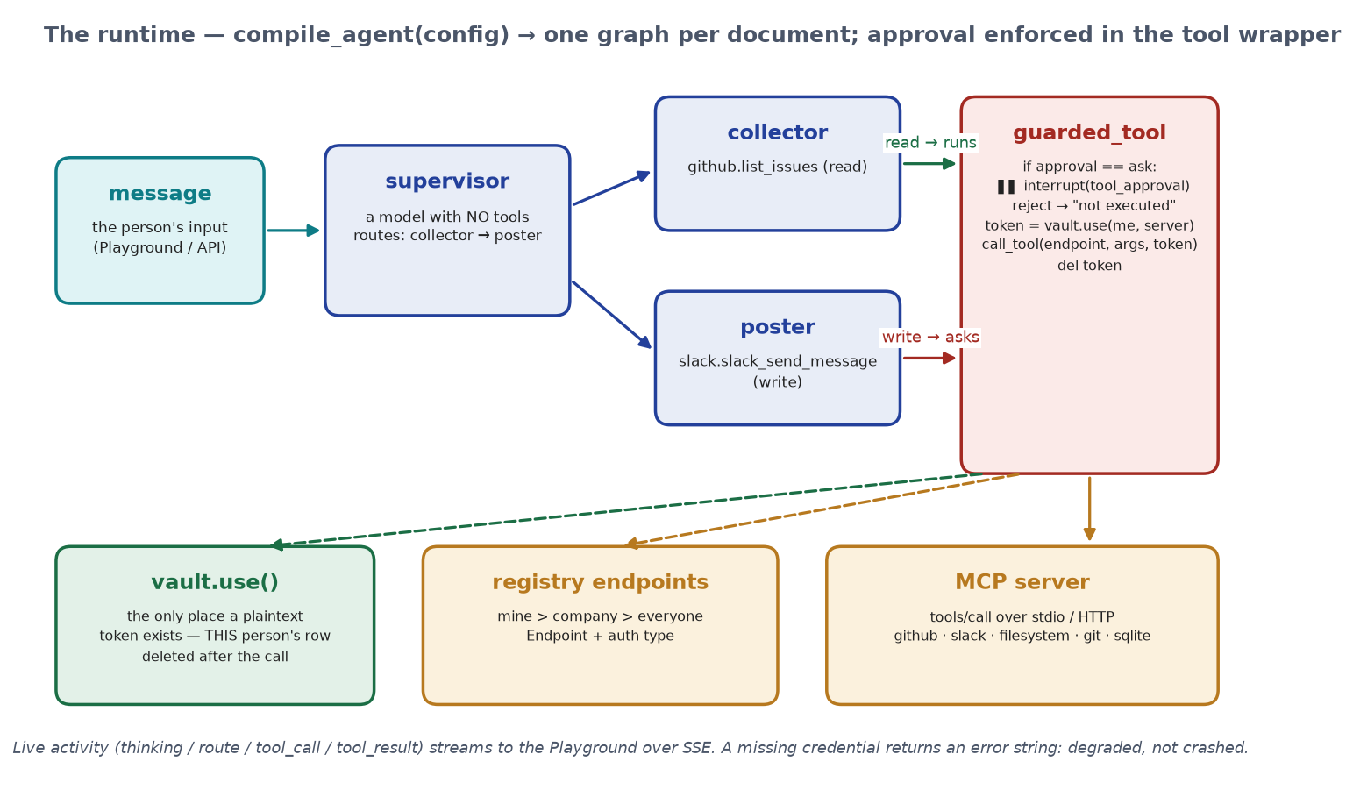
Figure 7 — The runtime: supervisor, specialists, and the guarded tool wrapper where approval is enforced.
compile_agent() is the only code that runs an agent — the Playground and the public API both call it. It builds a supervisor node (a model with no tools of its own, by design) and one node per specialist bound only to its own tools. Every tool is wrapped by runtime/guarded_tool.py:
if spec.approval is Approval.ASK: # set at build time from the registry's risk
decision = interrupt({"type": "tool_approval", "tool": spec.ref, "risk": ..., "args": redact(kwargs)})
if decision != "approve":
return f"Rejected by the user. {spec.ref} was not executed."
token = await ctx.resolve_token(spec.requires_connection) # vault.use(): THIS person's row
try: return await call_tool(ep, name, kwargs, token)
finally: del token
The model does not call tools; it calls this wrapper. A rejected call never reaches the server. A missing or expired credential returns an error string so the agent finishes the rest of its job and reports the broken tool — degraded, not crashed. Before a run the Playground asks GET /readiness and, if a connection is missing, asks for it instead of running degraded.

5.1 Real Worked Example — a run with a real approval pause
POST /v1/agents/<id>/stream {"input": "Summarise the open issues … and post it to Slack."}
activity: supervisor thinking · route → gatherer · gatherer calling github.list_issues (read)
[supervisor] -> gatherer
[gatherer] github.list_issues -> {"issues":[{"number":11220,"title":"Test Issue …
[supervisor] -> poster
poster calling slack.slack_send_message (write) — a human will be asked first
→ awaiting_approval · runs.pending = {tool: slack.slack_send_message, risk: write, args: {channel, text}}
(docker compose restart api · GET /v1/agents/<id>/runs/<run> → still awaiting_approval)
POST …/stream {"run_id": …, "decision": "approve"} → message posted · status ok
POST …/runs/<run>/feedback {"value": 1}
Latency (runs.latency_ms) sums the agent's own working segments before and after the pause; the minutes a human spends deciding do not count against it.

5.2 Rule 7 — Every Agent Gets an Endpoint
POST /v1/agents/<id>/invoke · /stream (SSE) · /runs/<run>/resume · GET /readiness · /runs · /postman
Authorization: Bearer forge_… (platform.api_tokens: sha256 hash + prefix; plaintext shown once)
Download Postman collection mints a token and embeds it in a v2.1 collection with base_url, agent_id and run_id variables. Verified live: import → Invoke → Send → 202 with a real answer; the same token asking for another company's agent → 404; a bad token → 401.

6. Scoring — Two Numbers, Both Explainable
scoring/score.py computes both from rows only — never a model. Every check is stored on the agent (agents.checks) with its reason, and the Overview shows all of them.
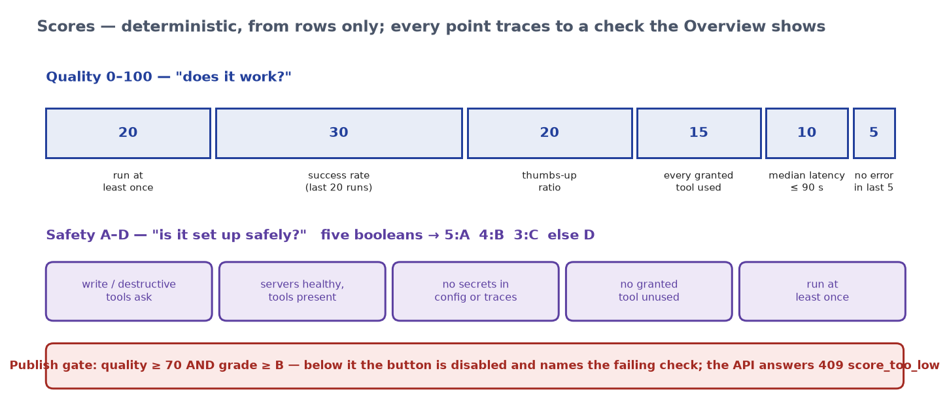
Figure 8 — Quality points, safety booleans, and the publish gate.
quality (0–100) = 20·run at least once + 30·success rate (last 20) + 20·thumbs-up ratio
+ 15·every granted tool used + 10·median latency ≤ 90 s + 5·no error in last 5
safety (A–D) = 5 booleans → 5:A 4:B 3:C else D
approvals · servers healthy & tool present · no secrets in config/traces · no unused tool · tested
publish gate = quality ≥ 70 AND grade ≥ B → otherwise 409 score_too_low naming the check

6.1 Real Worked Examples
Agent | Runs | Quality | Why | Safety | Publishable
GitHub Issue Summarizer (Priya) | 3 ok, none rated | 80 | Thumbs-up ratio 0 / 20 — no run rated yet | A (5/5) | yes (≥ 70, A)
GitHub Issue Summariser (walk-through) | 1 rejected | 63 | Success rate 0 / 30 — a rejected write is not a success | B | no — quality 63 is below 70
GitHub Issue Daily Summary (Shivani, the demo agent) | several, rated | 85–90 | all checks earning points | A | yes — published and installed

An agent with an unguarded write tool fails safety check 1 and the AgentConfig validator before that — it cannot be published (graded check 3).

7. Publish, Admin Review, and the Marketplace
Publish starts a second LangGraph — sanitize → ⏸ admin_review → decide — checkpointed in the author's company schema. The admin queue IS that graph, parked. It may wait days across restarts (graded check 6).
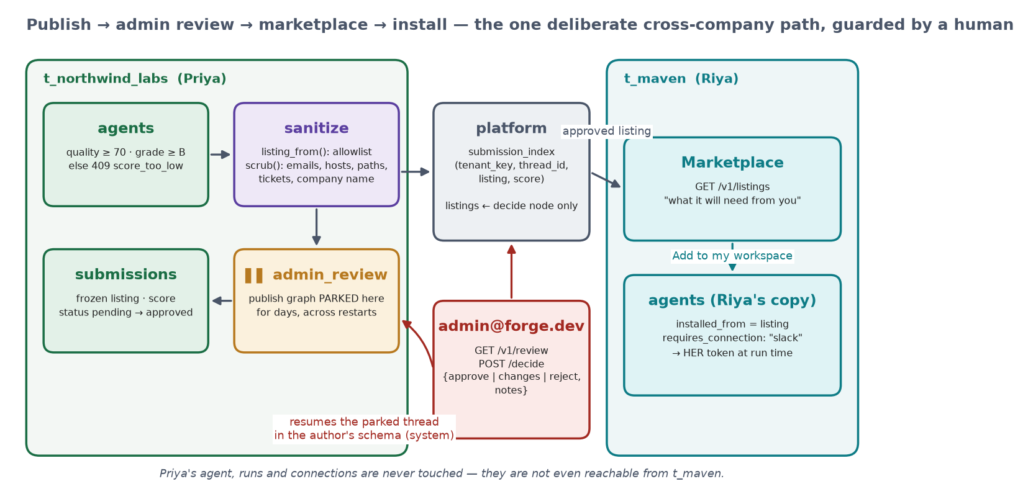
Figure 9 — Publish → admin review → marketplace → install, across two company schemas and the shared platform schema.

7.1 Rule 5 — the Allow-List Projection
publishing/sanitize.py::listing_from copies only named fields — name, description, model, topology (instructions included), tool refs with risk / approval / connection, policy, required server names, schedule — and runs scrub() over every free-text field: emails, URLs, *.internal/.local/.corp hosts, IPv4 addresses, filesystem paths, ABC-1234 ticket references, secret-shaped strings, and the company's own name. A field that is not named never exists on the other side. The author sees exactly this projection before confirming.

7.2 The one deliberate cross-company path
The platform admin has no company, yet must resume a graph parked in the author's schema. platform.submission_index records tenant_key, thread_id, listing and score at submit time; the admin's decision resumes that thread through checkpointer_for(tenant_key), and the decide node applies it in the author's schema under the system context (app.role = 'system') — the same setting the health sweep uses, never available to a request handler. Listing( is constructed in exactly one place, that node; a test asserts it.

7.3 Real Worked Example — the full loop
Northwind Labs / Shivani: GitHub Issue Daily Summary — coordinator + collector (github.list_issues) + poster (slack.slack_send_message)
built through Build · run against real GitHub issues · rated · scored 85–90 / A
POST /publish → t_northwind_labs.submissions (pending, frozen listing) · platform.submission_index · agents.status = pending_review
docker compose restart api
admin@forge.dev: GET /v1/review → the item, its tools and every check · POST /decide {approve, notes}
→ submissions.status = approved + notes · platform.listings +1 · agents.status = live
Maven / Jai: Marketplace → the card 'by Northwind Labs' → Add to my workspace
→ t_maven.agents new row (installed_from = listing, owner Jai) · listings.installs = 1 · t_maven.connections still empty
readiness: github needs_credential, slack needs_credential — his own tokens, never Shivani's

8. Database Reference — Every Table, and What Touches It
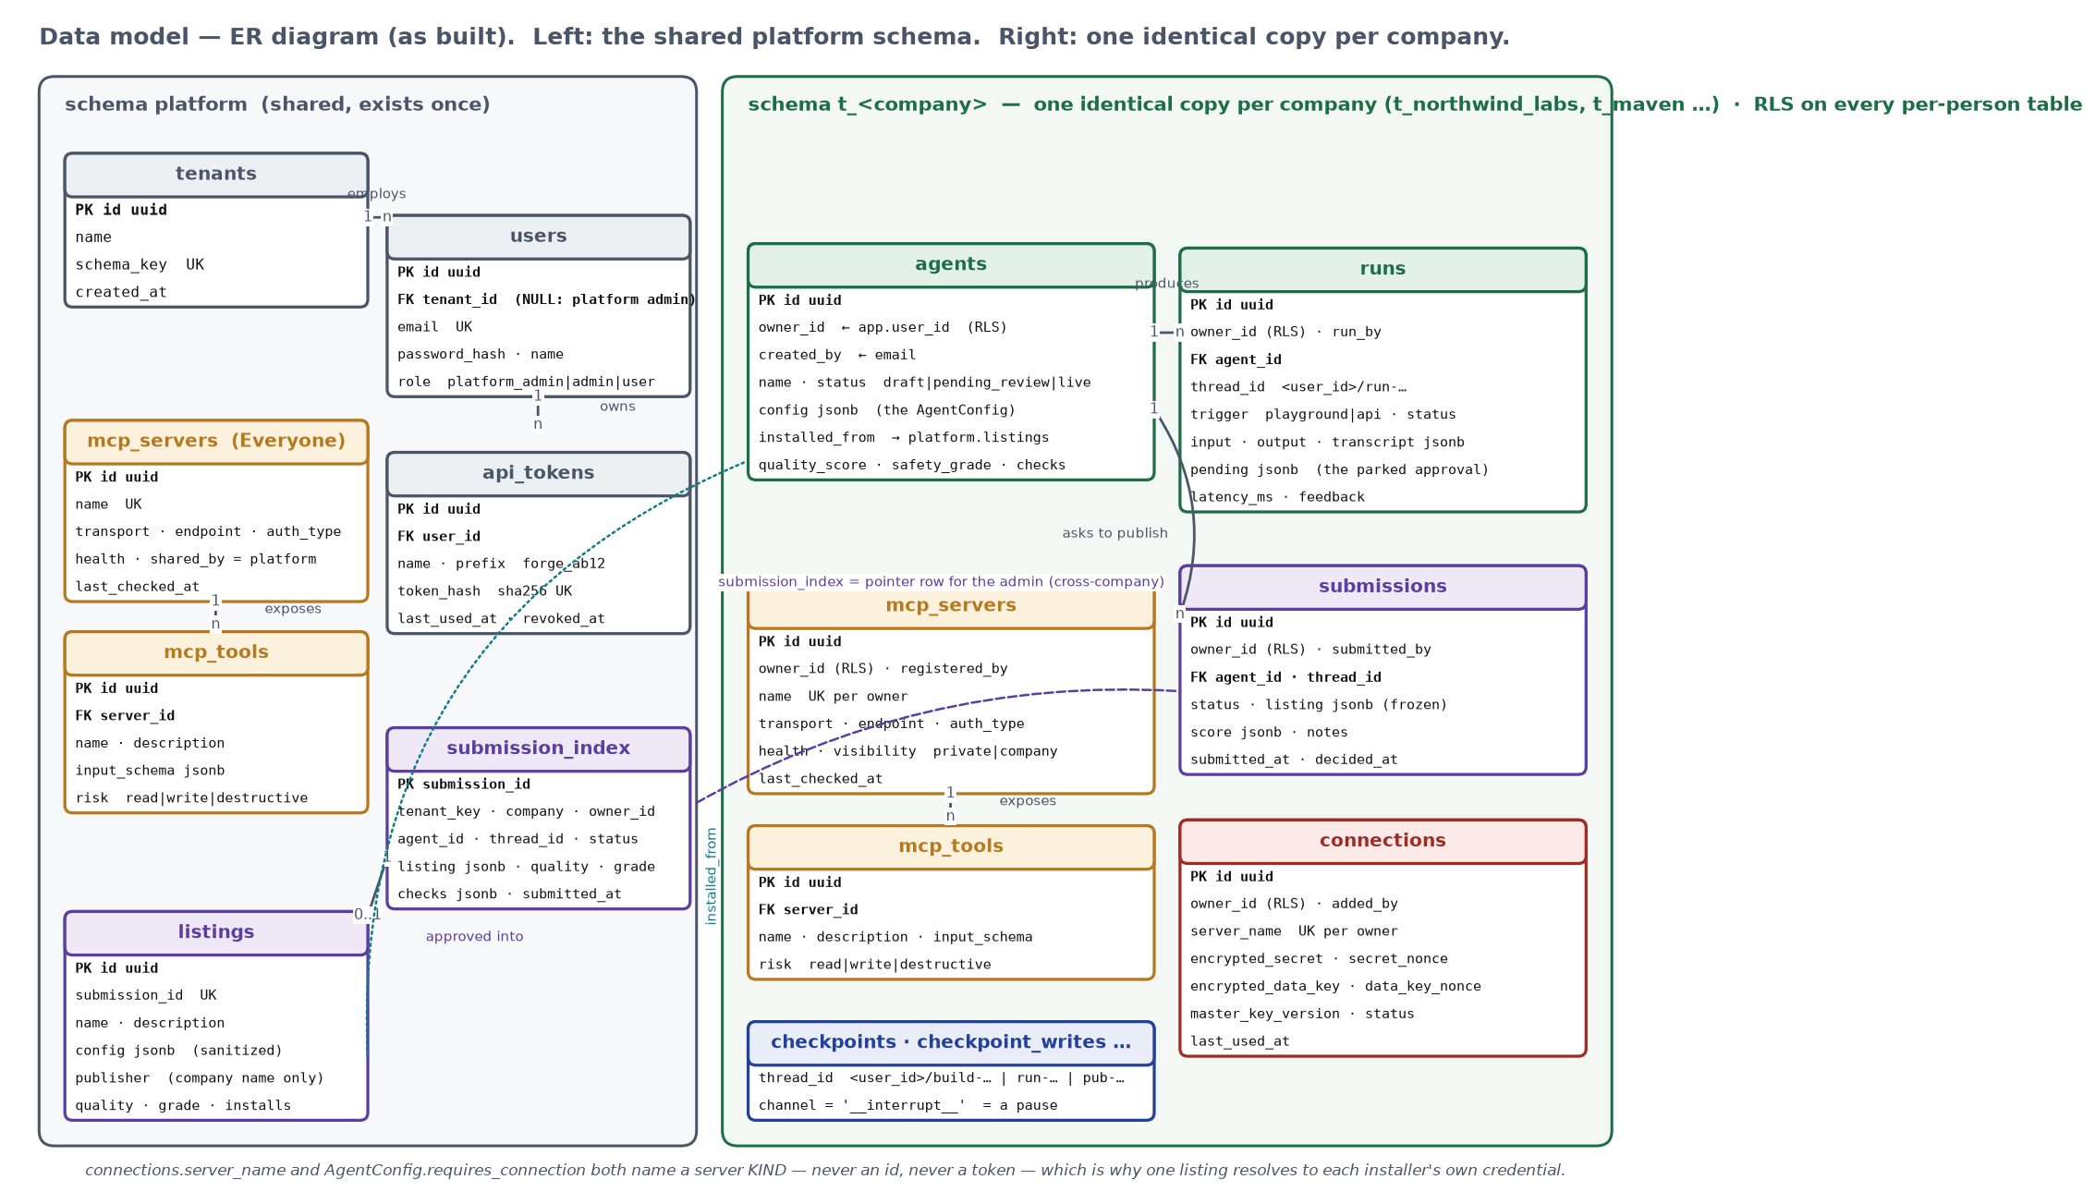
Figure 10 — Entity–relationship diagram of the data model as built: the shared platform schema and one company schema.

8.1 platform schema (shared, exists once)
Table | Key columns | Written by
tenants | id, name, schema_key (unique) | sign-up with intent = create
users | id, tenant_id (NULL for the platform admin), email (unique), password_hash, name, role | sign-up; ensure_platform_admin() at startup
mcp_servers / mcp_tools | name (unique), transport, endpoint, auth_type, health, shared_by, last_checked_at / name, description, input_schema, risk | platform admin registering with visibility = everyone; the health sweep
submission_index | submission_id, tenant_key, company, owner_id, agent_id, thread_id, status, listing, quality, grade, checks | POST /publish; the admin's decision
listings | id, submission_id (unique), name, description, config (sanitized), publisher (company name only), quality, grade, installs | the publish graph's decide node on approve; install increments installs
api_tokens | id, user_id, name, token_hash (sha256, unique), prefix, last_used_at, revoked_at | POST /v1/tokens; GET /postman

8.2 Company schema t_<schema_key> (one identical copy per company)
Table | Key columns | Written by
agents | id, owner_id, created_by, name, config (the AgentConfig), status (draft | pending_review | live), installed_from, quality_score, safety_grade, checks | build persist(); install; scoring; publish; the admin's decision
runs | id, owner_id, run_by, agent_id, thread_id, trigger (playground | api), status (running | awaiting_approval | ok | rejected | error), input, output, transcript, pending, latency_ms, feedback | every invoke / stream; resume; feedback
submissions | id, owner_id, submitted_by, agent_id, thread_id, status (pending | approved | changes_requested | rejected), listing (frozen), score, notes, decided_at | POST /publish; the decide node
mcp_servers / mcp_tools | owner_id, registered_by, name (unique per owner), transport, endpoint, auth_type, credential_env_var, health, visibility (private | company) / name, description, input_schema, risk | POST /v1/servers; PATCH visibility; refresh; the sweep
connections | owner_id, added_by, server_name (unique per owner), encrypted_secret, secret_nonce, encrypted_data_key, data_key_nonce, master_key_version, status, last_used_at | POST /v1/connections; registration with a token; revoke wipes the ciphertext
checkpoints, checkpoint_blobs, checkpoint_writes, checkpoint_migrations | thread_id = <user_id>/…; a pause is a checkpoint_writes row with channel = '__interrupt__' | LangGraph's AsyncPostgresSaver for this company

8.3 What Happens in the Database, Action by Action
Action in the UI | Tables touched
Sign up — Create a new company | platform.tenants, platform.users (role admin), CREATE SCHEMA t_<key>, its tables, RLS policies, CREATE ROLE t_<key>
Sign up — Join an existing company | platform.users (role user) only; 404 no_such_company if the name does not exist
Register a server | mcp_servers + mcp_tools × N, only after a real tools/list; a credential given here → connections
Share with company / make private / remove | mcp_servers.visibility; DELETE cascades mcp_tools
Add a connection | connections (four bytea columns; no readable value anywhere)
Build — pause 1 / pause 2 | checkpoints* under <user_id>/build-…; a checkpoint_writes row with channel __interrupt__
Build — done | agents (status draft, config, owner_id / created_by by default)
Playground run | runs (transcript, latency_ms); pending + status awaiting_approval while parked; checkpoints* under <user_id>/run-…
Approve / Reject · thumbs | runs.status ok / rejected, pending NULL, output; runs.feedback ±1; agents.quality_score / safety_grade / checks
Download Postman / mint token | platform.api_tokens (hash + prefix); runs.trigger = api when it is used
Publish | submissions (pending, frozen listing, score); platform.submission_index; agents.status = pending_review; checkpoints* under <user_id>/pub-…
Admin approve / changes / reject | submissions.status + notes; submission_index.status; on approve platform.listings (the only writer) and agents.status = live
Install from the Marketplace | installer's agents row (installed_from); platform.listings.installs + 1; the publisher's schema untouched

9. The Brief's Rules — Compliance Summary
# | Rule | How it is enforced | Proof
1 | An agent is configuration, not code | AgentConfig (Pydantic) + compile_agent() reads it; no Python is generated | one runtime, any document, any company
2 | One person cannot see another's things | schema + role per company; RLS per person; thread ids carry the owner | psql with no WHERE clause (§2.1); tests/graded/test_check_01_isolation.py
3 | Credentials go in once and vanish | AES-256-GCM envelope, AAD company:user:server; the API has no secret field | no readable value in any table; test_check_02_credentials.py
4 | Risky actions ask a human first | guarded_tool() calls interrupt() before the real tool ever runs; approval derived from the registry's risk | a live approval pause that survives a restart; test_check_07_runtime.py
5 | Publishing strips the company out | listing_from(): allowlist projection + scrub() | planted material never survives; test_check_04_sanitize.py
6 | Scores must mean something | deterministic checks; can_publish blocks with named reasons | 80 vs 63 above; 409 score_too_low
7 | Every agent gets an endpoint | the same handlers accept a cookie or a forge_ token; Postman collection with the token pre-filled | Send → 202; another company → 404; test_check_08_postman.py
8 | The demo agent is built through the platform | GitHub Issue Daily Summary built in Build, run, rated, published, approved, installed by another company | §7.3

10. What Was Actually Verified Live (Not Just Unit-Tested)
The automated suite — uv run pytest backend/tests — passes 172 tests (1 skipped: the opt-in live-model test) against a real Postgres with two throwaway companies and three people. Nearly every real bug below was found only by running the real thing end to end.
Area | Real bug found | Fix
Postgres role | The app's database user was a superuser, silently bypassing RLS; every isolation test passed for the wrong reason | forge_app role, NOSUPERUSER NOBYPASSRLS, created by docker/db/init.sql; FORCE ROW LEVEL SECURITY
Registry layering | A person's own registration was overridden by the company-shared one of the same name | nearest-wins ordering fixed in registry.list_servers (mine > company > everyone)
Builder honesty | A user who could not see a Slack server got a silently smaller single-tool agent | unmet in the design; “Not in your registry … look again” at pause 1; read-then-write always splits
Latency | A run's latency included the 20 minutes a human took to approve (1231 s) | latency_ms sums the agent's own segments only
Slack | A bot token (xoxb-) is rejected by Slack's remote MCP server with invalid_token; posting needs a channel ID the app is a member of | the form shows the server's reason; the agent degrades instead of crashing
Health sweep vs tests | The host-side test sweep marked real shared servers down (it cannot launch /srv/workspace servers) | check_shared / check_tenant split; tests sweep only their own company
Provisioning | create_all missed the runs table because the tenant models were not imported | explicit model import in tenancy/provision.py
Stale sessions | After a database reset old cookies produced a 500 (“role does not exist”) | 401 session_stale from the gate and /auth/me
Windows bind mounts | Single-file mounts went stale (ENOENT /srv/index.html) | mount the whole Frontend/ directory
Playground UX | Nothing on screen until the run finished | SSE streaming of thinking / route / tool_call / tool_result as they happen

11. Known Gaps (as of 18 September)
Gap | Today | Production answer
Migrations | metadata.create_all per schema; docker compose down -v to change a model | Alembic with two trees (platform, tenant template)
Joining a company | anyone who knows the name may join as a user | admin invite links
After “request changes” | the agent stays pending_review (the submission carries the notes; the author may publish again) | return it to draft on any non-approve decision — one line in publishing/graph.py
Model quality | a small free model occasionally over-selects a tool; pause 1 is where the person corrects it | a larger model behind the same ModelSpec

