**Project Report**

**On**

**AIR QUALITY**

Submitted in partial fulfillment of completion of the course

Advanced Diploma in IT, Networking and Cloud

**Submitted by:**

SHIVANI

&

KHUSBHOO

|  |  |  |
| --- | --- | --- |
| IBM-Logo - Chicago Innovation | DGT introduces high end diploma courses - digitalLEARNING Magazine | Edunet Foundation-Delhi- CSR Organization profile |

Year 2023

**ABSTRACT**

Our project, titled 'Air Quality Perspectives,' strives to redefine the analysis of air pollution through comprehensive data visualization techniques. Leveraging data analytics, our objective is to revolutionize the understanding and prediction of air quality issues, thereby enhancing preparedness and response strategies on a global scale. The primary aim of 'Air Quality Perspectives' is to develop a user-friendly platform that visually represents air pollution data, allowing researchers, policymakers, and the public to effectively comprehend intricate patterns and trends. This platform serves as a valuable tool for exploring and interpreting air quality dynamics, facilitating the identification of pollution hotspots and the formulation of proactive measures. In our interconnected world, well-informed decision-making concerning air quality is paramount for mitigating health risks and minimizing environmental impact. 'Air Quality Perspectives' employs advanced data visualization tools to present a comprehensive view of air pollution data, empowering stakeholders to make informed decisions and take proactive steps toward improving air quality and public health.

Top of Form

**ACKNOWLEDGEMENT**

We take this occasion to thank God, almighty for blessing us with his grace and taking our endeavor to a successful culmination. We extend our sincere and heartfelt thanks to our esteemed guide from Ms. Deepika Singh and Ms. Mala Mishra, for providing us with the right guidance and advice at the crucial junctures and for showing me the right way. We also take this opportunity to express a deep sense of gratitude to Ms. Ankita Shukla for their cordial support, course coordinator Mr. D.A.Guruvulu, valuable suggestions and guidance. We extend our sincere thanks to our respected Head of the division Mrs. Shashi Mathur [JD NSTI(W) NOIDA], for allowing us to use the facilities available. We would like to thank the other faculty members also, at this occasion. Last but not the least, we would like to thank our friends and family for the support and encouragement they have given us during the course of our work.

**ADIT TRADE IN NSTI (W) NOIDA**

The Advanced Diploma in IT and Cloud Computing program offered by NSTI (W) Noida in collaboration with Edunet Foundation is a comprehensive course designed to equip students with advanced skills in information technology and cloud computing. This program covers a wide range of topics, including computer networking, database management, virtualization, cloud technologies, and cybersecurity. Students will gain hands-on experience through practical labs, workshops, and real-world projects, enabling them to excel in the rapidly evolving IT industry. Upon completion of the program, graduates will have a strong foundation in both IT fundamentals and cloud computing, making them highly sought-after professionals in the field

**PROJECT REQUIREMENTS**

|  |  |
| --- | --- |
| PROJECT NAME | 'Air Quality |
| LANGUAGE USED | PYTHON,PANDAS,NUMPY,MATPLOTLIB,SEABORN |
| EDITOR | ANACONDA JUPYTER |
| WEB BROWSER | MOZILLA, GOOGLE CHROME |

**TABLES OF CONTENT**

|  |  |  |
| --- | --- | --- |
| **S.No** | **TOPIC** | **PAGE No.** |
| 1. | PROBLEM STATEMENT | 4 |
| 2. | PROCESS MODEL | 5 |
| 3. | REQUIREMENTS | 9 |
| 4. | DESIGN DOCUMENTATION | 10 |
| 5. | DEPLOYMENT | 12 |
| 6. | FUTURE SCOPE | 16 |
| 7. | CONCLUSION | 17 |
| 8. | SOURCE CODE | 28 |
| 9. | REFERENCE | 44 |
|  |  |  |
|  |  |  |

**1. PROBLEM STATEMENT**

• Limited Access to Air Quality Data Insights: Researchers and policymakers face challenges in accessing comprehensive air quality data for in-depth analysis and prediction, hindering the ability to make accurate predictions and informed decisions regarding air pollution occurrences.

• Accuracy and Reliability of Air Pollution Predictions: Ensuring the accuracy and reliability of air pollution predictions is a significant concern within the scientific community. There is a pressing need for advanced methodologies that enhance the precision and reliability of air quality forecasting to effectively mitigate potential health and environmental risks.

• Integration of Diverse Air Quality Data Sources: The integration and utilization of diverse air quality data sources pose a challenge in creating a unified platform for comprehensive analysis. The disparate nature of these data sources hampers seamless analysis and prediction efforts, impacting the development of effective pollution control strategies.

• Real-time Visualization for Decision-making: The absence of real-time visualization tools that can effectively represent air quality data impedes swift decision-making during critical pollution events. Rapid and intuitive data visualization tools are crucial for timely responses and the formulation of effective strategies to combat air pollution.

**2. PROCESS MODEL**

Our air pollution data analysis platform, committed to predicting and visualizing air quality, employs an ITERATIVE MODEL for streamlined development and deployment. While the foundational framework for data acquisition and analysis is established, the ongoing refinement of our platform is iterative, integrating new insights and methodologies into successive phases.

With a project timeline limited to 3 months and 3 weeks and the constraint of a small team consisting of only 2 members, the iterative model provides the flexibility and adaptability necessary to deliver a robust data visualizationplatform for airquality prediction within the specified timeframe. This iterative approach allows us to continuously enhance and optimize the platform's capabilities as we progress towards our goal of providing accurate and timely insights into air pollution dynamics**.**

INTRODUCTION

1.1 PURPOSE

The primary objective of our platform is to leverage advanced data visualization techniques to enhance the accuracy of air pollution prediction. By presenting comprehensive insights into air quality data, our goal is to contribute to proactive decision-making in regions affected by air pollution, providing valuable support to researchers and authorities responsible for environmental management.

1.2 SCOPE

The scope of our platform is dedicated to addressing critical challenges in air pollution prediction:

* Facilitating the development of accurate prediction models through insightful data visualization techniques.
* Providing accessible air quality data insights for areas with limited data accessibility.
* Contributing to proactive environmental management and pollution control strategies in regions prone to air quality issues.

This project aims to harness data visualization methodologies to empower stakeholders with actionable insights, facilitating informed decisions and effective measures in response to air pollution events.

Top of Form

**1.3 DEFINITIONS, ACRONYMS, and ABBREVIATIONS**

**Definitions**

Air Pollution: The presence in or introduction into the air of substances that are harmful to the health of humans and other living beings or cause damage to the environment.

Data Visualization: The representation of data in a visual format, such as charts, graphs, and maps, to facilitate understanding and analysis.

Data Analytics: The process of examining, cleaning, transforming, and modeling data to extract useful information, draw conclusions, and support decision-making.

Prediction Models: Mathematical algorithms and statistical techniques used to forecast future trends or outcomes based on historical and current data.

Environmental Management: The planning, implementation, and monitoring of policies and activities to protect and enhance the environment, including the control of air pollution.

Accessibility: The degree to which air quality data and insights are easily obtainable and comprehensible, particularly in areas where data accessibility is limited.

Pollution Control Strategies: Plans and actions aimed at preventing, reducing, or mitigating the impact of air pollution on the environment and public health.

**Acronyms**

* **APD: Air Pollution Data**
* **APPM: Air Pollution Prediction Models**
* **ARMM: Air Quality Risk Mitigation**
* **ADV: Air Quality Data Visualization**
* **EP: Environmental Preparedness**

**Abbreviations**

sec: seconds

km: kilometers

mph: miles per hour

GMT: Greenwich Mean Time

RSO: Regional Seismic Observatory

USGS: United States Geological Survey

RMS: Root Mean Square (a measure of seismic wave amplitude)

GIS: Geographic Information System

**1.4 OVERVIEW**

**3. Software Requirements:**

**Operating System:** Windows

**Server:** Windows Server

**Web Server:**

**Database Management System:** Django

**Programming Languages**: HTML, CSS, JavaScript (for front-end)

**Server-side scripting** :(e.g., Python and Django)

**Web Development Tools:**

**Text editors :**(e.g., Visual Studio Code,)

**Version Control System :**Git for code versioning and collaboration

**Web Hosting:** 000WebHost.

**Hardware Requirements:**

**Client Devices:** desktops, laptops.

**Internet Connection:** Reliable internet connectivity for server hosting and client access.

**Uninterruptible Power Supply (UPS):**To prevent data loss and downtime during power outages.

**4. Design Documentation**

**Important libraries**

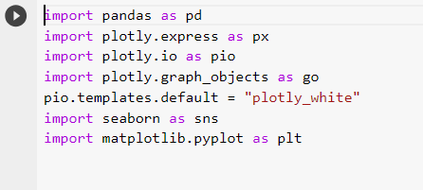

**Read csv file**

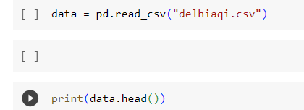

Output

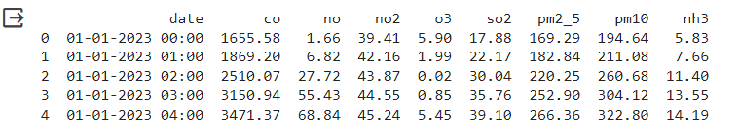

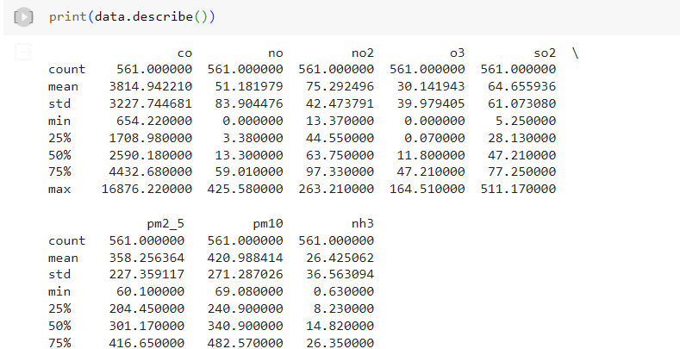

**time series plot for each air pollutant**

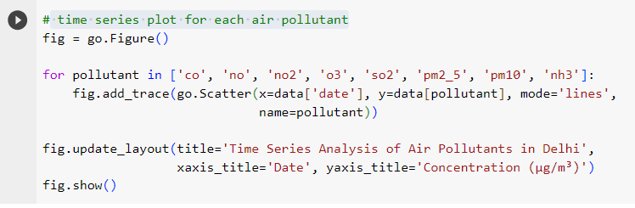

Output:-

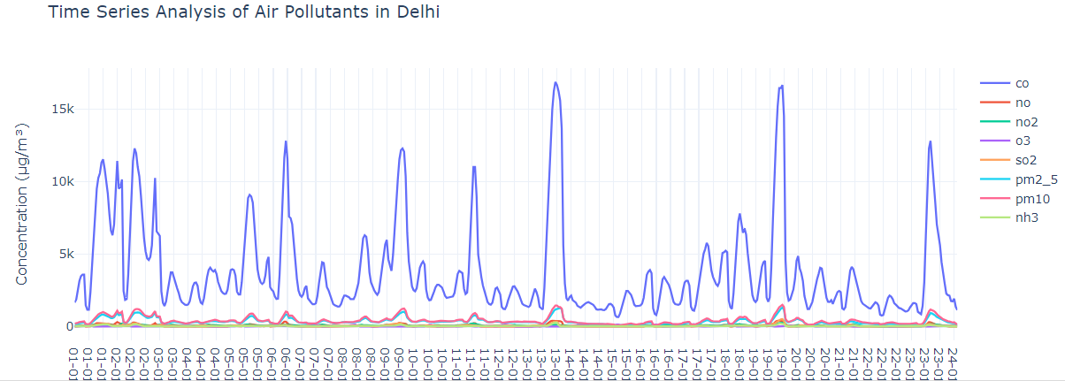

Define AQI breakpoints and corresponding AQI values

# Define AQI breakpoints and corresponding AQI values

aqi_breakpoints = [

    (0, 12.0, 50), (12.1, 35.4, 100), (35.5, 55.4, 150),

    (55.5, 150.4, 200), (150.5, 250.4, 300), (250.5, 350.4, 400),

    (350.5, 500.4, 500)

]

def calculate_aqi(pollutant_name, concentration):

    for low, high, aqi in aqi_breakpoints:

        if low <= concentration <= high:

            return aqi

    return None

def calculate_overall_aqi(row):

    aqi_values = []

    pollutants = ['co', 'no', 'no2', 'o3', 'so2', 'pm2_5', 'pm10', 'nh3']

    for pollutant in pollutants:

        aqi = calculate_aqi(pollutant, row[pollutant])

        if aqi is not None:

            aqi_values.append(aqi)

    return max(aqi_values)

# Calculate AQI for each row

data['AQI'] = data.apply(calculate_overall_aqi, axis=1)

# Define AQI categories

aqi_categories = [

    (0, 50, 'Good'), (51, 100, 'Moderate'), (101, 150, 'Unhealthy for Sensitive Groups'),

    (151, 200, 'Unhealthy'), (201, 300, 'Very Unhealthy'), (301, 500, 'Hazardous')

]

def categorize_aqi(aqi_value):

    for low, high, category in aqi_categories:

        if low <= aqi_value <= high:

            return category

    return None

# Categorize AQI

data['AQI Category'] = data['AQI'].apply(categorize_aqi)

print(data.head())

**output:-**

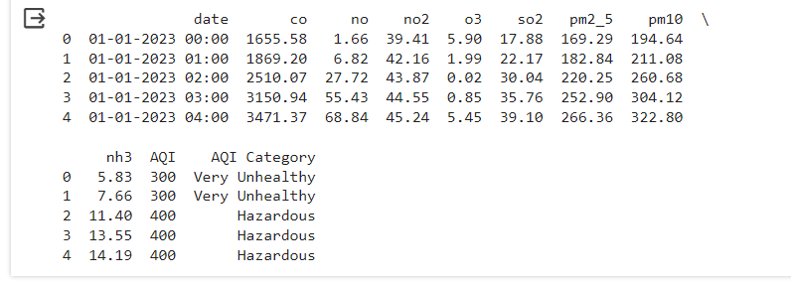

AQI over time

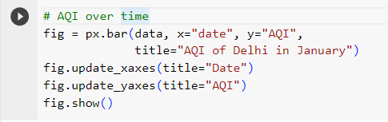

Output:-

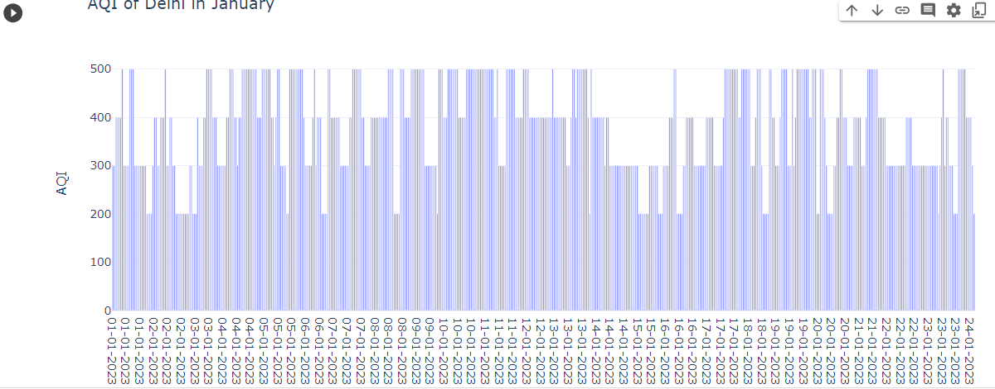

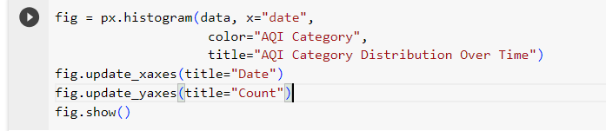

Output:-

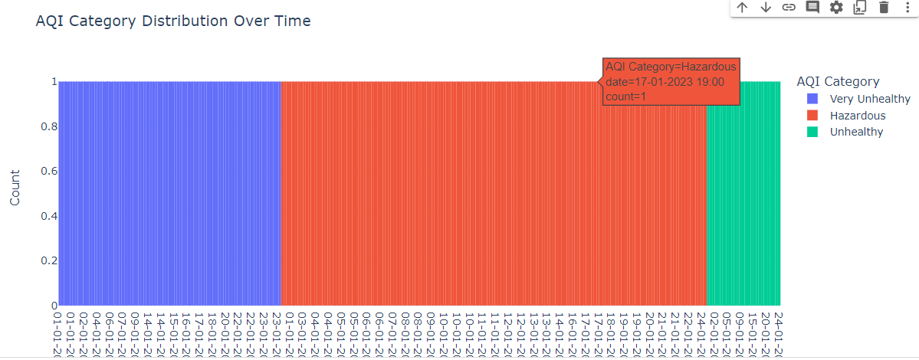

**Define pollutants and their colors**

# Define pollutants and their colors

pollutants = ["co", "no", "no2", "o3", "so2", "pm2_5", "pm10", "nh3"]

pollutant_colors = px.colors.qualitative.Plotly

# Calculate the sum of pollutant concentrations

total_concentrations = data[pollutants].sum()

# Create a DataFrame for the concentrations

concentration_data = pd.DataFrame({

    "Pollutant": pollutants,

    "Concentration": total_concentrations

})

# Create a donut plot for pollutant concentrations

fig = px.pie(concentration_data, names="Pollutant", values="Concentration",

             title="Pollutant Concentrations in Delhi",

             hole=0.4, color_discrete_sequence=pollutant_colors)

# Update layout for the donut plot

fig.update_traces(textinfo="percent+label")

fig.update_layout(legend_title="Pollutant")

# Show the donut plot

fig.show()

output:-

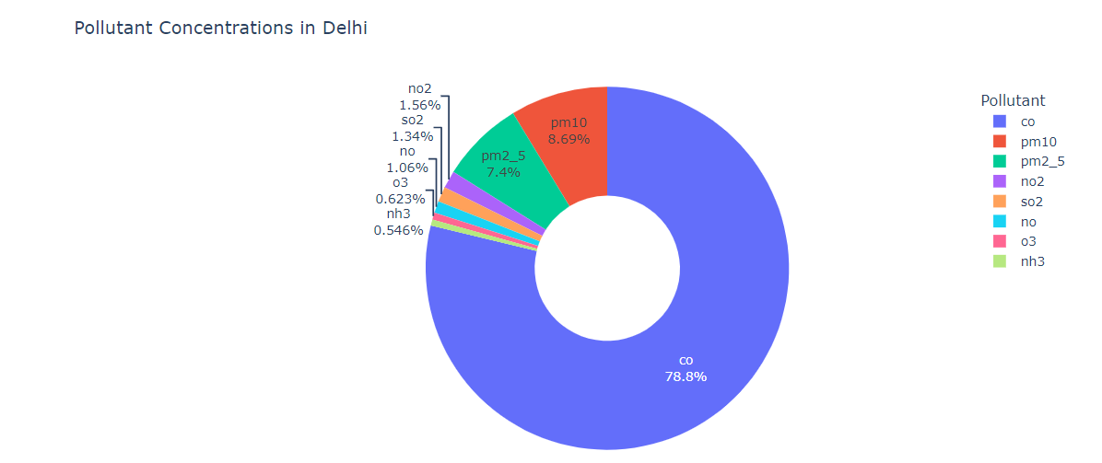

Correlation Between Pollutants

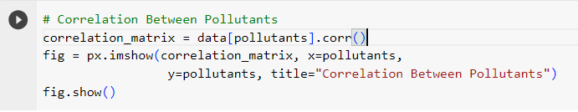

**Output:-**

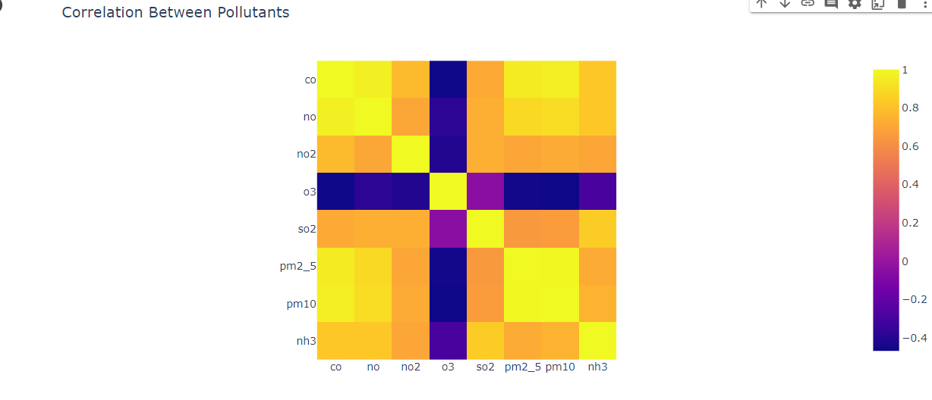

**Extract the hour from the date**

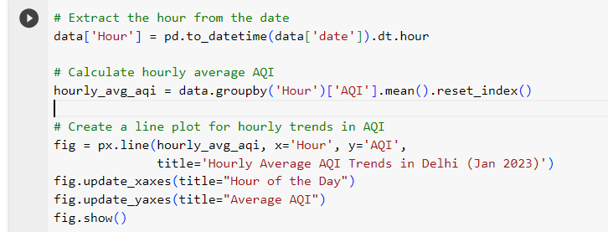

Output:-

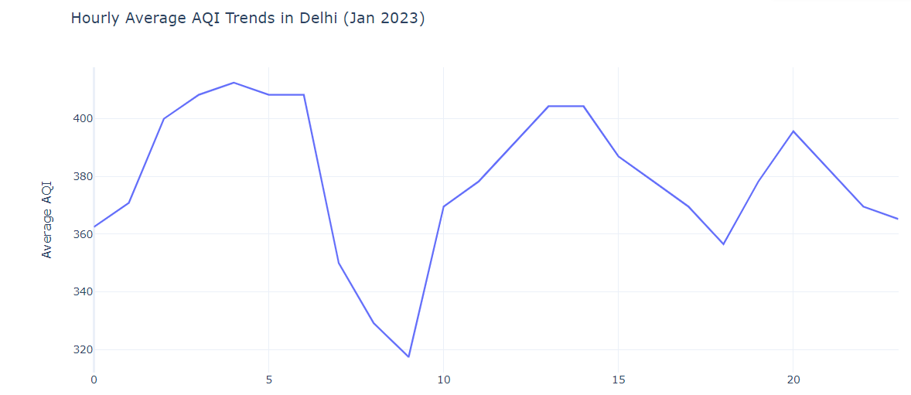

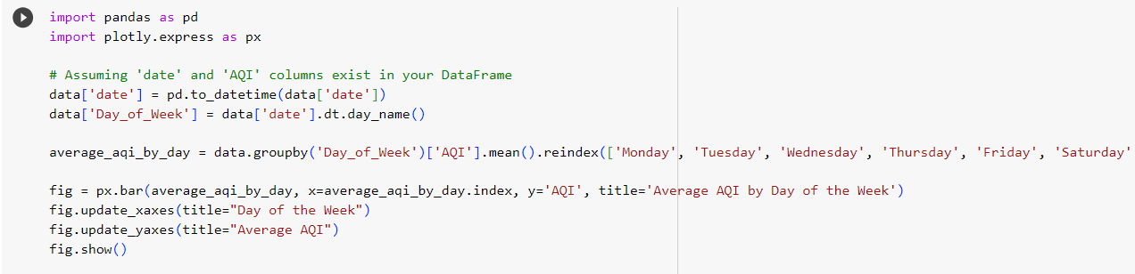

Output:-

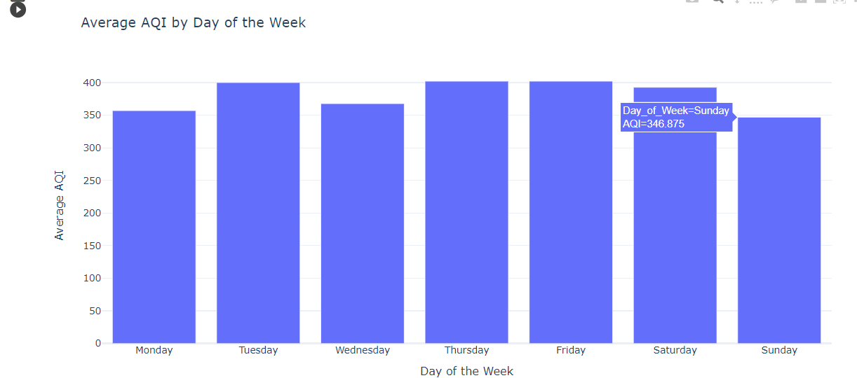

**FUTURE SCOPE**

1. Advanced Monitoring Technologies: Enhance the use of cutting-edge sensors and monitoring devices to provide more accurate and real-time data on air pollution levels.
2. Community-Driven Solutions: Implement initiatives that engage local communities in the fight against air pollution, encouraging participation in monitoring efforts and promoting sustainable practices.
3. Green Infrastructure Integration: Explore and promote the integration of green spaces, vertical gardens, and eco-friendly infrastructure to contribute to overall air quality improvement.
4. Technology-Enabled Awareness: Develop user-friendly mobile applications that provide real-time air quality information, health recommendations, and a platform for individuals to contribute to a collective understanding of air pollution.
5. Policy Advocacy and Collaboration: Strengthen collaborations with policymakers, advocating for stricter environmental regulations and policies to address the root causes of air pollution.
6. International Collaboration: Collaborate with global organizations and initiatives to share data, best practices, and innovative solutions, contributing to a collective effort to combat air pollution on a larger scale.

**Conclusion**

**Our air pollution initiative passionately captures the essence of environmental stewardship, where innovation meets responsibility. By curating a comprehensive approach to tackle air pollution exclusively in our region, we applaud the commitment to cleaner air, sustainable practices, and a healthier future.**

**In our project, you will witness a wealth of innovative solutions that exemplify our dedication to environmental well-being. From advanced monitoring technologies to community-driven green initiatives, from predictive modeling to active policy advocacy, we offer a unique blend of cutting-edge solutions and grassroots engagement.**

**We take pride in our unwavering commitment to supporting local communities, fostering collaborations with research institutions, and advocating for stronger environmental policies. By joining us in this initiative, you are not merely supporting a project but becoming an integral part of the broader movement to combat air pollution and create a sustainable living environment.**

**REFERENCES**

<https://www.w3schools.com/html/>

<https://getbootstrap.com/>

<https://github.com/>

<https://www.anytimefitness.com/>

<https://www.24hourfitness.com/>

<https://chat.openai.com/>

<https://www.google.com/>