**HEXAWARE FOUNDATION PROGRAM – BATCH 5**

**ASSIGNMENT -5 (03.04.2025)**

TASK 5:

Scope : Entity classes/Models/POJO, Abstraction/Encapsulation

Create the following model/entity classes within package entities with variables declared private, constructors(default and parametrized,getters,setters and toString())

1. User Class:

Variables:

userID , userName , email , password , contactNumber , address

2. Courier Class

Variables: courierID , senderName , senderAddress , receiverName , receiverAddress , weight ,

status, trackingNumber , deliveryDate ,userId

3. Employee Class:

Variables employeeID , employeeName , email , contactNumber , role String, salary

4. Location Class

Variables LocationID , LocationName , Address

5. CourierCompany Class

Variables companyName , courierDetails -collection of Courier Objects, employeeDetails-

collection of Employee Objects, locationDetails - collection of Location Objects.

6. Payment Class:

Variables PaymentID long, CourierID long, Amount double, PaymentDate Date

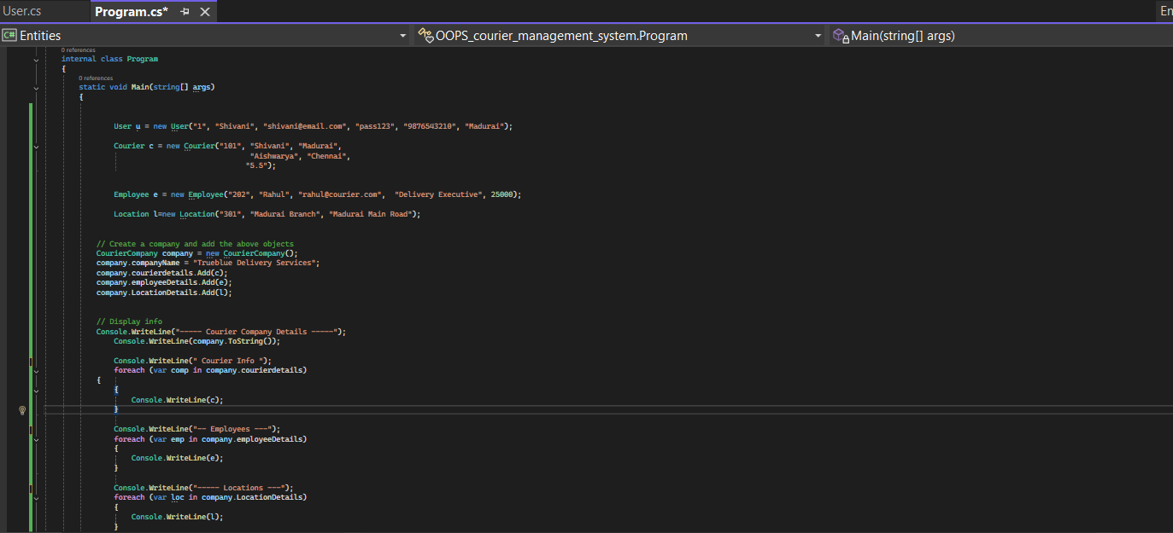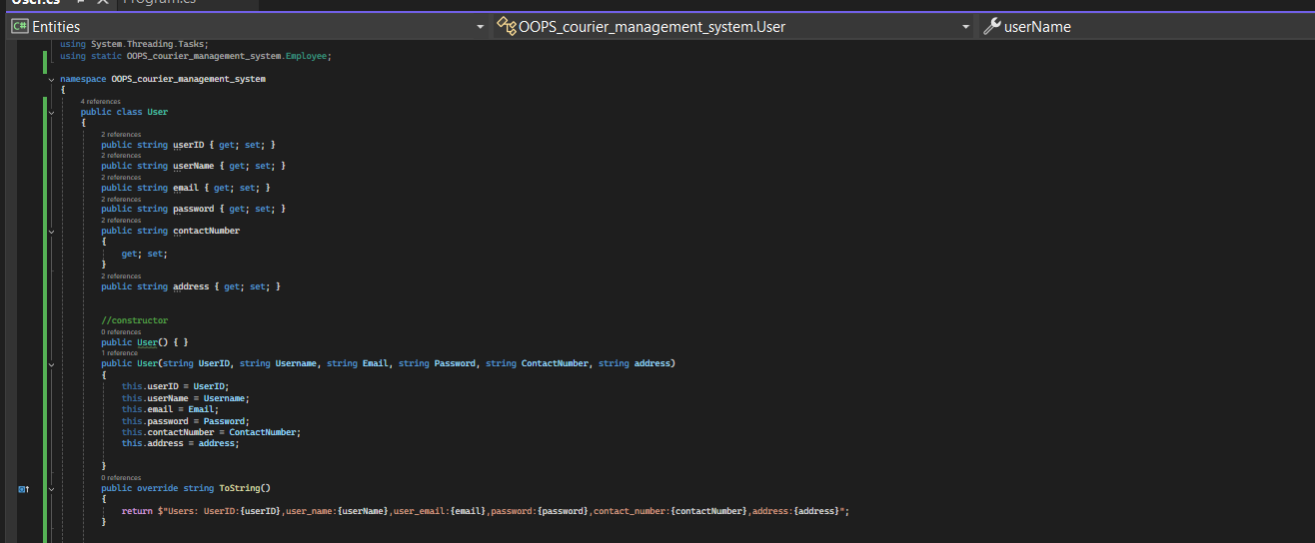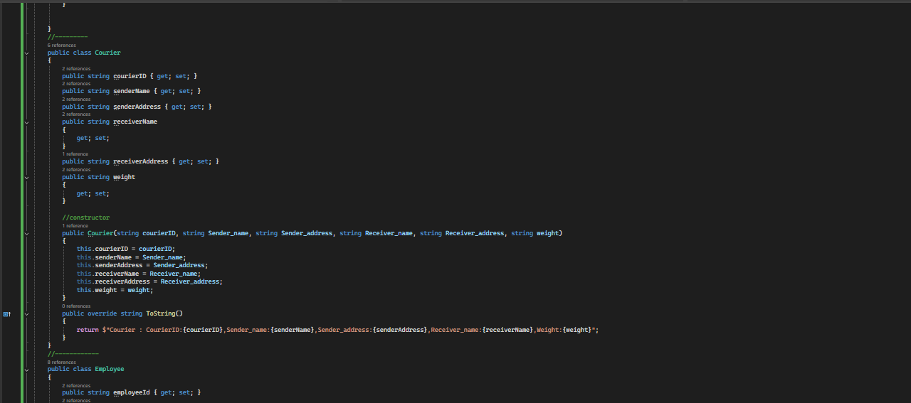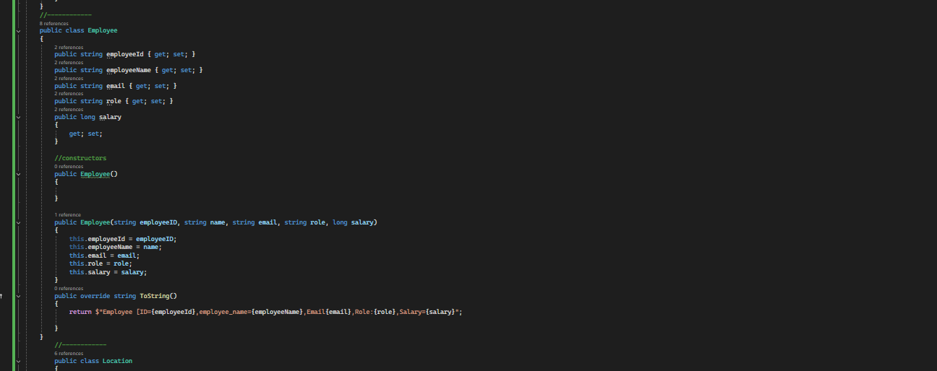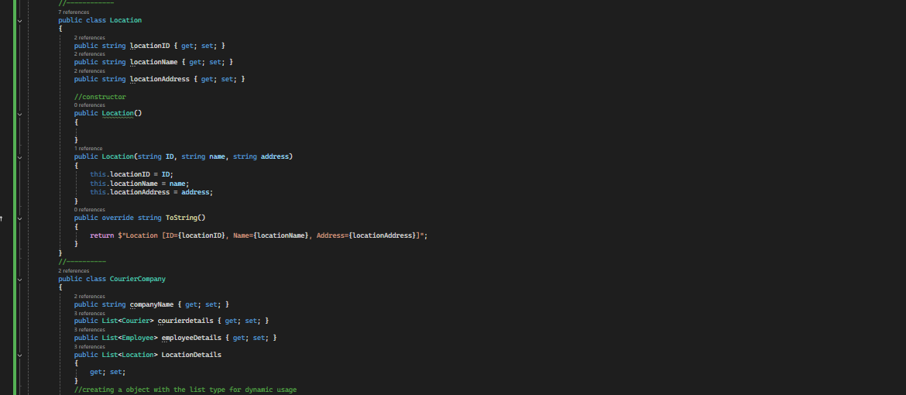

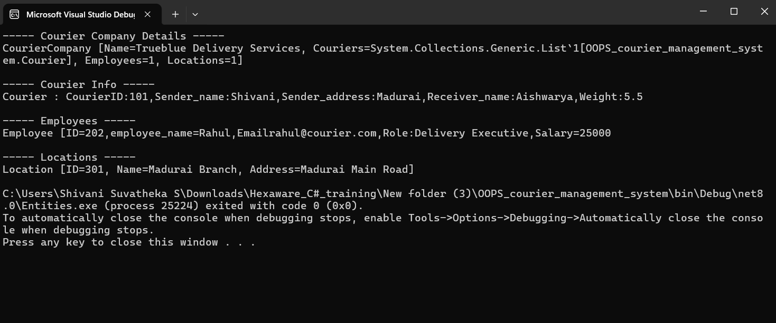

Task 6: Service Provider Interface /Abstract class

Create 2 Interface /Abstract class ICourierUserService and ICourierAdminService interface

ICourierUserService {

// Customer-related functions

placeOrder()

/** Place a new courier order.

* @param courierObj Courier object created using values entered by users

* @return The unique tracking number for the courier order .

Use a static variable to generate unique tracking number. Initialize the static variable in Courier

class with some random value. Increment the static variable each time in the constructor to

generate next values.

getOrderStatus();

/**Get the status of a courier order.

*@param trackingNumber The tracking number of the courier order.

* @return The status of the courier order (e.g., yetToTransit, In Transit, Delivered).

*/

cancelOrder()

/** Cancel a courier order.

* @param trackingNumber The tracking number of the courier order to be canceled.

* @return True if the order was successfully canceled, false otherwise.*/

getAssignedOrder();

/** Get a list of orders assigned to a specific courier staff member

* @param courierStaffId The ID of the courier staff member.

* @return A list of courier orders assigned to the staff member.*/

// Admin functions

ICourierAdminService

int addCourierStaff(Employee obj);

/** Add a new courier staff member to the system.

* @param name The name of the courier staff member.

* @param contactNumber The contact number of the courier staff member.

* @return The ID of the newly added courier staff member.

