**HEXAWARE FOUNDATION PROGRAM – BATCH 5**

**ASSIGNMENT -5 (02.04.2025)**

Write a program that checks whether a given order is delivered or not based on its status (e.g., "Processing," "Delivered," "Cancelled"). Use if-else statements for this.

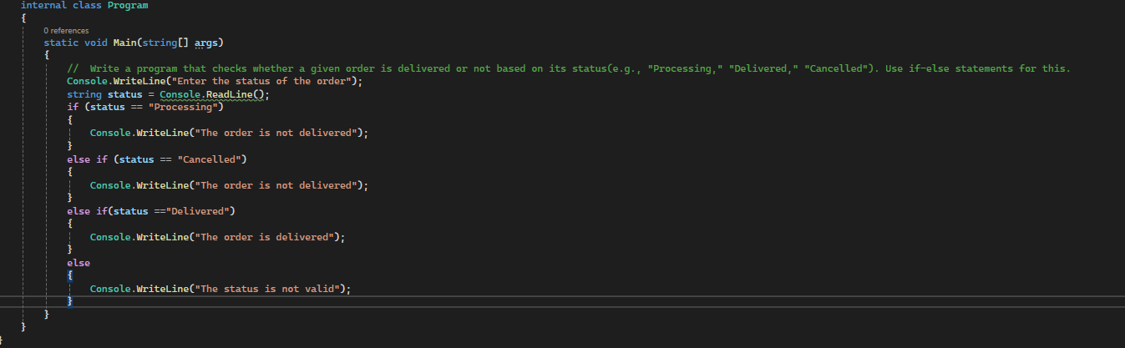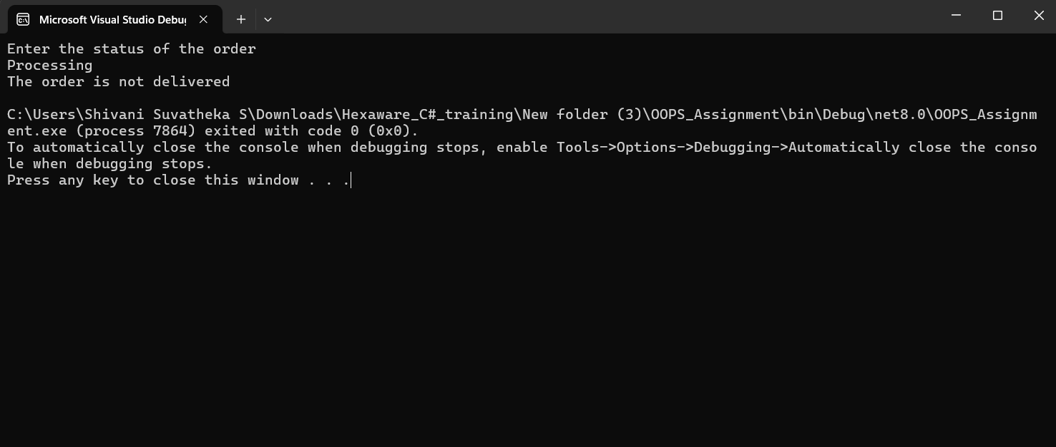

Implement a switch-case statement to categorize parcels based on their weight into "Light," "Medium," or "Heavy."

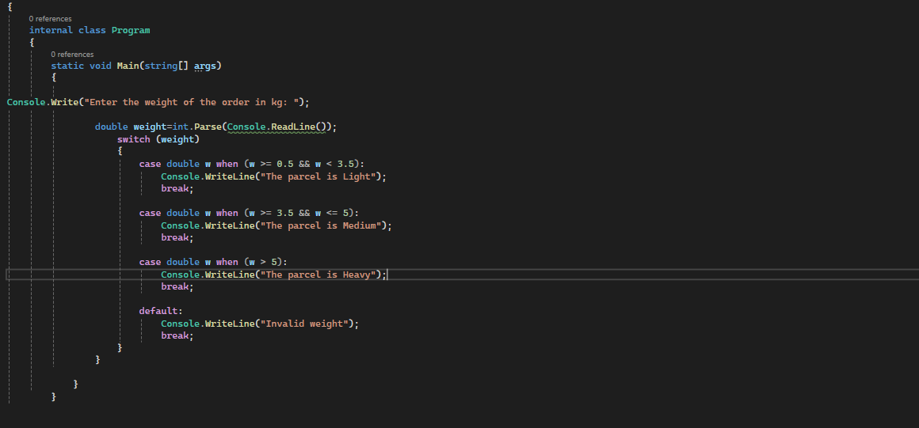

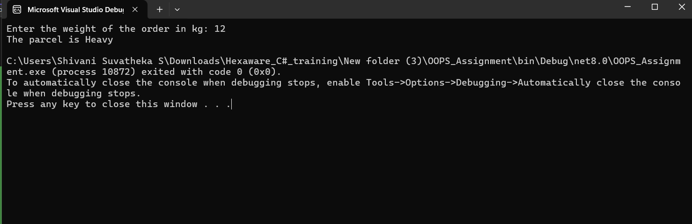

Implement User Authentication 1. Create a login system for employees and customers using C# control flow statements.

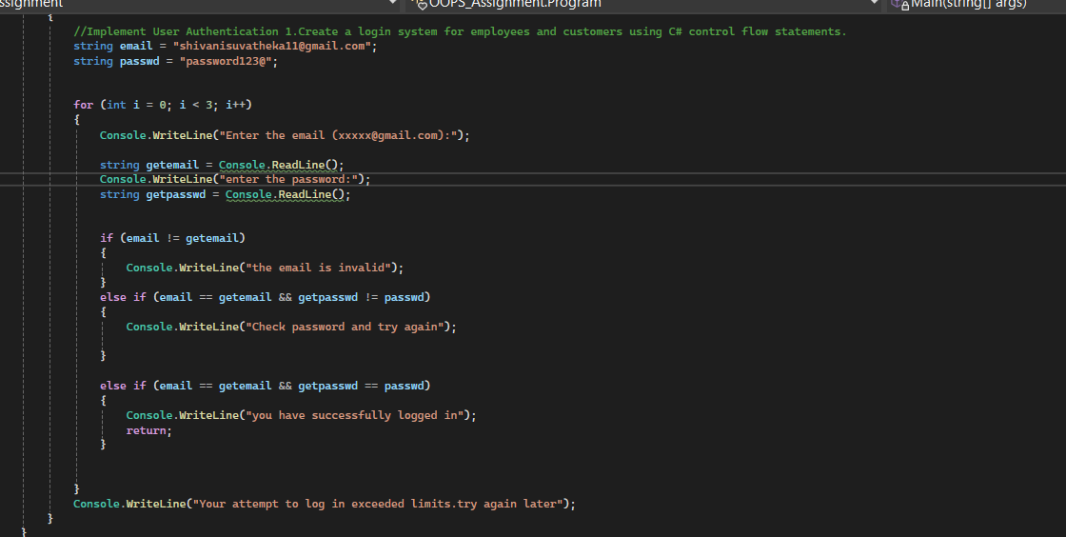

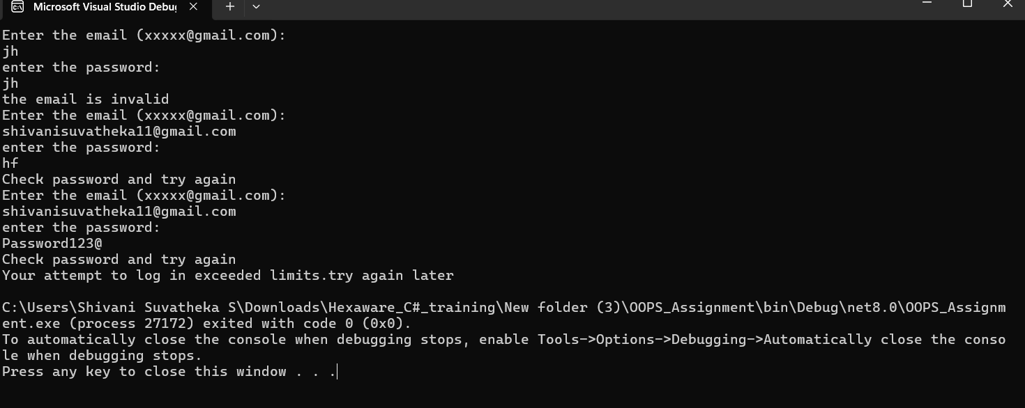

Implement Courier Assignment Logic 1. Develop a mechanism to assign couriers to shipments based on predefined criteria (e.g., proximity, load capacity) using loops.

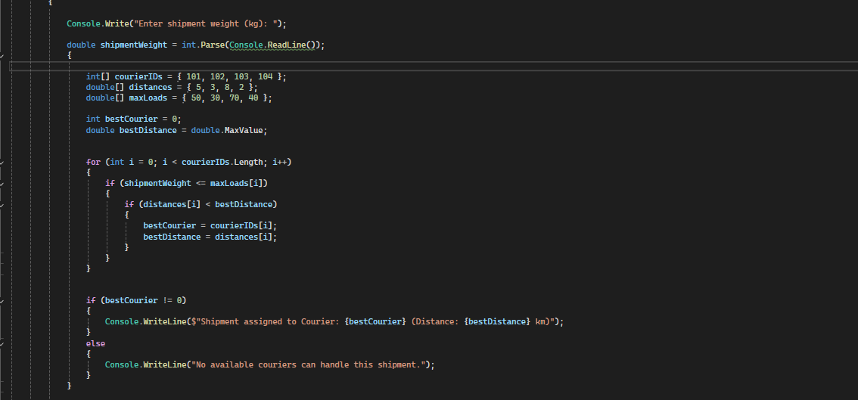

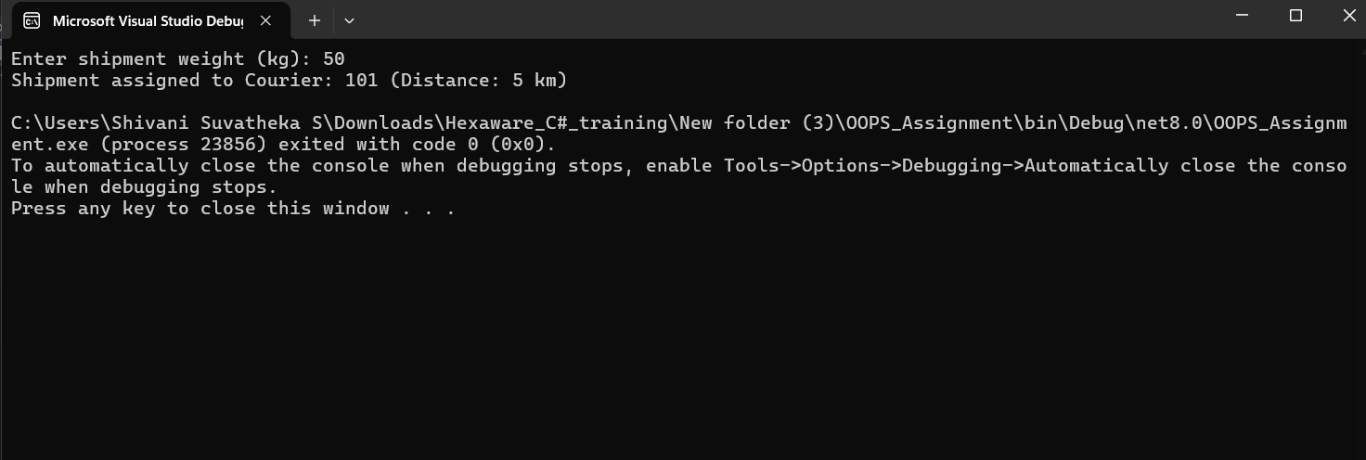

Write a Java program that uses a for loop to display all the orders for a specific customer.

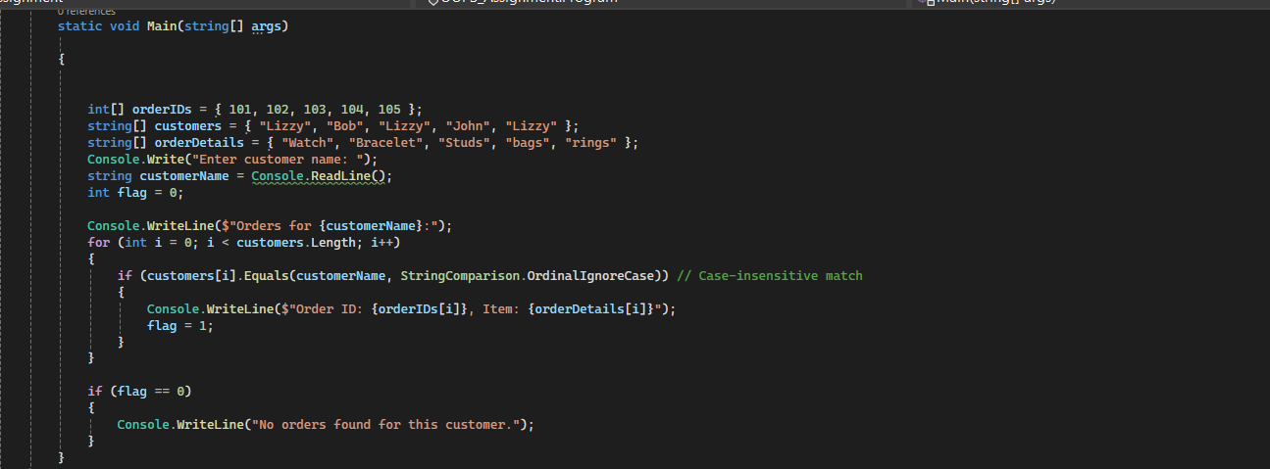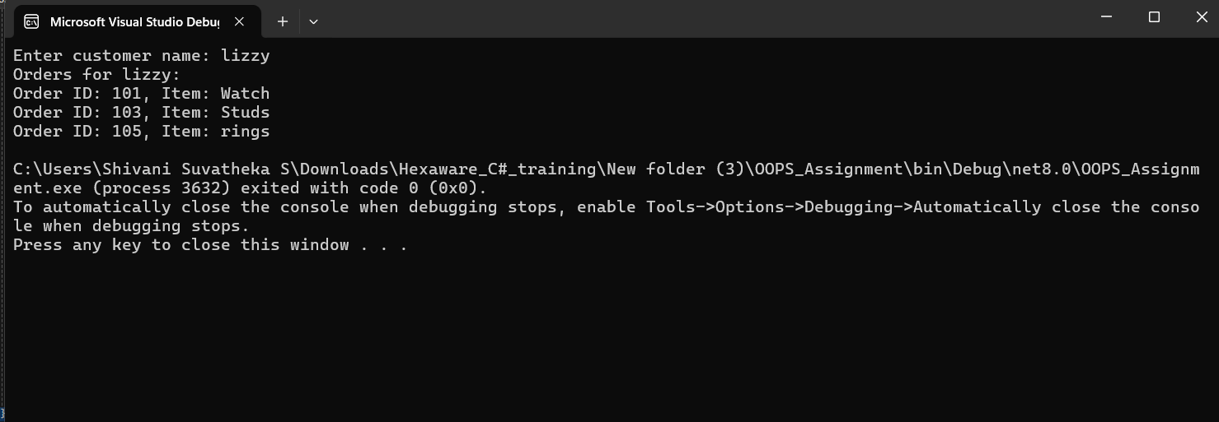

Implement a while loop to track the real-time location of a courier until it reaches its destination. 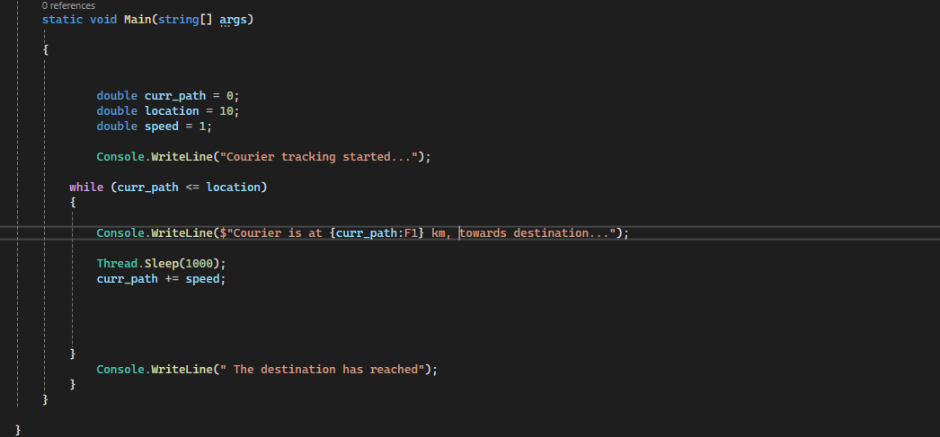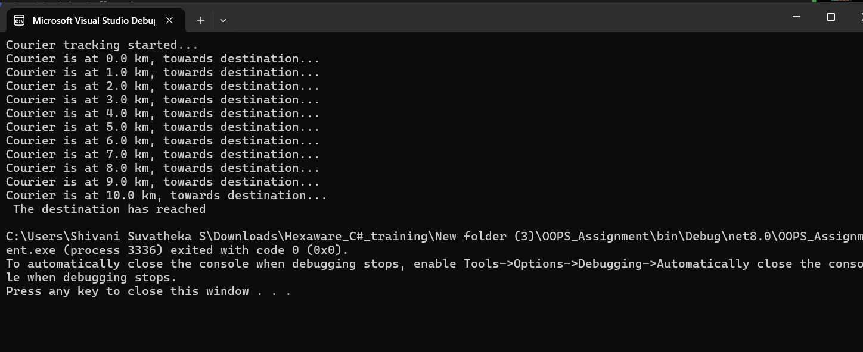

Create an array to store the tracking history of a parcel, where each entry represents a location update.

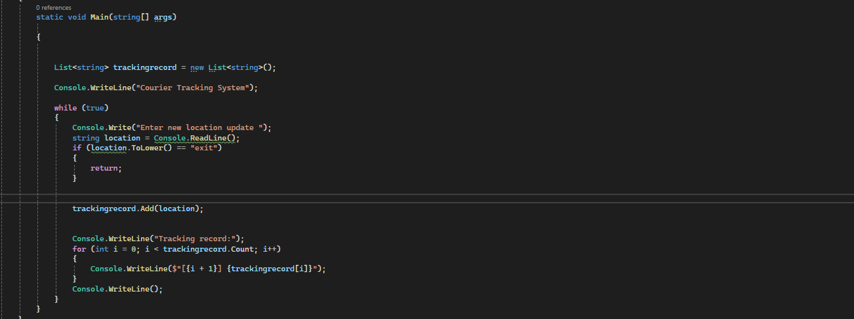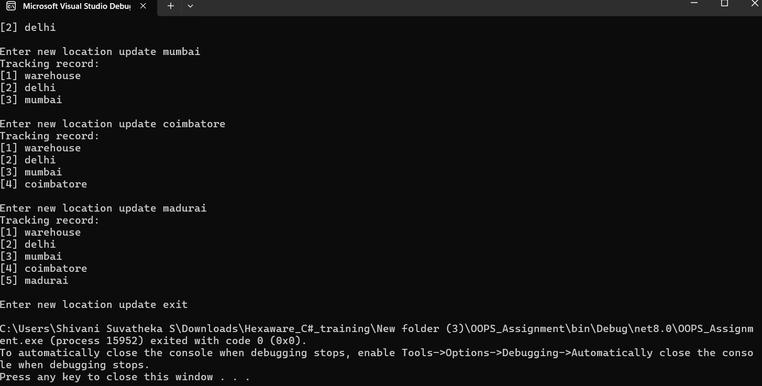

Implement a method to find the nearest available courier for a new order using an array of couriers.

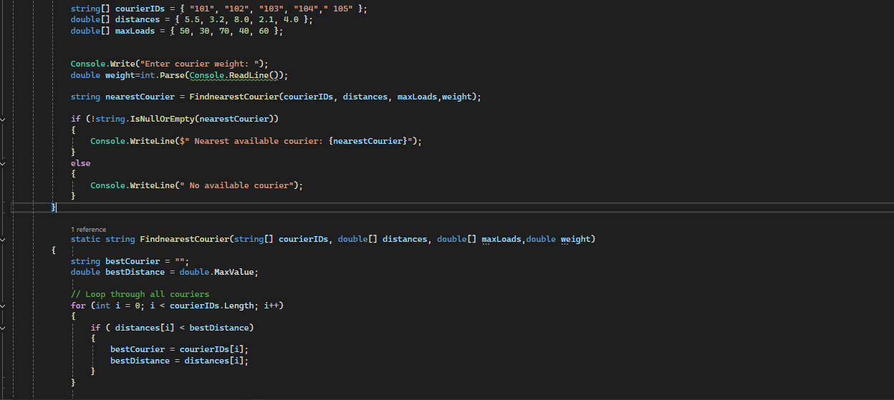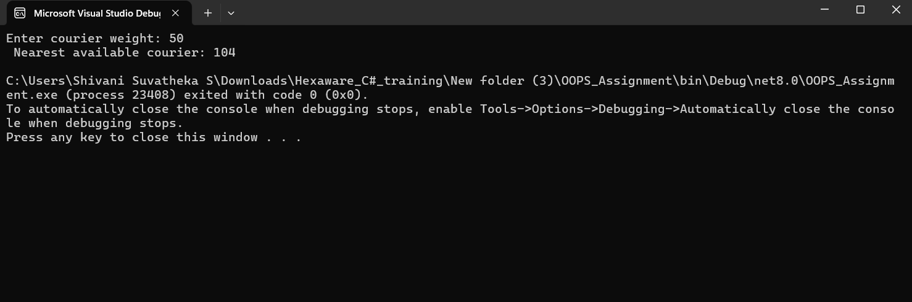

Parcel Tracking: Create a program that allows users to input a parcel tracking number.Store the tracking number and Status in 2d String Array. Initialize the array with values. Then, simulate the tracking process by displaying messages like "Parcel in transit," "Parcel out for delivery," or "Parcel delivered" based on the tracking number's status.

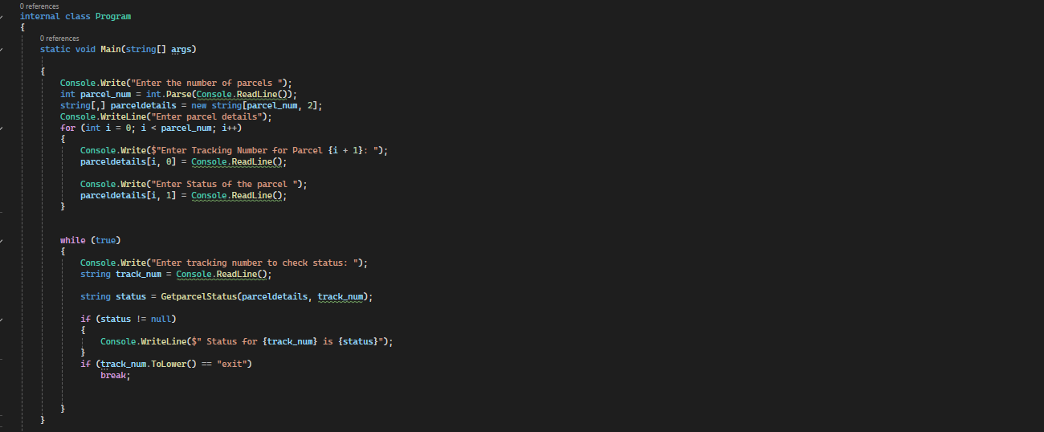

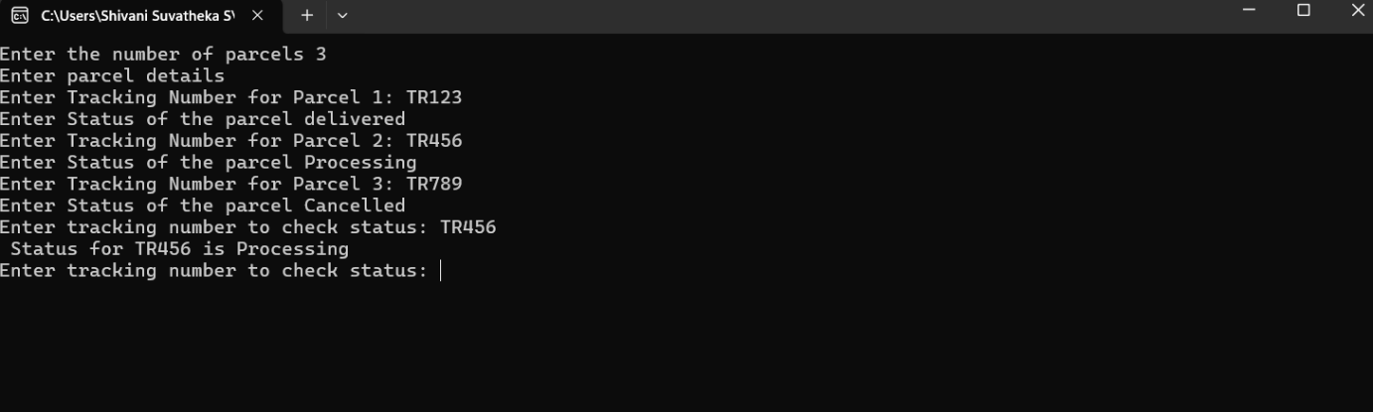

Address Formatting: Develop a function that takes an address as input (street,city, state, zip code) and formats it correctly, including capitalizing the first letter of each word and properly formatting the zip code.

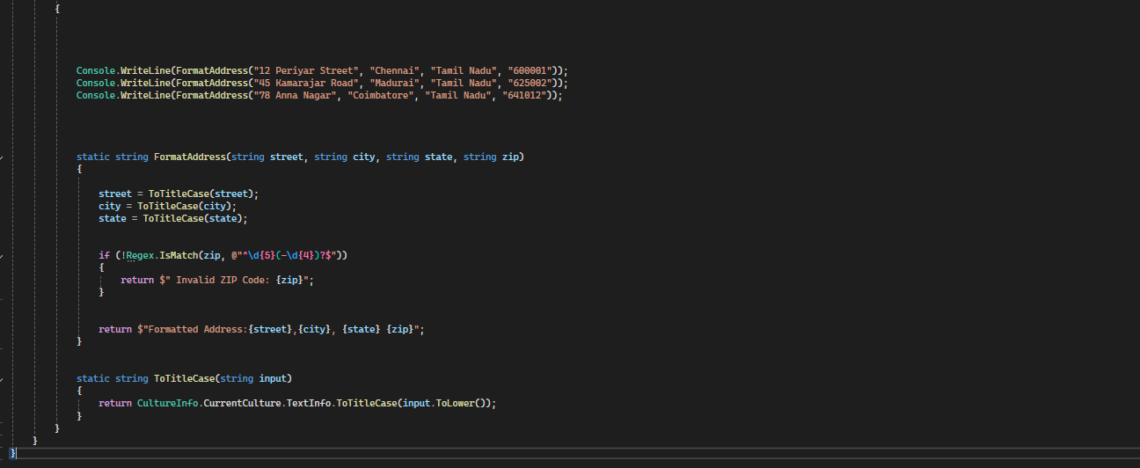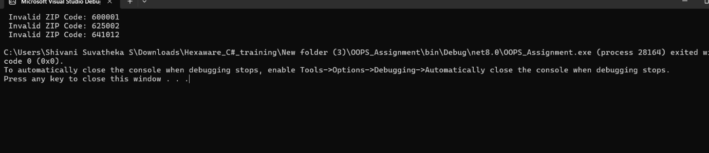

Order Confirmation Email: Create a program that generates an order confirmation email. The email should include details such as the customer's name, order number, delivery address, and expected delivery date.

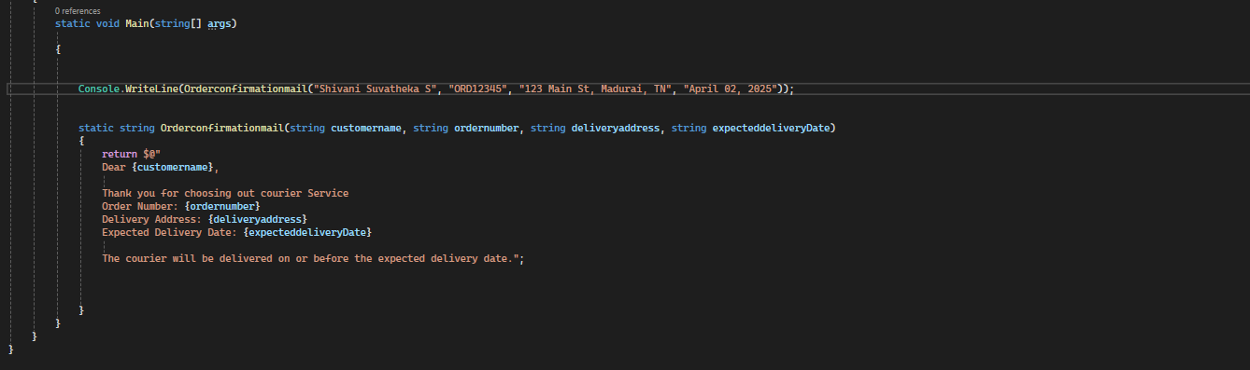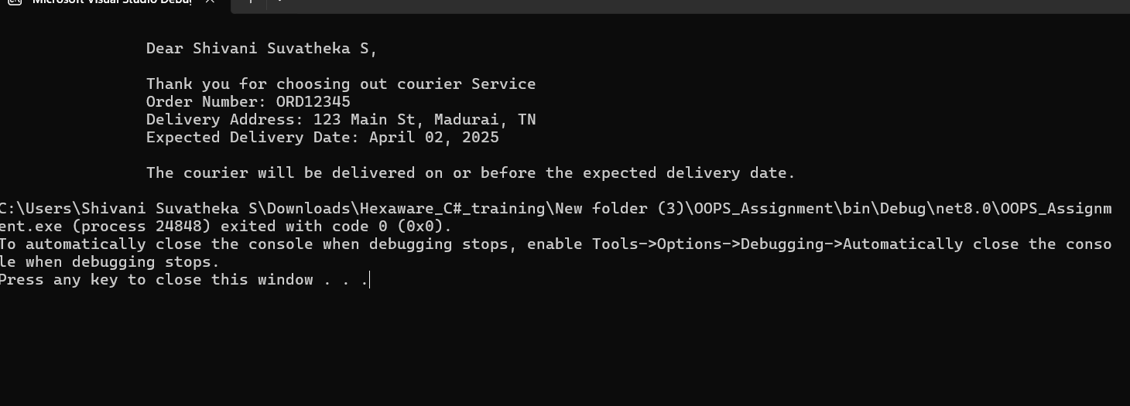

Find Similar Addresses: Implement a function that finds similar addresses in the system. This can be useful for identifying duplicate customer entries or optimizing delivery routes.Use string functions to implement this. Following tasks are incremental stages to build an application and should be done in a single project

