IBM NAANMUDHALVAN

# **INTERNET OF THINGS-PHASE 2**

**FLOOD MONITORING SYSTEM**

**INNOVATION:**

**Step 1- Analyzation of flood prone areas**

* Analysing flood-prone areas is a crucial aspect of flood monitoring systems, enabling the identification of regions at elevated risk of flooding and facilitating improved preparedness and response.
* Gathering of relevant data sources such as historical flood data, topographic data, land cover data, hydrological data, and rainfall data.
* Topographic Data includes Obtain Digital Elevation Models (DEMs) or topographic maps that provide elevation information for the study area.
* Collection of data on river and stream networks, including river gauges and streamflow measurements.
* Gathering of historical rainfall data, including records of intense rainfall events and past flood events in that area.

**Step 2- Parameters Detection**

* Flood monitoring systems incorporate various parameters and data sources to accurately assess flood risks and provide early warnings.
* The parameters include weather conditions, rainfall, humidity, temperature, direction and speed of air flow, intensity and velocity of rainfall.

**Step 3- Selection of Sensors**

* Suitable sensors are selected according to their specifications and for calculating various parameters in a flood monitoring system is essential to ensure accurate data collection.
* The following sensors are employed for the flooding monitoring and early warning systems:
* Parameters:

1. Temperature – DHT22
2. Humidity – DHT22
3. Rainfall – YL83
4. Wind Speed and direction – ELA1877
5. Water level Indicator – Ultrasonic sensor

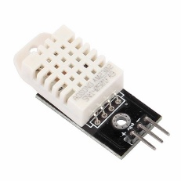

DHT22

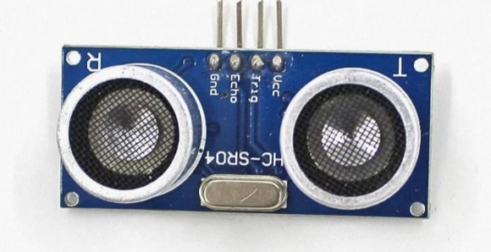 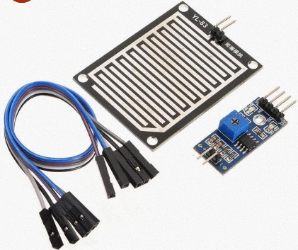

YL83

**Ultrasonic sensor**

**Step 4 - Selection of Microcontroller**

* For the integration of all these sensors to oversee environmental parameters, WIFI based the ESP8266 microcontroller is chosen.

1. Advantages of utilizing the ESP8266 for Flood monitoring system provides a cost-effective solution.
2. Built-in wireless Wi-Fi connectivity for remote monitoring over the flood prone areas.
3. Low power consumption, suitable for battery-powered applications.
4. Integration with a variety of sensors and peripherals.
5. Capable of data logging and remote data transmission.

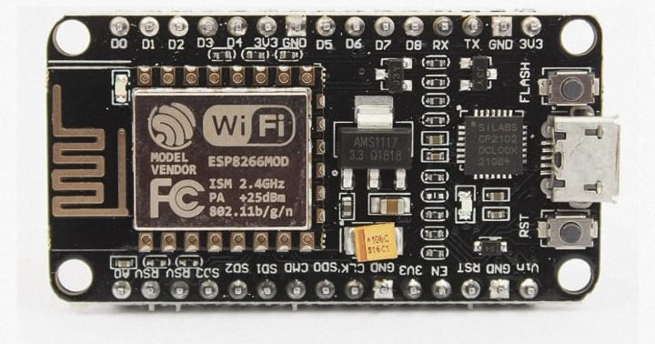

ESP8266

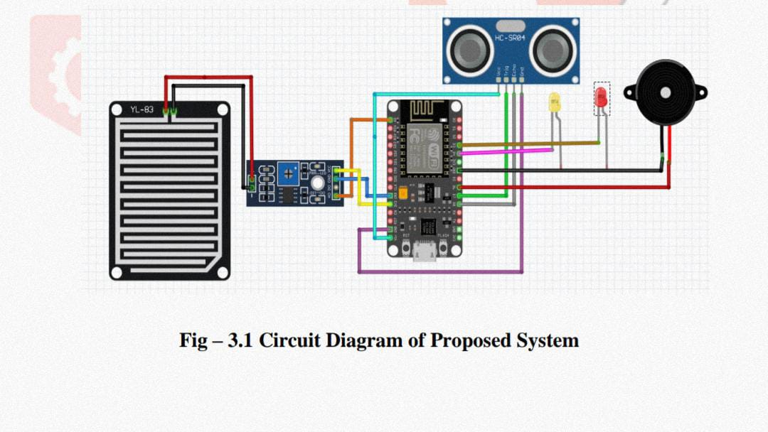

Circuit Connection of Rainfall sensor and Ultrasonic sensor with ESP8266

**Step 5- Selection of Monitoring Platform**

* A web-based platform has been chosen for monitoring and maintaining records of environmental parameters. This platform is accessible to the public for real-time updates and the generation of alert system is offered a setting a threshold for the parameters.
* We employ the Blynk 2.0 platform, known for its user-friendly display interface and a wide array of data visualization features, enhancing user experience and data comprehension.
* It helps to display the intensity of rainfall, water level and flood predictions.
* When exceeding the thresholds, it generates an alert to the control station via email notifications or text messages.

**Step 6-Data Storage**

* Data is initially collected from sensors and undergoes pre-processing.
* The processed data is transmitted to the cloud via WIFI protocol.
* This data is accessible remotely, eliminating the necessity for physical storage.
* Remote access facilitates the retention of historical flood records.

**BLOCK DIAGRAM:**

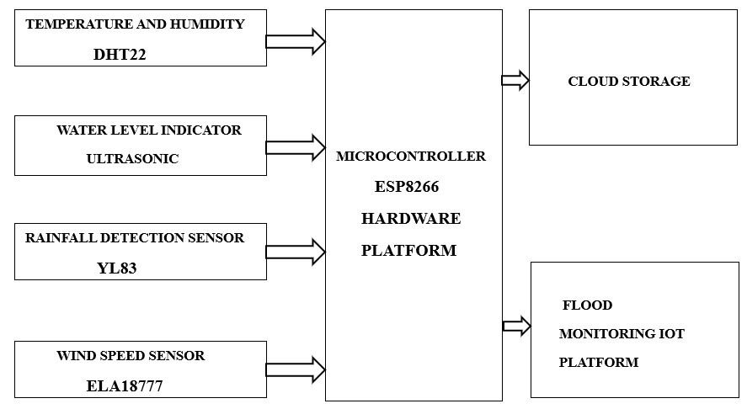

https://drive.google.com/drive/folders/1bX0RWQrPqwhwmf5QrQm4a-GmGZ5Qth4e