**IBM NAANMUDHALVAN**

# **INTERNET OF THINGS-PHASE 4**

**FLOOD MONITORING SYSTEM**

**Data Storage and model training:**

* The data collected from various sensors collecting the parameters that includes temperature, rain intensity and water level indication pays a way for predicting the possibility of occurrence of flood and the generation of alerting system during the response of the disaster.
* NEO 6M GPS module is used for location tracking and alerting systems. In the event of a flood onset, the device expeditiously transmits the gathered data to ESP32 (a WIFI based NodeMCU central microcontroller). Within the microcontroller, the data is subjected to validation and processing procedures to predict the possibility of the flood occurrence.

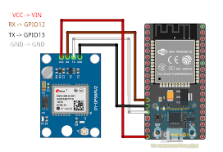

Fig 1. Connection of ESP32 with Neo 6M GPS

* The model is trained and the data are stored in the cloud platform called Firebase for the ease of later access of data.

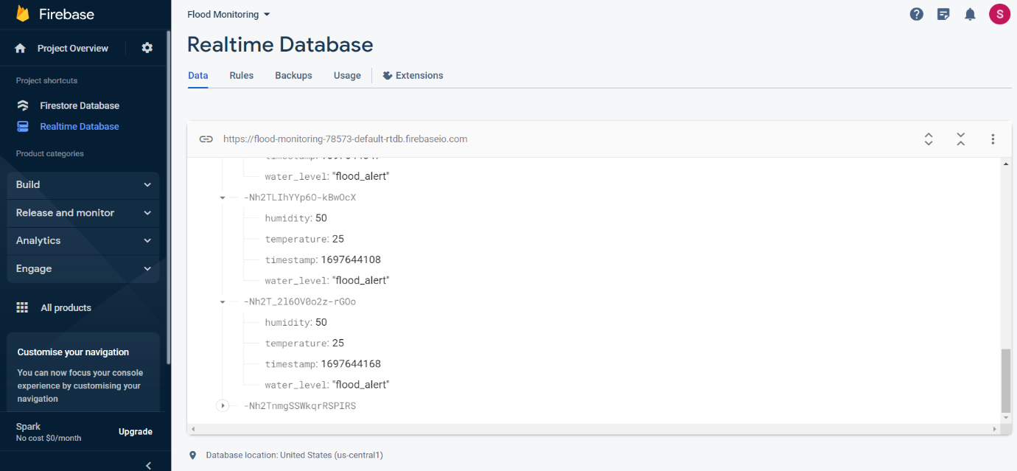

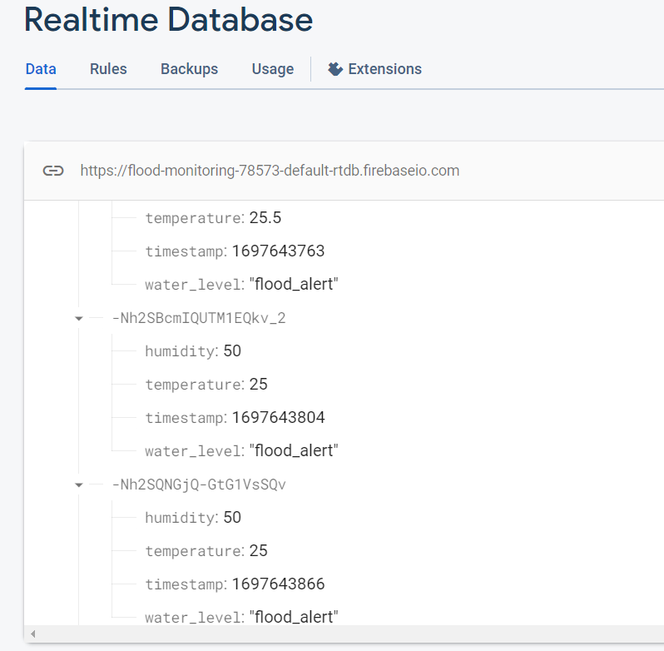

Fig 2. Model Training and Data storage in Firebase

**Concept Validation and real-time implementation:**

* Following the verification, an alert is promptly generated and conveyed to individuals residing in disaster-prone regions through user friendly mobile application via a variety of communication channels, thereby ensuring the timely dissemination of life-saving notifications via methods such as SMS, email, and other communication means.
* Blynk is a IOT based open-source application which has a user-friendly interface that displays the indication of various parameters such as water intensity and rainfall rate when flood occurs and the alerts are generated when the parameters exceed the thresholds provided.

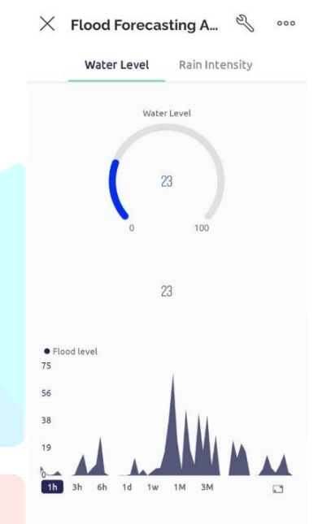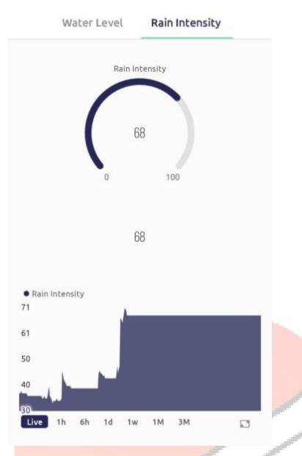

Fig 3. Indication of water level and rain intensity

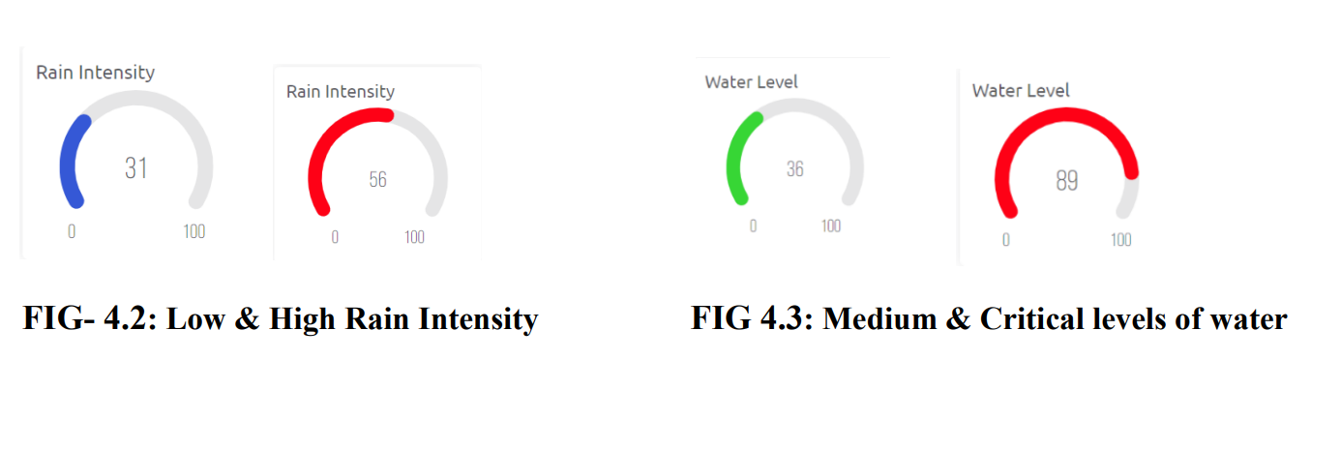

Fig 4. Indication of normal and critical level rain intensity



Fig 5. Indication of normal and critical water level

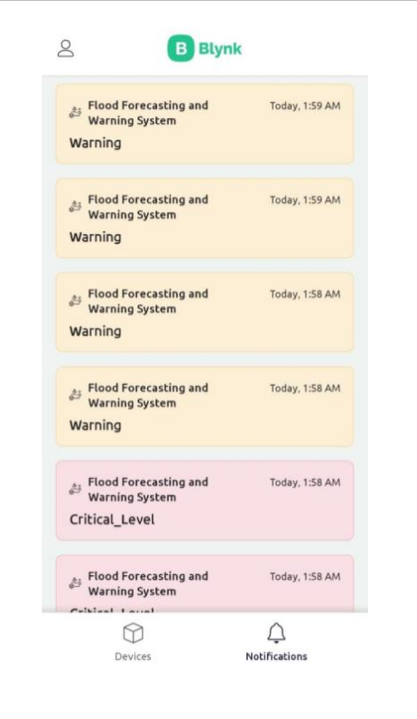

Fig 6. Alert generation and early warning notification through Blynk IOT

* Thus the project aims in developing a cost-effective and efficient smart flood monitoring system using NodeMCU and the Blynk application. This system leverages ultrasonic sensors to provide accurate data for flash flood detection and early warning.
* The wireless sensor node, built on the Blynk platform, offers flexibility and cost-effectiveness. By connecting ultrasonic sensors and a rain sensor to the NodeMCU, the system can accurately detect and monitor flooding conditions. It serves as a reliable solution for detecting, monitoring, and issuing community alerts in flood-prone areas.
* Moreover, the IoT system includes an accompanying application that enhances the overall functionality by offering real-time monitoring of fundamental environmental conditions. This element empowers users to monitor shifts in local conditions and receive periodic updates, thereby promoting flood preparedness and augmenting overall situational awareness.