**IBM NAANMUDHALVAN**

# **INTERNET OF THINGS-PHASE 3**

**FLOOD MONITORING SYSTEM**

**Steps Involved:**

For the building the IoT based flood monitoring and early warning system,

* Deployment of IoT sensors (e.g., Ultrasonic Sensors) in flood-prone areas and configure them to measure water levels.
* Develop a Python script on the IoT sensors to send collected water level data to the early warning platform.

**Sensor and Microcontroller:**

* Ultrasonic Sensor is connected with WIFI based ESP32 controller to measure the water levels.
* The alerts are generated through buzzer, LED and the data are transferred to the Firebase Cloud platform and are displayed in real-time database.

**Working Principle of Ultrasonic sensor:**

* The ultrasonic sensor contains a transducer that can both emit and receive ultrasonic sound waves. To measure the water level, the sensor emits a short burst of high-frequency ultrasonic sound waves (typically in the ultrasonic range, around 40 kHz).
* These sound waves travel through the air or any other medium until they encounter the water surface. When the emitted sound waves hit the water surface, they are partially reflected back toward the sensor. The time it takes for the sound wave to travel from the sensor to the water surface and back is measured.
* Once the distance to the water surface is known, you can calculate the water level by subtracting this distance from the sensor's mounting height above the water surface.
* Generation of alerts is for water level monitoring is based on setting specific thresholds. If the alert is generated when the water level rises beyond a certain point by programming the microcontroller (such as an ESP32) connected to the ultrasonic sensor to compare the calculated water level with the threshold.
* If the water level is below the threshold, no alert is generated.
* If the water level crosses the threshold, the system triggers an alert, which could be a visual indicator (LED), audible alarm, or a message is displayed in the firebase.

**Circuit Connection in Wokwi simulation environment:**

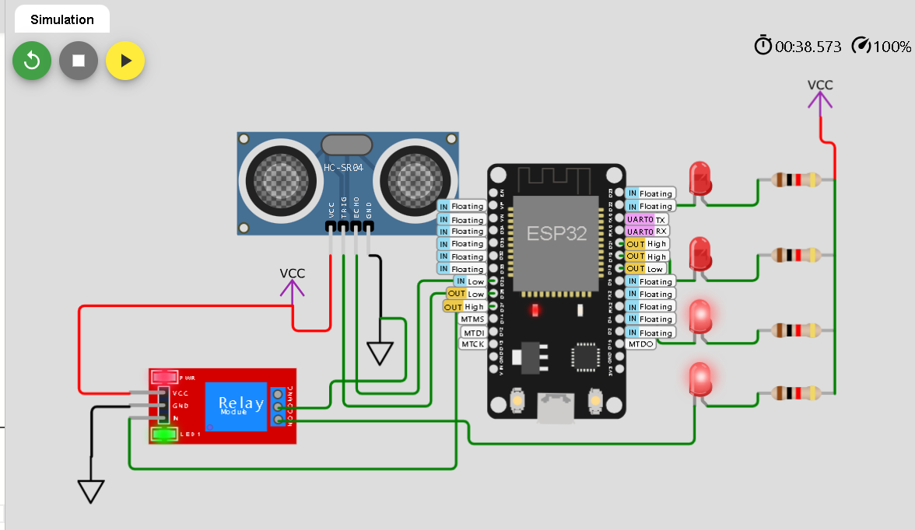

**Fig 1. Water level below threshold**

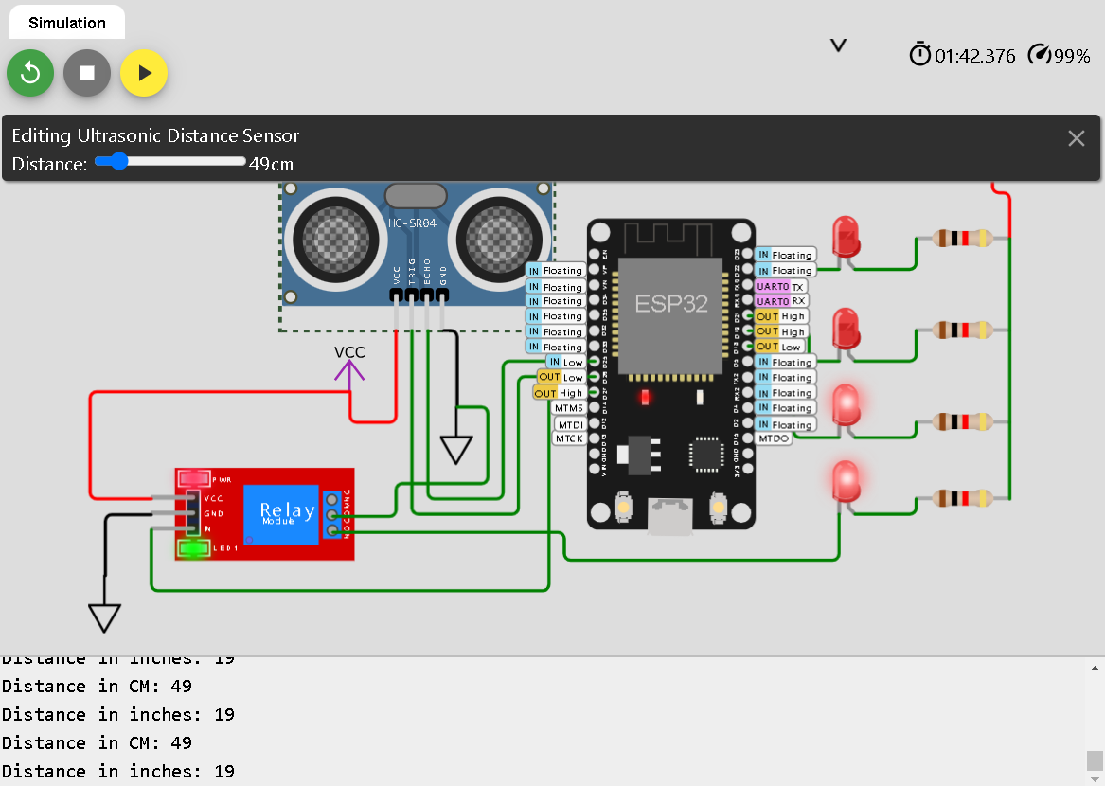

**Fig2. Water level above threshold**

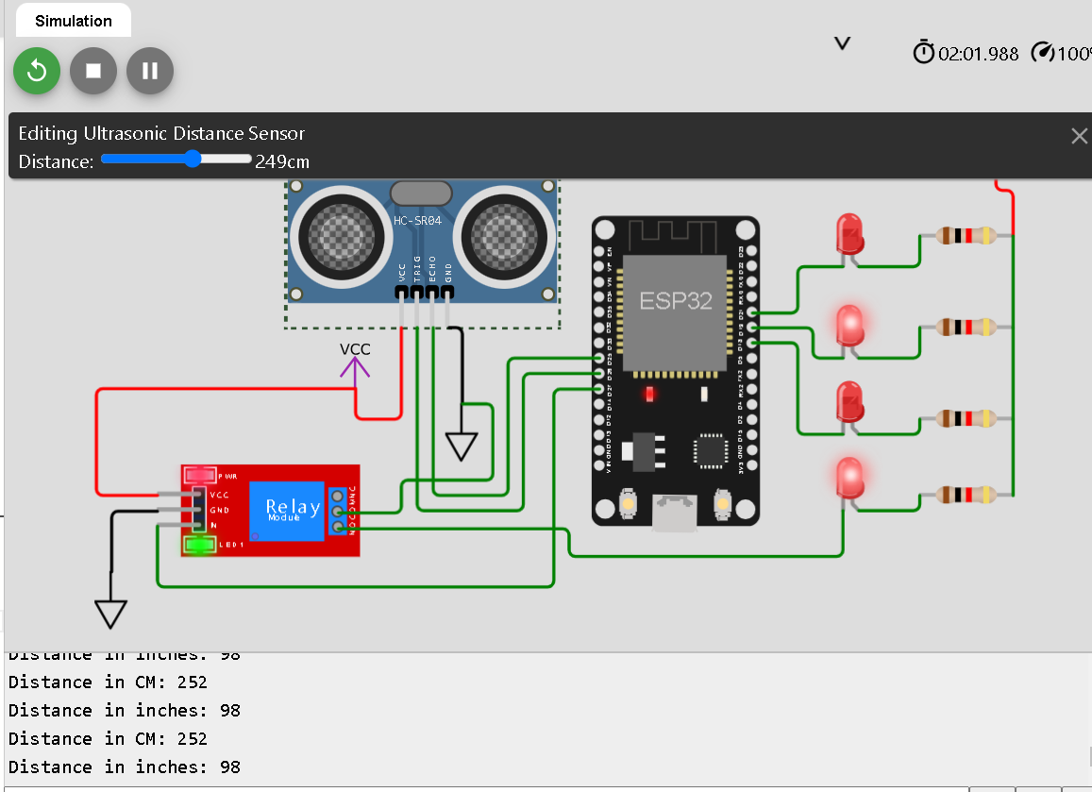

**Python Code for Water level Measurement:**

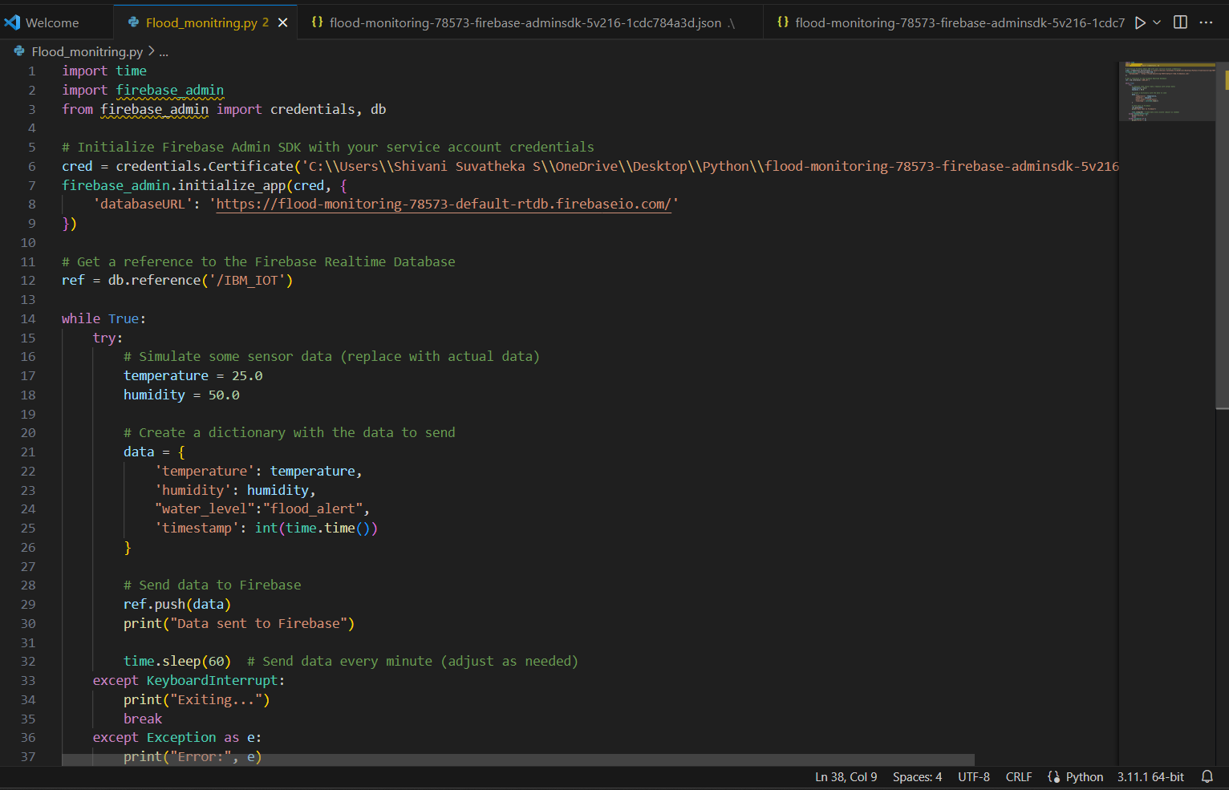

**Output:**

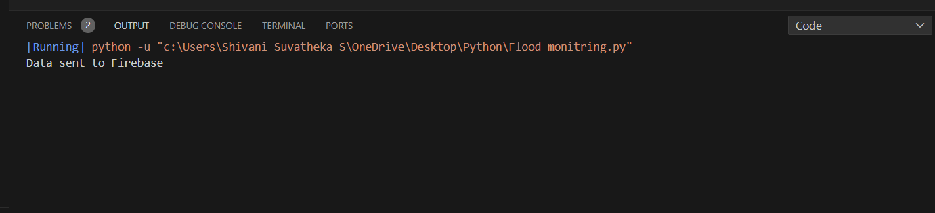

**Real-time display in Firebase:**



