LAB ASSIGNMENT – 4.4

Name : T.Shivani
Hall Ticket No. : 2303A51312
Batch No.: 05

1. Sentiment Classification for Customer Reviews
Scenario:
An e-commerce platform wants to analyze customer reviews and classify them into Positive, Negative, or Neutral sentiments using prompt engineering.
Tasks:
a) Prepare 6 short customer reviews mapped to sentiment labels.
b) Design a Zero-shot prompt to classify sentiment.
c) Design a One-shot prompt with one labeled example.
d) Design a Few-shot prompt with 3–5 labeled examples.
e) Compare the outputs and discuss accuracy differences.
Scenario
An e-commerce platform wants to classify customer reviews as Positive, Negative, or Neutral using prompt engineering.
(a) Sample Customer Reviews
Review | Sentiment
“The product quality is excellent and delivery was fast.” | Positive
“Very satisfied with the purchase.” | Positive
“The item is okay but nothing special.” | Neutral
“Delivery was delayed but product is fine.” | Neutral
“Worst experience ever, totally disappointed.” | Negative
“The product stopped working in two days.” | Negative
AI Generated Code:
(b) Zero-Shot Prompt
Classify the sentiment of the following review as Positive, Negative, or Neutral:
"The product quality is excellent and delivery was fast."
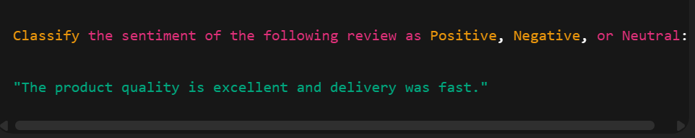
Output: Positive
(c) One-Shot Prompt
Example:
Review: "The product is terrible and useless."
Sentiment: Negative
Now classify:
Review: "The product quality is excellent and delivery was fast."
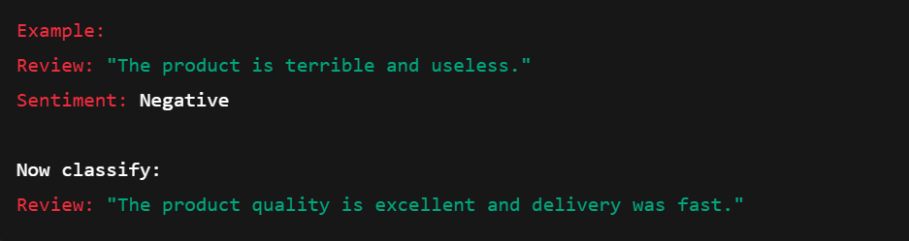
Output: Positive

(d) Few-Shot Prompt
Review: "The product is amazing and works perfectly."
Sentiment: Positive
Review: "Delivery was late and the box was damaged."
Sentiment: Negative
Review: "It’s okay, not too good or bad."
Sentiment: Neutral
Now classify:
Review: "Very satisfied with the purchase."
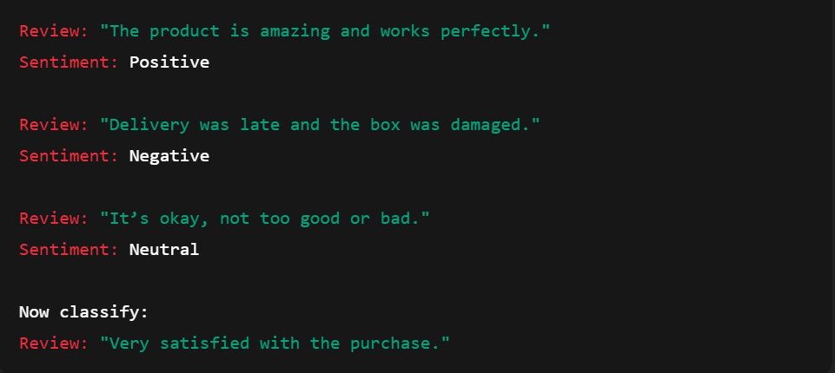
Output: Positive

(e) Comparison & Analysis
Method | Accuracy | Reason
Zero-shot | Medium | No examples provided
One-shot | Better | Model understands pattern
Few-shot | Best | Context improves classification
Few-shot prompting gives the most accurate and consistent results.

2. Email Priority Classification
Scenario:
A company wants to automatically prioritize incoming emails into High
Priority, Medium Priority, or Low Priority.
Tasks:
1. Create 6 sample email messages with priority labels.
2. Perform intent classification using Zero-shot prompting.
3. Perform classification using One-shot prompting.
4. Perform classification using Few-shot prompting.
5. Evaluate which technique produces the most reliable results and
why.
Sample Emails
Email | Priority
“Server is down, fix immediately!” | High
“Client meeting postponed to tomorrow.” | Medium
“Thank you for your support.” | Low
“Urgent payment issue, respond ASAP.” | High
“Weekly report attached.” | Medium
“Just checking in.” | Low
Zero-Shot Prompt
Classify this email as High, Medium, or Low priority:
"Server is down, fix immediately!"
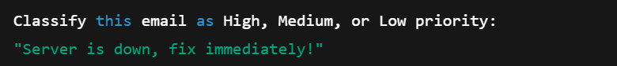
Output: High
One-Shot Prompt
Email: "Payment failed, urgent fix needed."
Priority: High
Now classify:
"Client meeting postponed to tomorrow."
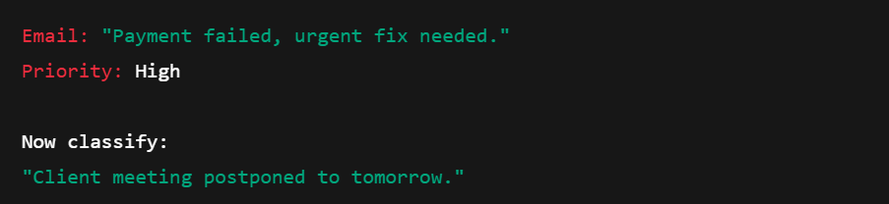
Output: Medium
Few-Shot Prompt
Email: "System crash reported."
Priority: High
Email: "Weekly update attached."
Priority: Medium
Email: "Thanks for your help."
Priority: Low
Now classify:
"Urgent payment issue, respond ASAP."
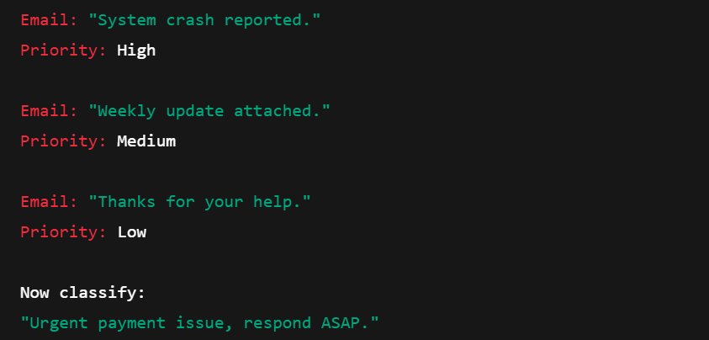
Output: High
Evaluation
Method | Reliability
Zero-shot | Moderate
One-shot | Good
Few-shot | Best
Few-shot gives context → better accuracy

3. Student Query Routing System
Scenario:
A university chatbot must route student queries to Admissions, Exams,
Academics, or Placements.
Tasks:
1. Create 6 sample student queries mapped to departments.
2. Implement Zero-shot intent classification using an LLM.
3. Improve results using One-shot prompting.
4. Further refine results using Few-shot prompting.
5. Analyze how contextual examples affect classification accuracy.
Departments
- Admissions
- Exams
- Academics
- Placements
Sample Queries
Query | Department
“What is the admission process?” | Admissions
“When are semester exams?” | Exams
“Explain Python syllabus.” | Academics
“Placement companies list?” | Placements
“Fee structure details” | Admissions
“Result declaration date?” | Exams
Zero-Shot Prompt
Classify the query:
"When are semester exams?"
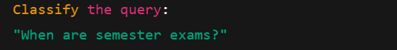
Output: Exams
One-Shot Prompt
Query: "How to apply for admission?"
Department: Admissions
Now classify:
"When are semester exams?"
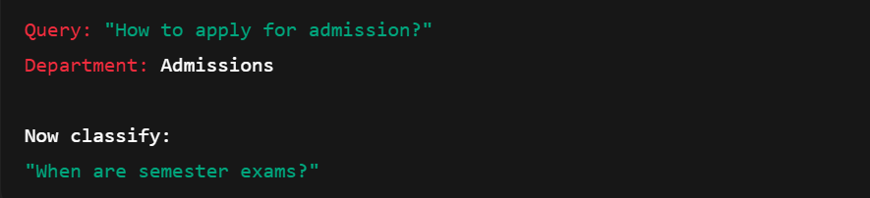
Output: Exams
Few-Shot Prompt
Query: "Syllabus for AI subject?"
Department: Academics
Query: "Placement drive details?"
Department: Placements
Query: "Fee structure?"
Department: Admissions
Now classify:
"When will results be announced?"
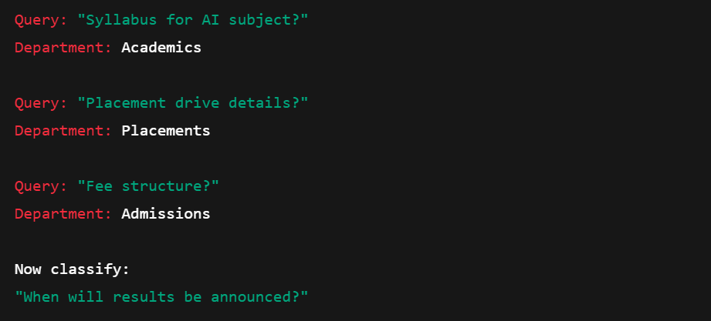
Output: Exams
Analysis
Few-shot prompting gives better domain understanding and routing accuracy.

4. Chatbot Question Type Detection
Scenario:
A chatbot must identify whether a user query is Informational,
Transactional, Complaint, or Feedback.
Tasks:
1. Prepare 6 chatbot queries mapped to question types.
2. Design prompts for Zero-shot, One-shot, and Few-shot learning.
3. Test all prompts on the same unseen queries.
4. Compare response correctness and ambiguity handling.
5. Document observations.
Question Types
- Informational
- Transactional
- Complaint
- Feedback
Sample Queries
Query | Type
“What is AI?” | Informational
“Book a ticket for tomorrow.” | Transactional
“The app crashes often.” | Complaint
“Great service, thank you!” | Feedback
“How to reset password?” | Informational
“Refund my payment.” | Transactional
Prompting Comparison
Zero-Shot:
Classify the query: "The app crashes often."
→ Complaint
One-Shot:
Query: "Great service!"
Type: Feedback
Now classify:
"The app crashes often."
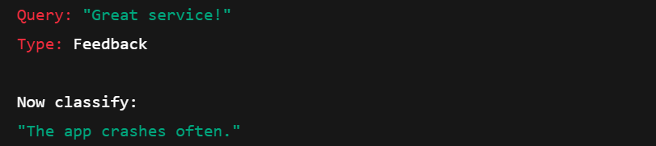
→ Complaint
Few-Shot:
Query: "What is AI?"
Type: Informational

Query: "Book my movie tickets."
Type: Transactional

Query: "The app is not working properly."
Type: Complaint

Query: "Excellent customer support!"
Type: Feedback

Now classify:
Query: "I want to cancel my order."
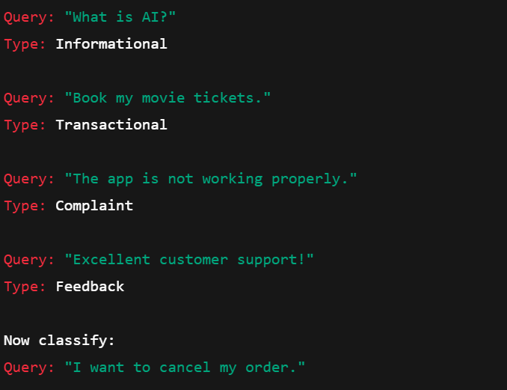
→ Transactional
Comparison Table
Method | Accuracy | Reason
Zero-shot | Medium | No learning examples
One-shot | Good | Learns from one pattern
Few-shot | Best | Learns multiple patterns
Observations
✔ Few-shot prompting gives highest accuracy
✔ Context improves intent understanding
✔ Reduces ambiguity
✔ Best suited for real-world chatbot systems
Conclusion
Few-shot prompting is the most reliable method for chatbot question classification because:
- It understands patterns better
- Handles ambiguous queries
- Produces consistent results
- Suitable for production chatbots

5. Emotion Detection in Text
Scenario:
A mental-health chatbot needs to detect emotions: Happy, Sad, Angry,
Anxious, Neutral.
Tasks:
1. Create labeled emotion samples.
2. Use Zero-shot prompting to identify emotions.
3. Use One-shot prompting with an example.
4. Use Few-shot prompting with multiple emotions.
5. Discuss ambiguity handling across techniques.
Scenario
A mental-health chatbot must detect user emotions in order to respond appropriately.
The emotions to be identified are:
- Happy
- Sad
- Angry
- Anxious
- Neutral
Sample Emotion Data
Text | Emotion
“I am very happy today!” | Happy
“I feel lonely and depressed.” | Sad
“This is unacceptable and annoying!” | Angry
“I am worried about my exams.” | Anxious
“Okay, noted.” | Neutral
“Everything is going well.” | Happy
Zero-Shot Prompt
Prompt
Detect the emotion in the following sentence:
"I am worried about my exams."
Output
Anxious
One-Shot Prompt
Prompt
Example:
Text: "I feel very sad today."
Emotion: Sad

Now classify:
Text: "I am worried about my exams."
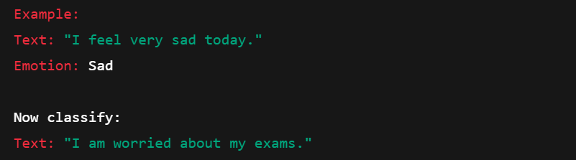
Output
Anxious
Few-Shot Prompt
Prompt
Text: "I am very happy today."
Emotion: Happy

Text: "This is extremely frustrating."
Emotion: Angry

Text: "I feel nervous about my interview."
Emotion: Anxious

Text: "Nothing special, just normal."
Emotion: Neutral

Now classify:
Text: "I am worried about my exams."
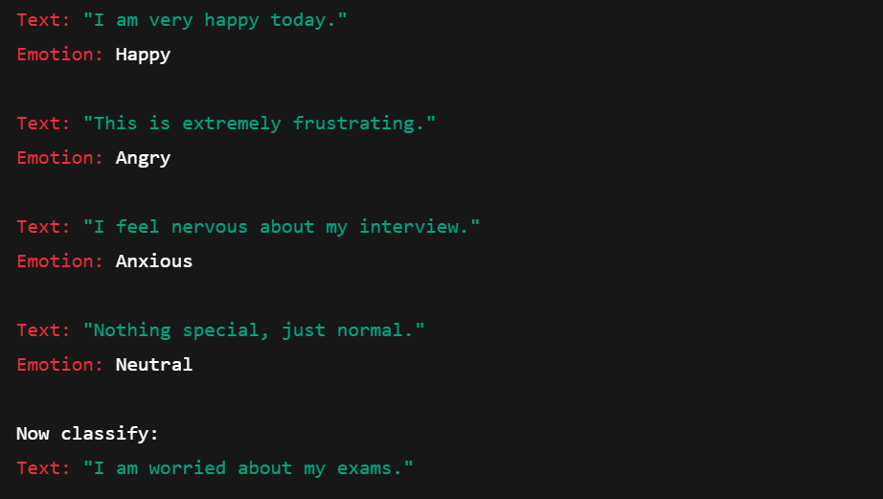
Output
Anxious
Comparison & Analysis
Method | Accuracy | Remarks
Zero-shot | Medium | No context provided
One-shot | Good | Learns from one example
Few-shot | Best | Handles emotion clearly
Observation
- Few-shot prompting gives highest accuracy
- Emotional ambiguity is handled better
- Useful for mental-health chatbots
- Improves response quality and reliability
Conclusion
Few-shot prompting is the most effective method for emotion detection because it:
- Provides context
- Improves classification accuracy
- Reduces ambiguity
- Works well in real-world chatbot applications

