Lab Assignment-01
Prompt:
#find fibonacci series upto n terms without using user defined functions
Code:
n = int(input("Enter the number of terms: "))
a, b = 0, 1
count = 0
if n <= 0:
print("Please enter a positive integer.")
elif n == 1:
print("Fibonacci sequence upto", n, ":")
print(a)
else:
print("Fibonacci sequence:")
while count < n:
print(a, end=' ')
a, b = b, a + b
count += 1
Output:
Enter the number of terms: 5
Fibonacci sequence:
0 1 1 2 3
Explaination:
1. The program asks for n and starts the Fibonacci series with a = 0 and b = 1.
2. If n is 0 or negative, it shows an error; if n == 1, it prints only 0.
3. Otherwise, it runs a while loop, printing a each time and updating the values using a, b = b, a + b.
4. The loop stops after printing n numbers.
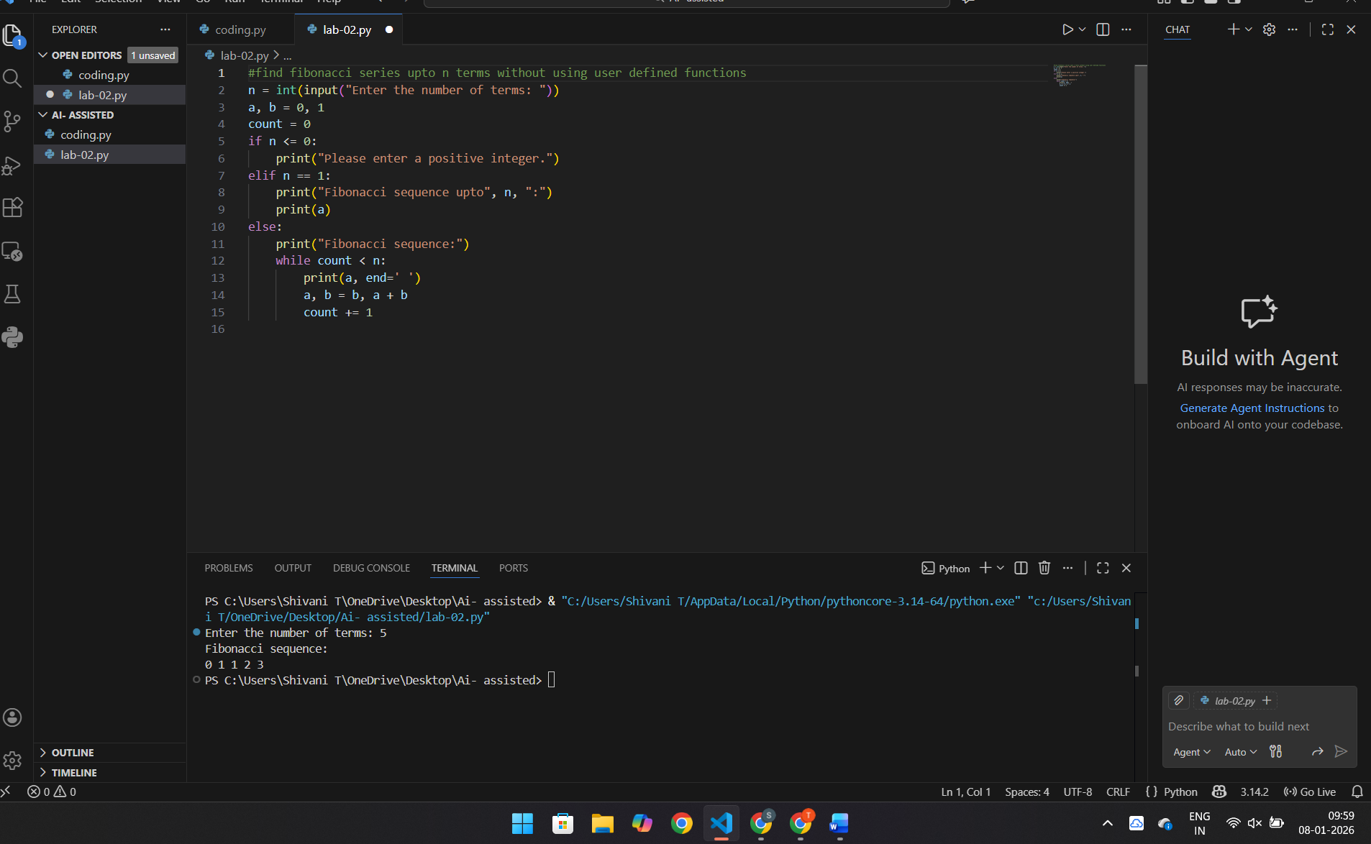

Prompt:
#find fibonacci series upto n terms without using user defined functions
Code:
n = int(input("Enter the number of terms: "))
a, b = 0, 1
if n <= 0:
print("Please enter a positive integer.")
elif n == 1:
print("Fibonacci sequence upto", n, ":")
print(a)
else:
print("Fibonacci sequence:")
for _ in range(n):
print(a, end=' ')
a, b = b, a + b
Explaination:
1. The program takes n from the user and starts with a = 0 and b = 1.
2. If n is not positive, it shows an error message.
3. Otherwise, a for loop runs n times, printing a each time.
4. Inside the loop, the next Fibonacci number is generated using a, b = b, a + b.

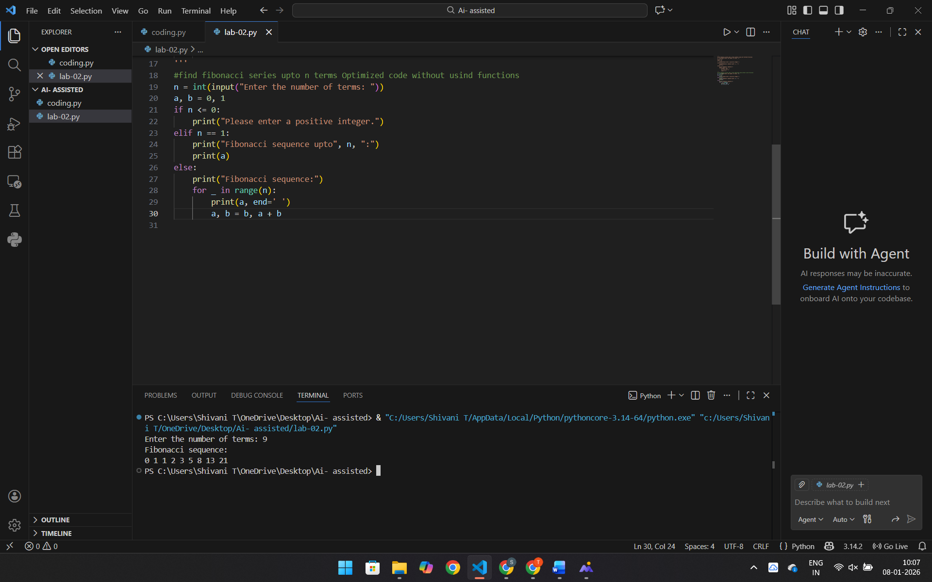
Prompt:
Find Fibanocci series using Functions returns or prints the sequence upto n terms
Code:
def fibonacci(n):
a, b = 0, 1
sequence = []
if n <= 0:
return "Please enter a positive integer."
elif n == 1:
sequence.append(a)
else:
for _ in range(n):
sequence.append(a)
a, b = b, a + b
return sequence
n = int(input("Enter the number of terms: "))
result = fibonacci(n)
print("Fibonacci sequence upto", n, "terms:")
print(result)
Explaination:
1. The function starts with 0 and 1 as the first Fibonacci numbers.
2. It repeats n times to create the next numbers.
3. Each number is added to a list.
4. The list is returned and printed as the Fibonacci sequence.
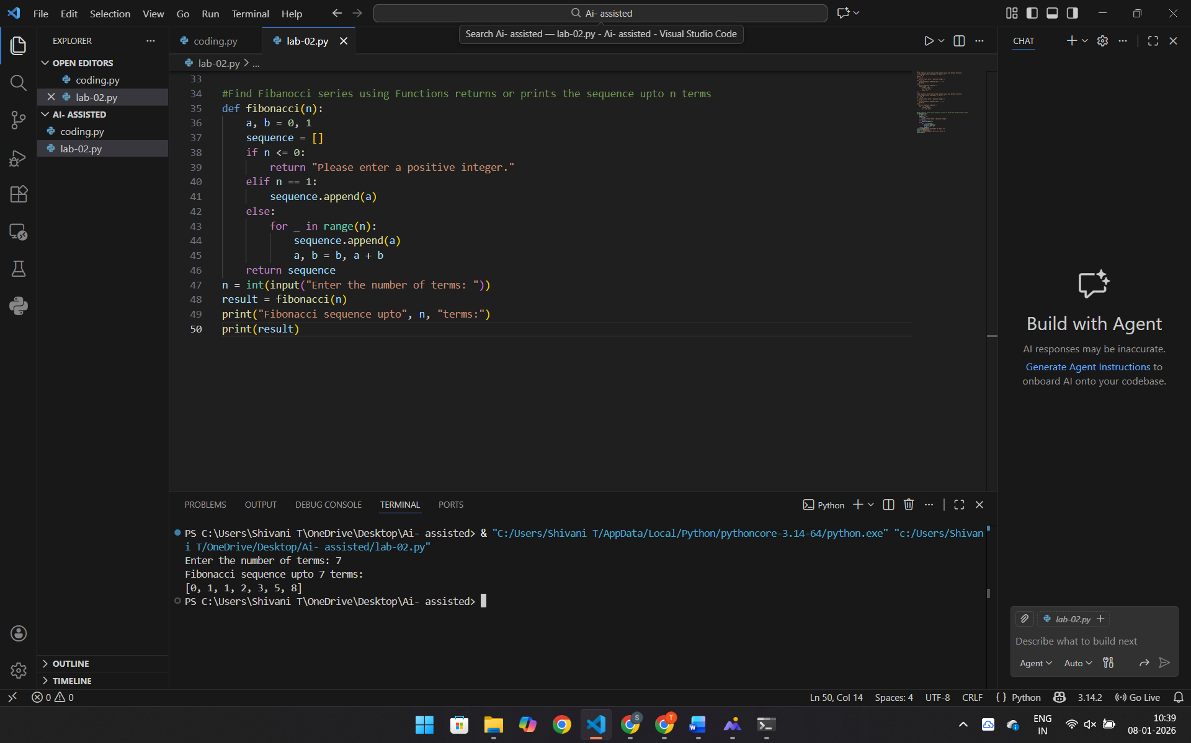
Prompt:
# Febonacci series with Procedural vs Modular Fibonacci Code AI code with and without functions
# Procedural approach
Code:
n = int(input("Enter the number of terms in modular fibonacci series: "))
a, b = 0, 1
if n <= 0:
print("Please enter a positive integer.")
else:
print("Fibonacci sequence up to", n, "terms:")
for _ in range(n):
print(a, end=' ')
a, b = b, a + b
print()
# Modular approach
def fibonacci_series(n):
a, b = 0, 1
series=[]
for _ in range(n):
series.append(a)
a, b = b, a + b
return series
n = int(input("Enter the number of terms in modular fibonacci series: "))
if n <= 0:
print("Please enter a positive integer.")
else:
print("Fibonacci sequence up to", n, "terms:")
print(fibonacci_series(n))
output:
Enter the number of terms in modular fibonacci series: 5
Fibonacci sequence up to 5 terms:
0 1 1 2 3
Explanation:
1.First part prints Fibonacci numbers directly using a for loop: it starts with a = 0, b = 1,
prints a each time, then updates with a, b = b, a + b.
2.It checks if n is positive before printing the series.
3.The second part uses a modular (function) approach: fibonacci_series(n) builds the
sequence in a list and returns it.
4.The program again asks for n, validates it, calls the function, and prints the returned list
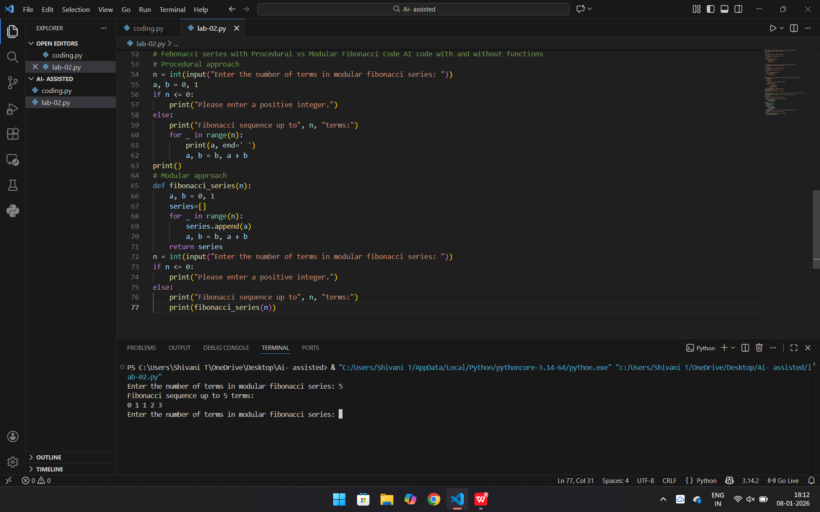
Prompt:
#AI-Generated Iterative vs Recursive Fibonacci Approaches (Different
#Algorithmic Approaches for Fibonacci Series)
# Iterative approach and Recursive approach
Code:
def fibonacci_iterative(n):
a, b = 0, 1
series = []
for _ in range(n):
series.append(a)
a, b = b, a + b
return series
def fibonacci_recursive(n, a=0, b=1, series=None):
if series is None:
series = []
if n == 0:
return series
series.append(a)
return fibonacci_recursive(n - 1, b, a + b, series)
n = int(input("Enter the number of terms for iterative Fibonacci series: "))
if n <= 0:
print("Please enter a positive integer.")
else:
print("Iterative Fibonacci series:")
print(fibonacci_iterative(n))
n = int(input("Enter the number of terms for recursive Fibonacci series: "))
if n <= 0:
print("Please enter a positive integer.")
else:
print("Recursive Fibonacci series:")
print(fibonacci_recursive(n))
Output:
Enter the number of terms in modular fibonacci series: 7
Fibonacci sequence up to 7 terms:
0 1 1 2 3 5 8
Explanation:
1. fibonacci_iterative(n) uses a loop: it starts with a = 0, b = 1, keeps appending
a to a list, updates a, b = b, a + b, and finally returns the list.
2.fibonacci_recursive(n, a, b, series) builds the same sequence using recursion:
it appends a, then calls itself with n-1 until n becomes 0.
3. The program asks the user for n twice (once for iterative, once for recursive),
checks that n is positive, and prints each result
