AI-Ass-2.3
Name: T.Shivani
HT.NO:2303A51312
Batch:05
Task: 1: Word Frequency from Text File
❖ Scenario:
You are analyzing log files for keyword frequency.
❖ Task:
Use Gemini to generate Python code that reads a text file and counts word
frequency, then explains the code.
Code:
"""
Read a text file and count word frequency.

Usage:
python word_frequency_counter.py path/to/file.txt
python word_frequency_counter.py path/to/file.txt --top 50
python word_frequency_counter.py path/to/file.txt --keywords error warn timeout
python word_frequency_counter.py path/to/file.txt --min-count 3 --top 100
"""
from __future__ import annotations
import argparse
import re
from collections import Counter
from pathlib import Path
from typing import Iterable
# Words are sequences of letters/digits/underscore; this naturally ignores punctuation.
WORD_RE = re.compile(r"\b\w+\b", re.UNICODE)
def iter_words(text: str) -> Iterable[str]:
"""Yield normalized words from text."""
for match in WORD_RE.finditer(text):
yield match.group(0).casefold()
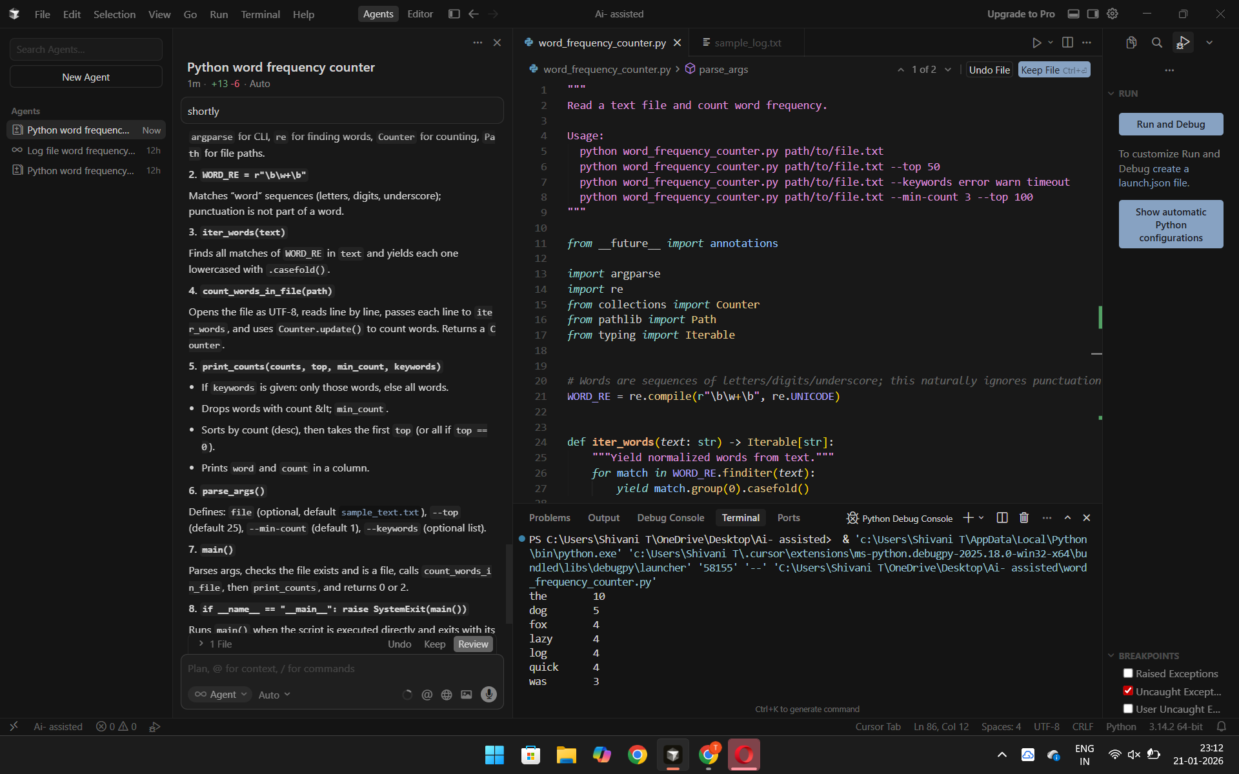
explanation: 1. Importsargparse for CLI, re for finding words, Counter for counting, Path for file paths.2. WORD_RE = r"\b\w+\b"Matches “word” sequences (letters, digits, underscore); punctuation is not part of a word.3. iter_words(text)Finds all matches of WORD_RE in text and yields each one lowercased with .casefold().4. count_words_in_file(path)Opens the file as UTF-8, reads line by line, passes each line to iter_words, and uses Counter.update() to count words. Returns a Counter.5. print_counts(counts, top, min_count, keywords)
- If keywords is given: only those words, else all words.
- Drops words with count &lt; min_count.
- Sorts by count (desc), then takes the first top (or all if top == 0).
- Prints word and count in a column.
6. parse_args()Defines: file (optional, default sample_text.txt), --top (default 25), --min-count (default 1), --keywords (optional list).7. main()Parses args, checks the file exists and is a file, calls count_words_in_file, then print_counts, and returns 0 or 2.8. if __name__ == "__main__": raise SystemExit(main())Runs main() when the script is executed directly and exits with its return code.
Task 2: File Operations Using Cursor AI
❖ Scenario:
You are automating basic file operations.
❖ Task:
Use Cursor AI to generate a program that:
➢ Creates a text file
➢ Writes sample text
➢ Reads and displays the content
Code:
def count_words_in_file(path: Path) -> Counter[str]:
"""Read a file and return a Counter of word frequencies."""
counts: Counter[str] = Counter()
# Use UTF-8 with replacement so "weird" bytes in logs won't crash the script.
with path.open("r", encoding="utf-8", errors="replace") as f:
for line in f:
counts.update(iter_words(line))
return counts

def print_counts(
counts: Counter[str],
*,
top: int,
min_count: int,
keywords: list[str] | None,
) -> None:
"""Print word counts, optionally filtered to specific keywords."""
if keywords:
# Normalize keywords the same way we normalize text.
wanted = [k.casefold() for k in keywords]
items = [(k, counts.get(k, 0)) for k in wanted]
items = [(k, c) for k, c in items if c >= min_count]
items.sort(key=lambda kv: (-kv[1], kv[0]))
else:
items = [(w, c) for (w, c) in counts.items() if c >= min_count]
items.sort(key=lambda kv: (-kv[1], kv[0]))
if top > 0:
items = items[:top]

if not items:
print("No matches (check --min-count / --keywords).")
return

width = max(len(w) for (w, _) in items)
for word, count in items:
print(f"{word:<{width}} {count}")

def parse_args() -> argparse.Namespace:
p = argparse.ArgumentParser(description="Count word/keyword frequency in a text/log file.")
p.add_argument(
"file",
type=Path,
nargs="?",
default=Path(__file__).parent / "sample_text.txt",
help="Path to the input .txt/.log file (default: sample_text.txt in same folder)",
)
p.add_argument("--top", type=int, default=25, help="Show top N words (ignored with --keywords). Use 0 for all.")
p.add_argument("--min-count", type=int, default=1, help="Only show words with count >= this value")
p.add_argument(
"--keywords",
nargs="*",
default=None,
help="If provided, only show counts for these specific words (case-insensitive).",
)
return p.parse_args()

def main() -> int:
args = parse_args()

if not args.file.exists():
print(f"File not found: {args.file}")
return 2
if not args.file.is_file():
print(f"Not a file: {args.file}")
return 2

counts = count_words_in_file(args.file)
print_counts(counts, top=args.top, min_count=args.min_count, keywords=args.keywords)
return 0

if __name__ == "__main__":
raise SystemExit(main())
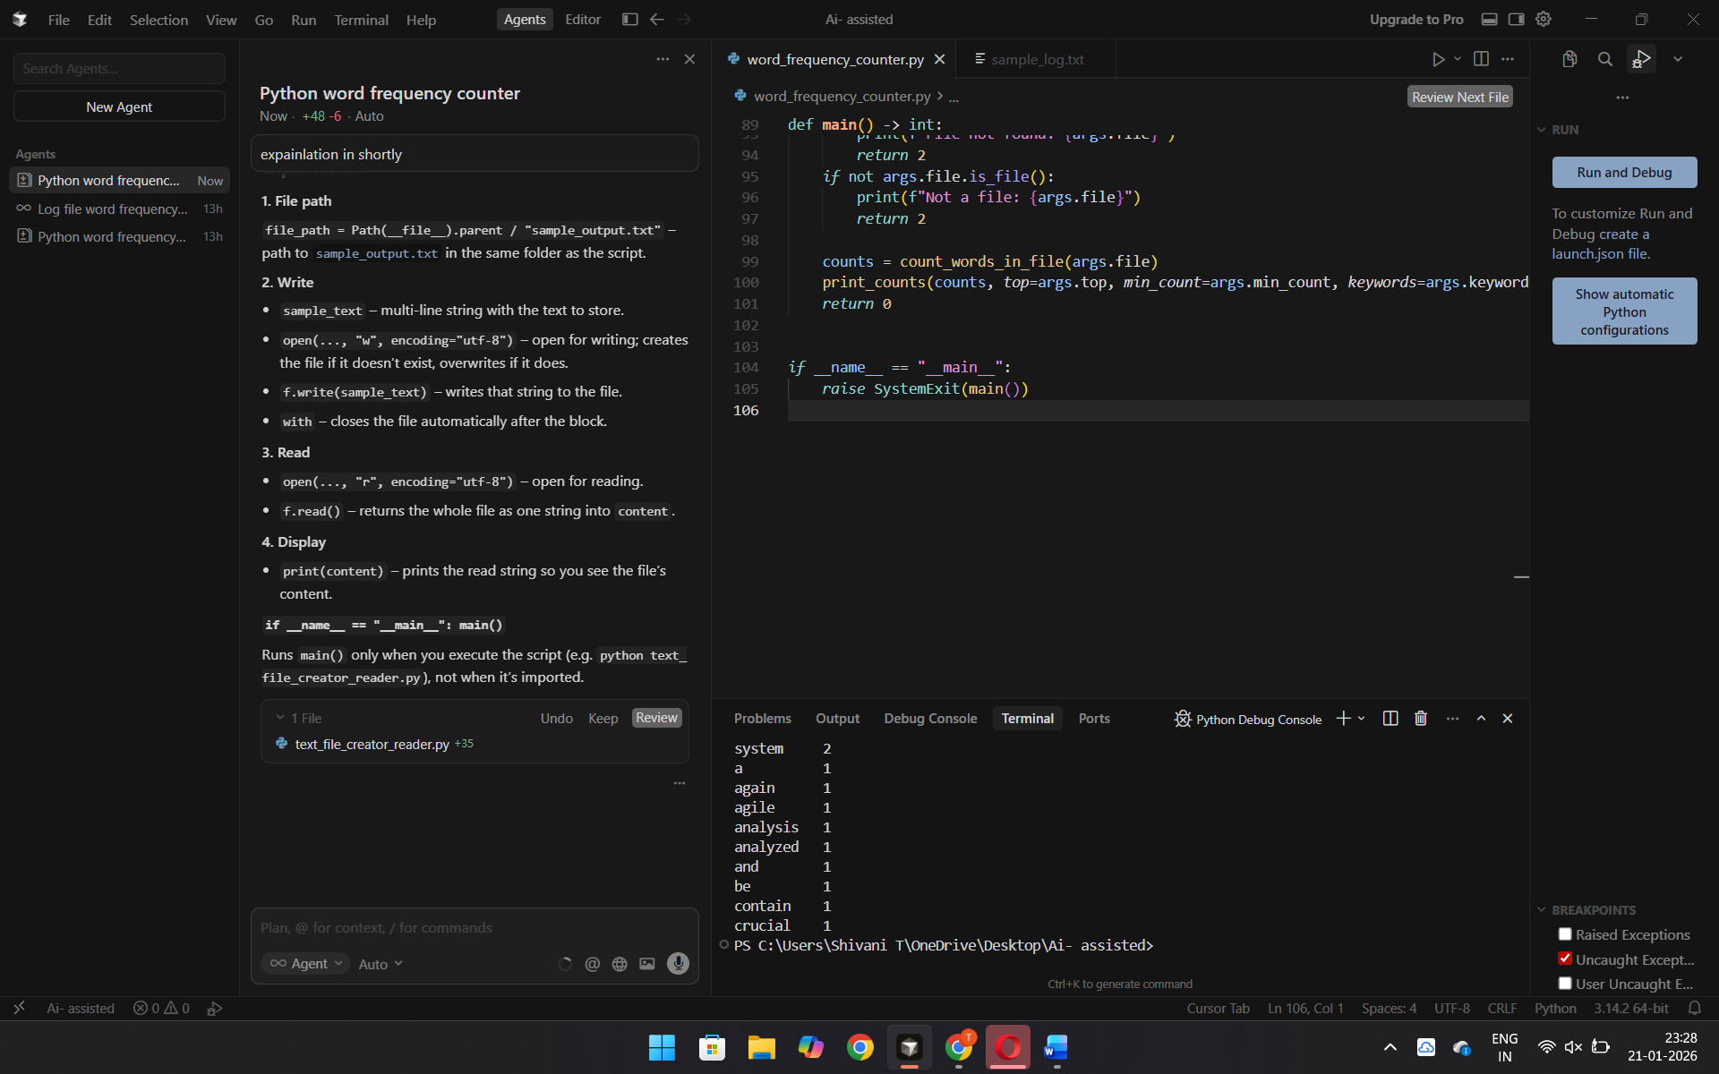
Explanation: 1. File pathfile_path = Path(__file__).parent / "sample_output.txt" – path to sample_output.txt in the same folder as the script.2. Write
- sample_text – multi-line string with the text to store.
- open(..., "w", encoding="utf-8") – open for writing; creates the file if it doesn’t exist, overwrites if it does.
- f.write(sample_text) – writes that string to the file.
- with – closes the file automatically after the block.
3. Read
- open(..., "r", encoding="utf-8") – open for reading.
- f.read() – returns the whole file as one string into content.
4. Display
- print(content) – prints the read string so you see the file’s content.
if __name__ == "__main__": main()Runs main() only when you execute the script (e.g. python text_file_creator_reader.py), not when it’s imported.
Task 3: CSV Data Analysis
❖ Scenario:
You are processing structured data from a CSV file.
❖ Task:
Use Gemini in Colab to read a CSV file and calculate mean, min, and max.
Code: “""
Read a CSV file and calculate mean, min, and max for numeric columns.

Usage:
python csv_stats.py [file.csv]
(default: sample_data.csv in same folder)
"""

import csv
import statistics
from pathlib import Path

def to_float(val: str) -> float | None:
"""Try to convert a string to float; return None if it fails."""
val = val.strip()
if not val:
return None
try:
return float(val)
except ValueError:
return None

def get_numeric_columns(rows: list[dict]) -> list[str]:
"""Find columns where at least one value can be parsed as a number."""
if not rows:
return []
numeric = []
for col in rows[0]:
values = [to_float(r.get(col, "")) for r in rows]
if any(v is not None for v in values):
numeric.append(col)
return numeric

def compute_stats(rows: list[dict], col: str) -> dict:
"""Compute mean, min, max for a numeric column."""
values = [to_float(r.get(col, "")) for r in rows]
values = [v for v in values if v is not None]
if not values:
return {"mean": None, "min": None, "max": None}
return {
"mean": statistics.mean(values),
"min": min(values),
"max": max(values),
}

def main(file_path: Path | None = None) -> int:
if file_path is None:
file_path = Path(__file__).parent / "sample_data.csv"

if not file_path.exists():
print(f"File not found: {file_path}")
print("Create sample_data.csv or pass a path: python csv_stats.py yourfile.csv")
return 2

with open(file_path, "r", encoding="utf-8", newline="") as f:
reader = csv.DictReader(f)
rows = list(reader)

if not rows:
print("CSV is empty or has no data rows.")
return 1

numeric_cols = get_numeric_columns(rows)
if not numeric_cols:
print("No numeric columns found.")
return 1

print(f"File: {file_path}\n")
print(f"{'Column':<16} {'Mean':>12} {'Min':>12} {'Max':>12}")
print("-" * 56)

for col in numeric_cols:
s = compute_stats(rows, col)
mean = f"{s['mean']:.2f}" if s["mean"] is not None else "N/A"
min_ = f"{s['min']:.2f}" if s["min"] is not None else "N/A"
max_ = f"{s['max']:.2f}" if s["max"] is not None else "N/A"
print(f"{col:<16} {mean:>12} {min_:>12} {max_:>12}")

return 0

if __name__ == "__main__":
import sys

path = Path(sys.argv[1]) if len(sys.argv) > 1 else None
raise SystemExit(main(path))
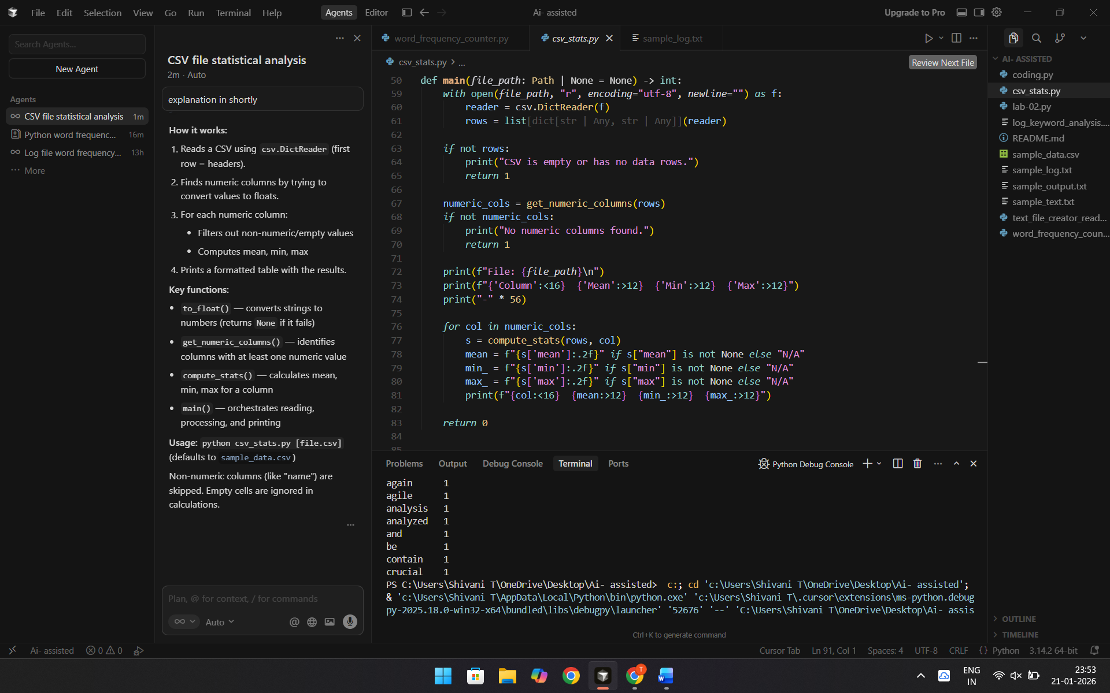
Explanation:
How it works:
- Reads a CSV using csv.DictReader (first row = headers).
- Finds numeric columns by trying to convert values to floats.
- For each numeric column:
- Filters out non-numeric/empty values
- Computes mean, min, max
- Prints a formatted table with the results.
Key functions:
- to_float() — converts strings to numbers (returns None if it fails)
- get_numeric_columns() — identifies columns with at least one numeric value
- compute_stats() — calculates mean, min, max for a column
- main() — orchestrates reading, processing, and printing
Usage: python csv_stats.py [file.csv] (defaults to sample_data.csv)Non-numeric columns (like "name") are skipped. Empty cells are ignored in calculations.
Task 4: Sorting Lists – Manual vs Built-in
❖ Scenario:
You are reviewing algorithm choices for efficiency.
❖ Task:
Use Gemini to generate:
➢ Bubble sort
➢ Python’s built-in sort()
➢ Compare both implementations.
Code: """
Sorting Algorithm Comparison: Bubble Sort vs Python's Built-in sort()

This script demonstrates:
1. Bubble sort implementation
2. Python's built-in sort() method
3. Performance and correctness comparison
"""

import time
import random
from typing import List, Callable

def bubble_sort(arr: List[int]) -> List[int]:
"""
Bubble Sort Algorithm Implementation

Time Complexity: O(n²)
Space Complexity: O(1)

Algorithm:
1. Compare adjacent elements
2. Swap if they are in wrong order
3. Repeat until no swaps are needed
"""
# Create a copy to avoid modifying the original list
arr = arr.copy()
n = len(arr)

# Traverse through all array elements
for i in range(n):
# Flag to optimize: if no swaps occur, list is sorted
swapped = False

# Last i elements are already in place
for j in range(0, n - i - 1):
# Compare adjacent elements
if arr[j] > arr[j + 1]:
# Swap if they are in wrong order
arr[j], arr[j + 1] = arr[j + 1], arr[j]
swapped = True

# If no swaps were made, array is sorted
if not swapped:
break

return arr

def python_builtin_sort(arr: List[int]) -> List[int]:
"""
Python's Built-in sort() Method

Uses Timsort algorithm (hybrid of merge sort and insertion sort)
Time Complexity: O(n log n) average case
Space Complexity: O(n)
"""
# Create a copy and sort in-place, then return
arr = arr.copy()
arr.sort()
return arr

def timed_sort(func: Callable, arr: List[int]) -> tuple[List[int], float]:
"""Measure execution time of a sorting function."""
start_time = time.perf_counter()
result = func(arr)
end_time = time.perf_counter()
elapsed_time = (end_time - start_time) * 1000 # Convert to milliseconds
return result, elapsed_time

def compare_sorts(test_data: List[int], label: str = "") -> None:
"""Compare bubble sort and Python's built-in sort on the same data."""
print(f"\n{'='*70}")
if label:
print(f"Test Case: {label}")
print(f"{'='*70}")
print(f"Input size: {len(test_data)} elements")
print(f"Input data (first 10): {test_data[:10]}...")

# Test Bubble Sort
bubble_result, bubble_time = timed_sort(bubble_sort, test_data)

# Test Python's Built-in Sort
builtin_result, builtin_time = timed_sort(python_builtin_sort, test_data)

# Verify correctness
is_correct = bubble_result == builtin_result
is_sorted = bubble_result == sorted(test_data)

# Display results
print(f"\n{'Results:':<25} {'Time (ms)':<15} {'Status':<20}")
print("-" * 70)
print(f"{'Bubble Sort':<25} {bubble_time:>12.4f} ms {'[OK] Correct' if is_correct else '[X] Incorrect'}")
print(f"{'Python built-in sort()':<25} {builtin_time:>12.4f} ms {'[OK] Correct' if is_sorted else '[X] Incorrect'}")

if is_correct:
print(f"\n[OK] Both implementations produce identical results!")
print(f"[OK] Speed difference: {bubble_time / builtin_time:.2f}x slower (Bubble Sort)")
else:
print(f"\n[X] Results differ! Check implementation.")
print(f"\nSorted output (first 10): {bubble_result[:10]}...")
print(f"{'='*70}\n")
def main():
"""Run comparison tests with different data sizes and patterns."""
print("Sorting Algorithm Comparison")
print("=" * 70)
# Test 1: Small random array
random.seed(42)
small_random = [random.randint(1, 100) for _ in range(50)]
compare_sorts(small_random, "Small Random Array (50 elements)"
# Test 2: Medium random array
medium_random = [random.randint(1, 1000) for _ in range(500)]
compare_sorts(medium_random, "Medium Random Array (500 elements)")

# Test 3: Large random array
large_random = [random.randint(1, 10000) for _ in range(5000)]
compare_sorts(large_random, "Large Random Array (5000 elements)")
# Test 4: Already sorted array (best case for bubble sort optimization)
sorted_array = list(range(100))
compare_sorts(sorted_array, "Already Sorted Array (100 elements)")
# Test 5: Reverse sorted array (worst case for bubble sort)
reverse_sorted = list(range(100, 0, -1))
compare_sorts(reverse_sorted, "Reverse Sorted Array (100 elements)")
# Test 6: Array with duplicates
duplicates = [5, 2, 8, 2, 9, 1, 5, 5, 3, 2] * 10
compare_sorts(duplicates, "Array with Duplicates (100 elements)")
# Summary
print("\n" + "="*70)
print("Summary")
print("="*70)
print("""
Key Differences:
1. TIME COMPLEXITY:
• Bubble Sort: O(n²) - quadratic time
• Python sort(): O(n log n) - linearithmic time
2. SPACE COMPLEXITY:
• Bubble Sort: O(1) - sorts in-place (we copy for comparison)
• Python sort(): O(n) - requires additional memory for Timsort

3. PERFORMANCE:
• Bubble Sort: Slower, especially for large datasets
• Python sort(): Much faster, highly optimized C implementation
4. USE CASES:
• Bubble Sort: Educational purposes, small datasets, when memory is limited
• Python sort(): Production code, large datasets, when performance matters
5. STABILITY:
• Both algorithms are stable (maintain relative order of equal elements)
6. ADAPTIVITY:
• Bubble Sort: Can be optimized to detect already-sorted arrays
• Python sort(): Highly adaptive, detects patterns in data
""")
print("="*70)
if __name__ == "__main__":
main()

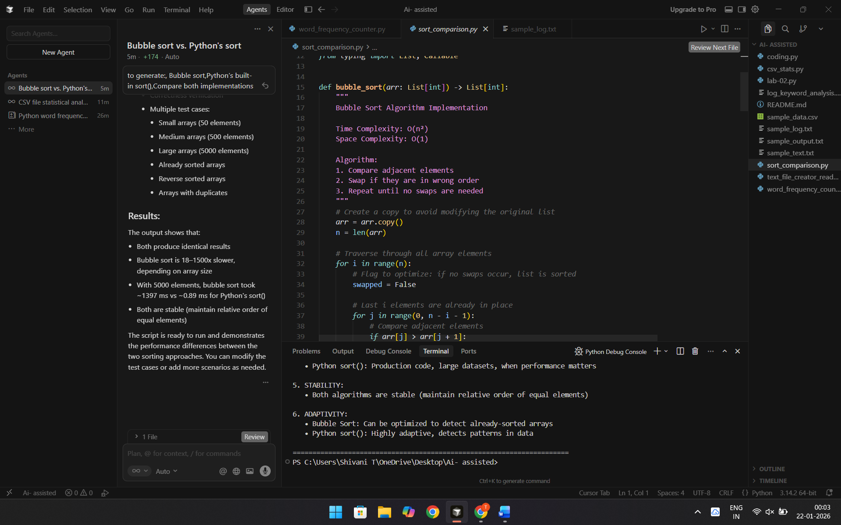
Explanation: Bubble Sort:
- Compares adjacent elements and swaps if out of order
- Repeats until no swaps occur
- Time: O(n²) — slow for large arrays
- Space: O(1) — sorts in place
Python's Built-in sort():
- Uses Timsort (merge + insertion sort hybrid)
- Time: O(n log n) — faster
- Space: O(n) — needs extra memory
- Optimized C implementation
Key differences:
- Speed: sort() is much faster (often 100–1000x+ on large arrays)
- Complexity: Bubble sort is O(n²), sort() is O(n log n)
- Use cases: Bubble sort is mainly educational; sort() is for production
Bottom line: Both produce correct results, but sort() is faster. Use bubble sort for learning; use sort() in real code.The script tests both on various datasets and shows the performance gap.

