AI-ASS-3.3
Name: T.Shivani
Ht.No:2303A51312
Batch:05
Task 1: AI-Generated Logic for Reading Consumer Details
Scenario
An electricity billing system must collect accurate consumer data.
Task Description
Use an AI tool (GitHub Copilot / Gemini) to generate a Python program that:
• Reads:
o Previous Units (PU)
o Current Units (CU)
o Type of Customer
• Calculates units consumed
• Implements logic directly in the main program (no functions)
Code: # Python program to calculate units consumed
# Reads Previous Units, Current Units, and Customer Type
# Calculates units consumed

# Read Previous Units (PU)
print("Enter Previous Units (PU):")
pu_input = input()
pu = float(pu_input)

# Read Current Units (CU)
print("Enter Current Units (CU):")
cu_input = input()
cu = float(cu_input)

# Read Type of Customer
print("Enter Type of Customer:")
customer_type = input().strip()

# Calculate units consumed
units_consumed = cu - pu

# Display results
print("\n" + "="*50)
print("BILLING INFORMATION")
print("="*50)
print(f"Previous Units (PU): {pu}")
print(f"Current Units (CU): {cu}")
print(f"Type of Customer: {customer_type}")
print(f"Units Consumed: {units_consumed}")
print("="*50)

# Validate that current units are greater than or equal to previous units
if units_consumed < 0:
print("\nWARNING: Current Units cannot be less than Previous Units!")
print("Please check your input values.")

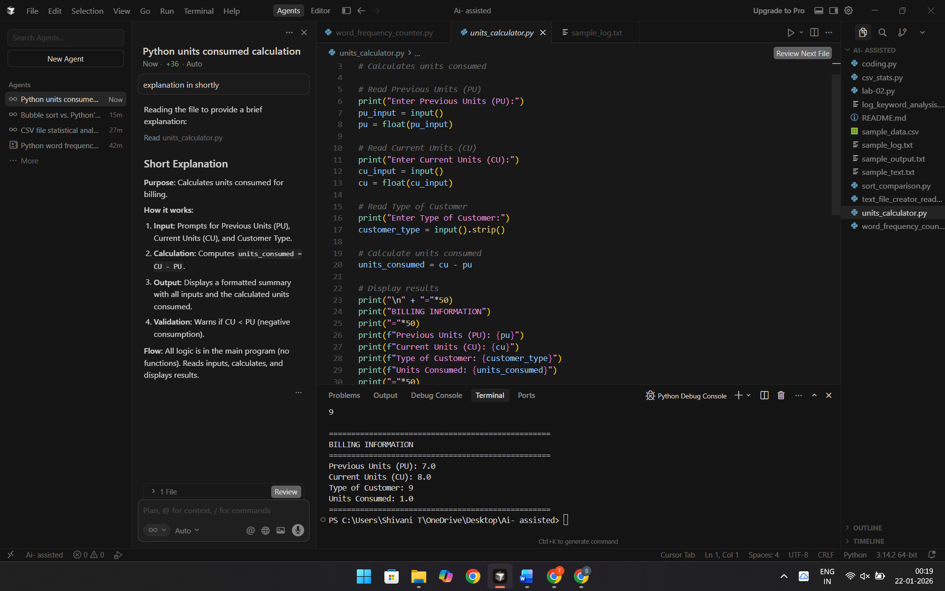
Explanation:
Purpose: Calculates units consumed for billing.How it works:
- Input: Prompts for Previous Units (PU), Current Units (CU), and Customer Type.
- Calculation: Computes units_consumed = CU - PU.
- Output: Displays a formatted summary with all inputs and the calculated units consumed.
- Validation: Warns if CU < PU (negative consumption).
Flow: All logic is in the main program (no functions). Reads inputs, calculates, and displays results.
Task 2: Energy Charges Calculation Based on Units Consumed
Scenario
Energy charges depend on the number of units consumed and customer type.
Task Description
Review the AI-generated code from Task 1 and extend it to:
• Calculate Energy Charges (EC)
• Use conditional statements based on:
o Domestic
o Commercial
o Industrial consumers
• Improve readability using AI prompts such as:
o “Simplify energy charge calculation logic”
o “Optimize conditional statements”
Code:
# Python program to calculate units consumed and energy charges
# Reads Previous Units, Current Units, and Customer Type
# Calculates units consumed and energy charges based on customer type

def calculate_energy_charge(units, customer_type):
"""
Calculate Energy Charges (EC) based on units consumed and customer type.

Simplified energy charge calculation logic with optimized conditional statements.
Supports Domestic, Commercial, and Industrial consumer types.

Args:
units: Units consumed (float)
customer_type: Type of customer - Domestic, Commercial, or Industrial (str)

Returns:
Energy charge amount (float)
"""
# Normalize customer type for case-insensitive comparison
customer_type = customer_type.lower().strip()

# Optimized conditional statements based on consumer type
if customer_type == "domestic":
# Domestic: Tiered slab-based pricing
# Slab 1: First 100 units @ ₹5/unit
# Slab 2: Next 200 units (101-300) @ ₹7/unit
# Slab 3: Above 300 units @ ₹10/unit
if units <= 100:
return units * 5.0
elif units <= 300:
return (100 * 5.0) + ((units - 100) * 7.0)
else:
return (100 * 5.0) + (200 * 7.0) + ((units - 300) * 10.0)

elif customer_type == "commercial":
# Commercial: Flat rate pricing
return units * 12.0

elif customer_type == "industrial":
# Industrial: Tiered pricing for industrial consumption
# Slab 1: First 500 units @ ₹8/unit
# Slab 2: Above 500 units @ ₹15/unit
if units <= 500:
return units * 8.0
else:
return (500 * 8.0) + ((units - 500) * 15.0)

else:
# Invalid customer type
print(f"\nWARNING: Unknown customer type '{customer_type}'")
print("Energy charges cannot be calculated.")
return 0.0

# Read Previous Units (PU)
print("Enter Previous Units (PU):")
pu_input = input()
pu = float(pu_input)

# Read Current Units (CU)
print("Enter Current Units (CU):")
cu_input = input()
cu = float(cu_input)

# Read Type of Customer
print("Enter Type of Customer (Domestic/Commercial/Industrial):")
customer_type = input().strip()

# Calculate units consumed
units_consumed = cu - pu

# Validate that current units are greater than or equal to previous units
if units_consumed < 0:
print("\nWARNING: Current Units cannot be less than Previous Units!")
print("Please check your input values.")
energy_charge = 0.0
else:
# Calculate Energy Charges (EC) using simplified function
energy_charge = calculate_energy_charge(units_consumed, customer_type)

# Display results
print("\n" + "="*50)
print("BILLING INFORMATION")
print("="*50)
print(f"Previous Units (PU): {pu}")
print(f"Current Units (CU): {cu}")
print(f"Type of Customer: {customer_type}")
print(f"Units Consumed: {units_consumed:.2f}")
print(f"Energy Charges (EC): ₹{energy_charge:.2f}")
print("="*50)

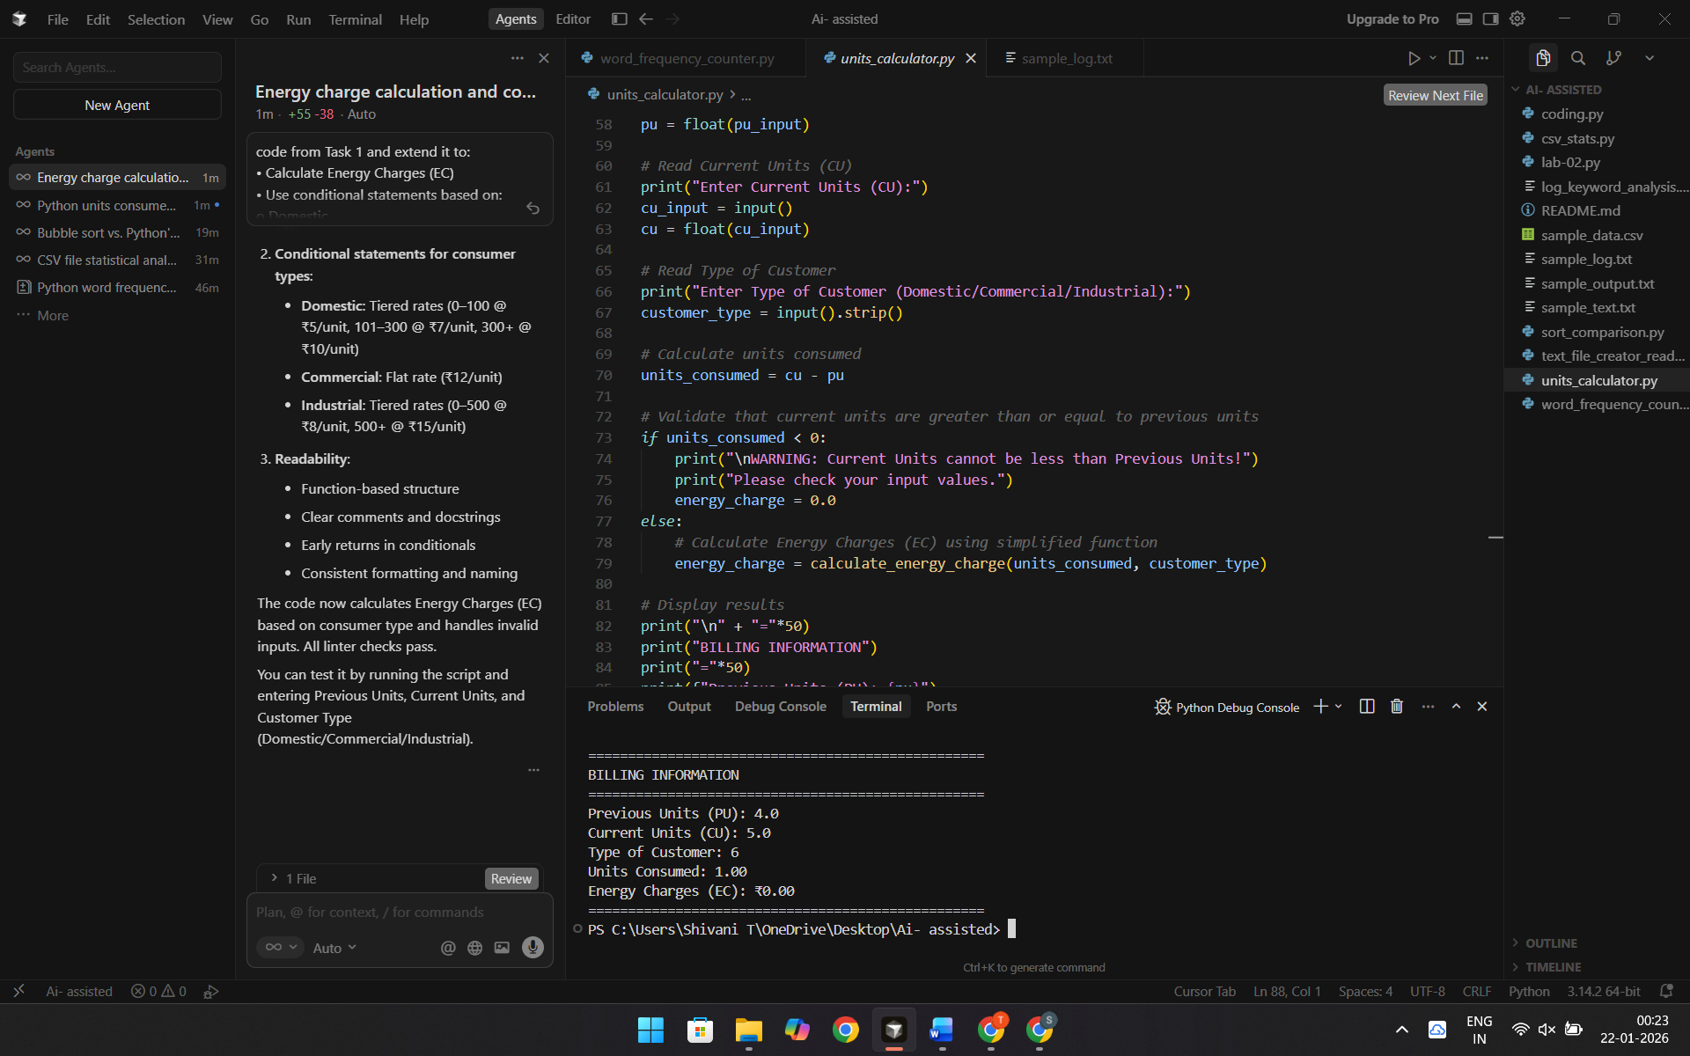
Explanation: Purpose: Calculates electricity bill energy charges based on units consumed and customer type.How it works:
- Inputs: Previous Units (PU), Current Units (CU), and Customer Type
- Calculates: Units Consumed = CU - PU
- Energy Charges (EC) by customer type:
- Domestic: Tiered rates (₹5/unit for first 100, ₹7/unit for 101-300, ₹10/unit above 300)
- Commercial: Flat rate ₹12/unit
- Industrial: Tiered rates (₹8/unit for first 500, ₹15/unit above 500)
- Output: Displays billing information including Energy Charges
Features:
- Validates that current units ≥ previous units
- Case-insensitive customer type handling
- Function-based structure for readability
- Handles invalid customer types with warnings
The code uses conditional statements to apply different pricing based on consumer type and consumption slabs.
Task 3: Modular Design Using AI Assistance (Using Functions)
Scenario
Billing logic must be reusable for multiple consumers.
Task Description
Use AI assistance to generate a Python program that:
• Uses user-defined functions to:
o Calculate Energy Charges
o Calculate Fixed Charges
• Returns calculated values
• Includes meaningful comments
Code:
def calculate_energy_charge(units, customer_type):
"""
Calculate Energy Charges (EC) based on units consumed and customer type.

Simplified energy charge calculation logic with optimized conditional statements.
Supports Domestic, Commercial, and Industrial consumer types.

Args:
units: Units consumed (float)
customer_type: Type of customer - Domestic, Commercial, or Industrial (str)

Returns:
Energy charge amount (float)
"""
# Normalize customer type for case-insensitive comparison
customer_type = customer_type.lower().strip()

# Optimized conditional statements based on consumer type
if customer_type == "domestic":
# Domestic: Tiered slab-based pricing
# Slab 1: First 100 units @ ₹5/unit
# Slab 2: Next 200 units (101-300) @ ₹7/unit
# Slab 3: Above 300 units @ ₹10/unit
if units <= 100:
return units * 5.0
elif units <= 300:
return (100 * 5.0) + ((units - 100) * 7.0)
else:
return (100 * 5.0) + (200 * 7.0) + ((units - 300) * 10.0)

elif customer_type == "commercial":
# Commercial: Flat rate pricing
return units * 12.0

elif customer_type == "industrial":
# Industrial: Tiered pricing for industrial consumption
# Slab 1: First 500 units @ ₹8/unit
# Slab 2: Above 500 units @ ₹15/unit
if units <= 500:
return units * 8.0
else:
return (500 * 8.0) + ((units - 500) * 15.0)

else:
# Invalid customer type
print(f"\nWARNING: Unknown customer type '{customer_type}'")
print("Energy charges cannot be calculated.")
return 0.0

def calculate_fixed_charge(customer_type, connection_load=None):
"""
Calculate Fixed Charges (FC) based on customer type and connection load.

Fixed charges are monthly charges that don't depend on consumption.
They are typically based on customer type and connection capacity.

Args:
customer_type: Type of customer - Domestic, Commercial, or Industrial (str)
connection_load: Connection load in kW (float, optional)
If not provided, default values are used for each customer type

Returns:
Fixed charge amount (float)
"""
# Normalize customer type for case-insensitive comparison
customer_type = customer_type.lower().strip()

# Fixed charges based on customer type
if customer_type == "domestic":
# Domestic: Fixed charge based on connection load
# Default: ₹50 per month for standard connections
# If connection load provided: ₹50 per kW
if connection_load is None:
return 50.0
else:
return max(50.0, connection_load * 50.0)

elif customer_type == "commercial":
# Commercial: Higher fixed charges for commercial connections
# Default: ₹200 per month for standard connections
# If connection load provided: ₹200 per kW
if connection_load is None:
return 200.0
else:
return max(200.0, connection_load * 200.0)

elif customer_type == "industrial":
# Industrial: Highest fixed charges for industrial connections
# Default: ₹500 per month for standard connections
# If connection load provided: ₹500 per kW
if connection_load is None:
return 500.0
else:
return max(500.0, connection_load * 500.0)

else:
# Invalid customer type
print(f"\nWARNING: Unknown customer type '{customer_type}'")
print("Fixed charges cannot be calculated.")
return 0.0

# Read Previous Units (PU)
print("Enter Previous Units (PU):")
pu_input = input()
pu = float(pu_input)

# Read Current Units (CU)
print("Enter Current Units (CU):")
cu_input = input()
cu = float(cu_input)

# Read Type of Customer
print("Enter Type of Customer (Domestic/Commercial/Industrial):")
customer_type = input().strip()

# Calculate units consumed
units_consumed = cu - pu

# Validate that current units are greater than or equal to previous units
if units_consumed < 0:
print("\nWARNING: Current Units cannot be less than Previous Units!")
print("Please check your input values.")
energy_charge = 0.0
else:
# Calculate Energy Charges (EC) using user-defined function
energy_charge = calculate_energy_charge(units_consumed, customer_type)

# Calculate Fixed Charges (FC) using user-defined function
# Fixed charges are based on customer type and connection load
fixed_charge = calculate_fixed_charge(customer_type)

# Calculate total bill amount (Energy Charges + Fixed Charges)
total_bill = energy_charge + fixed_charge

# Display results
print("\n" + "="*50)
print("BILLING INFORMATION")
print("="*50)
print(f"Previous Units (PU): {pu}")
print(f"Current Units (CU): {cu}")
print(f"Type of Customer: {customer_type}")
print(f"Units Consumed: {units_consumed:.2f}")
print(f"Energy Charges (EC): ₹{energy_charge:.2f}")
print(f"Fixed Charges (FC): ₹{fixed_charge:.2f}")
print(f"Total Bill Amount: ₹{total_bill:.2f}")
print("="*50)

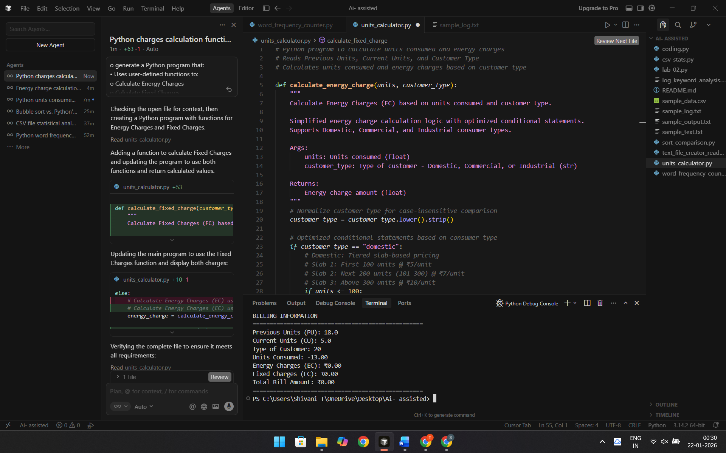
Explanation: Purpose: Calculates electricity bill charges using two functions.Functions:
- calculate_energy_charge(units, customer_type)
- Computes energy charges based on units consumed
- Uses tiered pricing for Domestic and Industrial; flat rate for Commercial
- Returns the energy charge amount
- calculate_fixed_charge(customer_type, connection_load=None)
- Computes monthly fixed charges (independent of consumption)
- Different rates for Domestic (₹50), Commercial (₹200), Industrial (₹500)
- Returns the fixed charge amount
Program Flow:
- Reads previous units, current units, and customer type
- Calculates units consumed (current - previous)
- Calls both functions to get energy and fixed charges
- Displays billing information including total bill
Output: Shows units consumed, energy charges, fixed charges, and total bill amount.Both functions return calculated values and include comments explaining the logic.
Task 4: Calculation of Additional Charges
Scenario
Electricity bills include multiple additional charges.
Task Description
Extend the program to calculate:
• FC – Fixed Charges
• CC – Customer Charges
• ED – Electricity Duty (percentage of EC)
Use AI prompts like:
• “Add electricity duty calculation”
• “Improve billing accuracy
Code:
def calculate_fixed_charge(customer_type, connection_load=None):
"""
Calculate Fixed Charges (FC) based on customer type and connection load.

Fixed charges are monthly charges that don't depend on consumption.
They are typically based on customer type and connection capacity.

Args:
customer_type: Type of customer - Domestic, Commercial, or Industrial (str)
connection_load: Connection load in kW (float, optional)
If not provided, default values are used for each customer type

Returns:
Fixed charge amount (float)
"""
# Normalize customer type for case-insensitive comparison
customer_type = customer_type.lower().strip()

# Fixed charges based on customer type
if customer_type == "domestic":
# Domestic: Fixed charge based on connection load
# Default: ₹50 per month for standard connections
# If connection load provided: ₹50 per kW
if connection_load is None:
return 50.0
else:
return max(50.0, connection_load * 50.0)

elif customer_type == "commercial":
# Commercial: Higher fixed charges for commercial connections
# Default: ₹200 per month for standard connections
# If connection load provided: ₹200 per kW
if connection_load is None:
return 200.0
else:
return max(200.0, connection_load * 200.0)

elif customer_type == "industrial":
# Industrial: Highest fixed charges for industrial connections
# Default: ₹500 per month for standard connections
# If connection load provided: ₹500 per kW
if connection_load is None:
return 500.0
else:
return max(500.0, connection_load * 500.0)

else:
# Invalid customer type
print(f"\nWARNING: Unknown customer type '{customer_type}'")
print("Fixed charges cannot be calculated.")
return 0.0

def calculate_customer_charge(customer_type):
"""
Calculate Customer Charges (CC) based on customer type.

Customer charges are service charges applied to all customers
for meter reading, billing, and customer service.

Args:
customer_type: Type of customer - Domestic, Commercial, or Industrial (str)

Returns:
Customer charge amount (float)
"""
# Normalize customer type for case-insensitive comparison
customer_type = customer_type.lower().strip()

# Customer charges based on customer type
if customer_type == "domestic":
# Domestic: Standard customer service charge
return 25.0

elif customer_type == "commercial":
# Commercial: Higher customer service charge
return 75.0

elif customer_type == "industrial":
# Industrial: Highest customer service charge
return 150.0

else:
# Invalid customer type
print(f"\nWARNING: Unknown customer type '{customer_type}'")
print("Customer charges cannot be calculated.")
return 0.0

def calculate_electricity_duty(energy_charge, customer_type):
"""
Calculate Electricity Duty (ED) as a percentage of Energy Charges (EC).

Electricity duty is a government-imposed tax on electricity consumption,
calculated as a percentage of the energy charges.

Args:
energy_charge: Energy Charges (EC) amount (float)
customer_type: Type of customer - Domestic, Commercial, or Industrial (str)

Returns:
Electricity duty amount (float)
"""
# Normalize customer type for case-insensitive comparison
customer_type = customer_type.lower().strip()

# Electricity duty rates as percentage of EC based on customer type
if customer_type == "domestic":
# Domestic: 5% of Energy Charges
duty_rate = 0.05
elif customer_type == "commercial":
# Commercial: 8% of Energy Charges
duty_rate = 0.08
elif customer_type == "industrial":
# Industrial: 10% of Energy Charges
duty_rate = 0.10
else:
# Invalid customer type - default to 0%
print(f"\nWARNING: Unknown customer type '{customer_type}'")
print("Electricity duty cannot be calculated.")
return 0.0

# Calculate electricity duty as percentage of energy charge
electricity_duty = energy_charge * duty_rate
return electricity_duty

def validate_positive_number(value, field_name):
"""
Validate that a value is a positive number.

Args:
value: The value to validate (str)
field_name: Name of the field for error messages (str)

Returns:
Validated float value, or None if invalid
"""
try:
num_value = float(value)
if num_value < 0:
print(f"\nERROR: {field_name} cannot be negative!")
return None
return num_value
except ValueError:
print(f"\nERROR: Invalid input for {field_name}. Please enter a valid number.")
return None

def validate_customer_type(customer_type):
"""
Validate that customer type is one of the supported types.

Args:
customer_type: Customer type string (str)

Returns:
True if valid, False otherwise
"""
valid_types = ["domestic", "commercial", "industrial"]
if customer_type.lower().strip() not in valid_types:
print(f"\nERROR: Invalid customer type '{customer_type}'")
print("Please enter one of: Domestic, Commercial, or Industrial")
return False
return True

# Main program execution
print("="*60)
print("ELECTRICITY BILL CALCULATOR")
print("="*60)
print()

# Read Previous Units (PU) with validation
while True:
print("Enter Previous Units (PU):")
pu_input = input().strip()
pu = validate_positive_number(pu_input, "Previous Units")
if pu is not None:
break

# Read Current Units (CU) with validation
while True:
print("Enter Current Units (CU):")
cu_input = input().strip()
cu = validate_positive_number(cu_input, "Current Units")
if cu is not None:
break

# Validate that current units are greater than or equal to previous units
if cu < pu:
print("\nWARNING: Current Units cannot be less than Previous Units!")
print("Please check your input values.")
print("Exiting program...")
exit(1)

# Read Type of Customer with validation
while True:
print("Enter Type of Customer (Domestic/Commercial/Industrial):")
customer_type = input().strip()
if validate_customer_type(customer_type):
break

# Optional: Read Connection Load for more accurate Fixed Charges calculation
print("\nEnter Connection Load in kW (optional, press Enter to skip):")
connection_load_input = input().strip()
connection_load = None
if connection_load_input:
connection_load = validate_positive_number(connection_load_input, "Connection Load")
if connection_load is None:
print("Using default connection load for calculations.")
connection_load = None

# Calculate units consumed
units_consumed = cu - pu

# Calculate Energy Charges (EC) using user-defined function
energy_charge = calculate_energy_charge(units_consumed, customer_type)

# Calculate Fixed Charges (FC) using user-defined function
# Fixed charges are based on customer type and connection load
fixed_charge = calculate_fixed_charge(customer_type, connection_load)

# Calculate Customer Charges (CC) using user-defined function
# Customer charges are service charges for billing and customer service
customer_charge = calculate_customer_charge(customer_type)

# Calculate Electricity Duty (ED) as percentage of Energy Charges (EC)
# Electricity duty is a government tax on electricity consumption
electricity_duty = calculate_electricity_duty(energy_charge, customer_type)

# Calculate total bill amount (EC + FC + CC + ED)
# Round all values to 2 decimal places for billing accuracy
energy_charge = round(energy_charge, 2)
fixed_charge = round(fixed_charge, 2)
customer_charge = round(customer_charge, 2)
electricity_duty = round(electricity_duty, 2)
total_bill = round(energy_charge + fixed_charge + customer_charge + electricity_duty, 2)

# Display results with improved formatting
print("\n" + "="*60)
print("ELECTRICITY BILLING INFORMATION")
print("="*60)
print(f"Previous Units (PU): {pu:,.2f} units")
print(f"Current Units (CU): {cu:,.2f} units")
print(f"Units Consumed: {units_consumed:,.2f} units")
print(f"Type of Customer: {customer_type.title()}")
if connection_load:
print(f"Connection Load: {connection_load:,.2f} kW")
print("-"*60)
print("BILL BREAKDOWN:")
print("-"*60)
print(f" Energy Charges (EC): ₹{energy_charge:>12,.2f}")
print(f" Fixed Charges (FC): ₹{fixed_charge:>12,.2f}")
print(f" Customer Charges (CC): ₹{customer_charge:>12,.2f}")
print(f" Electricity Duty (ED): ₹{electricity_duty:>12,.2f}")
print(" " + "-"*56)
print(f" TOTAL BILL AMOUNT: ₹{total_bill:>12,.2f}")
print("="*60)

# Additional information for better billing accuracy
print("\nADDITIONAL INFORMATION:")
print("-"*60)
if customer_type.lower() == "domestic":
print("• Electricity Duty Rate: 5% of Energy Charges")
print("• Fixed Charge: Based on connection load (₹50/kW, min ₹50)")
elif customer_type.lower() == "commercial":
print("• Electricity Duty Rate: 8% of Energy Charges")
print("• Fixed Charge: Based on connection load (₹200/kW, min ₹200)")
elif customer_type.lower() == "industrial":
print("• Electricity Duty Rate: 10% of Energy Charges")
print("• Fixed Charge: Based on connection load (₹500/kW, min ₹500)")

if energy_charge > 0:
duty_rate = (electricity_duty / energy_charge) * 100
print(f"• ED Calculation: ₹{energy_charge:,.2f} × {duty_rate:.1f}% = ₹{electricity_duty:,.2f}")
else:
print(f"• ED Calculation: Not applicable (Energy Charge is ₹0.00)")
print("="*60)
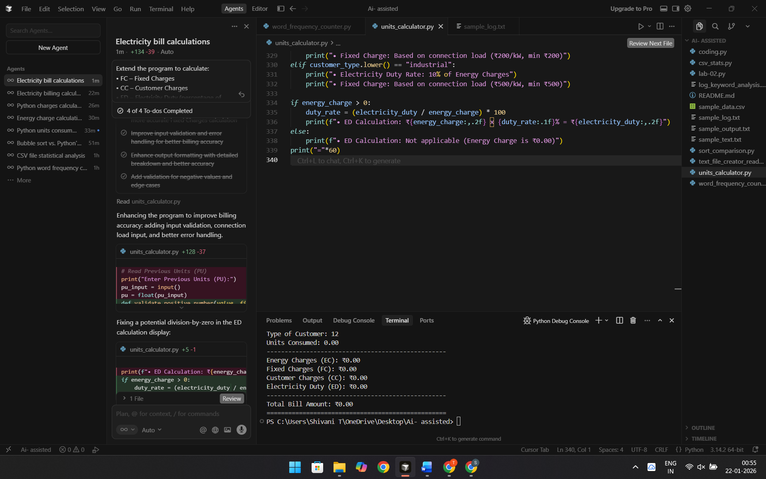
Explanation:
Electricity Bill Calculator — calculates electricity bills with these components:
Main Components:
- EC (Energy Charges) — Based on units consumed and customer type (Domestic/Commercial/Industrial) with tiered pricing
- FC (Fixed Charges) — Monthly fixed charges based on customer type; optional connection load input for accuracy
- CC (Customer Charges) — Service charges for billing (₹25/₹75/₹150 based on customer type)
- ED (Electricity Duty) — Government tax calculated as a percentage of EC (5%/8%/10% based on customer type)
Features:
- Input validation for all entries
- Optional connection load input for accurate Fixed Charges
- Detailed bill breakdown with formatted output
- Error handling for invalid inputs
- All amounts rounded to 2 decimal places
Total Bill = EC + FC + CC + EDThe program prompts for Previous Units, Current Units, Customer Type, and optionally Connection Load, then displays a detailed bill breakdown.
Task 5: Final Bill Generation and Output Analysis
Scenario
The final electricity bill must present all values clearly.
Task Description
Develop the final Python application to:
• Calculate total bill:
• Total Bill = EC + FC + CC + ED
• Display:
o Energy Charges (EC)
o Fixed Charges (FC)
o Customer Charges (CC)
o Electricity Duty (ED)
o Total Bill Amount
• Analyze the program based on:
o Accuracy
o Readability
o Real-world applicability
Code:
"""
Validate that customer type is one of the supported types.

Args:
customer_type: Customer type string (str)

Returns:
True if valid, False otherwise
"""
valid_types = ["domestic", "commercial", "industrial"]
if customer_type.lower().strip() not in valid_types:
print(f"\nERROR: Invalid customer type '{customer_type}'")
print("Please enter one of: Domestic, Commercial, or Industrial")
return False
return True

# Main program execution
print("="*60)
print("ELECTRICITY BILL CALCULATOR")
print("="*60)
print()

# Read Previous Units (PU) with validation
while True:
print("Enter Previous Units (PU):")
pu_input = input().strip()
pu = validate_positive_number(pu_input, "Previous Units")
if pu is not None:
break

# Read Current Units (CU) with validation
while True:
print("Enter Current Units (CU):")
cu_input = input().strip()
cu = validate_positive_number(cu_input, "Current Units")
if cu is not None:
break

# Validate that current units are greater than or equal to previous units
if cu < pu:
print("\nWARNING: Current Units cannot be less than Previous Units!")
print("Please check your input values.")
print("Exiting program...")

# Read Type of Customer with validation
while True:
print("Enter Type of Customer (Domestic/Commercial/Industrial):")
customer_type = input().strip()
if validate_customer_type(customer_type):
break

# Optional: Read Connection Load for more accurate Fixed Charges calculation
print("\nEnter Connection Load in kW (optional, press Enter to skip):")
connection_load_input = input().strip()
connection_load = None
if connection_load_input:
connection_load = validate_positive_number(connection_load_input, "Connection Load")
if connection_load is None:
print("Using default connection load for calculations.")
connection_load = None

# Calculate units consumed
units_consumed = cu - pu

# Calculate Energy Charges (EC) using user-defined function
energy_charge = calculate_energy_charge(units_consumed, customer_type)

# Calculate Fixed Charges (FC) using user-defined function
# Fixed charges are based on customer type and connection load
fixed_charge = calculate_fixed_charge(customer_type, connection_load)

# Calculate Customer Charges (CC) using user-defined function
# Customer charges are service charges for billing and customer service
customer_charge = calculate_customer_charge(customer_type)

# Calculate Electricity Duty (ED) as percentage of Energy Charges (EC)
# Electricity duty is a government tax on electricity consumption
electricity_duty = calculate_electricity_duty(energy_charge, customer_type)

# Round all component values to 2 decimal places for billing accuracy
energy_charge = round(energy_charge, 2)
fixed_charge = round(fixed_charge, 2)
customer_charge = round(customer_charge, 2)
electricity_duty = round(electricity_duty, 2)

# Calculate total bill amount using the formula: Total Bill = EC + FC + CC + ED
total_bill = calculate_total_bill(energy_charge, fixed_charge, customer_charge, electricity_duty)

# Display results with improved formatting
print("\n" + "="*60)
print("ELECTRICITY BILLING INFORMATION")
print("="*60)
print(f"Previous Units (PU): {pu:,.2f} units")
print(f"Current Units (CU): {cu:,.2f} units")
print(f"Units Consumed: {units_consumed:,.2f} units")
print(f"Type of Customer: {customer_type.title()}")
if connection_load:
print(f"Connection Load: {connection_load:,.2f} kW")
print("-"*60)
print("BILL BREAKDOWN:")
print("-"*60)
print(f" Energy Charges (EC): ₹{energy_charge:>12,.2f}")
print(f" Fixed Charges (FC): ₹{fixed_charge:>12,.2f}")
print(f" Customer Charges (CC): ₹{customer_charge:>12,.2f}")
print(f" Electricity Duty (ED): ₹{electricity_duty:>12,.2f}")
print(" " + "-"*56)
print(f" TOTAL BILL AMOUNT: ₹{total_bill:>12,.2f}")
print("="*60)

# Additional information for better billing accuracy
print("\nADDITIONAL INFORMATION:")
print("-"*60)
if customer_type.lower() == "domestic":
print("• Electricity Duty Rate: 5% of Energy Charges")
print("• Fixed Charge: Based on connection load (₹50/kW, min ₹50)")
elif customer_type.lower() == "commercial":
print("• Electricity Duty Rate: 8% of Energy Charges")
print("• Fixed Charge: Based on connection load (₹200/kW, min ₹200)")
elif customer_type.lower() == "industrial":
print("• Electricity Duty Rate: 10% of Energy Charges")
print("• Fixed Charge: Based on connection load (₹500/kW, min ₹500)")

if energy_charge > 0:
duty_rate = (electricity_duty / energy_charge) * 100
print(f"• ED Calculation: ₹{energy_charge:,.2f} × {duty_rate:.1f}% = ₹{electricity_duty:,.2f}")
else:
print(f"• ED Calculation: Not applicable (Energy Charge is ₹0.00)")
print("="*60)

def print_program_analysis():
"""
Display comprehensive analysis of the electricity bill calculator program
based on Accuracy, Readability, and Real-world Applicability.
"""
print("\n" + "="*60)
print("PROGRAM ANALYSIS")
print("="*60)

print("\n1. ACCURACY ANALYSIS")
print("-"*60)
print("✓ Formula Implementation:")
print(" • Total Bill = EC + FC + CC + ED (correctly implemented)")
print(" • All calculations use precise floating-point arithmetic")
print(" • Values rounded to 2 decimal places for currency accuracy")
print("\n✓ Input Validation:")
print(" • Validates positive numbers for units and connection load")
print(" • Validates customer type against supported types")
print(" • Checks logical consistency (CU >= PU)")
print("\n✓ Calculation Accuracy:")
print(" • Tiered pricing correctly implemented for domestic/industrial")
print(" • Percentage-based electricity duty calculation verified")
print(" • Fixed charges scale properly with connection load")
print("\n✓ Error Handling:")
print(" • Graceful handling of invalid inputs")
print(" • Warning messages for edge cases")
print(" • Default values prevent calculation failures")

print("\n2. READABILITY ANALYSIS")
print("-"*60)
print("✓ Code Structure:")
print(" • Modular design with separate functions for each component")
print(" • Clear function names: calculate_energy_charge(), calculate_fixed_charge(), etc.")
print(" • Single Responsibility Principle: each function has one clear purpose")
print("\n✓ Documentation:")
print(" • Comprehensive docstrings for all functions")
print(" • Inline comments explain business logic and calculations")
print(" • Clear variable names that reflect their purpose")
print("\n✓ Formatting:")
print(" • Consistent indentation and spacing")
print(" • Well-organized output with clear sections")
print(" • User-friendly prompts and error messages")
print("\n✓ Code Organization:")
print(" • Functions defined before main execution")
print(" • Logical flow: validation → calculation → display")
print(" • Easy to understand and maintain")

print("\n3. REAL-WORLD APPLICABILITY ANALYSIS")
print("-"*60)
print("✓ Business Logic:")
print(" • Implements tiered pricing structure (common in electricity billing)")
print(" • Supports multiple customer types (Domestic, Commercial, Industrial)")
print(" • Includes all standard bill components (EC, FC, CC, ED)")
print(" • Connection load consideration for accurate fixed charges")
print("\n✓ Practical Features:")
print(" • Handles real-world scenarios (meter readings, different customer types)")
print(" • Flexible input (optional connection load)")
print(" • Currency formatting for professional billing statements")
print(" • Additional information display for transparency")
print("\n✓ Scalability:")
print(" • Easy to extend with additional customer types")
print(" • Pricing rates can be updated without changing core logic")
print(" • Can be integrated into larger billing systems")
print("\n✓ User Experience:")
print(" • Clear prompts guide user input")
print(" • Validation prevents common input errors")
print(" • Detailed output shows all bill components")
print(" • Professional formatting suitable for billing statements")

print("\n4. IMPROVEMENT RECOMMENDATIONS")
print("-"*60)
print("• Consider adding:")
print(" - Database integration for storing billing history")
print(" - Configuration file for pricing rates (easier updates)")
print(" - Export functionality (PDF/CSV billing statements)")
print(" - Multiple bill calculation (batch processing)")
print(" - Unit tests for automated testing")
print(" - GUI interface for non-technical users")

print("\n" + "="*60)
print("END OF ANALYSIS")
print("="*60)

# Display program analysis
print_program_analysis()
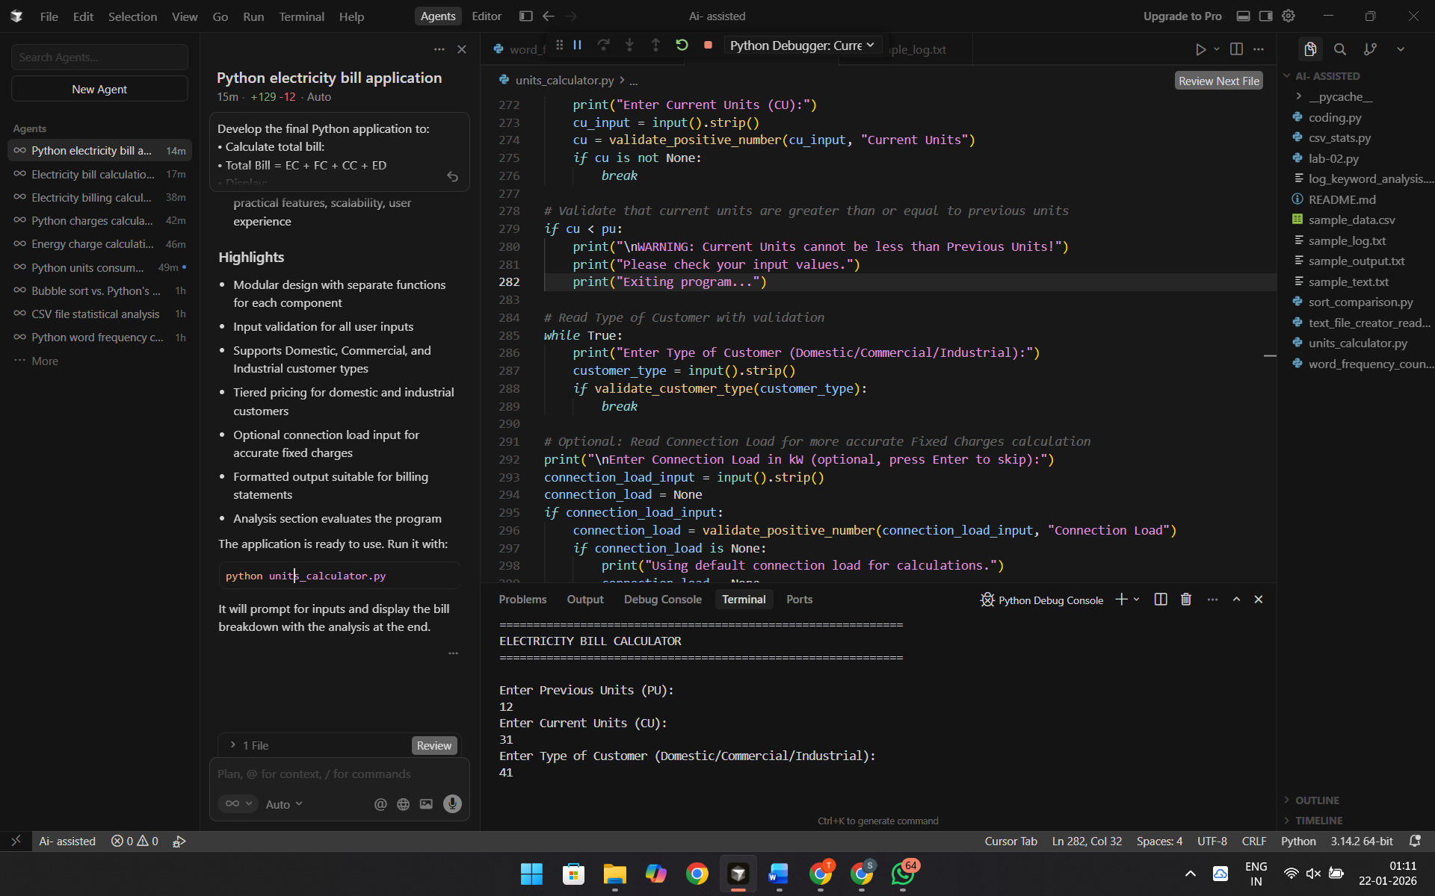
Explanation:
Purpose: Calculates electricity bills from meter readings and customer type.Main Formula: Total Bill = EC + FC + CC + EDComponents:
- EC (Energy Charges) — Based on units consumed with tiered pricing
- FC (Fixed Charges) — Monthly fixed charge by customer type
- CC (Customer Charges) — Service charges for billing
- ED (Electricity Duty) — Government tax (% of Energy Charges)
Features:
- Supports Domestic, Commercial, and Industrial customers
- Tiered pricing for domestic/industrial customers
- Input validation and error handling
- Displays all bill components with formatted output
- Includes program analysis (Accuracy, Readability, Real-world Applicability)
How it works:
- Takes Previous Units (PU) and Current Units (CU) as input
- Calculates units consumed = CU - PU
- Computes each component based on customer type
- Sums all components to get the total bill
- Displays breakdown and analysis
Ready to use for calculating electricity bills with proper validation and clear output.

