**Week - 10: Exploration of Pandas Package**

**1. Import Pandas and Plotpy and explore their functionalities.**

* **Pandas**

**Import panda**

**Or**

**Import pandas as pd**

**Pandas Series:**

**Program:**

Import pandas as pd

a=[1,2,3]

s=pd.series(a)

print(s)

**Output:**

0 1

1 2

2 3

dtype: int64

**Labels:**

**Program:**

import pandas as pd

a=[1,2,3]

s=pd.Series(a)

print(s[0])

**Output:**

1

**Creating Labels:**

**Program**

import pandas as pd

a=[1,2,3]

s=pd.Series(a,index= 'a','b','c')

print(s)

**Output:**

a 1

b 2

c 3

* **Plotpy**

**import matplotlib.pyplot as plt**

**Matplotlib Line Plot:**

**Program:**

import matplotlib.pyplot as plt

import numpy as np

xpoints = np.array([0, 6])

ypoints = np.array([0, 250])

plt.plot(xpoints, ypoints)

plt.show()

**output:**

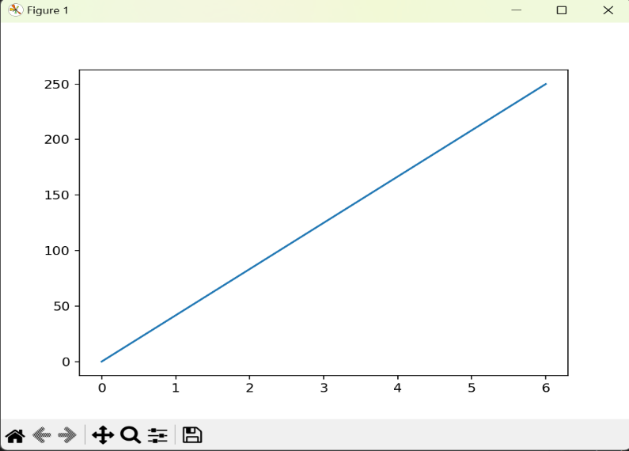

**2. Python Data Frame**

**DataFrames:**

**Program:**

import pandas as pd

a={"Fruits":["apple","mango","kiwi"], "Qty.":[1,2,3], "color":["red","Yellow","Rust"] }

df=pd.DataFrame(a)

print(df)

**Output:**

Fruits Qty. color

0 apple 1 red

1 mango 2 Yellow

2 kiwi 3 Rust

**Index in DataFrame:**

**Program:**

import pandas as pd

a={

"Fruits":["apple","mango","kiwi"],

"Qty":[1,2,3]

}

df=pd.DataFrame(a,index=["x","y","z"])

print(df)

**output:**

Fruits Qty

x apple 1

y mango 2

z kiwi 3

**Loc :**

**Program:**

import pandas as pd

a={

"Fruits":["apple","mango","kiwi"],

"Qty":[1,2,3]

}

df=pd.DataFrame(a,index=["x","y","z"])

**Output:**

print(df.loc["x"])

Fruits apple

Qty 1

Name: x, dtype: object