**Week - 9: Exploration of NumPy Package**

**1. Import numpy, and explore their functionalities.**

**Import NumPy:**

Impot numpy as np

**Functionalities:**

**Creating Arrays:**

**Program:**

import numpy as np

arr1 = np.array([10,20,30,40,50])

print(arr1)

print(type(arr1))

**Output:**

[10 20 30 40 50]

<class ‘numpy.ndarray’>

**1-D Arrays**

**Program:**

import numpy as np

arr = np.array([1, 2, 3, 4, 5])

print(arr)

print(arr[0]

**Output:**

['1' '2' '3' '4' '5']

1

**2-D Arrays**

**Program:**

import numpy as np

arr = np.array([[1, 2, 3], [4, 5, 6]])

print(arr)

print(arr[1][1])

print(arr[1])

**Output:**

[[1 2 3]

[4 5 6]]

5

[4 5 6]

**Dimension**

**Program:**

import numpy as np

arr = np.array([[1, 2, 3], [4, 5, 6]])

print(arr.ndim)

**Output:**

2

**Size of each element (in bytes)**

**Program:**

import numpy as np

arr = np.array([[1, 2, 3], [4, 5, 6]])

print(arr.itemsize)

**Output:**

4

**Datatype**

**Program:**

import numpy as np

arr = np.array([[1, 2, 3], [4, 5, 6]])

print(arr.dtype)

**Output:**

Int32

**Size and Shape**

**Program:**

import numpy as np

arr = np.array([[1, 2, 3], [4, 5, 6]])

print(arr.size)

print(arr.shape)

**Output:**

6

(2, 3)

**Reshape**

**Program:**

import numpy as np

arr = np.array([[1, 2, 3], [4, 5, 6]])

a=arr.reshape(3,2)

print(a)

**Output:**

[[1 2]

[3 4]

[5 6]]

**Slicing**

**Program:**

import numpy as np

arr = np.array([[1, 2, 3], [4, 5, 6]])

print(arr[0:,2])

**Output:**

[3 6]

**Min/Max/Sum**

**Program:**

import numpy as np

arr = np.array([[1, 2, 3], [4, 5, 6]])

print(arr.min())

print(arr.max())

print(arr.sum())

**Output:**

1

6

21

**2. a) Install NumPy package with pip and explore it.**

**Python is not installed by default in windows operating system. You can download the required version of python from python.org. Once python is installed successfully, open command prompt and use pip to install numpy.**

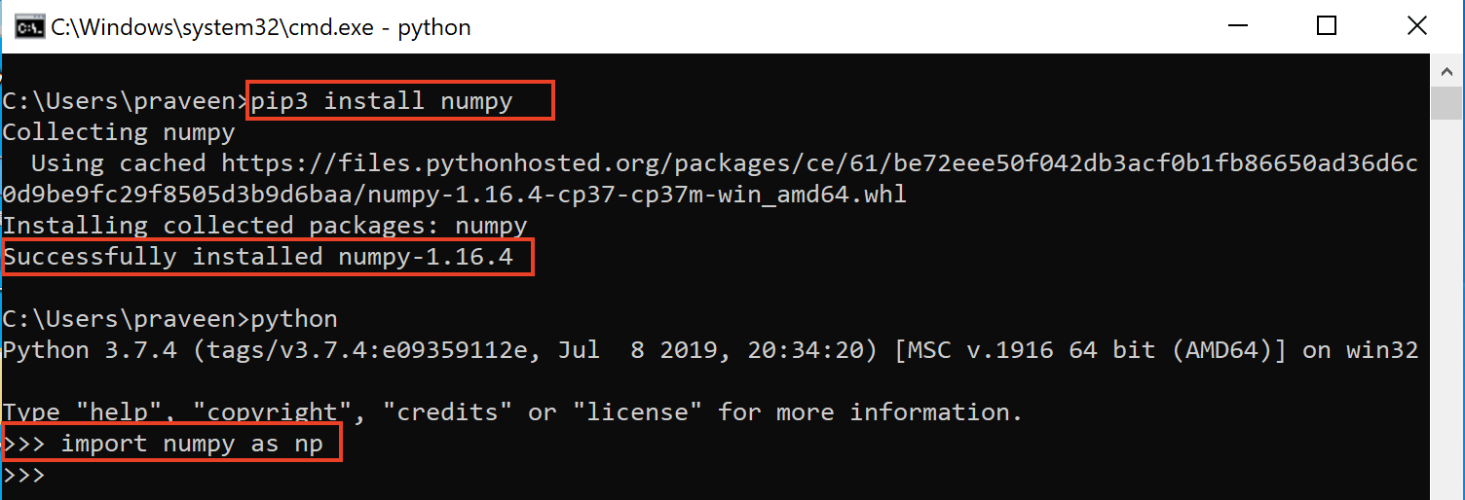

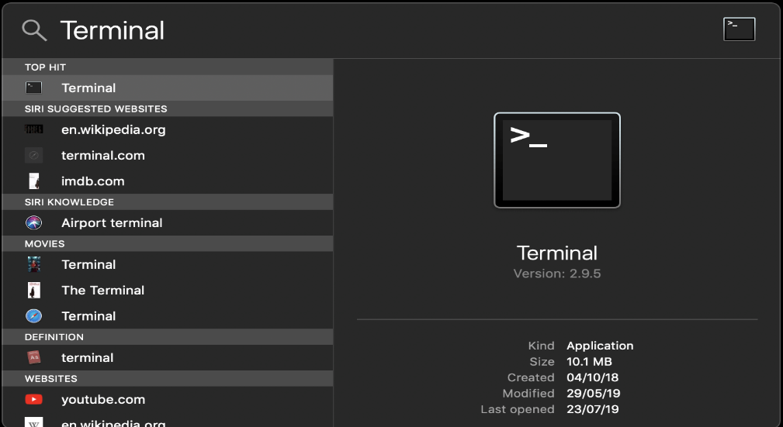

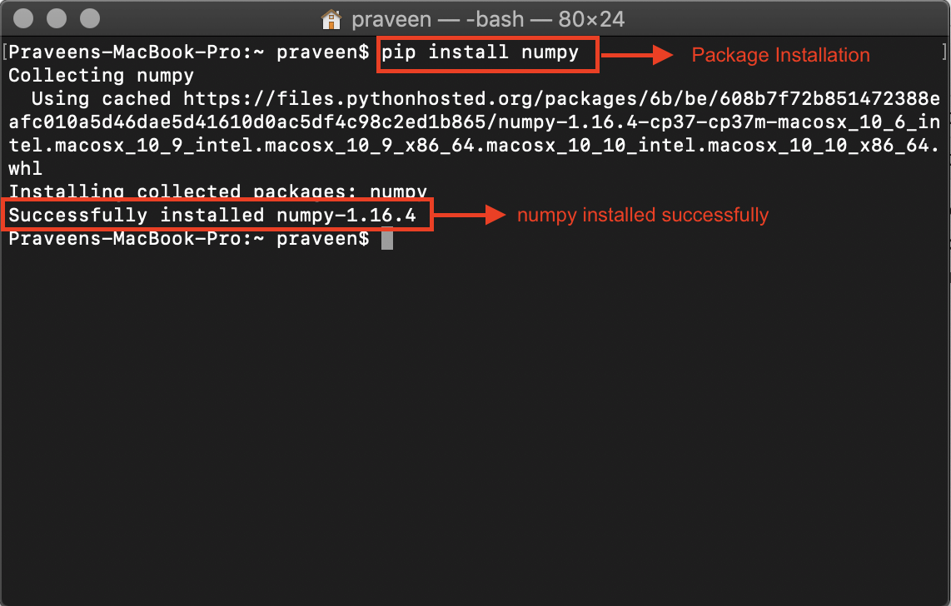

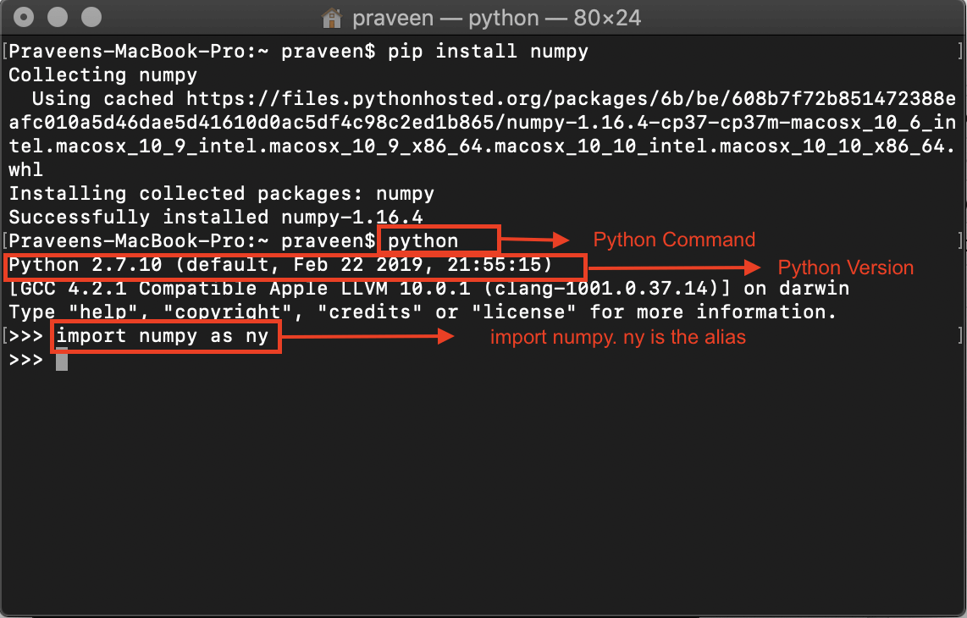

**3. Write a program for slicing arrays using numpy .**

**Program:**

import numpy as np arr = np.

array([1, 2, 3, 4, 5, 6, 7])

print(arr[1:5])

print(arr[4:])

print(arr[:4])

print(arr[-3:-1])

print(arr[1:5:2])

print(arr[::2])

**Output:**

[2 3 4 5]

[5 6 7]

[1 2 3 4]

[5 6]

[2 4]

[1 3 5 7]

**4. Write a program for Math operations on array using numpy.**

* **Square Root and Standard Deviation**

**Program:**

import numpy as np

arr=np.array([[1,2,3],[4,5,6]])

print(np.sqrt(arr))

print(np.std(arr))

**Output:**

[[1. 1.41421356 1.73205081]

[2. 2.23606798 2.44948974]]

1.707825127659933

* **Addition, subtraction, multiplication and division of the two matrices**

**Program:**

import numpy as np

arr1=np.array([[1,2,3],[4,5,6]])

arr2=np.array([[1,2,3],[4,5,6]])

print(arr1+arr2)

print(arr1-arr2)

print(arr1*arr2)

print(arr1/arr2)

**Output:**

[[ 2 4 6]

[ 8 10 12]]

[[0 0 0]

[0 0 0]]

[[ 1 4 9]

[16 25 36]]

[[1. 1. 1.]

[1. 1. 1.]]

* **Vertical and Horizontal Stacking**

**Program:**

import numpy as np

arr1=np.array([[1,2,3],[4,5,6]])

arr2=np.array([[7,8,9],[10,11,12]])

print("vstack:",np.vstack((arr1,arr2)))

print("hstack:",np.hstack((arr1,arr2)))

**Output:**

vstack: [[ 1 2 3]

[ 4 5 6]

[ 7 8 9]

[10 11 12]]

hstack: [[ 1 2 3 7 8 9]

[ 4 5 6 10 11 12]]

* **Ravel:**

**Program:**

import numpy as np

arr=np.array([[1,2,3],[4,5,6]])

print(np.ravel(arr))

**Output:**

[1 2 3 4 5 6]

**5. Write a program for searching .**

**Program:**

import numpy as np

arr = np.array([10, 32, 30, 50, 20, 82, 91, 45])

i = np.where(arr == 30)

print(i)

**Output:**

(array([2], dtype=int64),)

**6. Write a program for sorting.**

**Program:**

import numpy as np

arr=np.array([[1,4,2,3],[9,13,61,1],[43,24,88,22]])

sort_arr=np.sort(arr)

print(sort_arr)

**Output:**

[[ 1 2 3 4]

[ 1 9 13 61]

[22 24 43 88]]