Git-HOL

**Step 1: Setup your machine with Git Configuration**

To check if Git client is installed properly: Open Git bash shell and execute

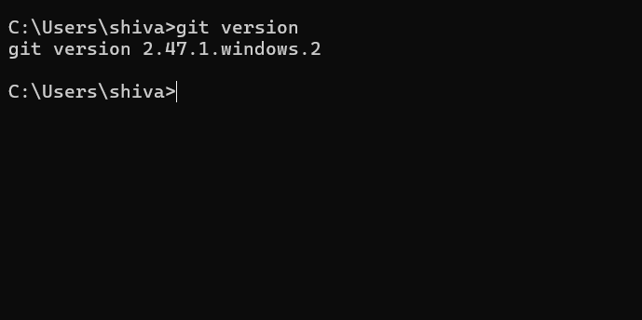

To configure user level configuration of user ID and email ID execute

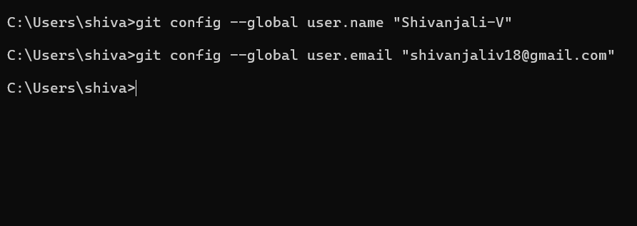

To check if the configuration is properly set, execute the following command.

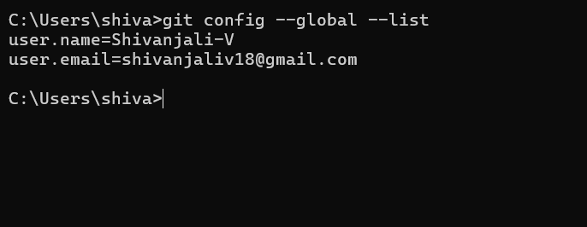

**Step 2: Integrate notepad++.exe to Git and make it a default editor**

To check, if notepad++.exe execute from Git bash

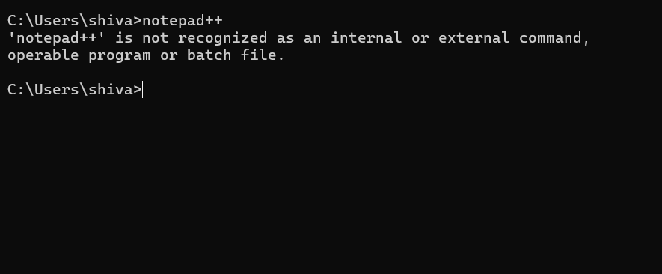

To add path of notepad++.exe to environment variable, go to control panel -> System -> Advanced System settings. Go to Advanced tab -> Environment variables -> Add path of notepad++.exe to the path user variable by clicking on “Edit”

**Step 3: Add a file to source code repository**

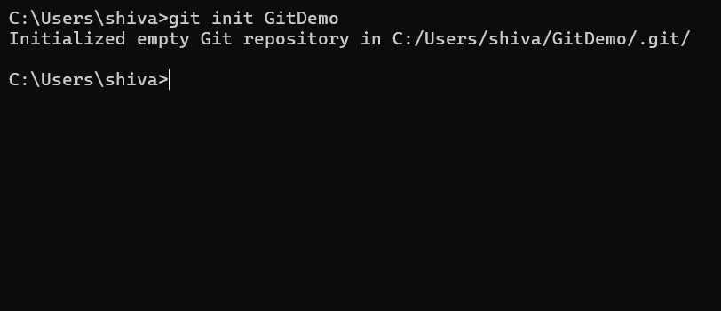

Git bash initializes the “**GitDemo**” repository. To verify, execute the command

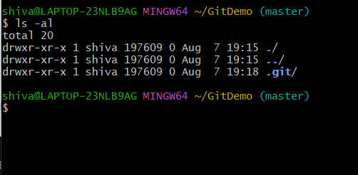

To create a file **“welcome.txt”** and add content to the file, execute the command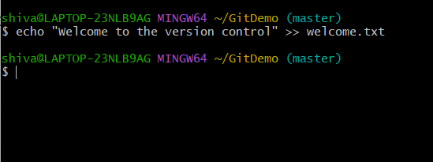

To verify if the file “welcome.txt” is created, execute

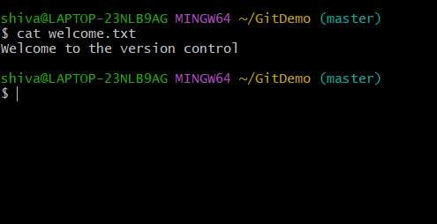

Check the status by executing

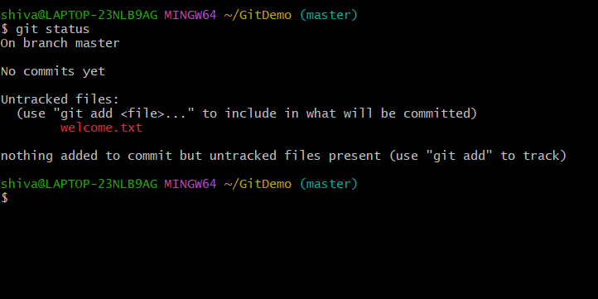

Now the file **“welcome.txt”** is available in Git “working directory”

To make the file to be tracked by Git repository, execute the command

