**Module 3 : Algorithm & Data Structures**

Date: 18-04-2022 (Assignment: 1)

**1) What do you mean by Data Structures?**

Ans.:

A data structure is **a particular way of organizing data in a computer memory so that it can be used effectively**.

ex. we can store a list of items having the same data-type using the array data structure.

**2) Define The Goals Of Data Structure?**

Ans.: 1] Goals of Data Structures is **to reduce the space and time complexities of different tasks**.

2] Also to move the focus of programming away from the constructs found in programming languages to considering how we can program the computer to do useful things.

**3) What is the Need of DS**

Ans.: Data structures are useful in **storing and organizing the data in an efficient manner**.

**4) List out the areas in which data structures are applied extensively (real time examples)?**

Ans.: 1] Social media content “feeds”. (use of linkedlist)

2] History of visited websites. (use of stack)

3] To store evolutionary development information of biological species. (use of tree)

4] Sending an e-mail (Queue)

5] a] Arrangement of the leader-board of a game (use of Matrix... as we arrange according to rank in descending order)

b] Our viewing screen is also a multidimensional array of pixels.

**6) What Does Abstract Data Type Mean?**

Ans.: abstract data types are the entities that are definitions of data and operations but do not have implementation details.

**For example :** a List is an abstract data type that is implemented using a dynamic array and linked list.

**Real Time example**: Mobile functions like click photo, call, message, etc

**5) List different types of data structures.**

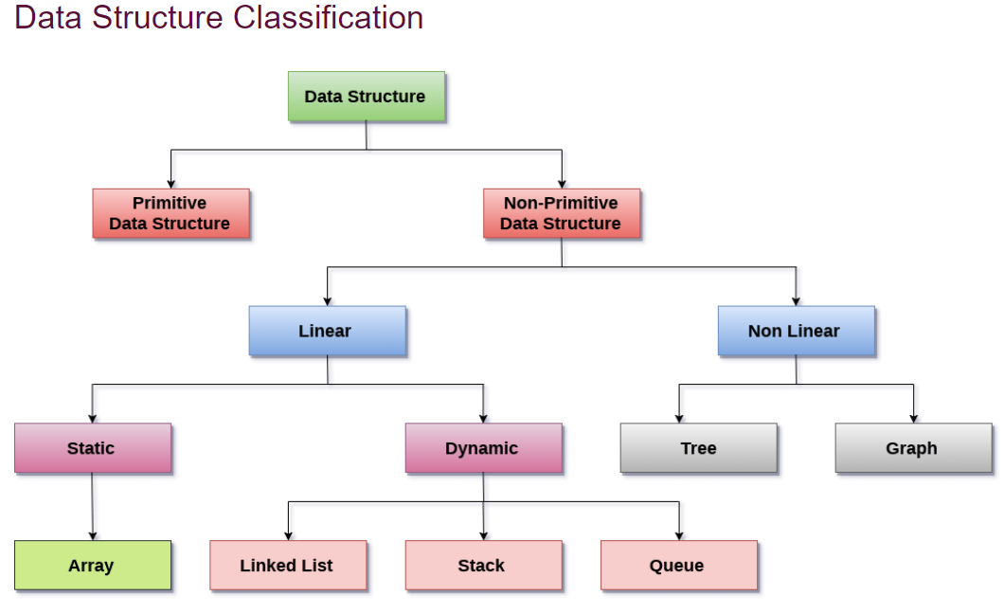

group of data elements which provides an efficient way of storing and organising data in the computer so that it can be used efficiently

abstract data type (ADT)

elements can be inserted only at one end called **rear** and deleted only at the other end called **front**. First-In-First-Out (FIFO)

pictorial representation of the set of elements (represented by vertices) connected by the links known as edges. **DIFF**.: graph can have cycle while the tree cannot have the one.

Trees are multilevel data structures with a hierarchical relationship among its elements known as nodes. based on the parent-child relationship among the nodes

This data structure does not form a sequence i.e. each item or element is connected with two or more other items in a non-linear arrangement.

abstract data type (ADT)

linear list in which insertion and deletions are allowed only at one end, called **top**. Ex. deck of cards

collection of nodes stored at non-contiguous memory locations. Also maintain a list in the memory.

collection of finite, ordered & homogenous datatypes

elements are stored in non-hierarchical way where each element has the successors and predecessors except the first and last element.

**7) Difference between Primitive and Non-Primitive DS**

|  |  |  |
| --- | --- | --- |
| **Sr. No.** | **Primitive** | **Non-Primitive** |
| 1 | Primitive Data Structure are predefined in the language | Non-Primitive Data structure are not defined in language and created by the programmer |
| 2 | Examples of primitive data structure are integer, character, float. | Examples of non-primitive data structure are Array, Linked list, stack. |
| 3 | Primitive Data structures will have a certain value | Non Primitive Data structure can have NULL value |
| 4 | The size depends upon the type of data structure | The size of non primitive data structure are not fixed |
| 5 | It starts with a lowercase character. | It starts with an uppercase character. |
| 6 | Can be used to call methods to perform operations | Cannot be used to call methods. |

**8) Difference between Linear and Non Linear DS**

|  |  |  |
| --- | --- | --- |
| **Sr.No.** | **Linear Data structures** | **Non Linear Data structures** |
| 1 | In this structure, the elements are arranged sequentially or linearly and attached to one another. | In this structure, the elements are arranged hierarchically or non-linear manner. |
| 2 | examples are: array, stack, queue, linked list, etc. | examples are: trees and graphs. |
| 3 | Due to the linear organization, they are easy to implement. | Due to the non-linear organization, they are difficult to implement. |
| 4 | Each data item is attached to the previous and next items. | Each item is attached to many other items. |
| 5 | This data structure does not contain any hierarchy, and all the data elements are organized in a single level. | In this, the data elements are arranged in multiple levels. |
| 6 | In a linear data structure, memory is not utilized in an efficient way. | While in a non-linear data structure, memory is utilized in an efficient way. |
| 7 | The time complexity of linear data structure increases with the increase in the input size. | The time complexity of non-linear data structure often remains same with the increase in the input size. |
| 8 | Linear data structures are mainly used for developing the software. | Non-linear data structures are used in **image processing** and **Artificial Intelligence**. |