# **Collection Service Testing after version upgrade**

1. **Payment Controller**

- Payment Search - http://localhost:8280/collection-services/payments/_search?tenantId=pg.citya&mobileNumber=7645325127  
  
Payload - curl --location 'http://localhost:8280/collection-services/payments/_search?tenantId=pg.citya&mobileNumber=7645325127' \

--header 'Content-Type: application/json' \

--data-raw '{

"RequestInfo": {

"apiId": "Rainmaker",

"authToken": "dummy-token",

"userInfo": {

"id": 243,

"uuid": "f8672e56-71e7-4863-b75d-9f3f37d5f742",

"userName": "9999009999",

"name": "Shivank",

"mobileNumber": "9999009999",

"emailId": "shivank@gmail.com",

"locale": "en_IN",

"type": "CITIZEN",

"roles": [

{

"name": "Citizen",

"code": "CITIZEN",

"tenantId": "pg"

}

],

"active": true,

"tenantId": "pg"

}

}

}'

Response:  
{

    "ResponseInfo": {

        "apiId": "Rainmaker",

        "ver": **null**,

        "ts": **null**,

        "resMsgId": "uief87324",

        "msgId": **null**,

        "status": "200 OK"

    },

    "Payments": [

        {

            "id": "34a2dd8f-9186-4a52-8cc0-89f5313c9ecc",

            "tenantId": "pg.citya",

            "totalDue": 1500,

            "totalAmountPaid": 1500,

            "transactionNumber": "citya2024311178",

            "transactionDate": 1751016630034,

            "paymentMode": "CASH",

            "instrumentDate": 1751016630034,

            "instrumentNumber": **null**,

            "instrumentStatus": "APPROVED",

            "ifscCode": **null**,

            "auditDetails": {

                "createdBy": "832",

                "createdTime": 1751016629969,

                "lastModifiedBy": "832",

                "lastModifiedTime": 1751016629969

            },

            "additionalDetails": {

                "manualReceiptDate": 1751016629649,

                "manualReceiptNumber": "MIG-1751016629-SV-1013-002255",

                "manualInstrumentType": "CASH",

                "manualCollectionCenter": "MigrationScript"

            },

            "paymentDetails": [

                {

                    "paymentId": **null**,

                    "id": "e6f29f82-3e79-44e1-9926-c640c9897a14",

                    "tenantId": "pg.citya",

                    "totalDue": 1500,

                    "totalAmountPaid": 1500,

                    "receiptNumber": "SV/1013/2025-26/002016",

                    "manualReceiptNumber": **null**,

                    "manualReceiptDate": 0,

                    "receiptDate": 1751016629969,

                    "receiptType": "BILLBASED",

                    "businessService": "sv-services",

                    "billId": "66cd2e6e-a160-41d8-ba82-1fafad2eb6de",

                    "bill": {

                        "id": "66cd2e6e-a160-41d8-ba82-1fafad2eb6de",

                        "mobileNumber": **null**,

                        "paidBy": **null**,

                        "payerName": **null**,

                        "payerAddress": **null**,

                        "payerEmail": **null**,

                        "payerId": **null**,

                        "status": "ACTIVE",

                        "reasonForCancellation": **null**,

                        "isCancelled": **null**,

                        "additionalDetails": **null**,

                        "billDetails": [

                            {

                                "billDescription": **null**,

                                "displayMessage": **null**,

                                "callBackForApportioning": **null**,

                                "cancellationRemarks": **null**,

                                "id": "b35ec071-f1bf-4e46-a846-a5dc23664292",

                                "tenantId": "pg.citya",

                                "demandId": "7ad41c06-844a-40cb-9be5-200fc93689aa",

                                "billId": "66cd2e6e-a160-41d8-ba82-1fafad2eb6de",

                                "amount": 1500,

                                "amountPaid": 1500,

                                "fromPeriod": 1751016629230,

                                "toPeriod": 1782552629230,

                                "additionalDetails": **null**,

                                "channel": **null**,

                                "voucherHeader": **null**,

                                "boundary": **null**,

                                "manualReceiptNumber": **null**,

                                "manualReceiptDate": **null**,

                                "billAccountDetails": [

                                    {

                                        "id": "8ce24980-cdad-4bcc-8f93-13220c5a32de",

                                        "tenantId": "pg.citya",

                                        "billDetailId": "b35ec071-f1bf-4e46-a846-a5dc23664292",

                                        "demandDetailId": "8734b161-8568-4681-bac3-a20a42e32026",

                                        "order": 0,

                                        "amount": 1500,

                                        "adjustedAmount": 1500,

                                        "isActualDemand": **null**,

                                        "taxHeadCode": "SV_STREET_VENDING_REGISTRATION_FEE",

                                        "additionalDetails": **null**,

                                        "purpose": **null**,

                                        "auditDetails": **null**

                                    }

                                ],

                                "collectionType": **null**,

                                "auditDetails": **null**,

                                "expiryDate": 1751048999780

                            }

                        ],

                        "tenantId": "pg.citya",

                        "auditDetails": {

                            "createdBy": "7f4fd980-628e-4266-a992-40fa629e2f05",

                            "createdTime": 1751016629780,

                            "lastModifiedBy": "7f4fd980-628e-4266-a992-40fa629e2f05",

                            "lastModifiedTime": 1751016629780

                        },

                        "collectionModesNotAllowed": [

                            "DD"

                        ],

                        "partPaymentAllowed": **false**,

                        "isAdvanceAllowed": **false**,

                        "minimumAmountToBePaid": **null**,

                        "businessService": "sv-services",

                        "totalAmount": 1500,

                        "consumerCode": "SV-1013-002255",

                        "billNumber": "BILL-013582",

                        "billDate": 1751016629780,

                        "amountPaid": **null**

                    },

                    "additionalDetails": **null**,

                    "auditDetails": {

                        "createdBy": "832",

                        "createdTime": 1751016629969,

                        "lastModifiedBy": "832",

                        "lastModifiedTime": 1751016629969

                    }

                }

            ],

            "paidBy": "OWNER",

            "mobileNumber": "9728765418",

            "payerName": "Atul",

            "payerAddress": **null**,

            "payerEmail": **null**,

            "payerId": "9cedd0a1-de9b-484b-8b62-0fe8e30c1978",

            "paymentStatus": "NEW",

            "fileStoreId": **null**

        }

    ]

}

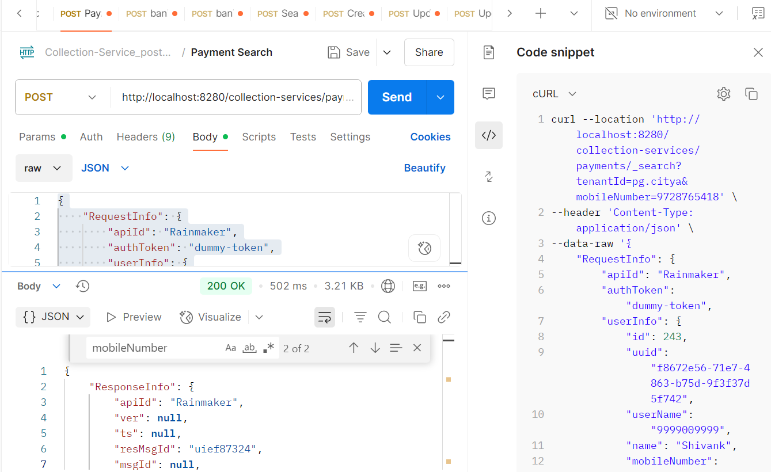

From env via port forward:  
  
Response:  
{

    "ResponseInfo": {

        "apiId": "Rainmaker",

        "ver": **null**,

        "ts": **null**,

        "resMsgId": "uief87324",

        "msgId": **null**,

        "status": "200 OK"

    },

    "Payments": [

        {

            "id": "34a2dd8f-9186-4a52-8cc0-89f5313c9ecc",

            "tenantId": "pg.citya",

            "totalDue": 1500,

            "totalAmountPaid": 1500,

            "transactionNumber": "citya2024311178",

            "transactionDate": 1751016630034,

            "paymentMode": "CASH",

            "instrumentDate": 1751016630034,

            "instrumentNumber": **null**,

            "instrumentStatus": "APPROVED",

            "ifscCode": **null**,

            "auditDetails": {

                "createdBy": "832",

                "createdTime": 1751016629969,

                "lastModifiedBy": "832",

                "lastModifiedTime": 1751016629969

            },

            "additionalDetails": {

                "manualReceiptDate": 1751016629649,

                "manualReceiptNumber": "MIG-1751016629-SV-1013-002255",

                "manualInstrumentType": "CASH",

                "manualCollectionCenter": "MigrationScript"

            },

            "paymentDetails": [

                {

                    "paymentId": **null**,

                    "id": "e6f29f82-3e79-44e1-9926-c640c9897a14",

                    "tenantId": "pg.citya",

                    "totalDue": 1500,

                    "totalAmountPaid": 1500,

                    "receiptNumber": "SV/1013/2025-26/002016",

                    "manualReceiptNumber": **null**,

                    "manualReceiptDate": 0,

                    "receiptDate": 1751016629969,

                    "receiptType": "BILLBASED",

                    "businessService": "sv-services",

                    "billId": "66cd2e6e-a160-41d8-ba82-1fafad2eb6de",

                    "bill": {

                        "id": "66cd2e6e-a160-41d8-ba82-1fafad2eb6de",

                        "mobileNumber": **null**,

                        "paidBy": **null**,

                        "payerName": **null**,

                        "payerAddress": **null**,

                        "payerEmail": **null**,

                        "payerId": **null**,

                        "status": "ACTIVE",

                        "reasonForCancellation": **null**,

                        "isCancelled": **null**,

                        "additionalDetails": **null**,

                        "billDetails": [

                            {

                                "billDescription": **null**,

                                "displayMessage": **null**,

                                "callBackForApportioning": **null**,

                                "cancellationRemarks": **null**,

                                "id": "b35ec071-f1bf-4e46-a846-a5dc23664292",

                                "tenantId": "pg.citya",

                                "demandId": "7ad41c06-844a-40cb-9be5-200fc93689aa",

                                "billId": "66cd2e6e-a160-41d8-ba82-1fafad2eb6de",

                                "amount": 1500,

                                "amountPaid": 1500,

                                "fromPeriod": 1751016629230,

                                "toPeriod": 1782552629230,

                                "additionalDetails": **null**,

                                "channel": **null**,

                                "voucherHeader": **null**,

                                "boundary": **null**,

                                "manualReceiptNumber": **null**,

                                "manualReceiptDate": **null**,

                                "billAccountDetails": [

                                    {

                                        "id": "8ce24980-cdad-4bcc-8f93-13220c5a32de",

                                        "tenantId": "pg.citya",

                                        "billDetailId": "b35ec071-f1bf-4e46-a846-a5dc23664292",

                                        "demandDetailId": "8734b161-8568-4681-bac3-a20a42e32026",

                                        "order": 0,

                                        "amount": 1500,

                                        "adjustedAmount": 1500,

                                        "isActualDemand": **null**,

                                        "taxHeadCode": "SV_STREET_VENDING_REGISTRATION_FEE",

                                        "additionalDetails": **null**,

                                        "purpose": **null**,

                                        "auditDetails": **null**

                                    }

                                ],

                                "collectionType": **null**,

                                "auditDetails": **null**,

                                "expiryDate": 1751048999780

                            }

                        ],

                        "tenantId": "pg.citya",

                        "auditDetails": {

                            "createdBy": "7f4fd980-628e-4266-a992-40fa629e2f05",

                            "createdTime": 1751016629780,

                            "lastModifiedBy": "7f4fd980-628e-4266-a992-40fa629e2f05",

                            "lastModifiedTime": 1751016629780

                        },

                        "collectionModesNotAllowed": [

                            "DD"

                        ],

                        "partPaymentAllowed": **false**,

                        "isAdvanceAllowed": **false**,

                        "minimumAmountToBePaid": **null**,

                        "businessService": "sv-services",

                        "totalAmount": 1500,

                        "consumerCode": "SV-1013-002255",

                        "billNumber": "BILL-013582",

                        "billDate": 1751016629780,

                        "amountPaid": **null**

                    },

                    "additionalDetails": **null**,

                    "auditDetails": {

                        "createdBy": "832",

                        "createdTime": 1751016629969,

                        "lastModifiedBy": "832",

                        "lastModifiedTime": 1751016629969

                    }

                }

            ],

            "paidBy": "OWNER",

            "mobileNumber": "9728765418",

            "payerName": "Atul",

            "payerAddress": **null**,

            "payerEmail": **null**,

            "payerId": "9cedd0a1-de9b-484b-8b62-0fe8e30c1978",

            "paymentStatus": "NEW",

            "fileStoreId": **null**

        }

    ]

}

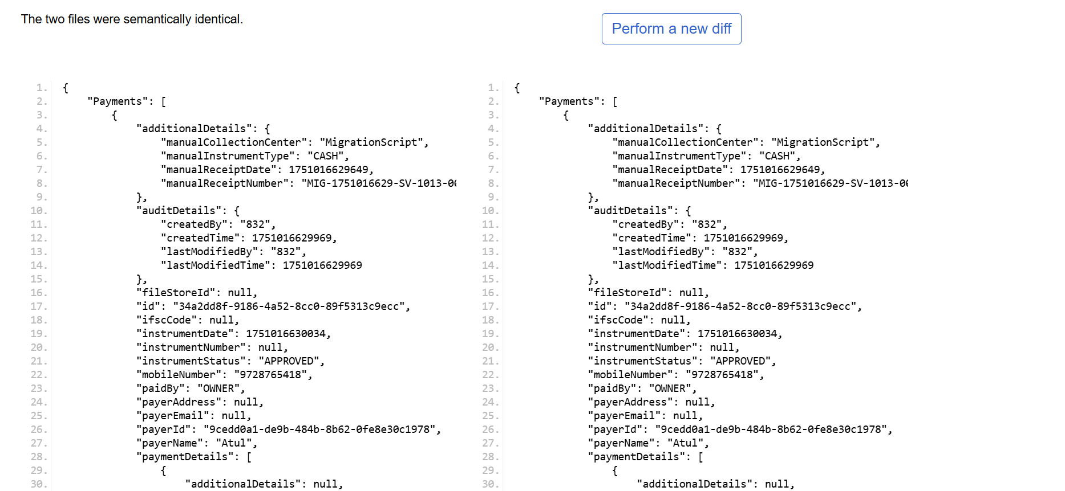

Payment Create: <http://localhost:8280/collection-services/payments/_create>

Request Payload:  
curl -X POST "http://localhost:8280/collection-services/payments/_create" \

-H "Content-Type: application/json" \

-d '{

"RequestInfo": {

"apiId": "Rainmaker",

"msgId": "1751347293277|en_IN",

"authToken": null,

"correlationId": "22c9e877-c666-4293-a3d2-6b2cbdfbb4ce",

"userInfo": {

"id": 1001,

"userName": "TLEMP",

"name": "Atul",

"type": "EMPLOYEE",

"mobileNumber": "7809234712",

"emailId": null,

"roles": [

{

"name": "TL doc verifier",

"code": "TL_DOC_VERIFIER",

"tenantId": "pg.citya"

},

{

"name": "TL Admin",

"code": "TL_ADMIN",

"tenantId": "pg.citya"

},

{

"name": "TL Creator",

"code": "TL_CREATOR",

"tenantId": "pg.citya"

},

{

"name": "TL Approver",

"code": "TL_APPROVER",

"tenantId": "pg.citya"

},

{

"name": "TL Field Inspector",

"code": "TL_FIELD_INSPECTOR",

"tenantId": "pg.citya"

},

{

"name": "TL Counter Employee",

"code": "TL_CEMP",

"tenantId": "pg.citya"

}

],

"tenantId": "pg.citya",

"uuid": "fd7421c7-b444-442c-a63d-d87e8a58a21e"

}

},

"Payment": {

"tenantId": "pg.citya",

"totalAmountPaid": 350,

"paymentMode": "CASH",

"paidBy": "OWNER",

"mobileNumber": "9848475757",

"payerName": "sourabh",

"payerId": "18b6844b-cf23-4d36-a672-55027f71f261",

"paymentStatus": "NEW",

"paymentDetails": [

{

"tenantId": "pg.citya",

"totalAmountPaid": 350,

"businessService": "TL",

"billId": "c70fcb8f-2a1a-4232-ab70-a8a6789aa607"

}

]

}

}'

Response from local:  
{

"ResponseInfo": {

"apiId": "Rainmaker",

"ver": null,

"ts": null,

"resMsgId": "uief87324",

"msgId": "1751347293277|en_IN",

"status": "200 OK"

},

"Payments": [

{

"id": "b627b5dc-6df9-4cc7-8e94-d187c210156b",

"tenantId": "pg.citya",

"totalDue": 350,

"totalAmountPaid": 350,

"transactionNumber": "citya2451834161",

"transactionDate": 1751348549489,

"paymentMode": "CASH",

"instrumentDate": 1751348549489,

"instrumentNumber": null,

"instrumentStatus": "APPROVED",

"ifscCode": null,

"auditDetails": {

"createdBy": "1001",

"createdTime": 1751348549252,

"lastModifiedBy": "1001",

"lastModifiedTime": 1751348549252

},

"additionalDetails": null,

"paymentDetails": [

{

"paymentId": null,

"id": "114c9d81-5e4f-487e-9129-2350bb41c0bf",

"tenantId": "pg.citya",

"totalDue": 350,

"totalAmountPaid": 350,

"receiptNumber": "07/2025-26/000081",

"manualReceiptNumber": null,

"manualReceiptDate": null,

"receiptDate": 1751348549253,

"receiptType": "BILLBASED",

"businessService": "TL",

"billId": "c70fcb8f-2a1a-4232-ab70-a8a6789aa607",

"bill": {

"id": "c70fcb8f-2a1a-4232-ab70-a8a6789aa607",

"mobileNumber": "8474857362",

"paidBy": "OWNER",

"payerName": "sourabh",

"payerAddress": null,

"payerEmail": null,

"payerId": null,

"status": "PAID",

"reasonForCancellation": null,

"isCancelled": null,

"additionalDetails": null,

"billDetails": [

{

"billDescription": null,

"displayMessage": null,

"callBackForApportioning": null,

"cancellationRemarks": null,

"id": "cefdb0c3-185c-4369-ba5e-04221a5581a9",

"tenantId": "pg.citya",

"demandId": "e428f539-a771-4e17-aa72-d2dc699221d4",

"billId": "c70fcb8f-2a1a-4232-ab70-a8a6789aa607",

"amount": 350,

"amountPaid": 350,

"fromPeriod": 1743465565000,

"toPeriod": 1774976013000,

"additionalDetails": {

"calculationDescription": [

"77c3a328-d692-45fe-9e7a-2cf9c80b9d6e|0|bc4cda12-dab3-4e6e-8218-6888835c4550"

]

},

"channel": null,

"voucherHeader": null,

"boundary": null,

"manualReceiptNumber": null,

"manualReceiptDate": null,

"billAccountDetails": [

{

"id": "2a427e85-9ef1-46bc-863e-ea59781209bd",

"tenantId": "pg.citya",

"billDetailId": "cefdb0c3-185c-4369-ba5e-04221a5581a9",

"demandDetailId": "27182595-59a1-45a4-84a1-d15c2bd70196",

"order": 2,

"amount": 350,

"adjustedAmount": 350,

"isActualDemand": null,

"taxHeadCode": "TL_TAX",

"additionalDetails": null,

"purpose": null,

"auditDetails": null

}

],

"collectionType": null,

"auditDetails": null,

"expiryDate": 1751394599526

}

],

"tenantId": "pg.citya",

"auditDetails": {

"createdBy": "fd7421c7-b444-442c-a63d-d87e8a58a21e",

"createdTime": 1751347275527,

"lastModifiedBy": "fd7421c7-b444-442c-a63d-d87e8a58a21e",

"lastModifiedTime": 1751347275527

},

"collectionModesNotAllowed": [

"DD",

"OFFLINE_NEFT",

"OFFLINE_RTGS",

"POSTAL_ORDER"

],

"partPaymentAllowed": false,

"isAdvanceAllowed": false,

"minimumAmountToBePaid": null,

"businessService": "TL",

"totalAmount": 350,

"consumerCode": "APP-000224",

"billNumber": "BILL-013746",

"billDate": 1751347275527,

"amountPaid": 350

},

"additionalDetails": null,

"auditDetails": {

"createdBy": "1001",

"createdTime": 1751348549252,

"lastModifiedBy": "1001",

"lastModifiedTime": 1751348549252

}

}

],

"paidBy": "OWNER",

"mobileNumber": "9848475757",

"payerName": "sourabh",

"payerAddress": null,

"payerEmail": null,

"payerId": "18b6844b-cf23-4d36-a672-55027f71f261",

"paymentStatus": "NEW",

"fileStoreId": null

}

]

}

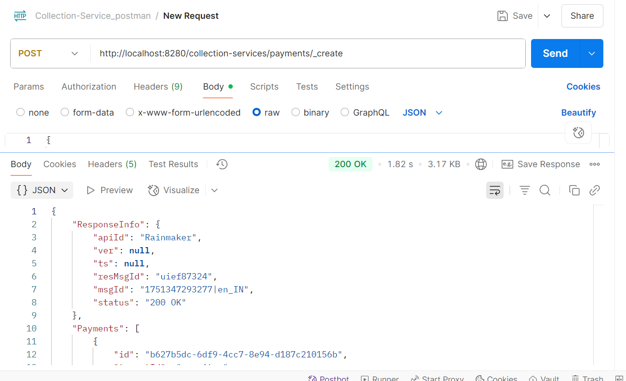

Response from Env:  
{

"ResponseInfo": {

"apiId": "Rainmaker",

"ver": null,

"ts": null,

"resMsgId": "uief87324",

"msgId": "1751347293277|en_IN",

"status": "200 OK"

},

"Payments": [

{

"id": "227287ee-5c7e-4b56-9754-5096cfc1c6ad",

"tenantId": "pg.citya",

"totalDue": 350,

"totalAmountPaid": 350,

"transactionNumber": "citya1301162218",

"transactionDate": 1751349012559,

"paymentMode": "CASH",

"instrumentDate": 1751349012559,

"instrumentNumber": null,

"instrumentStatus": "APPROVED",

"ifscCode": null,

"auditDetails": {

"createdBy": "1001",

"createdTime": 1751349012479,

"lastModifiedBy": "1001",

"lastModifiedTime": 1751349012479

},

"additionalDetails": null,

"paymentDetails": [

{

"paymentId": null,

"id": "8d2b19da-20f4-48f9-8c74-07f74a92e0c9",

"tenantId": "pg.citya",

"totalDue": 350,

"totalAmountPaid": 350,

"receiptNumber": "TL/1013/2025-26/002172",

"manualReceiptNumber": null,

"manualReceiptDate": null,

"receiptDate": 1751349012479,

"receiptType": "BILLBASED",

"businessService": "TL",

"billId": "c70fcb8f-2a1a-4232-ab70-a8a6789aa607",

"bill": {

"id": "c70fcb8f-2a1a-4232-ab70-a8a6789aa607",

"mobileNumber": "8474857362",

"paidBy": "OWNER",

"payerName": "sourabh",

"payerAddress": null,

"payerEmail": null,

"payerId": null,

"status": "PAID",

"reasonForCancellation": null,

"isCancelled": null,

"additionalDetails": null,

"billDetails": [

{

"billDescription": null,

"displayMessage": null,

"callBackForApportioning": null,

"cancellationRemarks": null,

"id": "cefdb0c3-185c-4369-ba5e-04221a5581a9",

"tenantId": "pg.citya",

"demandId": "e428f539-a771-4e17-aa72-d2dc699221d4",

"billId": "c70fcb8f-2a1a-4232-ab70-a8a6789aa607",

"amount": 350,

"amountPaid": 350,

"fromPeriod": 1743465565000,

"toPeriod": 1774976013000,

"additionalDetails": {

"calculationDescription": [

"77c3a328-d692-45fe-9e7a-2cf9c80b9d6e|0|bc4cda12-dab3-4e6e-8218-6888835c4550"

]

},

"channel": null,

"voucherHeader": null,

"boundary": null,

"manualReceiptNumber": null,

"manualReceiptDate": null,

"billAccountDetails": [

{

"id": "2a427e85-9ef1-46bc-863e-ea59781209bd",

"tenantId": "pg.citya",

"billDetailId": "cefdb0c3-185c-4369-ba5e-04221a5581a9",

"demandDetailId": "27182595-59a1-45a4-84a1-d15c2bd70196",

"order": 2,

"amount": 350,

"adjustedAmount": 350,

"isActualDemand": null,

"taxHeadCode": "TL_TAX",

"additionalDetails": null,

"purpose": null,

"auditDetails": null

}

],

"collectionType": null,

"auditDetails": null,

"expiryDate": 1751394599526

}

],

"tenantId": "pg.citya",

"auditDetails": {

"createdBy": "fd7421c7-b444-442c-a63d-d87e8a58a21e",

"createdTime": 1751347275527,

"lastModifiedBy": "fd7421c7-b444-442c-a63d-d87e8a58a21e",

"lastModifiedTime": 1751347275527

},

"collectionModesNotAllowed": [

"DD",

"OFFLINE_NEFT",

"OFFLINE_RTGS",

"POSTAL_ORDER"

],

"partPaymentAllowed": false,

"isAdvanceAllowed": false,

"minimumAmountToBePaid": null,

"businessService": "TL",

"totalAmount": 350,

"consumerCode": "APP-000224",

"billNumber": "BILL-013746",

"billDate": 1751347275527,

"amountPaid": 350

},

"additionalDetails": null,

"auditDetails": {

"createdBy": "1001",

"createdTime": 1751349012479,

"lastModifiedBy": "1001",

"lastModifiedTime": 1751349012479

}

}

],

"paidBy": "OWNER",

"mobileNumber": "9848475757",

"payerName": "sourabh",

"payerAddress": null,

"payerEmail": null,

"payerId": "18b6844b-cf23-4d36-a672-55027f71f261",

"paymentStatus": "NEW",

"fileStoreId": null

}

]

}

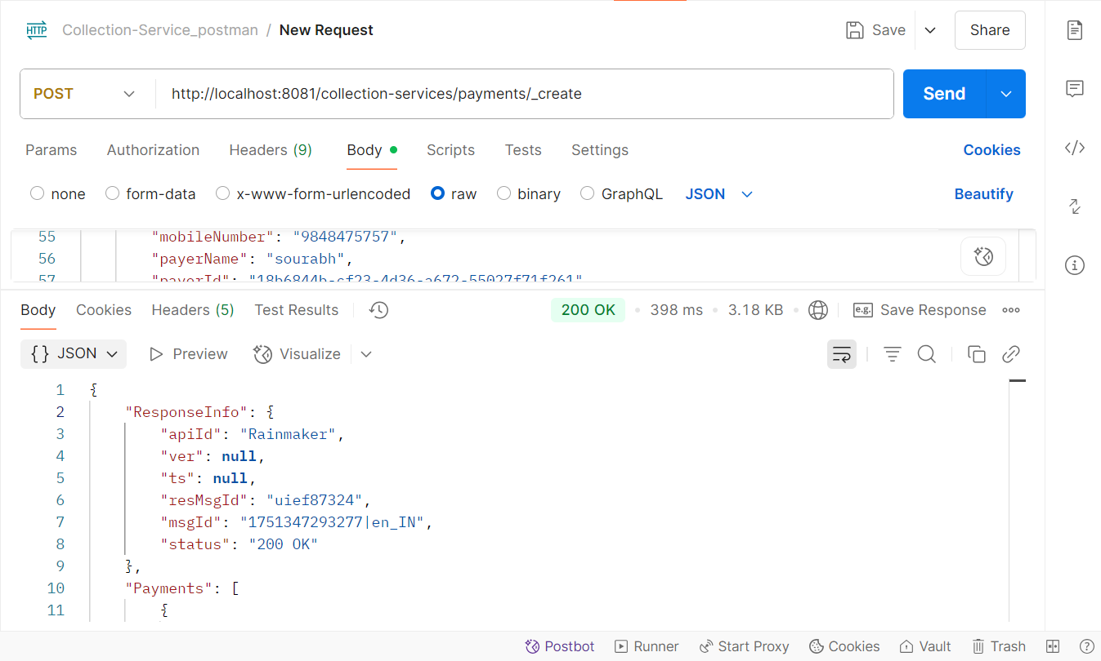

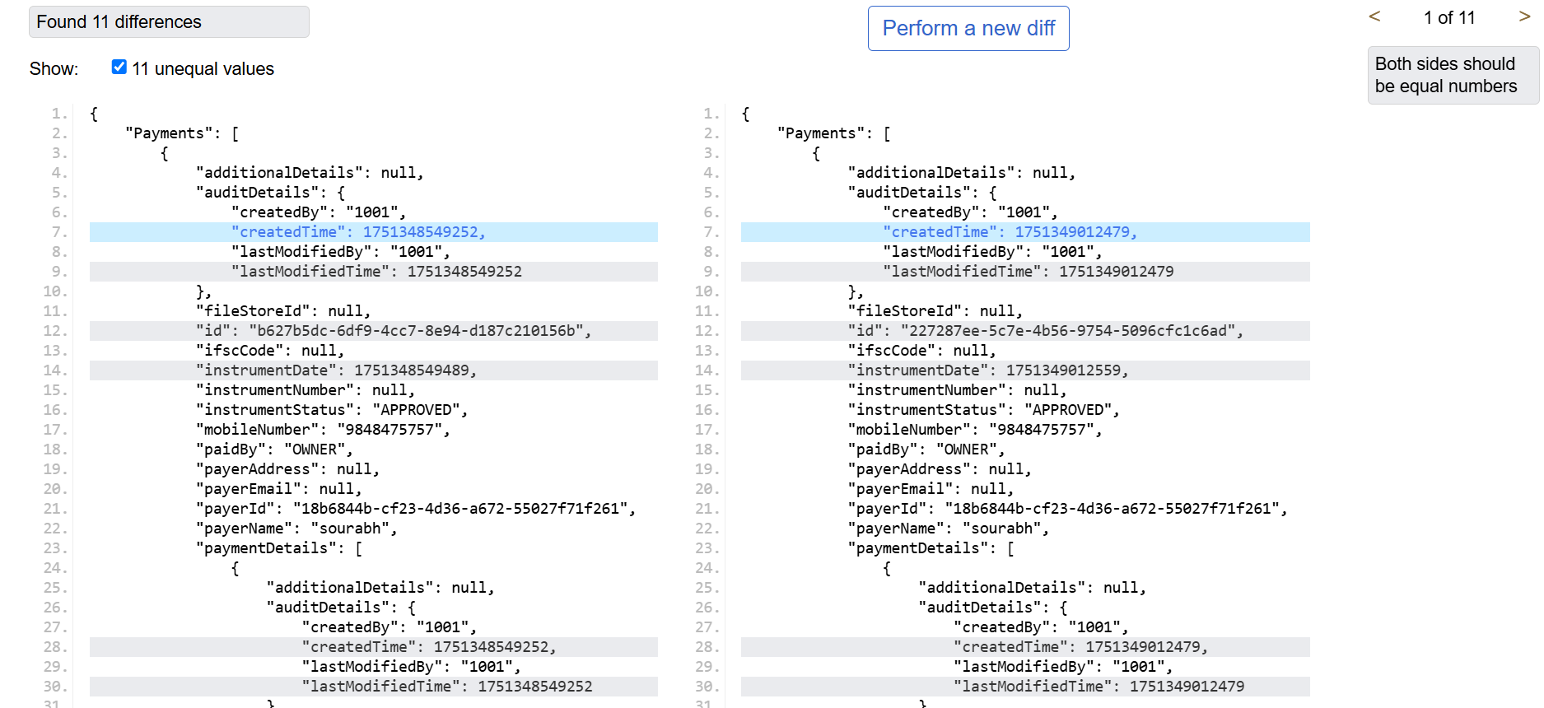

Payment Validate: http://localhost:8280/collection-services/payments/_validate

Request Payload:  
curl --location 'http://localhost:8280/collection-services/payments/_validate' \

--header 'Content-Type: application/json' \

--data-raw '{

"RequestInfo": {

"apiId": "Rainmaker",

"msgId": "1751434355993|en_IN",

"authToken": null,

"correlationId": "04c85b84-a8f2-42c7-9ba4-1e57f21cb115",

"userInfo": {

"id": 811,

"userName": "8010012414",

"name": "OWNER",

"type": "CITIZEN",

"mobileNumber": "8010012414",

"emailId": "cghvjbnk@gmail.com",

"roles": [

{

"name": "Citizen",

"code": "CITIZEN",

"tenantId": "pg"

}

],

"tenantId": "pg",

"uuid": "f789d679-352d-4aec-8198-4d61af1e0566"

}

},

"Payment": {

"tenantId": "pg.citya",

"totalAmountPaid": 3540.0,

"paymentMode": "CASH",

"paidBy": "OWNER",

"mobileNumber": "8010012414",

"payerName": "OWNER",

"payerId": "f789d679-352d-4aec-8198-4d61af1e0566",

"paymentStatus": "DEPOSITED",

"paymentDetails": [

{

"tenantId": "pg.citya",

"totalAmountPaid": 3540.0,

"businessService": "adv-services",

"billId": "21915a63-0f04-4f08-a3bf-a9af06ab9ef5"

}

]

}

}'

Response from local:  
{

"ResponseInfo": {

"apiId": "Rainmaker",

"ver": null,

"ts": null,

"resMsgId": "uief87324",

"msgId": "1751434355993|en_IN",

"status": "200 OK"

},

"Payments": [

{

"id": "4582cafb-60a1-4bf3-ad18-5757d4f6c074",

"tenantId": "pg.citya",

"totalDue": 3540.00,

"totalAmountPaid": 3540.0,

"transactionNumber": null,

"transactionDate": null,

"paymentMode": "CASH",

"instrumentDate": null,

"instrumentNumber": null,

"instrumentStatus": null,

"ifscCode": null,

"auditDetails": {

"createdBy": "811",

"createdTime": 1751435420236,

"lastModifiedBy": "811",

"lastModifiedTime": 1751435420236

},

"additionalDetails": null,

"paymentDetails": [

{

"paymentId": null,

"id": "819f5adc-1a94-482e-9e6d-71cd8e590348",

"tenantId": "pg.citya",

"totalDue": 3540.00,

"totalAmountPaid": 3540.0,

"receiptNumber": null,

"manualReceiptNumber": null,

"manualReceiptDate": null,

"receiptDate": 1751435420236,

"receiptType": "BILLBASED",

"businessService": "adv-services",

"billId": "21915a63-0f04-4f08-a3bf-a9af06ab9ef5",

"bill": {

"id": "21915a63-0f04-4f08-a3bf-a9af06ab9ef5",

"mobileNumber": "8010012414",

"paidBy": "OWNER",

"payerName": "OWNER",

"payerAddress": null,

"payerEmail": null,

"payerId": null,

"status": "PAID",

"reasonForCancellation": null,

"isCancelled": null,

"additionalDetails": null,

"billDetails": [

{

"billDescription": null,

"displayMessage": null,

"callBackForApportioning": null,

"cancellationRemarks": null,

"id": "22392a8a-8c3c-4470-a5c9-dac916d0bdfd",

"tenantId": "pg.citya",

"demandId": "b12476a8-6997-4cec-8fcf-70edf52eb098",

"billId": "21915a63-0f04-4f08-a3bf-a9af06ab9ef5",

"amount": 3540.00,

"amountPaid": null,

"fromPeriod": 1751434329997,

"toPeriod": 1760380200000,

"additionalDetails": null,

"channel": null,

"voucherHeader": null,

"boundary": null,

"manualReceiptNumber": null,

"manualReceiptDate": null,

"billAccountDetails": [

{

"id": "95b8f6a6-3bac-4013-8110-1821b2b0154a",

"tenantId": "pg.citya",

"billDetailId": "22392a8a-8c3c-4470-a5c9-dac916d0bdfd",

"demandDetailId": "575e306f-fc84-4531-9f21-678ef72d04e8",

"order": 0,

"amount": 3000.00,

"adjustedAmount": 0.00,

"isActualDemand": null,

"taxHeadCode": "ADV_BOOKING_FEES",

"additionalDetails": null,

"purpose": null,

"auditDetails": null

},

{

"id": "fe11c1c5-09bf-408d-b11e-89a73fd57106",

"tenantId": "pg.citya",

"billDetailId": "22392a8a-8c3c-4470-a5c9-dac916d0bdfd",

"demandDetailId": "16141cc7-cbb2-4323-9a6e-83f82a7652ba",

"order": 0,

"amount": 270.00,

"adjustedAmount": 0.00,

"isActualDemand": null,

"taxHeadCode": "ADV_SGST",

"additionalDetails": null,

"purpose": null,

"auditDetails": null

},

{

"id": "925f021d-b9ec-4dd9-8e3d-dd8acfb029d5",

"tenantId": "pg.citya",

"billDetailId": "22392a8a-8c3c-4470-a5c9-dac916d0bdfd",

"demandDetailId": "faf81c2a-37ea-425b-8124-e9c57e99964a",

"order": 0,

"amount": 270.00,

"adjustedAmount": 0.00,

"isActualDemand": null,

"taxHeadCode": "ADV_CGST",

"additionalDetails": null,

"purpose": null,

"auditDetails": null

}

],

"collectionType": null,

"auditDetails": null,

"expiryDate": 1751480999692

}

],

"tenantId": "pg.citya",

"auditDetails": {

"createdBy": "f789d679-352d-4aec-8198-4d61af1e0566",

"createdTime": 1751434332692,

"lastModifiedBy": "f789d679-352d-4aec-8198-4d61af1e0566",

"lastModifiedTime": 1751434332692

},

"collectionModesNotAllowed": [

"DD"

],

"partPaymentAllowed": false,

"isAdvanceAllowed": false,

"minimumAmountToBePaid": null,

"businessService": "adv-services",

"totalAmount": 3540.00,

"consumerCode": "ADV-1013-000507",

"billNumber": "BILL-013761",

"billDate": 1751434332692,

"amountPaid": null

},

"additionalDetails": null,

"auditDetails": {

"createdBy": "811",

"createdTime": 1751435420236,

"lastModifiedBy": "811",

"lastModifiedTime": 1751435420236

}

}

],

"paidBy": "OWNER",

"mobileNumber": "8010012414",

"payerName": "OWNER",

"payerAddress": null,

"payerEmail": null,

"payerId": "f789d679-352d-4aec-8198-4d61af1e0566",

"paymentStatus": "DEPOSITED",

"fileStoreId": null

}

]

}  
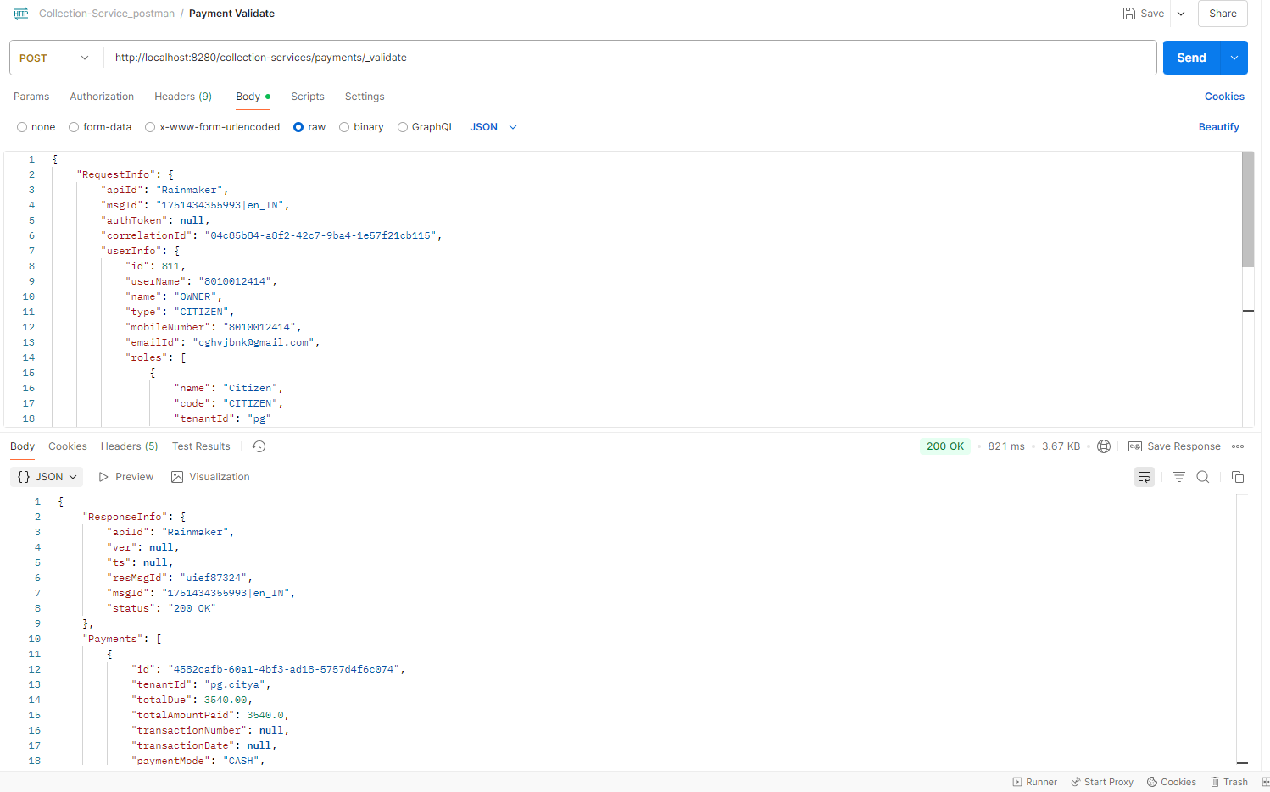  
Response from env:  
{

"ResponseInfo": {

"apiId": "Rainmaker",

"ver": null,

"ts": null,

"resMsgId": "uief87324",

"msgId": "1751434355993|en_IN",

"status": "200 OK"

},

"Payments": [

{

"id": "f7fb6ad9-388b-43a8-a02b-4d2534ca4356",

"tenantId": "pg.citya",

"totalDue": 3540.00,

"totalAmountPaid": 3540.0,

"transactionNumber": null,

"transactionDate": null,

"paymentMode": "CASH",

"instrumentDate": null,

"instrumentNumber": null,

"instrumentStatus": null,

"ifscCode": null,

"auditDetails": {

"createdBy": "811",

"createdTime": 1751435986348,

"lastModifiedBy": "811",

"lastModifiedTime": 1751435986348

},

"additionalDetails": null,

"paymentDetails": [

{

"paymentId": null,

"id": "eb53ead0-4a82-4e31-a90a-963fba5cb5b9",

"tenantId": "pg.citya",

"totalDue": 3540.00,

"totalAmountPaid": 3540.0,

"receiptNumber": null,

"manualReceiptNumber": null,

"manualReceiptDate": null,

"receiptDate": 1751435986348,

"receiptType": "BILLBASED",

"businessService": "adv-services",

"billId": "21915a63-0f04-4f08-a3bf-a9af06ab9ef5",

"bill": {

"id": "21915a63-0f04-4f08-a3bf-a9af06ab9ef5",

"mobileNumber": "8010012414",

"paidBy": "OWNER",

"payerName": "OWNER",

"payerAddress": null,

"payerEmail": null,

"payerId": null,

"status": "PAID",

"reasonForCancellation": null,

"isCancelled": null,

"additionalDetails": null,

"billDetails": [

{

"billDescription": null,

"displayMessage": null,

"callBackForApportioning": null,

"cancellationRemarks": null,

"id": "22392a8a-8c3c-4470-a5c9-dac916d0bdfd",

"tenantId": "pg.citya",

"demandId": "b12476a8-6997-4cec-8fcf-70edf52eb098",

"billId": "21915a63-0f04-4f08-a3bf-a9af06ab9ef5",

"amount": 3540.00,

"amountPaid": null,

"fromPeriod": 1751434329997,

"toPeriod": 1760380200000,

"additionalDetails": null,

"channel": null,

"voucherHeader": null,

"boundary": null,

"manualReceiptNumber": null,

"manualReceiptDate": null,

"billAccountDetails": [

{

"id": "95b8f6a6-3bac-4013-8110-1821b2b0154a",

"tenantId": "pg.citya",

"billDetailId": "22392a8a-8c3c-4470-a5c9-dac916d0bdfd",

"demandDetailId": "575e306f-fc84-4531-9f21-678ef72d04e8",

"order": 0,

"amount": 3000.00,

"adjustedAmount": 0.00,

"isActualDemand": null,

"taxHeadCode": "ADV_BOOKING_FEES",

"additionalDetails": null,

"purpose": null,

"auditDetails": null

},

{

"id": "fe11c1c5-09bf-408d-b11e-89a73fd57106",

"tenantId": "pg.citya",

"billDetailId": "22392a8a-8c3c-4470-a5c9-dac916d0bdfd",

"demandDetailId": "16141cc7-cbb2-4323-9a6e-83f82a7652ba",

"order": 0,

"amount": 270.00,

"adjustedAmount": 0.00,

"isActualDemand": null,

"taxHeadCode": "ADV_SGST",

"additionalDetails": null,

"purpose": null,

"auditDetails": null

},

{

"id": "925f021d-b9ec-4dd9-8e3d-dd8acfb029d5",

"tenantId": "pg.citya",

"billDetailId": "22392a8a-8c3c-4470-a5c9-dac916d0bdfd",

"demandDetailId": "faf81c2a-37ea-425b-8124-e9c57e99964a",

"order": 0,

"amount": 270.00,

"adjustedAmount": 0.00,

"isActualDemand": null,

"taxHeadCode": "ADV_CGST",

"additionalDetails": null,

"purpose": null,

"auditDetails": null

}

],

"collectionType": null,

"auditDetails": null,

"expiryDate": 1751480999692

}

],

"tenantId": "pg.citya",

"auditDetails": {

"createdBy": "f789d679-352d-4aec-8198-4d61af1e0566",

"createdTime": 1751434332692,

"lastModifiedBy": "f789d679-352d-4aec-8198-4d61af1e0566",

"lastModifiedTime": 1751434332692

},

"collectionModesNotAllowed": [

"DD"

],

"partPaymentAllowed": false,

"isAdvanceAllowed": false,

"minimumAmountToBePaid": null,

"businessService": "adv-services",

"totalAmount": 3540.00,

"consumerCode": "ADV-1013-000507",

"billNumber": "BILL-013761",

"billDate": 1751434332692,

"amountPaid": null

},

"additionalDetails": null,

"auditDetails": {

"createdBy": "811",

"createdTime": 1751435986348,

"lastModifiedBy": "811",

"lastModifiedTime": 1751435986348

}

}

],

"paidBy": "OWNER",

"mobileNumber": "8010012414",

"payerName": "OWNER",

"payerAddress": null,

"payerEmail": null,

"payerId": "f789d679-352d-4aec-8198-4d61af1e0566",

"paymentStatus": "DEPOSITED",

"fileStoreId": null

}

]

}

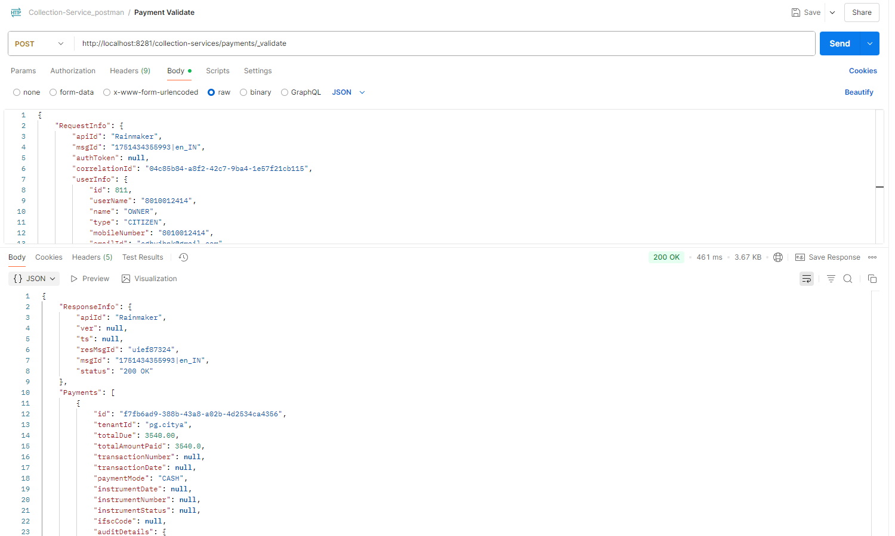

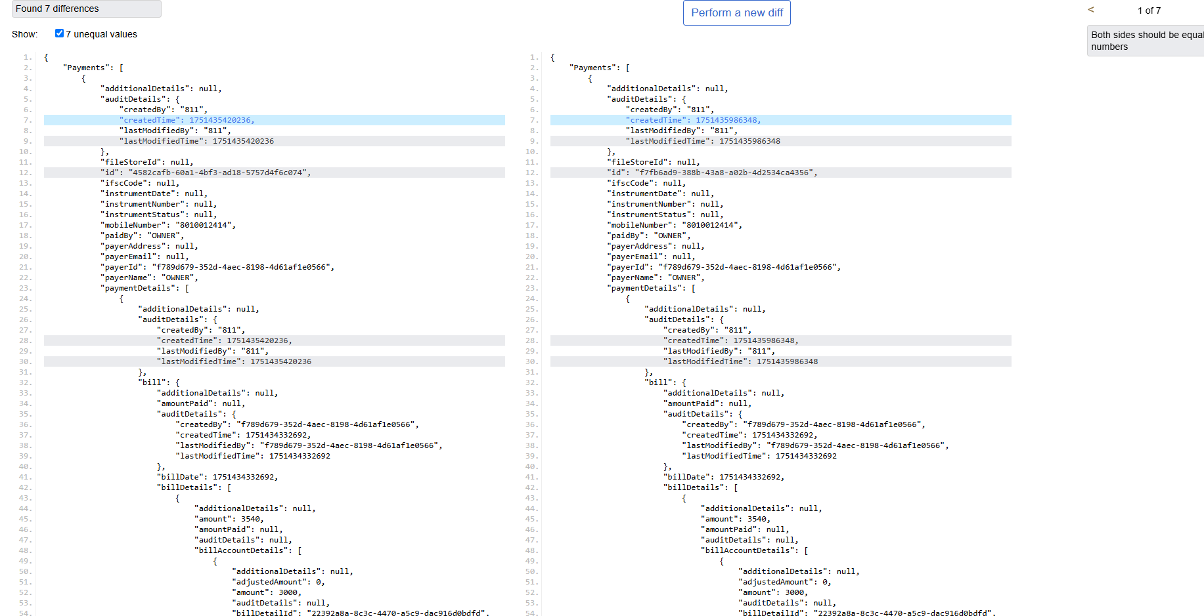

2 **Remittance Controller**

Remittance Search:

Request Payload: http://localhost:8280/collection-services/remittances/_search?tenantId=pg.citya

curl --location 'http://localhost:8280/collection-services/remittances/_search?tenantId=pg.citya' \

--header 'Content-Type: application/json' \

--data '{

"RequestInfo": {

"apiId": "Rainmaker",

"authToken": "dummy-token",

"userInfo": {

"id": 1,

"uuid": "test-uuid",

"userName": "testuser",

"tenantId": "pg.citya",

"type": "EMPLOYEE",

"roles": [

{

"name": "Finance Admin",

"code": "FIN_ADMIN",

"tenantId": "pg.citya"

}

]

}

}

}'

Response :  
  
{

"ResponseInfo": {

"apiId": "Rainmaker",

"ver": null,

"ts": null,

"resMsgId": "uief87324",

"msgId": null,

"status": "200 OK"

},

"Remittance": [

{

"tenantId": "pg.citya",

"id": "f4b306ae01764ab384b3c5188fb55717",

"referenceNumber": "REF-001",

"referenceDate": 1719400000000,

"voucherHeader": null,

"function": null,

"fund": null,

"remarks": null,

"reasonForDelay": null,

"status": "APPROVED",

"bankaccount": "000000000001",

"auditDetails": {

"createdBy": "1",

"createdTime": 1751008018990,

"lastModifiedBy": "1",

"lastModifiedTime": 1751008018990

},

"remittanceReceipts": [

{

"tenantId": null,

"id": null,

"remittance": null,

"receipt": null

}

],

"remittanceDetails": [

{

"tenantId": "pg.citya",

"id": "4ea449e3f2d64d0e95f1331bc3158e88",

"remittance": "f4b306ae01764ab384b3c5188fb55717",

"chartOfAccount": "COA-001",

"creditAmount": 1000,

"debitAmount": 0

}

],

"remittanceInstruments": [

{

"tenantId": "pg.citya",

"id": "4059e8b802834953a982b25b70bc6fe3",

"remittance": "f4b306ae01764ab384b3c5188fb55717",

"instrument": "CHQ-123456",

"reconciled": false

}

]

}

]

}  
  
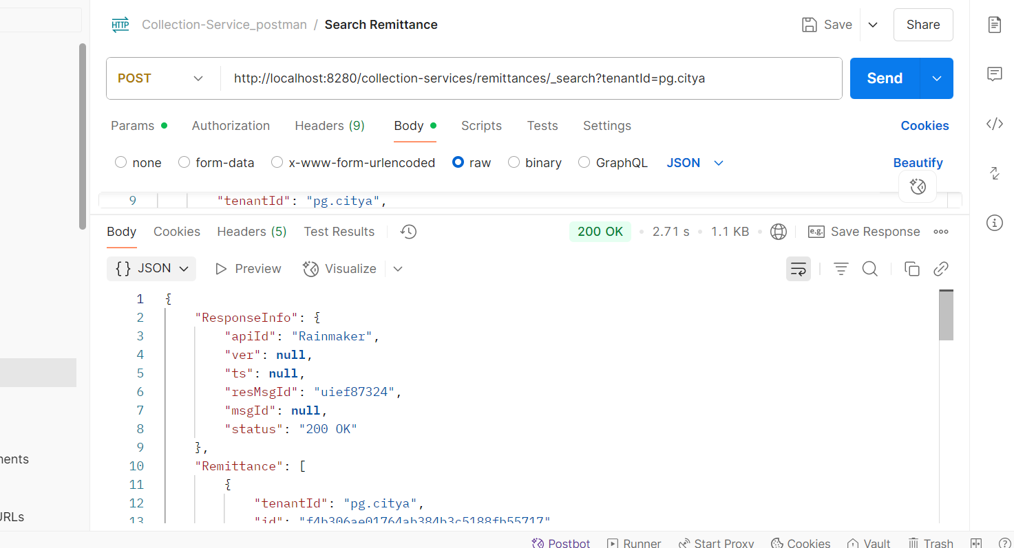

* **Create Remittance** : <http://localhost:8280/collection-services/remittances/_create>

Request Payload:  
curl --location 'http://localhost:8280/collection-services/remittances/_create' \

--header 'Content-Type: application/json' \

--data '{

"RequestInfo": {

"apiId": "Rainmaker",

"authToken": "dummy-token",

"userInfo": {

"id": 1,

"uuid": "test-uuid",

"userName": "testuser",

"tenantId": "pg.citya",

"type": "EMPLOYEE",

"roles": [

{

"name": "Finance Admin",

"code": "FIN_ADMIN",

"tenantId": "pg.citya"

}

]

}

},

"Remittance": [

{

"tenantId": "pg.citya",

"referenceNumber": "REF-002",

"referenceDate": 1719400000000,

"status": "PENDING",

"bankaccount": "000000000002",

"remittanceDetails": [

{

"chartOfAccount": "COA-002",

"creditAmount": 1000.0,

"debitAmount": 0.0

}

],

"remittanceInstruments": [

{

"instrument": "CHQ-1234567"

}

]

}

]

}'  
Response from local:  
  
{

"ResponseInfo": {

"apiId": "Rainmaker",

"ver": null,

"ts": null,

"resMsgId": "uief87324",

"msgId": null,

"status": "200 OK"

},

"Remittance": [

{

"tenantId": "pg.citya",

"id": "5d2f9ee34bdb451b8e8d17c2d5de1108",

"referenceNumber": "REF-002",

"referenceDate": 1719400000000,

"voucherHeader": null,

"function": null,

"fund": null,

"remarks": null,

"reasonForDelay": null,

"status": "APPROVED",

"bankaccount": "000000000002",

"auditDetails": {

"createdBy": "1",

"createdTime": 1751138042606,

"lastModifiedBy": "1",

"lastModifiedTime": 1751138042606

},

"remittanceReceipts": [],

"remittanceDetails": [

{

"tenantId": "pg.citya",

"id": "9a14567e27ba4a64b8e1fa4c5960bbdd",

"remittance": "5d2f9ee34bdb451b8e8d17c2d5de1108",

"chartOfAccount": "COA-002",

"creditAmount": 1000,

"debitAmount": 0

}

],

"remittanceInstruments": [

{

"tenantId": "pg.citya",

"id": "59d49596e3d7482392e51ab12cab214f",

"remittance": "5d2f9ee34bdb451b8e8d17c2d5de1108",

"instrument": "CHQ-1234567",

"reconciled": null

}

]

}

]

}  
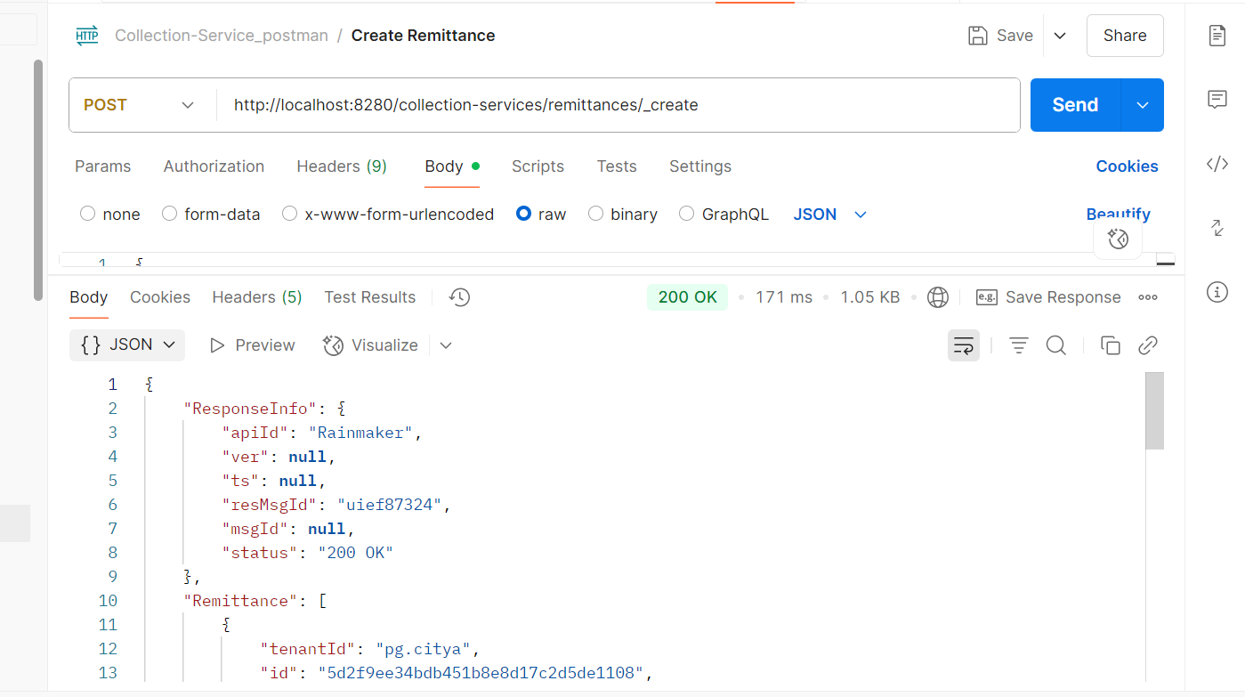  
Response from environment:  
{

"ResponseInfo": {

"apiId": "Rainmaker",

"ver": null,

"ts": null,

"resMsgId": "uief87324",

"msgId": null,

"status": "200 OK"

},

"Remittance": [

{

"tenantId": "pg.citya",

"id": "4b4b24594eea4c46b2bc6d15aa5e97fe",

"referenceNumber": "REF-002",

"referenceDate": 1719400000000,

"voucherHeader": null,

"function": null,

"fund": null,

"remarks": null,

"reasonForDelay": null,

"status": "APPROVED",

"bankaccount": "000000000002",

"auditDetails": {

"createdBy": "1",

"createdTime": 1751271212403,

"lastModifiedBy": "1",

"lastModifiedTime": 1751271212403

},

"remittanceReceipts": [],

"remittanceDetails": [

{

"tenantId": "pg.citya",

"id": "33e64b334bde41f0845222febaac3a99",

"remittance": "4b4b24594eea4c46b2bc6d15aa5e97fe",

"chartOfAccount": "COA-002",

"creditAmount": 1000,

"debitAmount": 0

}

],

"remittanceInstruments": [

{

"tenantId": "pg.citya",

"id": "d5c59c519cd54813b7ff08be0b72d1c8",

"remittance": "4b4b24594eea4c46b2bc6d15aa5e97fe",

"instrument": "CHQ-1234567",

"reconciled": null

}

]

}

]

}  
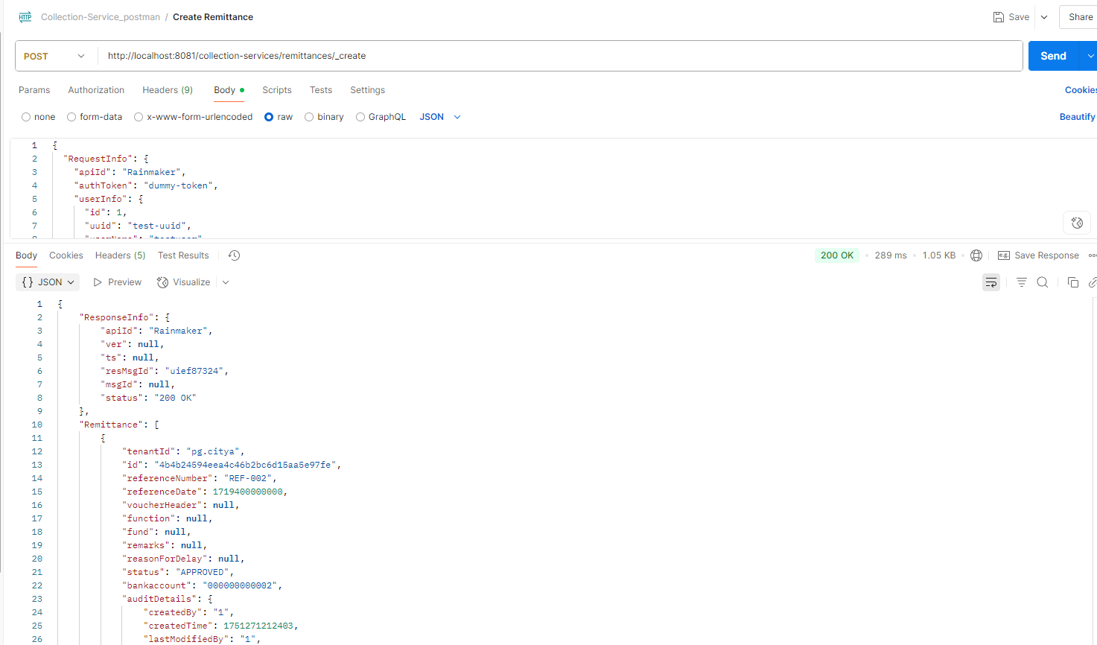

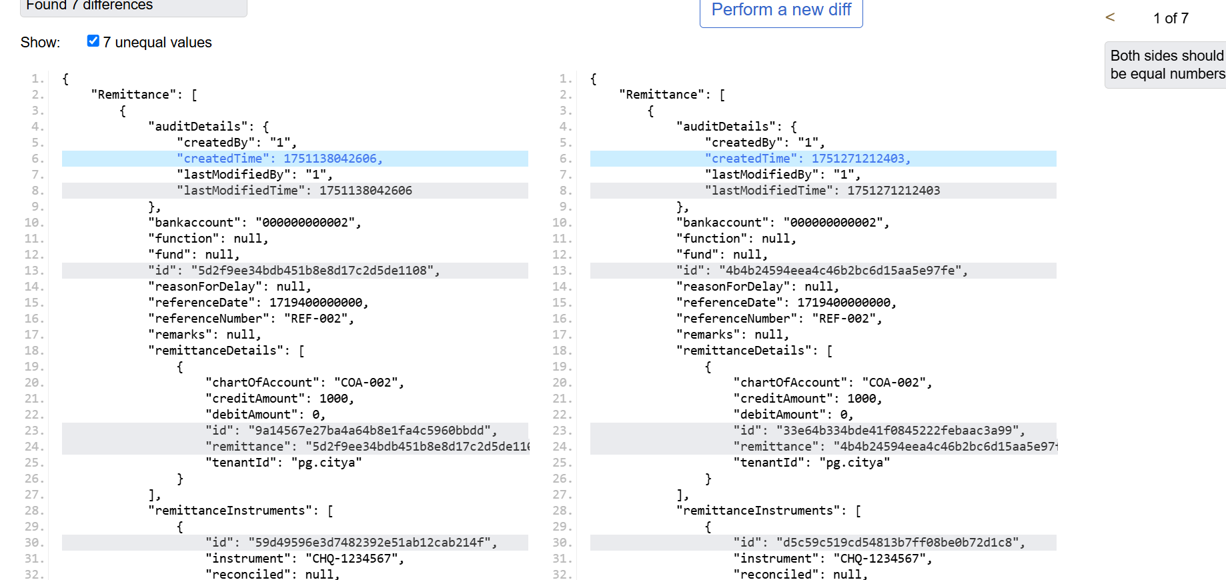  
Update Remittance: <http://localhost:8280/collection-services/remittances/_update>  
  
Request payload:  
curl --location 'http://localhost:8280/collection-services/remittances/_update' \

--header 'Content-Type: application/json' \

--data '{

"RequestInfo": {

"apiId": "Rainmaker",

"authToken": "dummy-token",

"userInfo": {

"id": 1,

"uuid": "test-uuid",

"userName": "testuser",

"tenantId": "pg.citya",

"type": "EMPLOYEE",

"roles": [

{

"name": "Finance Admin",

"code": "FIN_ADMIN",

"tenantId": "pg.citya"

}

]

}

},

"Remittance": [

{

"tenantId": "pg.citya",

"id": "f4b306ae01764ab384b3c5188fb55717",

"referenceNumber": "REF-001",

"referenceDate": 1719400000000,

"voucherHeader": null,

"function": null,

"fund": null,

"remarks": "Updated remarks",

"reasonForDelay": null,

"status": "APPROVED",

"bankaccount": "000000000001",

"auditDetails": {

"createdBy": "1",

"createdTime": 1751008018990,

"lastModifiedBy": "1",

"lastModifiedTime": 1751008018990

},

"remittanceReceipts": [],

"remittanceDetails": [

{

"tenantId": "pg.citya",

"id": "4ea449e3f2d64d0e95f1331bc3158e88",

"remittance": "f4b306ae01764ab384b3c5188fb55717",

"chartOfAccount": "COA-001",

"creditAmount": 1000.0,

"debitAmount": 0.0

}

],

"remittanceInstruments": [

{

"tenantId": "pg.citya",

"id": "4059e8b802834953a982b25b70bc6fe3",

"remittance": "f4b306ae01764ab384b3c5188fb55717",

"instrument": "CHQ-123456",

"reconciled": null

}

]

}

]

}'  
Response from local:  
{

"ResponseInfo": {

"apiId": "Rainmaker",

"ver": null,

"ts": null,

"resMsgId": "uief87324",

"msgId": null,

"status": "200 OK"

},

"Remittance": [

{

"tenantId": "pg.citya",

"id": "f4b306ae01764ab384b3c5188fb55717",

"referenceNumber": "REF-001",

"referenceDate": 1719400000000,

"voucherHeader": null,

"function": null,

"fund": null,

"remarks": "Updated remarks",

"reasonForDelay": null,

"status": "APPROVED",

"bankaccount": "000000000001",

"auditDetails": {

"createdBy": "1",

"createdTime": 1751008018990,

"lastModifiedBy": "1",

"lastModifiedTime": 1751008018990

},

"remittanceReceipts": [],

"remittanceDetails": [

{

"tenantId": "pg.citya",

"id": "4ea449e3f2d64d0e95f1331bc3158e88",

"remittance": "f4b306ae01764ab384b3c5188fb55717",

"chartOfAccount": "COA-001",

"creditAmount": 1000,

"debitAmount": 0

}

],

"remittanceInstruments": [

{

"tenantId": "pg.citya",

"id": "4059e8b802834953a982b25b70bc6fe3",

"remittance": "f4b306ae01764ab384b3c5188fb55717",

"instrument": "CHQ-123456",

"reconciled": null

}

]

}

]

}  
  
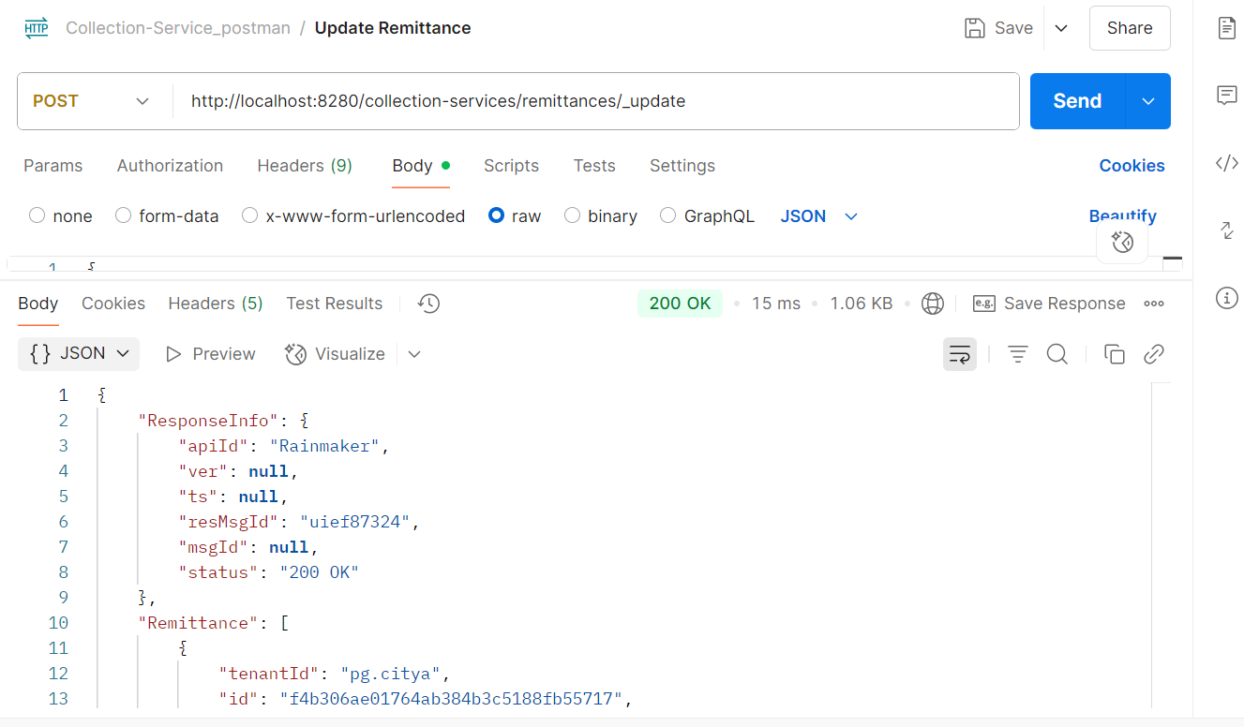

Response from Env:  
{

"ResponseInfo": {

"apiId": "Rainmaker",

"ver": null,

"ts": null,

"resMsgId": "uief87324",

"msgId": null,

"status": "200 OK"

},

"Remittance": [

{

"tenantId": "pg.citya",

"id": "f4b306ae01764ab384b3c5188fb55717",

"referenceNumber": "REF-001",

"referenceDate": 1719400000000,

"voucherHeader": null,

"function": null,

"fund": null,

"remarks": "Updated remarks",

"reasonForDelay": null,

"status": "APPROVED",

"bankaccount": "000000000001",

"auditDetails": {

"createdBy": "1",

"createdTime": 1751008018990,

"lastModifiedBy": "1",

"lastModifiedTime": 1751008018990

},

"remittanceReceipts": [],

"remittanceDetails": [

{

"tenantId": "pg.citya",

"id": "4ea449e3f2d64d0e95f1331bc3158e88",

"remittance": "f4b306ae01764ab384b3c5188fb55717",

"chartOfAccount": "COA-001",

"creditAmount": 1000,

"debitAmount": 0

}

],

"remittanceInstruments": [

{

"tenantId": "pg.citya",

"id": "4059e8b802834953a982b25b70bc6fe3",

"remittance": "f4b306ae01764ab384b3c5188fb55717",

"instrument": "CHQ-123456",

"reconciled": null

}

]

}

]

}  
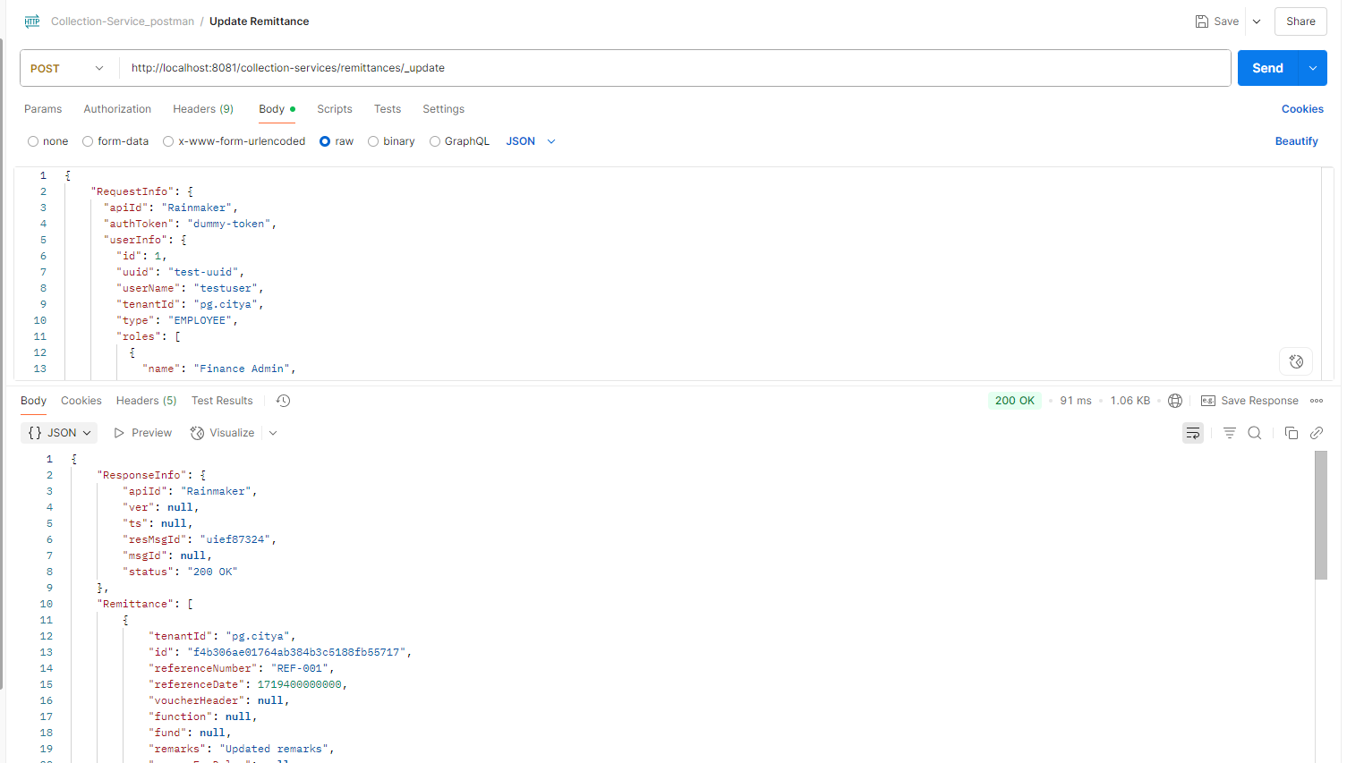

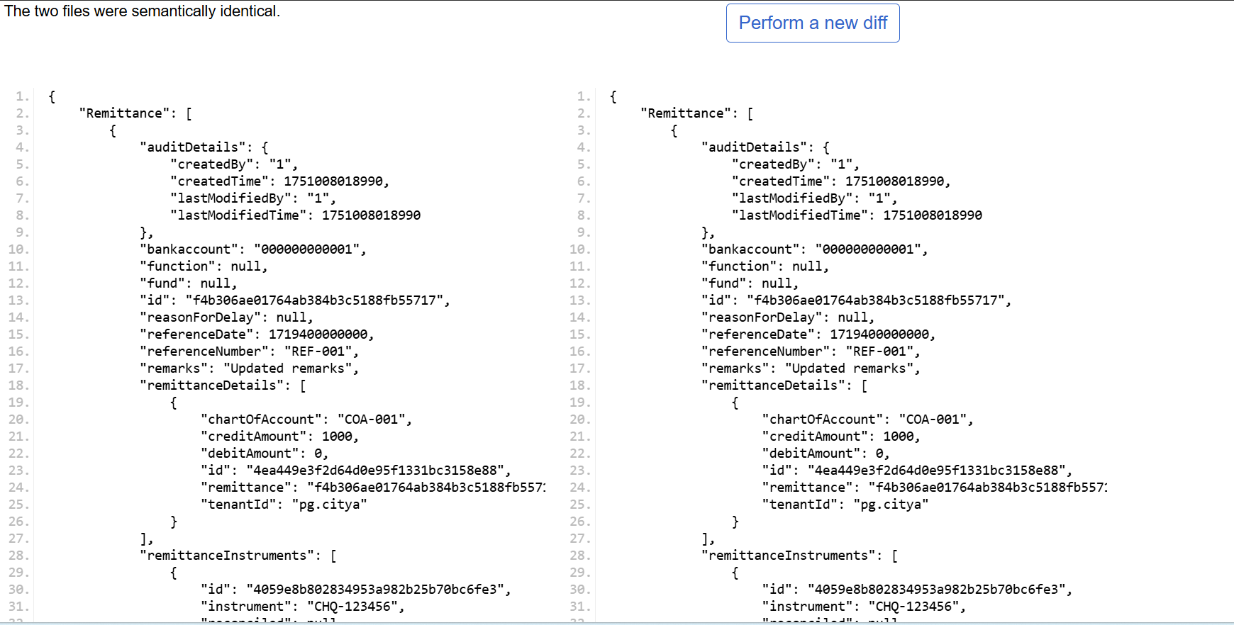

3 **Bank Account Controller**

* Create Bank Account

Request Payload:  
  
curl --location 'http://localhost:8280/collection-services/bankAccountServiceMapping/_create' \

--header 'Content-Type: application/json' \

--data '{

"RequestInfo": {

"apiId": "Rainmaker",

"authToken": "dummy-token",

"userInfo": {

"id": 1,

"uuid": "test-uuid",

"userName": "testuser",

"tenantId": "pg.citya",

"type": "EMPLOYEE",

"roles": [

{

"name": "Finance Admin",

"code": "FIN_ADMIN",

"tenantId": "pg.citya"

}

]

}

},

"bankAccountServiceMapping": [

{

"tenantId": "pg.citya",

"bankAccount": "000000000002",

"bank": "Allahabad UP Gramin Bank",

"bankBranch": "001",

"businessDetails": "TL.RENEWAL"

}

]

}'  
Response from local:  
{

"BankAccountServiceMapping": [

{

"businessDetails": "TL.RENEWAL",

"bankAccount": "000000000002",

"bank": "Allahabad UP Gramin Bank",

"bankBranch": "001",

"tenantId": "pg.citya"

}

],

"ResponseInfo": {

"apiId": "Rainmaker",

"ver": null,

"ts": null,

"resMsgId": "uief87324",

"msgId": null,

"status": "200 OK"

}

}

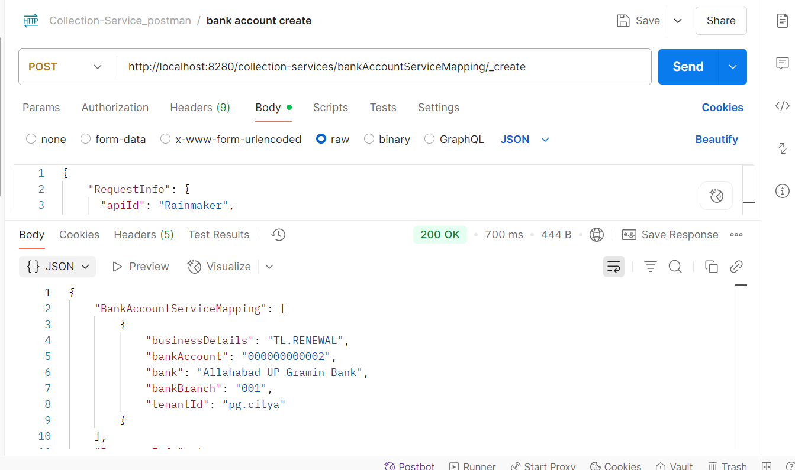  
Response from env:  
{

"BankAccountServiceMapping": [

{

"businessDetails": "TL.RENEWAL",

"bankAccount": "000000000002",

"bank": "Allahabad UP Gramin Bank",

"bankBranch": "001",

"tenantId": "pg.citya"

}

],

"ResponseInfo": {

"apiId": "Rainmaker",

"ver": null,

"ts": null,

"resMsgId": "uief87324",

"msgId": null,

"status": "200 OK"

}

}

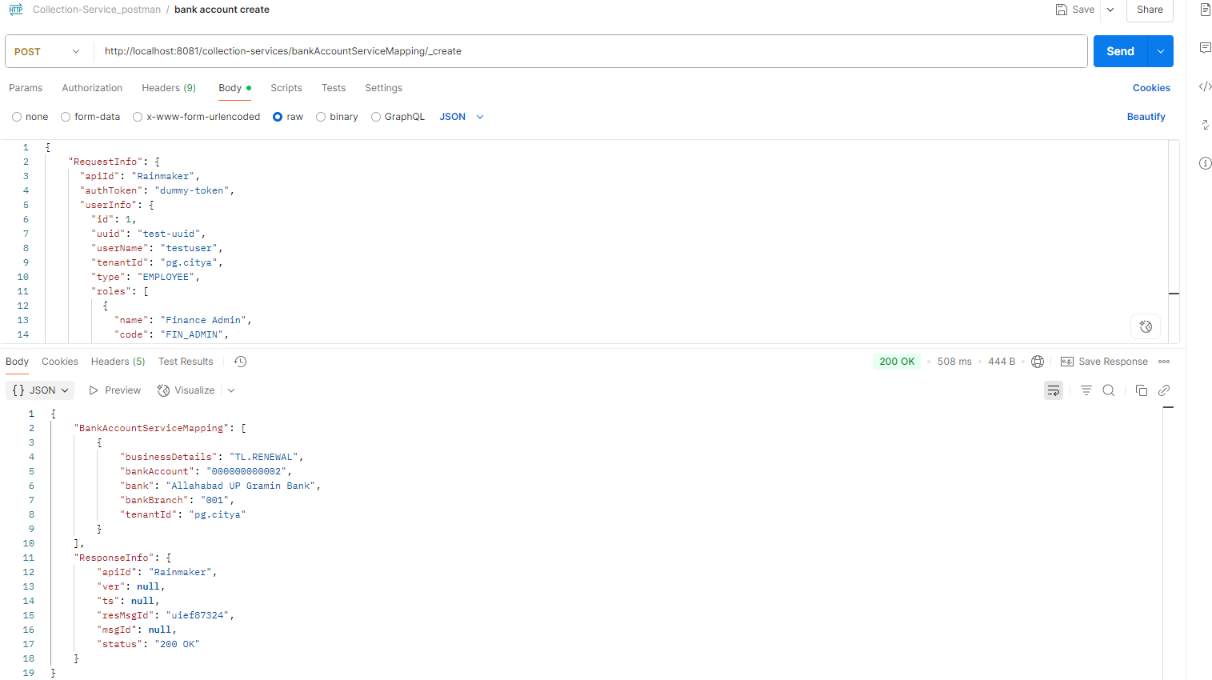

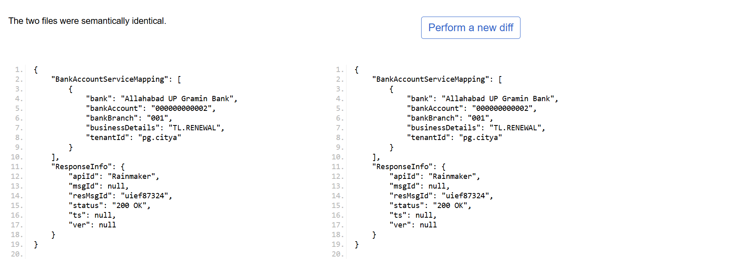

* Bank Account Search  
    
  Request Payload:  
  curl --location 'http://localhost:8081/collection-services/bankAccountServiceMapping/_search?tenantId=pg.citya' \
* --header 'Content-Type: application/json' \
* --data '{
* "RequestInfo": {
* "apiId": "Rainmaker",
* "authToken": "dummy-token",
* "userInfo": {
* "id": 1,
* "uuid": "test-uuid",
* "userName": "testuser",
* "tenantId": "pb.amritsar",
* "type": "EMPLOYEE",
* "roles": [
* {
* "name": "Finance Admin",
* "code": "FIN_ADMIN",
* "tenantId": "pb.amritsar"
* }
* ]
* }
* }
* }'  
  Response from local:  
  {
* "BankAccountServiceMapping": [
* {
* "businessDetails": "TL.RENEWAL",
* "bankAccount": "000000000001",
* "bank": "Allahabad UP Gramin Bank",
* "bankBranch": "001",
* "tenantId": "pg.citya"
* },
* {
* "businessDetails": "chb-services",
* "bankAccount": "1234567890123456",
* "bank": "kunal",
* "bankBranch": "069",
* "tenantId": "pg.citya"
* },
* {
* "businessDetails": "chb-services",
* "bankAccount": "844102001001VN",
* "bank": "STATE BANK OF INDIA",
* "bankBranch": "6305",
* "tenantId": "pg.citya"
* },
* {
* "businessDetails": "sv-services",
* "bankAccount": "844102001001VN",
* "bank": "STATE BANK OF INDIA",
* "bankBranch": "11959",
* "tenantId": "pg.citya"
* }
* ],
* "ResponseInfo": {
* "apiId": "Rainmaker",
* "ver": null,
* "ts": null,
* "resMsgId": "uief87324",
* "msgId": null,
* "status": "200 OK"
* }
* }
* 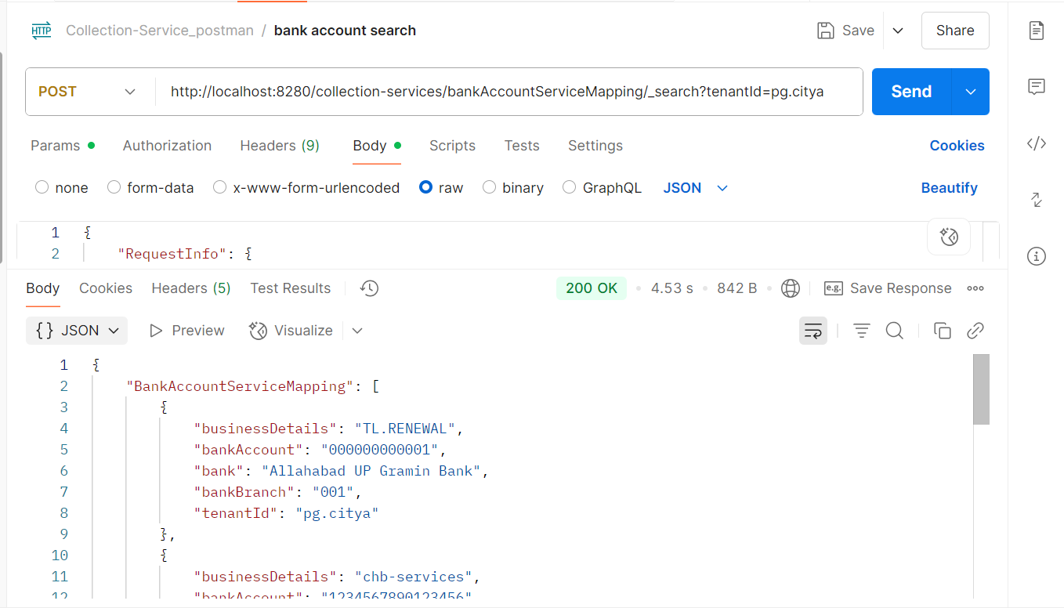  
  Response from env:  
  {
* "BankAccountServiceMapping": [
* {
* "businessDetails": "TL.RENEWAL",
* "bankAccount": "000000000001",
* "bank": "Allahabad UP Gramin Bank",
* "bankBranch": "001",
* "tenantId": "pg.citya"
* },
* {
* "businessDetails": "chb-services",
* "bankAccount": "1234567890123456",
* "bank": "kunal",
* "bankBranch": "069",
* "tenantId": "pg.citya"
* },
* {
* "businessDetails": "chb-services",
* "bankAccount": "844102001001VN",
* "bank": "STATE BANK OF INDIA",
* "bankBranch": "6305",
* "tenantId": "pg.citya"
* },
* {
* "businessDetails": "sv-services",
* "bankAccount": "844102001001VN",
* "bank": "STATE BANK OF INDIA",
* "bankBranch": "11959",
* "tenantId": "pg.citya"
* }
* ],
* "ResponseInfo": {
* "apiId": "Rainmaker",
* "ver": null,
* "ts": null,
* "resMsgId": "uief87324",
* "msgId": null,
* "status": "200 OK"
* }
* }  
    
  
 