1. Database Choice
I picked PostgreSQL instead of MySQL or Informix for a few practical reasons tied to what this assessment needs.
- EXPLAIN ANALYZE in Postgres actually shows real execution numbers like actual time, actual rows and buffer hits. That matters because the task asks for before and after performance comparison and Postgres makes that evidence much clearer.
- I also used window functions like ROW_NUMBER and CTEs in the compliance_risk dataset. Postgres handles these cleanly and they are pretty stable and predictable there.
- Another reason was generate_series. I used it to create the large sample datasets (around 1 million rows and 5 lakh rows). In MySQL this would need extra workarounds, but here it was straightforward and faster to implement.
- Setup wise, everything was containerised. PostgreSQL was running in Docker and Superset was also running through Docker Compose from the official Apache Superset setup. Both were connected using host.docker.internal since they were in separate Docker network
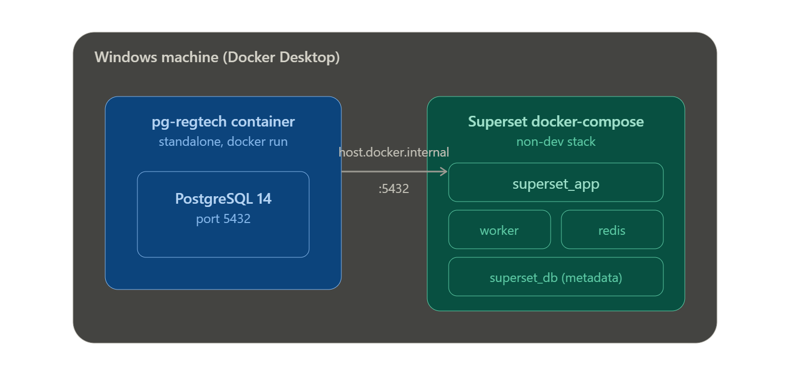

2. Virtual Dataset JOIN Strategy and NULL Handling

The compliance_risk dataset is built using a LEFT JOIN. The main table is xbrl_submissions and it joins to two aggregated CTEs coming from non_xbrl_returns using entity_id.
- Why LEFT JOIN
  - Because every regulated entity will have XBRL submissions, but not all entities will have matching non XBRL returns at all times. If I used INNER JOIN, some valid XBRL records would disappear from the output which would mess up totals and KPIs.
- Why not RIGHT JOIN
  - RIGHT JOIN would flip the logic and make non_xbrl_returns the main table. That would break the expected grain of the dataset which is one row per XBRL submission.
- Why two CTEs
non_xbrl_returns is one to many with entity_id. If I joined directly, it would multiply rows and inflate counts. So I split it into two CTEs. One gives latest record per entity using ROW_NUMBER, and the other gives aggregated summary using GROUP BY. This keeps one row per entity before join and avoids duplication issues.
- Risk category NULL handling
  - The CASE logic is written carefully so NULL values dont silently turn into wrong risk labels.
  - If both signals are missing it becomes Unrated, not Low. That is important because missing data should not be treated as safe.
  - If NPA is NULL, like in insurance entities, it relies only on compliance status. If compliance is NULL then it relies only on NPA. If both exist then combined logic is applied where either can push risk higher.
This is intentional because mixing a good and bad signal should not dilute risk.

3. Database/Security: User Roles and Permissions
- Public_Viewer role
  - This role is only for viewing dashboards. It has read access on dashboard and chart. Without chart read access, dashboards would not render properly since charts are embedded objects.
  - Explore access is intentionally not given because it exposes SQL builder and dataset logic. Same for SQL Lab, write access, and security menus. All of these are editing or admin level actions and not needed for viewing.
  - Also datasource access is not given because viewers never directly query data. Superset handles query execution internally based on dataset permissions.

- RegTech_Analyst role
  - This role is for full analysis work. It has read and write access on dashboards, charts and datasets. It also has explore access so charts can be modified and analysed.
  - SQL Lab access is included so analyst can run queries and export results. Query cost estimation is also enabled since that is part of normal analyst workflow.
  - Admin level permissions like user management, role management, database write access and security settings are blocked completely. Analyst should not be able to create users or change connections.
  - Database connection control is also restricted so the analyst cannot point Superset to a new database or change credentials. They can only work on the approved regtech connection.

4. Row Level Security
- The rule starts with a simple filter like regulator equals RBI in the basic version.
- In the dynamic version, it pulls allowed regulators from user_attribute table based on logged in user. So each user only sees their assigned regulators.
- If a user has multiple regulators assigned, IN clause naturally supports that so no code change is needed.
- How Superset applies it
  - When a chart runs, Superset collects all matching RLS rules for that user, renders them using Jinja context like current_user, and then injects them into the final SQL WHERE clause.
  - Rules with same group key are combined using OR and different groups are combined using AND. This happens server side so users cannot bypass it from UI or URL.

5. Performance Optimisation
The query was a grouped aggregation on xbrl_submissions filtered by reporting period.
- Before indexing
Postgres was doing a sequential scan on the whole table. Even rows outside the date range were scanned and discarded which slowed everything down as table size increased.
- Index added
I created a composite index on reporting_period, regulator and entity_type and included status, capital_adequacy and total_assets so Postgres can answer query directly from index without going back to main table.
- Before vs after
  - Execution time dropped from around 1600 ms to around 56 ms. Scan type changed from sequential scan to index only scan. Heap fetches became zero.
  - This is not just small tuning. It changes how query scales. Earlier it was O n and now it behaves closer to log n plus filtered data size so performance stays stable even if data grows.

Before / after comparison
Metric | Before Index | After Index | Improvement
Execution Time | 1618.561 ms | 56.435 ms | 96.5% faster
Planning Time | 13.467 ms | 0.552 ms | 95.9% faster
Scan Type | Parallel Seq Scan | Parallel Index Only Scan | —
Rows Discarded by Filter | 222,259 | 0 | —
Heap Fetches | n/a (full row scan) | 0 | —

6. Caching Configuration
- Superset has two main cache layers.
  - CACHE_CONFIG is for general app level caching like dashboard metadata and UI elements.
  - DATA_CACHE_CONFIG is for actual chart query results.
- I separated them using different Redis DBs so flushing one does not affect the other.
- Cache invalidation
  - Cache is based on query hash not actual data changes. So Superset does not know if underlying table changed. It only expires based on timeout or manual refresh.
- Risk of long cache TTL
  - If cache is too long in a regulatory dashboard, users might see outdated compliance data which is risky because decisions may be taken on stale numbers. That is why cache timeout was kept around 10 minutes and aligned with dashboard refresh cycle.

7. Jinja2 Templating

I used filter_values for dynamic filtering in charts.
Earlier I considered sqlsafe but that can directly inject raw SQL without escaping. If that value ever comes from untrusted input like URL or filter manipulation it can lead to SQL injection.
So sqlsafe is only acceptable when values come from controlled dataset columns like regulator list or entity list.
As a safety practice I avoided using sqlsafe on anything that could come from user input and kept role based restriction on who can edit SQL logic.

8. Known Limitations
- RLS setup needed explicit datasource access permissions for analyst role, otherwise dashboard loads blank. That was a practical Superset behaviour issue.
- Repo naming does not exactly follow required naming format but structure and implementation are complete.
- Dynamic RLS with user attributes is explained but final setup uses static fallback rules for simplicity in demo environment.
- Async SQL Lab execution is not configured because local docker setup does not include background worker.

9. Bonus Work
Drill down was added in Penalty Trend chart using custom SQL with Jinja filters for entity level drill. Conditional formatting was used in tables to highlight compliance status with colors.
Some bonus items like API scripts and alerts are partially implemented in bonus folder

