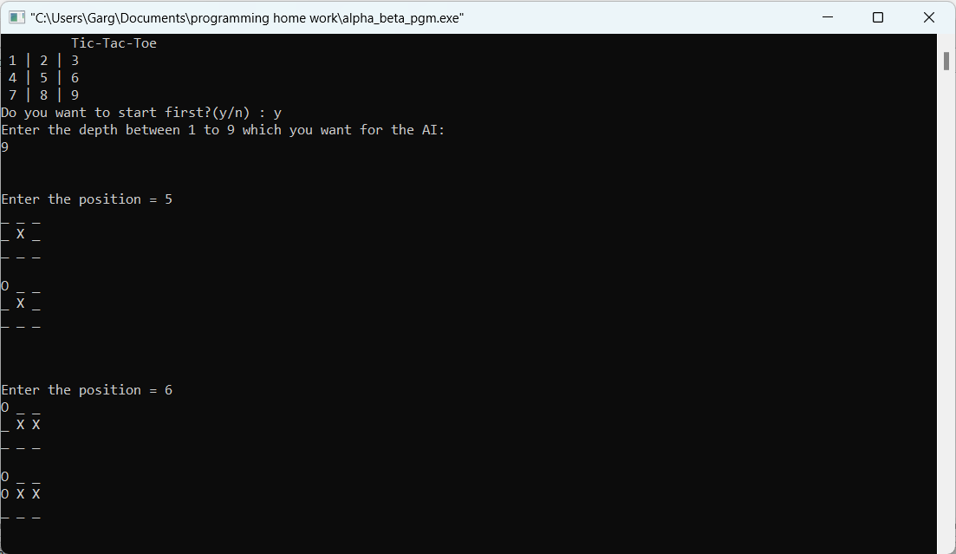

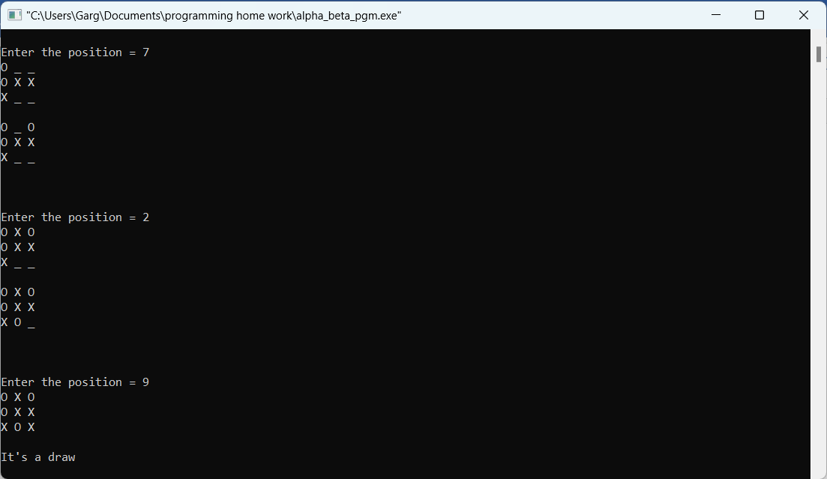

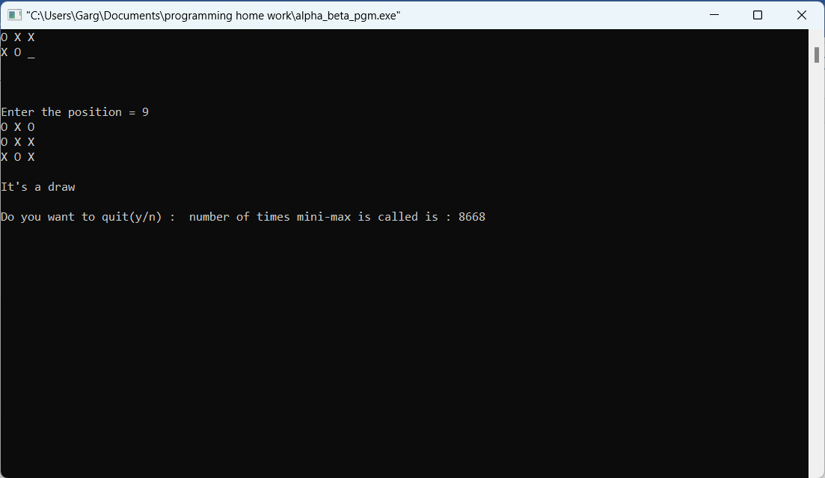

Number of times mini-max is called in alpha-beta pruning is **8868**

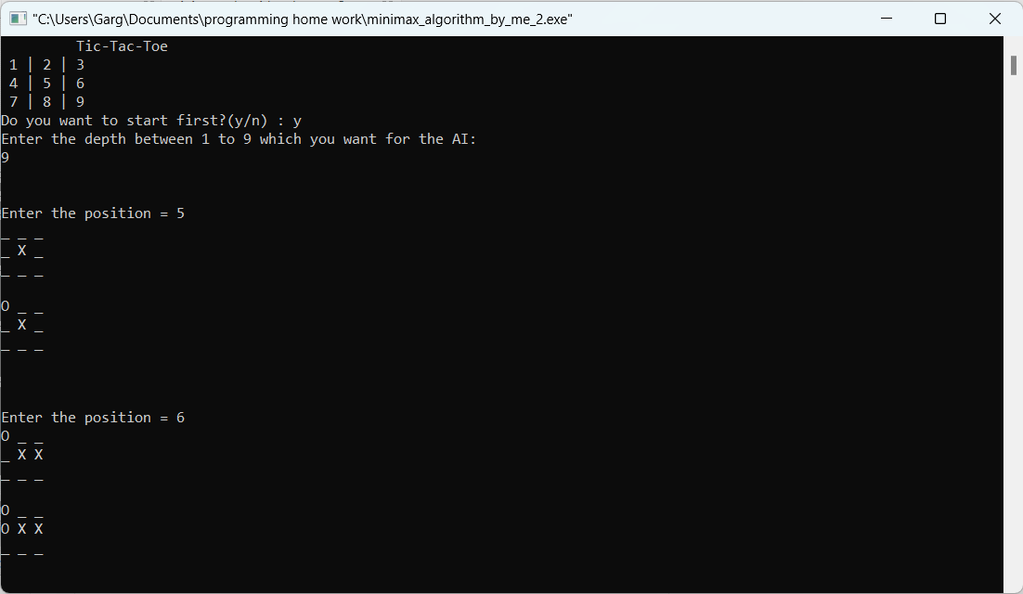

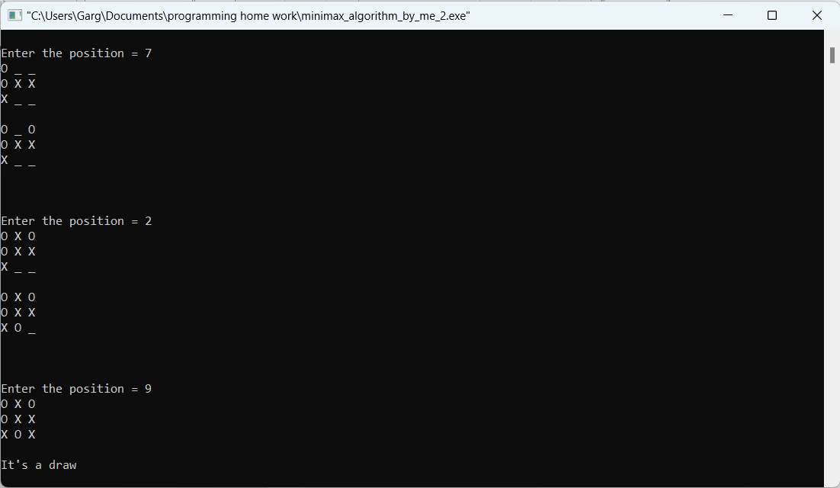

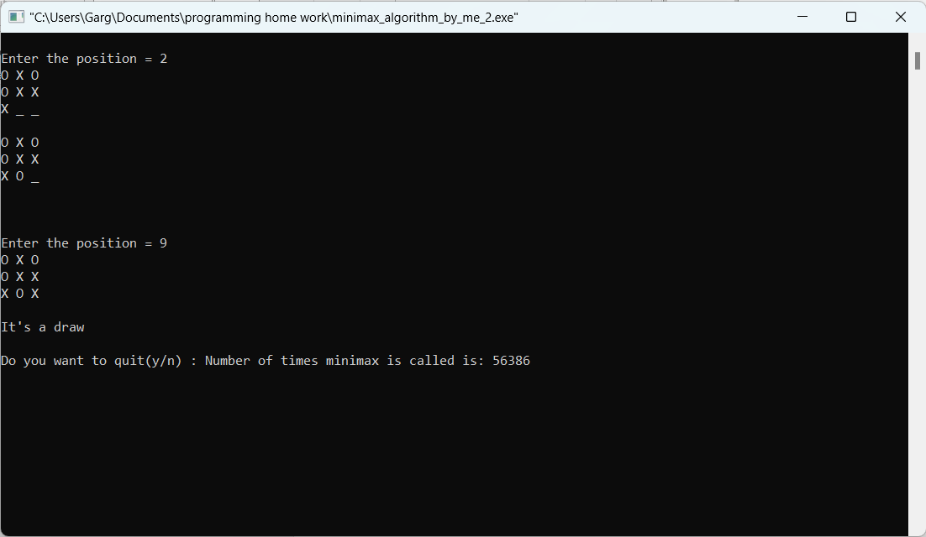

Number of times mini-max is called in mini-max algorithm for the same case is pruning is **56386**

Therefore, the difference in the number of calls is 56386 – 8868 = **47518**

**Hence alpha – beta drastically reduces the recursive calls to the mini-max function**