Test Case1: Generate a Series of 100 numbers in a range 0-100 with seed points: 90, 80, 65, 50.

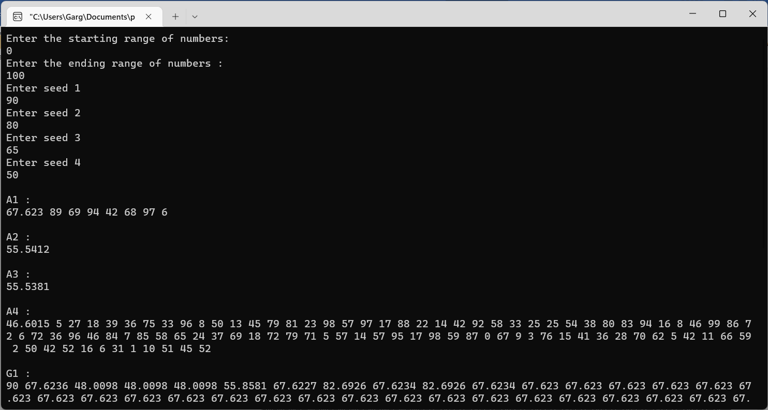

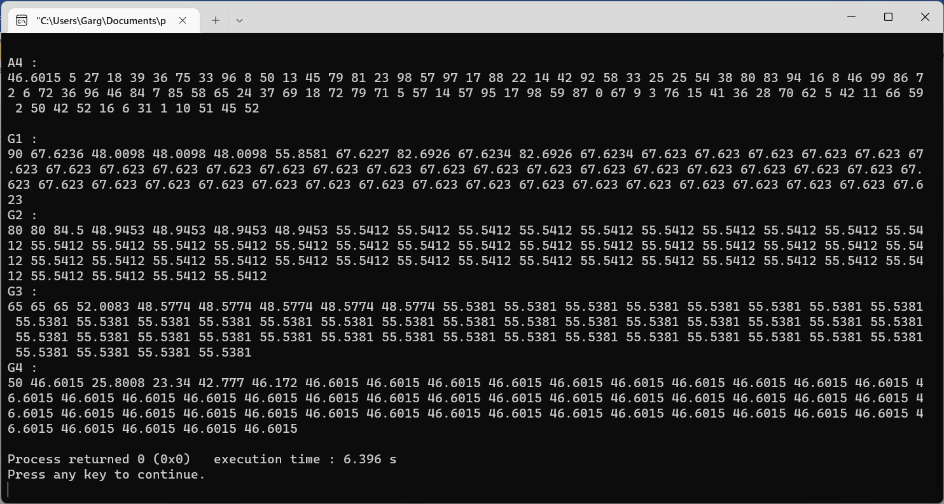

Test Case 2: Generate a Series of 100 numbers in a range 20-60 with seed points: 90, 80, 65, 50.

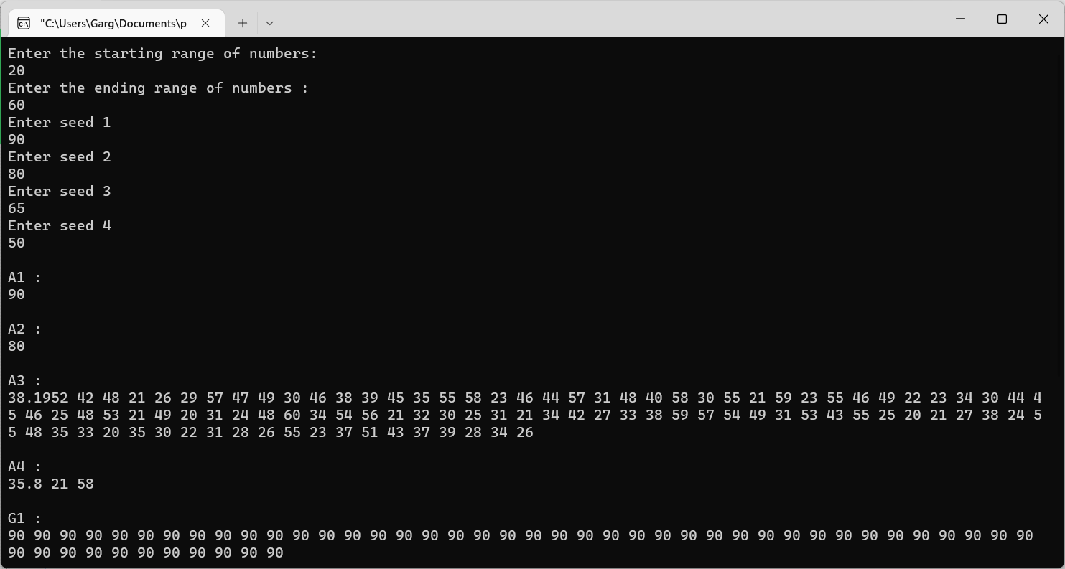

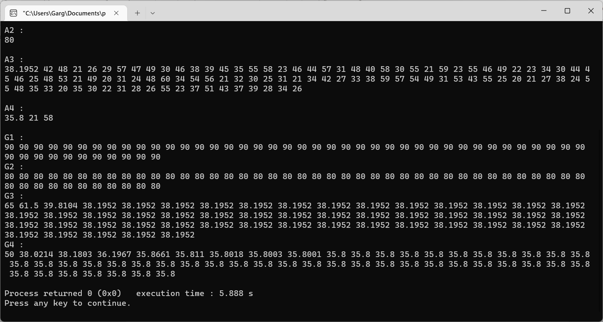

Test Case 3:  Generate a Series of 100 numbers in a range 0-60 with seed points: 4,3,2,1

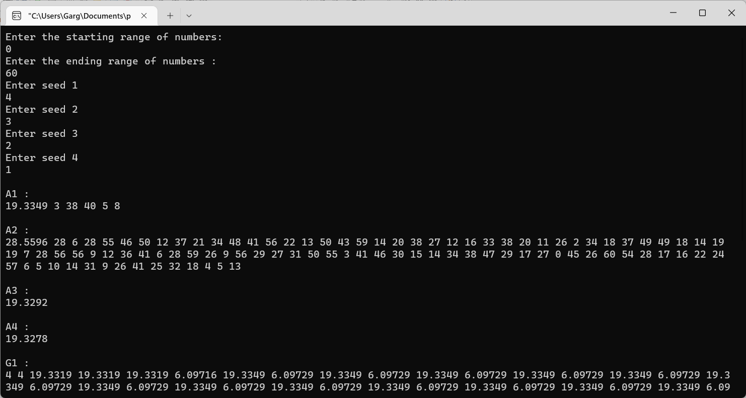

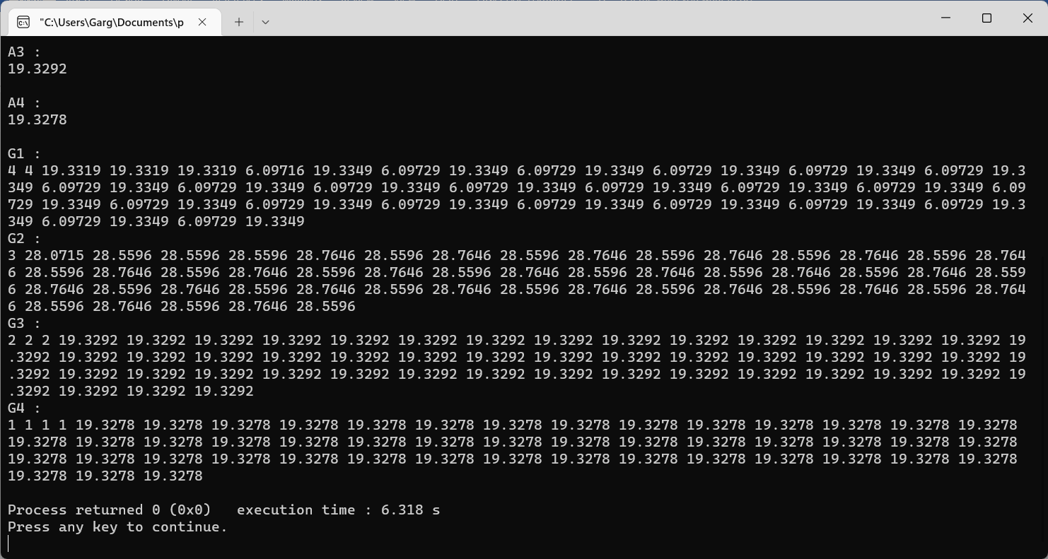

Test Case 4: Generate a Series of 100 numbers in a range 60-100 with seed points: 95, 90, 85, 80.

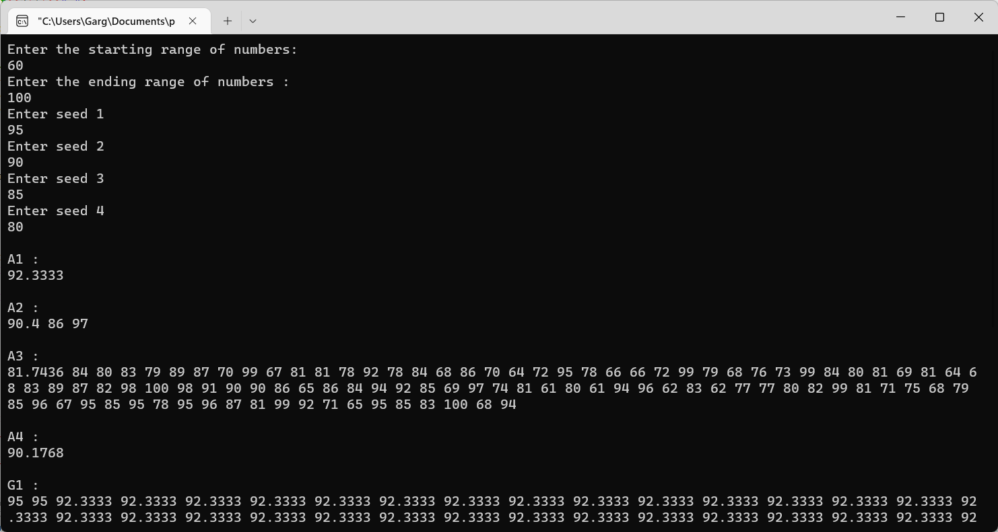

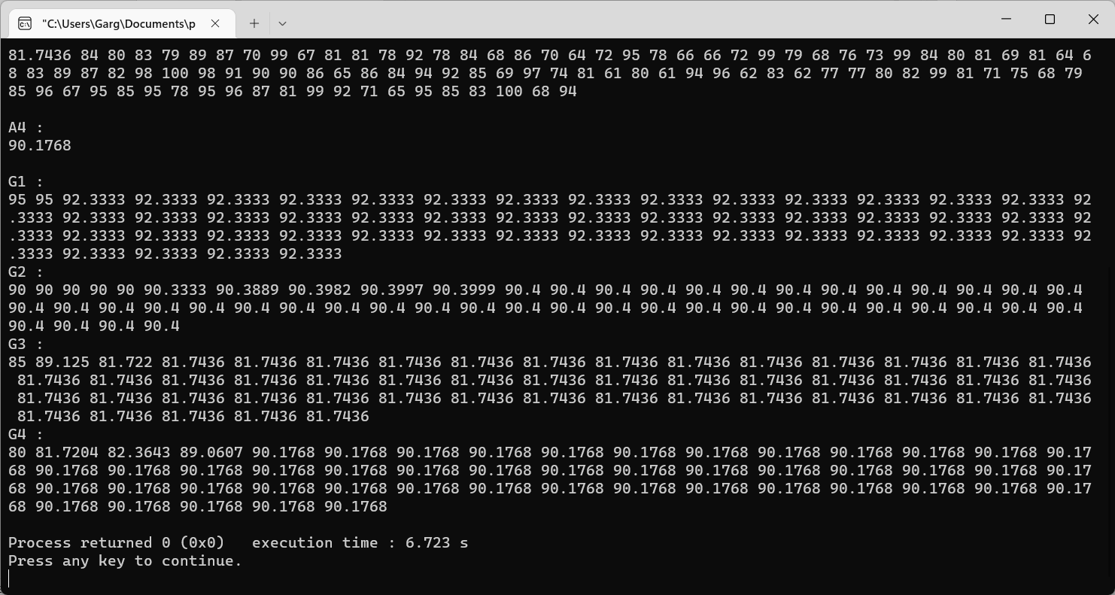

Test Case 5:   Generate a Series of 100 numbers in a range 0-100 with seed points:  4,3,2,1

