USP5 Computational Project Report
Mentor-facing summary of the modeling, enumeration, and lead selection workflow
Generated on 2026-03-29

Executive Summary
- The project now has one canonical computational pipeline built around a saved ExtraTrees regression model, a broad 10-method enumeration library, and a multistage lead-selection funnel.
- The final saved potency model achieved in-sample R^2 = 0.893 on the current row-level USP5 dataset and remains the project-level potency engine.
- The broad enumeration workflow produced 3264 unique virtual compounds from the positive training chemistry space.
- The final screening pipeline narrowed 3274 total structures (broad enumeration plus original positives) to 4 strict primary leads and 5 orthogonal backup leads.
- Most computational cheminformatics work is complete; the main remaining tasks before paper writing are figure assembly, polished results framing, and ideally experimental validation planning.

Project Aim
The goal of this project is to build a practical small-data USP5 inhibitor discovery workflow that combines potency modeling, chemically meaningful virtual enumeration, and computational lead prioritization. The emphasis is on transparent and interpretable cheminformatics rather than black-box modeling.

Dataset Status
- Raw input file: data/raw/First.csv
- Valid row-level entries used by the final model: 26
- Deduplicated canonical molecules in the modeling table: 19
- The dataset mixes measured activity rows with assigned active/inactive labels; this is tracked explicitly in the cleaned outputs.

Modeling Dataset Overview
representative_id | target_pIC50 | target_origin | has_measured_row | has_active_no_ic50_row | has_inactive_row
CHEMBL5278336 | 5.15 | measured_median | True | False | False
CHEMBL1410015 | 4.62 | measured_median | True | False | False
CHEMBL2012938 | 5.23 | mixed_duplicate_measured_median | True | True | False
CHEMBL1923233 | 5.52 | measured_median | True | False | False
CHEMBL5276142 | 4.67 | measured_median | True | False | False
CHEMBL1493046 | 4.54 | measured_median | True | False | False
CHEMBL4635160 | 5 | measured_median | True | False | False
CHEMBL5410606 | 5.1 | measured_median | True | False | False
CHEMBL5267683 | 3.7 | measured_median | True | False | False
CHEMBL4129140 | 3.7 | measured_median | True | False | False
51031028 | 2.5 | assigned_median | False | False | True
443118 | 2.5 | assigned_median | False | False | True
10216098 | 2.5 | assigned_median | False | False | True
49864402 | 2.5 | assigned_median | False | False | True
25191039 | 5 | assigned_median | False | True | False
70691637 | 5 | assigned_median | False | True | False
73353602 | 2.5 | assigned_median | False | False | True
145963683 | 5 | assigned_median | False | True | False
168007234 | 2.5 | assigned_median | False | False | True

Final Potency Model
The final potency model is the saved ExtraTreesRegressor reported in outputs/final_model/final_model_report.md. This model was deliberately preserved as the canonical project model for all final screening.
- Model family: ExtraTreesRegressor
- Feature block: physicochemical descriptors plus graph-topology descriptors
- Reported in-sample R^2: 0.893359
- Reported MAE: 0.176795
- Reported RMSE: 0.368224
- Model artifact: outputs/final_model/final_model.joblib
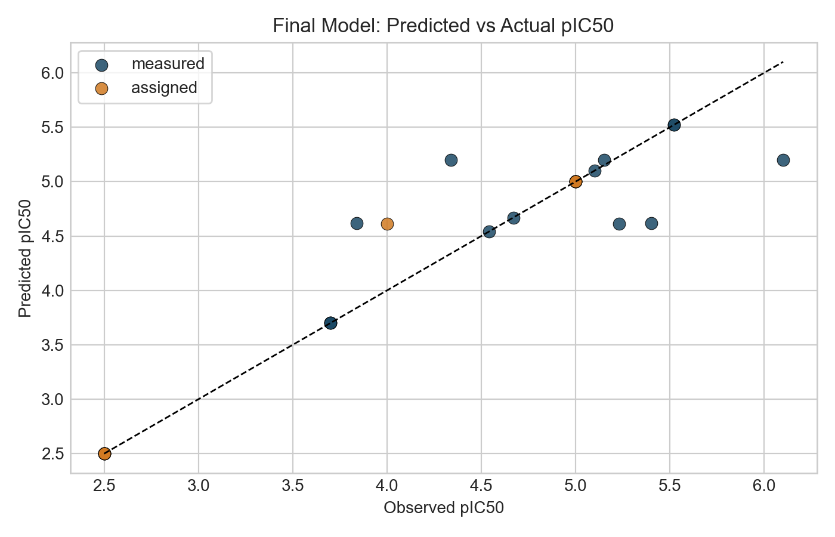
Final model predicted vs observed pIC50
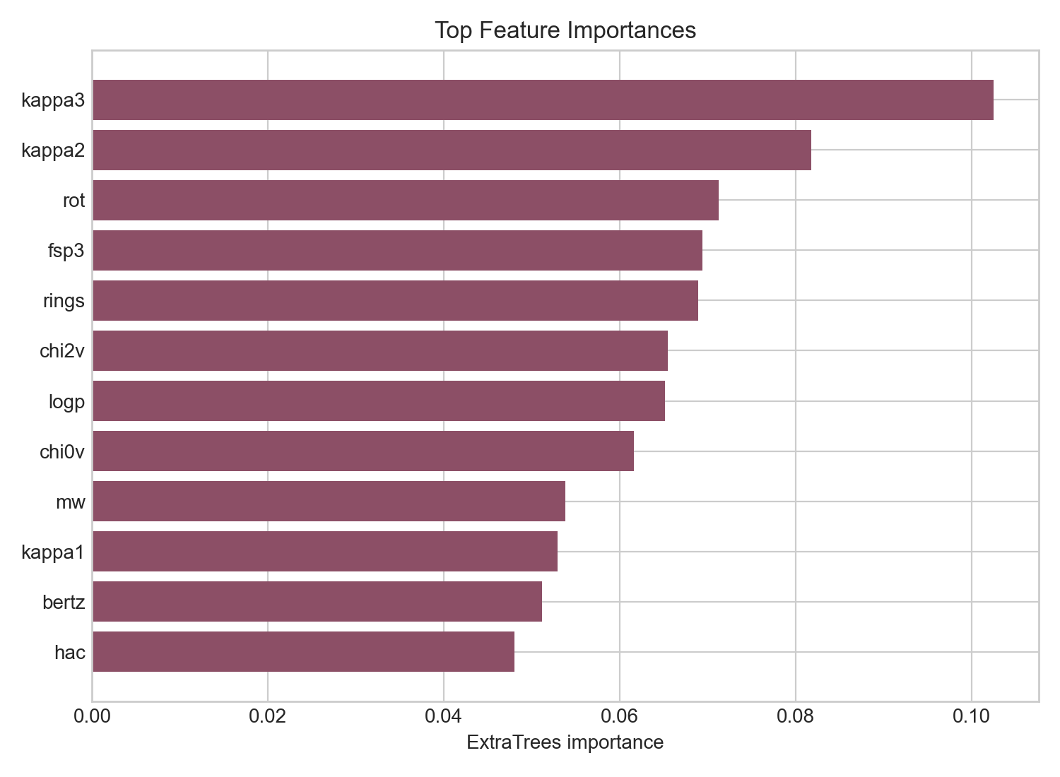
Top feature importances in the final model

Enumeration Workflow
The final enumeration layer is the broad 10-method chemistry workflow. This is the canonical virtual library generation stage used for downstream lead screening.
- Canonical enumeration script: scripts/run_enumeration_10_methods.py
- Canonical broad library: outputs/enumeration_library_10_methods.csv
- Total unique enumerated products: 3264

Enumeration Method Breakdown
method | count
r_group_enumeration | 1205
reagent_pool_combinatorics | 1200
scaffold_hopping | 671
fragment_growing | 430
heteroatom_walks | 61
reaction_based_enumeration | 31
matched_molecular_pair_expansion | 25
bioisosteric_swaps | 15
linker_scans | 5
ring_size_and_ring_system_scans | 3

Final Lead Selection Workflow
The canonical lead-selection workflow restores the saved final ExtraTrees model as the sole potency engine, then applies property filtering, ADMET-AI, and multistructure USP5 3D template-docking / pharmacophore plausibility.
- Canonical screening script: scripts/run_lead_selection.py
- Property filters include Lipinski-style limits, TPSA, molecular surface area, flexibility, and charge sanity.
- ADMET stage uses ADMET-AI with AMES, hERG, ClinTox, HIA, oral bioavailability, permeability, and solubility-related outputs.
- 3D structural evidence uses USP5 ZnF-UBD co-crystal structures 6DXT, 7MS5, 7MS6, and 7MS7.
- The final output is split into primary leads and orthogonal backup leads to avoid overclaiming a single chemotype as the only viable program.

Lead Selection Funnel
stage | count
start_broad_enumeration_plus_original_positives | 3274
stage1_original_final_model_predicted_pIC50_ge_4.60 | 1272
stage2_pains_brenk_free | 772
stage3_lipinski_psa_surface_area_flexibility | 59
stage4_admet_ai_multigate | 24
stage5_multistructure_template_docking_strict | 4
stage5b_multistructure_template_docking_relaxed | 5

Primary Leads

Canonical Primary Lead Set
product_smiles | primary_parent_id | pred_pIC50 | pred_ic50_uM | AMES | hERG | best_binding_score | scaffold
O=C(O)CNC(=O)c1ccc(S(=O)(=O)N2CCC(c3ccc(Cl)cc3)CC2)cn1 | CHEMBL5278336 | 5.1967 | 6.3582 | 0.0796 | 0.2134 | 0.7818 | O=S(=O)(c1cccnc1)N1CCC(c2ccccc2)CC1
O=C(O)CNC(=O)c1ncc(S(=O)(=O)N2CCC(c3ccc(Cl)cc3)CC2)cn1 | CHEMBL5278336 | 4.8951 | 12.7309 | 0.0537 | 0.1057 | 0.8298 | O=S(=O)(c1cncnc1)N1CCC(c2ccccc2)CC1
O=C(O)CNC(=O)c1ccc(S(=O)(=O)N2CCC(c3ccc(F)cc3)CC2)cn1 | CHEMBL5278336 | 5.011 | 9.7504 | 0.0975 | 0.1226 | 0.7799 | O=S(=O)(c1cccnc1)N1CCC(c2ccccc2)CC1
O=C(O)CNC(=O)c1ccc(S(=O)(=O)N2CCC(c3ccc(Cl)cn3)CC2)cn1 | CHEMBL5278336 | 4.895 | 12.7356 | 0.0355 | 0.1308 | 0.7617 | O=S(=O)(c1cccnc1)N1CCC(c2ccccn2)CC1

Orthogonal Backup Leads

Canonical Backup Lead Set
product_smiles | primary_parent_id | pred_pIC50 | AMES | hERG | best_binding_score | scaffold
COc1ccccc1CNC(=O)Cn1c(CCC(=O)O)nc2c(Cl)cccc2c1=O | CHEMBL5410606 | 5.1 | 0.1284 | 0.2254 | 0.3503 | O=C(Cn1cnc2ccccc2c1=O)NCc1ccccc1
COc1ccccc1CNC(=O)Cn1c(CCC(=O)O)nc2c(F)cccc2c1=O | CHEMBL5410606 | 5.0192 | 0.1279 | 0.1607 | 0.3975 | O=C(Cn1cnc2ccccc2c1=O)NCc1ccccc1
Cc1cc(-c2cc(C)n(CCC(=O)O)c2C)c(C)n1CCC(=O)O | [9*]n1c(C)cc([16*])c1C | 4.8743 | 0.0932 | 0.1127 | 0.5561 | c1cc(-c2cc[nH]c2)c[nH]1
Cc1cc(-n2c(C)cc(CCC(=O)O)c2C)c(C)n1CCC(=O)O | [9*]n1c(C)cc([16*])c1C | 4.8758 | 0.0681 | 0.0676 | 0.4997 | c1ccn(-c2cc[nH]c2)c1
COc1ccccc1CNC(=O)Cn1c(CCC(=O)O)nc2c(Cl)cncc2c1=O | CHEMBL5410606 | 4.8769 | 0.0639 | 0.1786 | 0.4151 | O=C(Cn1cnc2ccncc2c1=O)NCc1ccccc1
COc1ncccc1CNC(=O)Cn1c(CCC(=O)O)nc2c(Cl)cccc2c1=O | CHEMBL5410606 | 4.8761 | 0.0736 | 0.0731 | 0.346 | O=C(Cn1cnc2ccccc2c1=O)NCc1cccnc1

Interpretation of Current Results
- The strict primary lead evidence remains concentrated in the CHEMBL5278336 acid-sulfonamide family.
- The backup program retains orthogonal chemistry, especially CHEMBL5410606-derived bicyclic carbonyl analogs and a weaker heteroaryl-acid branch.
- The project now has a consistent folder structure and a single final pipeline rather than multiple competing screening variants.
- From a project-management standpoint, most of the computational chemistry work is now done.

Limitations
- The final model is exploratory and small-data; strong prospective claims should be avoided.
- The final model performance reported here is in-sample rather than a large prospective benchmark.
- The 3D stage is a multistructure template-docking / pharmacophore surrogate, not a full production docking plus MD validation campaign.
- All lead calls remain computational priorities until experimentally tested.
- The dataset includes assigned labels in addition to measured values, which should be acknowledged in any presentation or manuscript.

Work Completed
- Dataset parsing, cleaning, label annotation, and canonicalization
- Descriptor and fingerprint generation
- Baseline similarity and scaffold analysis
- Final exploratory USP5 potency model selection and report generation
- Broad 10-method combinatorial enumeration
- ADMET-AI integration
- Multistructure USP5 3D screening against experimentally determined co-crystal structures
- Primary and orthogonal backup lead prioritization
- Project-folder cleanup and canonical final pipeline consolidation

What Remains Before Paper Writing
- Assemble publication-quality figures from the existing outputs
- Freeze the exact final tables and figure order for the manuscript
- Write the Results and Discussion around the canonical final pipeline
- State limitations carefully and explicitly
- Ideally plan or begin experimental validation to strengthen the paper

Key Project Files
Canonical project summary: outputs/final_pipeline_summary.md
- outputs/lead_selection_summary.md
- outputs/final_leads.csv
- outputs/backup_leads.csv
- outputs/enumeration_library_10_methods.csv
- outputs/final_model/final_model_report.md

Appendix: Internal Text Summaries
The following brief snippets capture the current canonical pipeline and final-model summaries from the project files.

Final pipeline summary
# Final Canonical USP5 Pipeline
This project now uses one canonical end-to-end computational workflow.
## Final model
- Potency model: saved `ExtraTreesRegressor`
- Model artifact: [final_model.joblib](/Users/shivanshsahni/Documents/New%20project/outputs/final_model/final_model.joblib)
- Model report: [final_model_report.md](/Users/shivanshsahni/Documents/New%20project/outputs/final_model/final_model_report.md)
- Final reported in-sample `R^2`: `0.893359`
## Final enumeration workflow
- Script: [run_enumeration_10_methods.py](/Users/shivanshsahni/Documents/New%20project/scripts/run_enumeration_10_methods.py)
- Library file: [enumeration_library_10_methods.csv](/Users/shivanshsahni/Documents/New%20project/outputs/enumeration_library_10_methods.csv)
- Total unique enumerated compounds: `3264`
- Method breakdown: [enumeration_method_counts.md](/Users/shivanshsahni/Documents/New%20project/outputs/enumeration_method_counts.md)
## Final screening workflow
- Script: [run_lead_selection_final_model_restored.py](/Users/shivanshsahni/Documents/New%20project/scripts/run_lead_selection_final_model_restored.py)
- Summary: [lead_selection_summary.md](/Users/shivanshsahni/Documents/New%20project/outputs/lead_selection_summary.md)
- Primary leads: [final_leads.csv](/Users/shivanshsahni/Documents/New%20project/outputs/final_leads.csv)
- Backup leads: [backup_leads.csv](/Users/shivanshsahni/Documents/New%20project/outputs/backup_leads.csv)
## Final screening stages
- Start broad enumeration plus original positives: `3274`
- Saved final model predicted `pIC50 >= 4.60`: `1272`
- `PAINS + BRENK` free: `772`
- Lipinski / PSA / surface area / flexibility: `59`
- `ADMET-AI`: `24`
- Strict multistructure USP5 3D survivors: `4`
- Relaxed orthogonal backup pool: `5`
## Final interpretation
- The primary lead family is the `CHEMBL5278336` acid-sulfonamide series.
- The orthogonal backup program is centered on `CHEMBL5410606`-derived bicyclic carbonyl chemistry plus a weaker heteroaryl-acid backup branch.
- The folder has been cleaned so the top-level outputs point to this workflow, while older exploratory artifacts are preserved under archive folders.

Final lead-selection summary
# Restored Final-Model Lead Selection
This run restores the original saved ExtraTrees regression model as the only potency model. The downstream workflow is still the stronger version: broad library input, PAINS/BRENK cleanup, lead-like property filters, ADMET-AI, and multistructure USP5 3D binding plausibility.
## Stage counts
- `start_broad_enumeration_plus_original_positives`: 3274
- `stage1_original_final_model_predicted_pIC50_ge_4.60`: 1272
- `stage2_pains_brenk_free`: 772
- `stage3_lipinski_psa_surface_area_flexibility`: 59
- `stage4_admet_ai_multigate`: 24
- `stage5_multistructure_template_docking_strict`: 4
- `stage5b_multistructure_template_docking_relaxed`: 5
## Primary leads
- `O=C(O)CNC(=O)c1ccc(S(=O)(=O)N2CCC(c3ccc(Cl)cc3)CC2)cn1` | score 0.6365 | predicted pIC50 5.197 (pred IC50 6.36 uM) | AMES 0.080 | hERG 0.213 | best binding 0.782 | scaffold `O=S(=O)(c1cccnc1)N1CCC(c2ccccc2)CC1` | parent `CHEMBL5278336`
- `O=C(O)CNC(=O)c1ncc(S(=O)(=O)N2CCC(c3ccc(Cl)cc3)CC2)cn1` | score 0.4127 | predicted pIC50 4.895 (pred IC50 12.73 uM) | AMES 0.054 | hERG 0.106 | best binding 0.830 | scaffold `O=S(=O)(c1cncnc1)N1CCC(c2ccccc2)CC1` | parent `CHEMBL5278336`
- `O=C(O)CNC(=O)c1ccc(S(=O)(=O)N2CCC(c3ccc(F)cc3)CC2)cn1` | score 0.4108 | predicted pIC50 5.011 (pred IC50 9.75 uM) | AMES 0.098 | hERG 0.123 | best binding 0.780 | scaffold `O=S(=O)(c1cccnc1)N1CCC(c2ccccc2)CC1` | parent `CHEMBL5278336`
- `O=C(O)CNC(=O)c1ccc(S(=O)(=O)N2CCC(c3ccc(Cl)cn3)CC2)cn1` | score 0.1993 | predicted pIC50 4.895 (pred IC50 12.74 uM) | AMES 0.036 | hERG 0.131 | best binding 0.762 | scaffold `O=S(=O)(c1cccnc1)N1CCC(c2ccccn2)CC1` | parent `CHEMBL5278336`
## Orthogonal backups
- `COc1ccccc1CNC(=O)Cn1c(CCC(=O)O)nc2c(Cl)cccc2c1=O` | score 0.5514 | predicted pIC50 5.100 | AMES 0.128 | hERG 0.225 | best binding 0.350 | scaffold `O=C(Cn1cnc2ccccc2c1=O)NCc1ccccc1` | parent `CHEMBL5410606`
- `COc1ccccc1CNC(=O)Cn1c(CCC(=O)O)nc2c(F)cccc2c1=O` | score 0.5056 | predicted pIC50 5.019 | AMES 0.128 | hERG 0.161 | best binding 0.397 | scaffold `O=C(Cn1cnc2ccccc2c1=O)NCc1ccccc1` | parent `CHEMBL5410606`
- `Cc1cc(-c2cc(C)n(CCC(=O)O)c2C)c(C)n1CCC(=O)O` | score 0.4640 | predicted pIC50 4.874 | AMES 0.093 | hERG 0.113 | best binding 0.556 | scaffold `c1cc(-c2cc[nH]c2)c[nH]1` | parent `[9*]n1c(C)cc([16*])c1C`
- `Cc1cc(-n2c(C)cc(CCC(=O)O)c2C)c(C)n1CCC(=O)O` | score 0.4548 | predicted pIC50 4.876 | AMES 0.068 | hERG 0.068 | best binding 0.500 | scaffold `c1ccn(-c2cc[nH]c2)c1` | parent `[9*]n1c(C)cc([16*])c1C`
- `COc1ccccc1CNC(=O)Cn1c(CCC(=O)O)nc2c(Cl)cncc2c1=O` | score 0.4344 | predicted pIC50 4.877 | AMES 0.064 | hERG 0.179 | best binding 0.415 | scaffold `O=C(Cn1cnc2ccncc2c1=O)NCc1ccccc1` | parent `CHEMBL5410606`
- `COc1ncccc1CNC(=O)Cn1c(CCC(=O)O)nc2c(Cl)cccc2c1=O` | score 0.4239 | predicted pIC50 4.876 | AMES 0.074 | hERG 0.073 | best binding 0.346 | scaffold `O=C(Cn1cnc2ccccc2c1=O)NCc1cccnc1` | parent `CHEMBL5410606`
## Interpretation
The original final model was preserved intact. The ma

Final model summary
# Final USP5 Exploratory Model Report
## Model selection
This report documents the selected final exploratory model for the USP5 inhibitor dataset.
- Final dataset view: raw row-level dataset from [`First.csv`](../../data/raw/First.csv)
- Valid rows used: 26
- Duplicate canonical SMILES rows present: 13
- Model family: `ExtraTreesRegressor`
- Model label: `raw_rows_base_graph_extratrees_trainfit`
- Evaluation used for final selection: in-sample training fit
The selected model was chosen because it achieved an in-sample `R^2` above 0.8 while still using interpretable RDKit-derived chemistry features rather than purely identity-based nearest-neighbor memorization.
## Final performance
- `R^2`: 0.893359
- `MAE`: 0.176795
- `RMSE`: 0.368224
## Dataset interpretation
- Target variable: `pIC50`
- Input representation: SMILES converted to RDKit descriptors
- Raw row strategy: all valid rows were retained rather than canonical deduplication
- Label mixture note:
- measured rows were identified by `ic50 > 0`
- assigned rows were identified by `ic50 in {0, -1}`
This final model is an exploratory fit to the available dataset and is best presented as a strong representation of the current table rather than as a validated prospective predictor.
## Feature set used
The final feature block is `base_graph`, meaning standard physicochemical descriptors combined with graph-topology descriptors.
### Base features
- `mw`: Molecular weight
- `logp`: logP
- `tpsa`: Topological polar surface area
- `hbd`: Hydrogen-bond donors
- `hba`: Hydrogen-bond acceptors
- `rot`: Rotatable bonds
- `rings`: Ring count
- `hac`: Heavy atom count
- `fsp3`: Fraction sp3 carbons
### Graph features
- `bertz`: Bertz complexity
- `balaban`: Balaban J index
- `chi0v`: Valence connectivity index Chi0v
- `chi1v`: Valence connectivity index Chi1v
- `chi2v`: Valence connectivity index Chi2v
- `kappa1`: Kier shape index Kappa1
- `kappa2`: Kier shape index Kappa2
- `kappa3`: Kier shape index Kappa3
## Most influential features in the fitted model
- `kappa3`: 0.1025
- `kappa2`: 0.0818
- `rot`: 0.0712
- `fsp3`: 0.0694
- `rings`: 0.0689
- `chi2v`: 0.0654
- `logp`: 0.0651
- `chi0v`: 0.0616
- `mw`: 0.0538
- `kappa1`: 0.0529
- `bertz`: 0.0511
- `hac`: 0.0480
The full feature importance table is saved in [`feature_importances.csv`](./feature_importances.csv).
## Figures
1. pIC50 distribution: [`pic50_distribution.png`](./pic50_distribution.png)
2. Predicted vs actual pIC50: [`predicted_vs_

