Regression Features, Enumeration Methods, and Narrowing Pipeline
Compact project summary for mentor discussion
Generated on 2026-03-31

Project Context
- Final potency model: saved ExtraTreesRegressor
- Final reported in-sample R^2: 0.893359
- Broad enumerated library: 3264 unique compounds
- Final screening start set: 3274 compounds including original positives

1. Features Used for Regression
The final model used the base_graph feature set: standard physicochemical descriptors combined with graph-topology descriptors.
feature | name | why it matters
mw | Molecular weight | Tracks overall size and strongly affects permeability, potency trends, and developability.
logp | logP | Captures lipophilicity, which often influences membrane penetration and nonspecific binding.
tpsa | Topological polar surface area | Measures polarity and is useful for absorption and binding-environment balance.
hbd | Hydrogen-bond donors | Counts donor groups that can drive binding or reduce permeability if too high.
hba | Hydrogen-bond acceptors | Counts acceptor groups that affect recognition and physicochemical behavior.
rot | Rotatable bonds | Approximates flexibility, which can affect entropy, oral exposure, and 3D fit.
rings | Ring count | Tracks scaffold rigidity and shape complexity.
hac | Heavy atom count | A simple size and complexity descriptor that often correlates with potency trends.
fsp3 | Fraction sp3 carbons | Measures saturation / 3D character and can help distinguish flat from more three-dimensional molecules.
bertz | Bertz complexity | Summarizes structural complexity from the molecular graph.
balaban | Balaban J index | A graph-connectivity descriptor that reflects topology.
chi0v | Valence connectivity index Chi0v | Encodes atom connectivity at a local graph level.
chi1v | Valence connectivity index Chi1v | Encodes one-bond connectivity patterns.
chi2v | Valence connectivity index Chi2v | Encodes two-bond graph connectivity patterns.
kappa1 | Kier shape index Kappa1 | Represents coarse molecular shape.
kappa2 | Kier shape index Kappa2 | Represents shape and branching at a deeper level.
kappa3 | Kier shape index Kappa3 | Represents higher-order shape complexity and was the top single feature in the final fit.
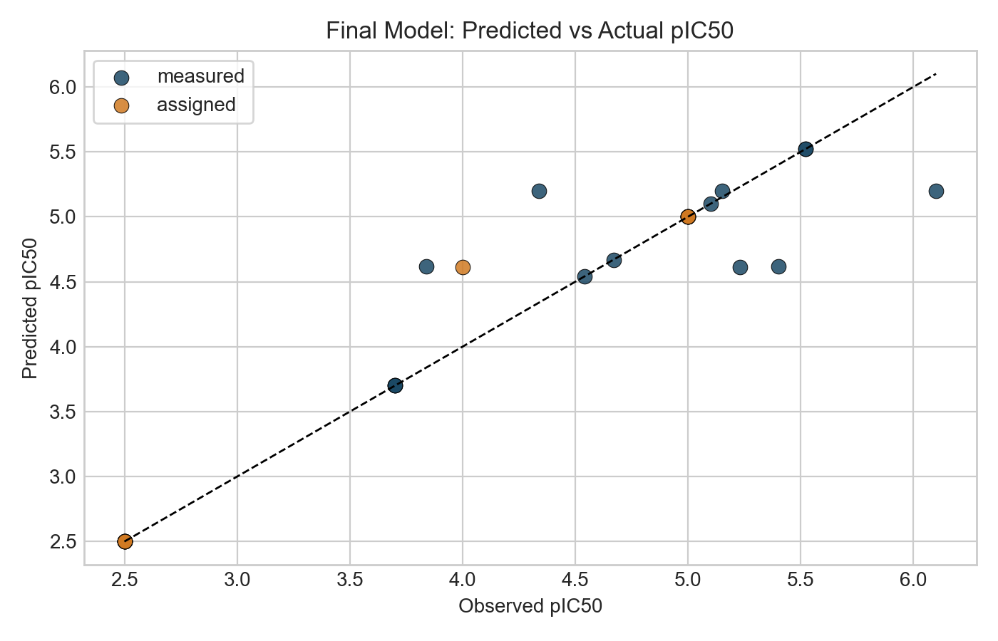
Final model predicted vs observed pIC50
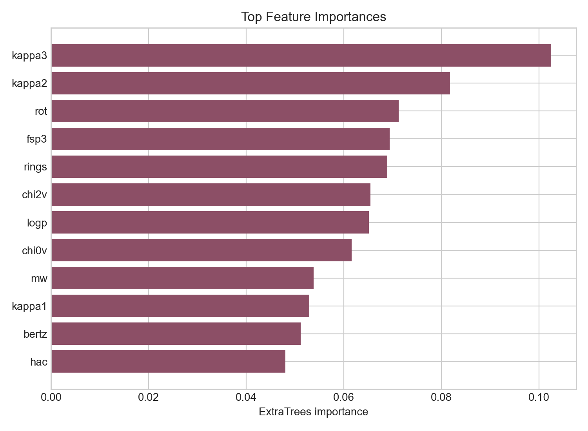
Top feature importances

2. Enumeration Techniques
The canonical enumeration workflow used 10 complementary methods. The table below explains each method and shows how many unique products it contributed to the final broad library.
technique | what it does | how it was done | unique products
R-group enumeration | Keep a core fragment fixed and swap side fragments around it. | Implemented with BRICS core fragments plus a pooled side-fragment set, rebuilding products while preserving the parent core. | 1205
Reaction-based enumeration | Generate analogs only through specific chemistry transforms. | Implemented with RDKit reaction SMARTS such as acid-to-amide conversions and phenol O-alkylation. | 31
Reagent-pool combinatorics | Combine a shared pool of compatible core and side fragments to make many plausible analogs. | Implemented with a limited BRICS fragment pool and BRICSBuild to create global combinations. | 1200
Matched molecular pair expansion | Make small medicinal-chemistry edits such as halogen swaps or methoxy/hydroxyl interconversion. | Implemented with targeted single-step SMARTS replacements like Cl to F, Br to Cl, and OMe to OH. | 25
Bioisosteric swaps | Replace one functional group with a chemically related surrogate. | Implemented with transforms such as acid to amide, acid to thioacid, and amide to thioamide. | 15
Linker scans | Vary the connector between motifs to alter spacing, polarity, or flexibility. | Implemented with predefined SMARTS transforms that insert oxygen or carbamate-like changes into existing linkers. | 5
Ring-size / ring-system scans | Change ring size or ring composition to test shape and polarity changes. | Implemented with SMARTS transforms such as pyrrolidine to piperidine and piperidine to morpholine. | 3
Heteroatom walks | Move from aryl CH positions into heteroaryl nitrogens to tune polarity and recognition. | Implemented as aromatic CH to N conversions, capped per parent to avoid runaway expansion. | 61
Scaffold hopping | Preserve side chains but replace the central core with an alternative BRICS core. | Implemented by pairing parent-derived side fragments with non-native core fragments from other positives. | 671
Fragment growing | Start from a core fragment and add one side fragment outward. | Implemented with limited BRICS builds of one core plus one side fragment to create smaller controlled expansions. | 430

Final method counts from the canonical broad library:
method | count
r_group_enumeration | 1205
reagent_pool_combinatorics | 1200
scaffold_hopping | 671
fragment_growing | 430
heteroatom_walks | 61
reaction_based_enumeration | 31
matched_molecular_pair_expansion | 25
bioisosteric_swaps | 15
linker_scans | 5
ring_size_and_ring_system_scans | 3

3. Techniques Used to Narrow Down to Leads
The final narrowing funnel is intentionally ordered from fast high-throughput scoring to stricter developability and structural plausibility checks.
narrowing technique | role in the pipeline
Model-first potency screen | The saved ExtraTrees regression model scores the full library first, and only compounds with predicted pIC50 >= 4.60 and acceptable descriptor-space distance continue.
PAINS and BRENK alert removal | Compounds with nuisance or problematic substructure alerts are removed before deeper triage.
Lipinski-style developability filter | The pipeline keeps compounds with <= 1 Lipinski violation to avoid drifting too far into poor oral-drug-like space.
Topological polar surface area filter | TPSA is constrained to 40-140 A^2 to balance permeability with needed polarity.
Molecular surface area filter | Labute approximate surface area is constrained to 130-235 A^2 to avoid structures that are too small or too bulky for the intended pocket and exposure profile.
Molecular weight filter | MW is constrained to 250-550 to remove very small fragments and oversized analogs.
Flexibility and charge filter | Rotatable bonds are capped at 10 and absolute formal charge at 1 to keep molecules closer to plausible lead space.
ADMET-AI multigate | The surviving set is screened with ADMET-AI for AMES, hERG, ClinTox, HIA, oral bioavailability, Caco-2, and solubility-related properties.
Multistructure 3D binding plausibility | Compounds are compared against several USP5 ZnF-UBD co-crystal-inspired templates to assess binding-score, shape overlap, pharmacophore match, and steric clashes.
Portfolio selection | The last step separates strict primary leads from orthogonal backups so the project does not overcommit to only one chemotype.

Final Funnel Counts
stage | count
start_broad_enumeration_plus_original_positives | 3274
stage1_original_final_model_predicted_pIC50_ge_4.60 | 1272
stage2_pains_brenk_free | 772
stage3_lipinski_psa_surface_area_flexibility | 59
stage4_admet_ai_multigate | 24
stage5_multistructure_template_docking_strict | 4
stage5b_multistructure_template_docking_relaxed | 5

Short Summary
The final workflow uses interpretable chemistry descriptors for regression, ten medicinal-chemistry-inspired expansion methods for enumeration, and a multistage narrowing pipeline built around potency, properties, ADMET-AI, and USP5 3D binding plausibility. This means the major computational steps of the project are already in place and ready to support mentor discussion, paper planning, and experimental prioritization.

