DOSS TECHNICAL TRAINING PROGRAM

TRAINEE :- SHIVANSH SRIVASTAVA

Source code of Project- https://github.com/Aesthetics-Arshad/Final-project

Contact information:-

Email- srivastavashivansh8922@gmail.com

Linkedin- https://www.linkedin.com/in/shivansh-srivastava-3b593928b/

TEAM MEMBERS:-
1. SHIVANSH SRIVASTAVA
2. ARSHAD ASHRAFI
3. SAURABH CHANDRA SUKLA
4. RICHA TIWARI
5. ABDULLAH

Project Report

1. Introduction
- Project Overview: This project involves developing a multi-functional application using Python and various libraries.
- Objective: The application integrates gesture recognition, camera functionality, nearby places search, email sending, AWS instance checking, generative AI, and Wikipedia summarization.
- Significance: It demonstrates the integration of diverse functionalities into a single user-friendly interface.

2. Technology Stack
User Interface
- Tkinter: A standard Python library for creating graphical user interfaces. It is used to develop the main GUI for the application, including windows, buttons, and labels.
- Image and Video Processing
- OpenCV: An open-source computer vision library used for real-time image and video processing. It is employed for capturing video from the webcam, applying filters, and recognizing gestures and postures.
- Pillow (PIL): A Python Imaging Library (PIL) fork used for opening, manipulating, and saving different image file formats. It is utilized for handling images within the application.
2. Geolocation and Distance Calculation
- Geopy: A Python client for several popular geocoding web services, it simplifies the process of finding geographical locations and calculating distances between them. It is used for finding nearby places and determining distances.
3. HTTP Requests
- Requests: A simple and elegant HTTP library for Python. It is used to make requests to the Wikipedia API for fetching article summaries.
4.Generative AI
- Cohere: An NLP platform providing a large language model API. It is used to generate detailed explanations based on Wikipedia summaries.
5.Web Services and Cloud
- Boto3: The Amazon Web Services (AWS) SDK for Python. It is used to interact with AWS services, specifically for checking the status of running EC2 instances.
- Webbrowser: A module that provides a high-level interface to allow displaying web-based documents to users. It is used to open specific URLs within the application.
6.Gesture Recognition
- Mediapipe: A cross-platform library for building multimodal applied machine learning pipelines. It is used for recognizing gestures and postures from webcam video streams.
7.Email Functionality
- Smtplib: A built-in Python library for sending emails using the Simple Mail Transfer Protocol (SMTP).
- Email.mime: Modules for constructing email messages with text and attachments. Used in conjunction with smtplib to send emails.
User Agent
- Custom User Agent: A user agent string specified for HTTP requests to ensure that requests made by the application are well-identified.
Additional Tools
- Boto3: The Amazon Web Services (AWS) SDK for Python. Used for interacting with AWS services, specifically for checking the status of running EC2 instances.
- Webbrowser: A built-in module for opening URLs in the default web browser. Used to open specific web pages from within the application.

3. Working
- Camera Application: Utilizes OpenCV to capture video feed, apply filters, and capture photos.
- Gesture Recognition: Uses Mediapipe to recognize hand gestures such as thumbs up, pointing, and peace sign.
- Nearby Places Finder: Implements Geopy to find nearby places based on user-defined parameters like place type and radius.
- Email Sending: Integrates Smtplib for sending emails with user-provided content.
- AWS Instance Checker: Utilizes Boto3 to check and display the number of running instances on AWS.
- Generative AI: Uses Cohere to generate detailed explanations based on Wikipedia summaries.
- User Interface: Developed using Tkinter to provide an intuitive interface with buttons for each functionality.

4. Benefits
- User Convenience: Offers a single platform for multiple functionalities like gesture recognition, camera operations, nearby places search, email sending, AWS instance management, and generative AI.
- Educational Value: Demonstrates integration of various Python libraries and APIs to achieve complex functionalities.
- Practical Applications: Can be adapted for educational purposes, interactive demos, and practical demonstrations of AI and cloud computing concepts.

5. Conclusion
- Achievements: Successfully integrated diverse functionalities into a cohesive application.
- Future Scope: Potential enhancements include improving gesture recognition accuracy, adding more AI capabilities, and enhancing user interface design.
Projects Working With the help of Screenshorts:-
GUI OF PROJECT:-
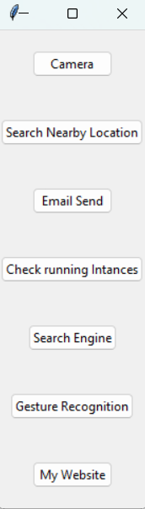

EMAIL SEND:-
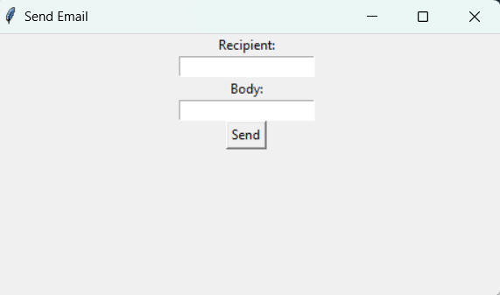

SEARCH NEARBY LOCATION:-
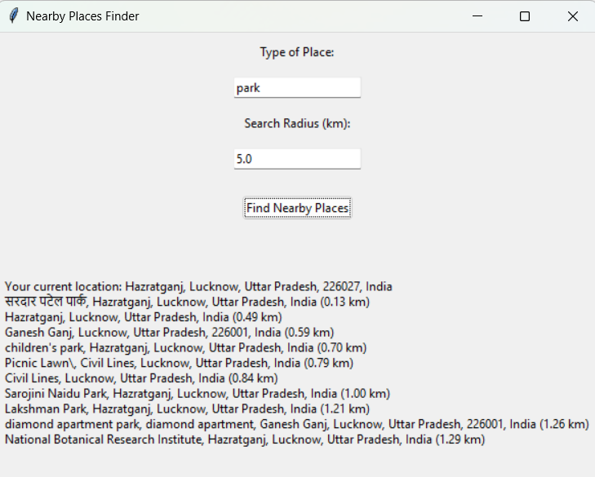

SEARCH ENGINE:-
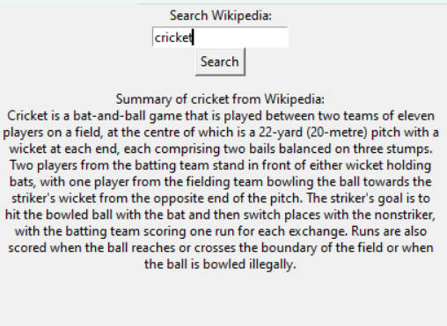

CAMERA:-
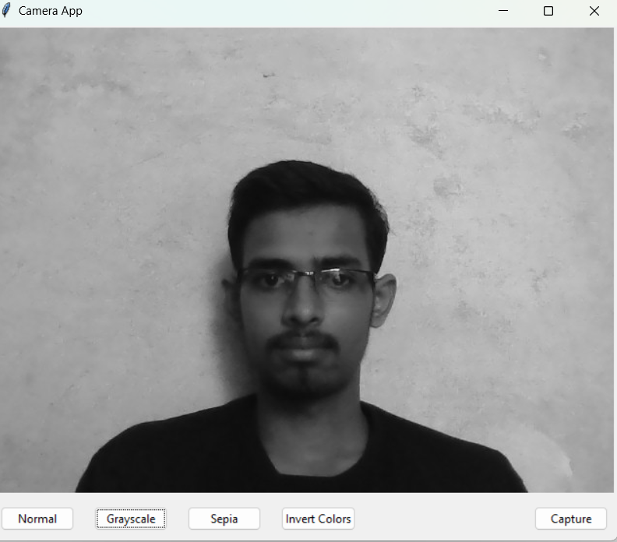

GESTURE RECOGNITION:-
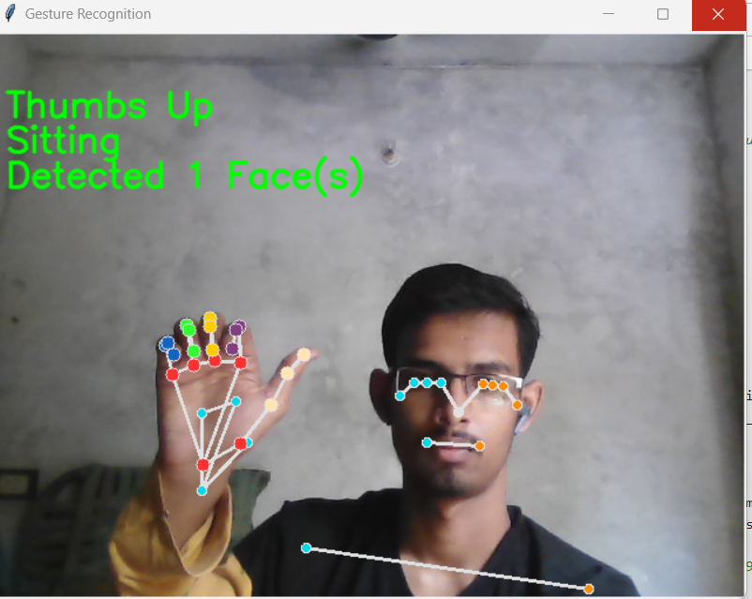

MYWEBSITE:-
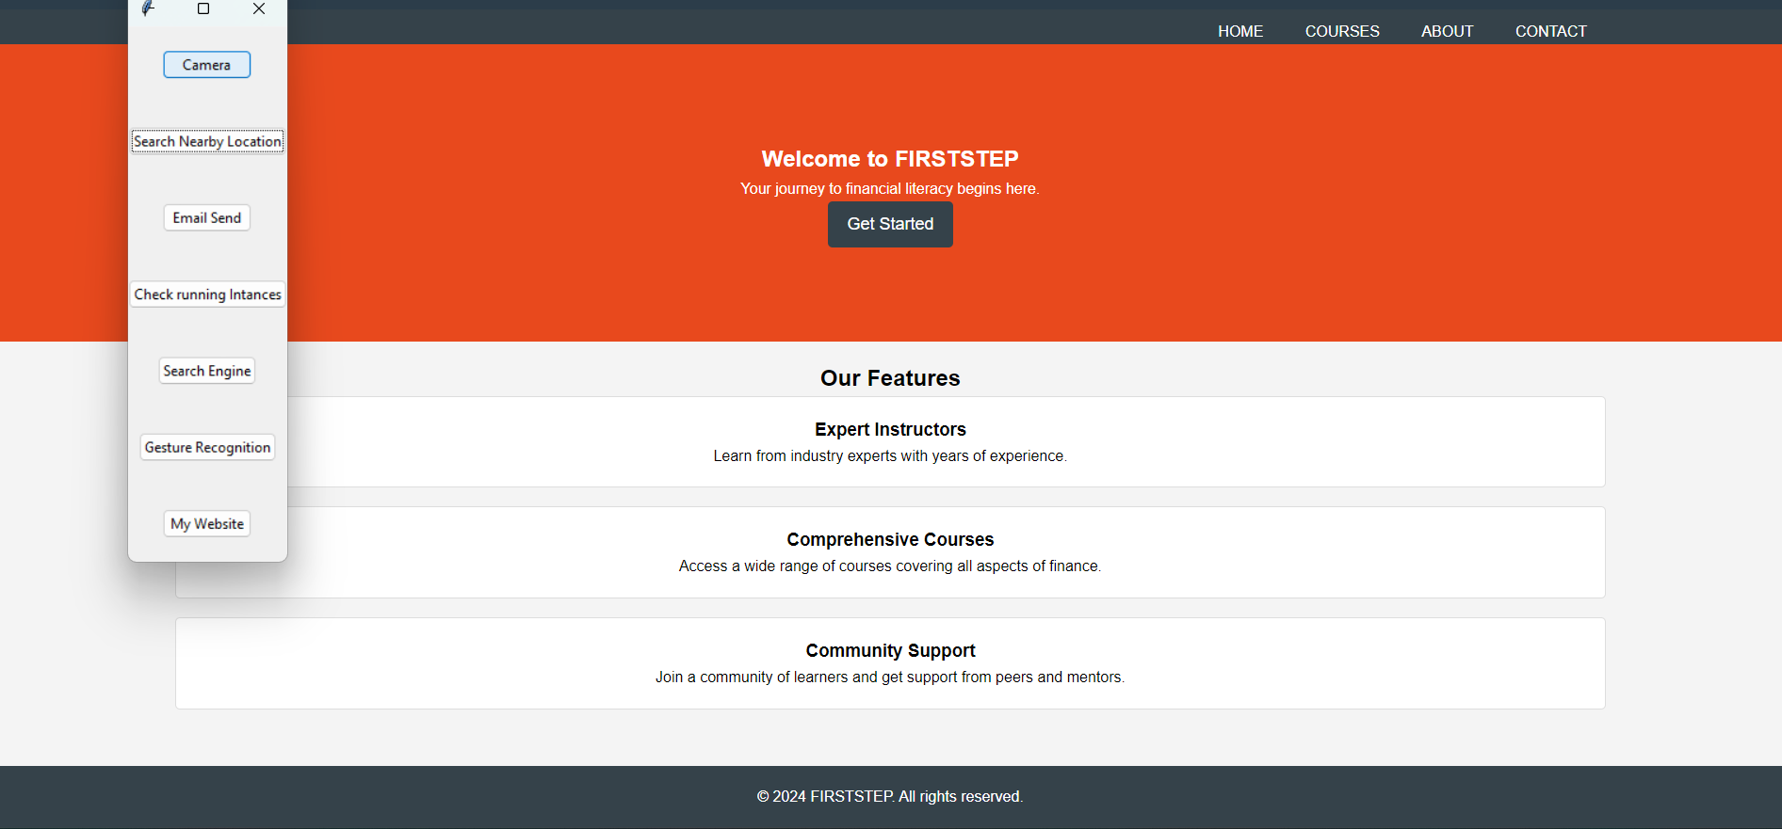
CHECK RUNNING INSTANCES:-
