**GLA UNIVERSITY, MATHURA**

**Self-Practice Lab Assignments**

**List of Experiments with Running Programme and Screen Shot of Output**



Department of Computer Engineering & Application

**Institute of Engineering & Technology**

**SUBMITTED BY:- SUBMITTED TO :**

Name : Ritik Bhushan Yadav Dr. Gaurav Kumar

Uni. Roll No. 191500658

Sec & Roll No : 3F(33)

* Bubble Sort

*import* java.util.Scanner;  
*public class* DaaLabAssignment {  
 *static void* bubbleSort(*int*[] arr)  
 {  
 *for*(*int* i = 0;i<arr.length;i++)  
 {  
 *for*(*int* j = 0;j<arr.length-1-i;j++)  
 {  
 *if*(arr[j+1]<arr[j])  
 {  
 *int* temp = arr[j];  
 arr[j] = arr[j+1];  
 arr[j+1] = temp;  
 }  
 }  
 }  
 }  
  
 *static void* displayArray(*int*[] arr,String msg)  
 {  
 System.*out*.println(msg);  
 *for* (*int* ele:  
 arr) {  
 System.*out*.print(ele+" ");  
 }  
 System.*out*.println();  
 }  
 *static void* detail()  
 {  
 System.*out*.println("Created By : Ritik Bhushan Yadav \nUniv.Roll No: 191500658\nSec&Roll No : 3F(33)");  
 }  
 *public static void* main(String[] args) {  
 Scanner scan = *new* Scanner(System.*in*);  
 System.*out*.println("Enter the Length Of Array");  
 *int* len = scan.nextInt();  
 *int*[] arr = *new int*[len];  
 System.*out*.println("Enter the Array Elements");  
 *for*(*int* index = 0;index<len;index++)  
 {  
 arr[index] = scan.nextInt();  
 }  
 *displayArray*(arr,"Unsorted Array!");  
 *bubbleSort*(arr);  
 *displayArray*(arr,"Sorted Array!");  
 *detail*();  
 }  
}

* Output Of Bubble Sort

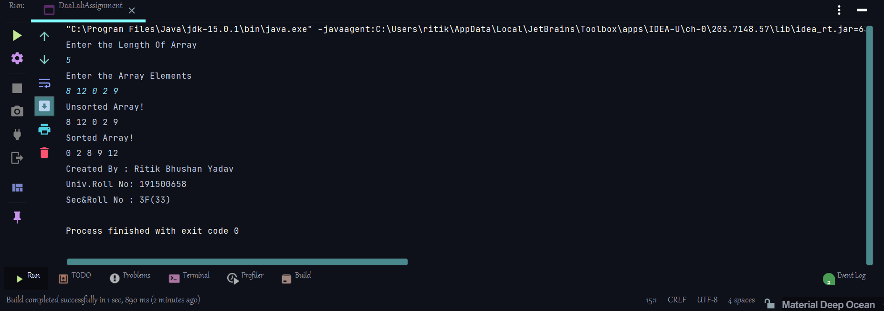

* Selection Sort

*import* java.util.Scanner;  
*public class* DaaLabAssignment {  
 *static void* selectionSort(*int*[] arr)  
 {  
 *for*(*int* i = 0;i< arr.length;i++)  
 {  
 *int* minIndex = i;  
 *for*(*int* j = i+1;j< arr.length;j++)  
 {  
 *if*(arr[j]<arr[minIndex])  
 {  
 minIndex = j;  
 }  
 }  
 *int* temp = arr[minIndex];  
 arr[minIndex] = arr[i];  
 arr[i] = temp;  
 }  
 }  
 *static void* displayArray(*int*[] arr,String msg)  
 {  
 System.*out*.println(msg);  
 *for* (*int* ele:  
 arr) {  
 System.*out*.print(ele+" ");  
 }  
 System.*out*.println();  
 }  
 *static void* detail()  
 {  
 System.*out*.println("Created By : Ritik Bhushan Yadav \nUniv.Roll No: 191500658\nSec&Roll No : 3F(33)");  
 }  
 *public static void* main(String[] args) {  
 Scanner scan = *new* Scanner(System.*in*);  
 System.*out*.println("Enter the Length Of Array");  
 *int* len = scan.nextInt();  
 *int*[] arr = *new int*[len];  
 System.*out*.println("Enter the Array Elements");  
 *for*(*int* index = 0;index<len;index++)  
 {  
 arr[index] = scan.nextInt();  
 }  
 *displayArray*(arr,"Unsorted Array!");  
 *selectionSort*(arr);  
 *displayArray*(arr,"Sorted Array!");  
 *detail*();  
 }  
}

* Output Of Selection Sort

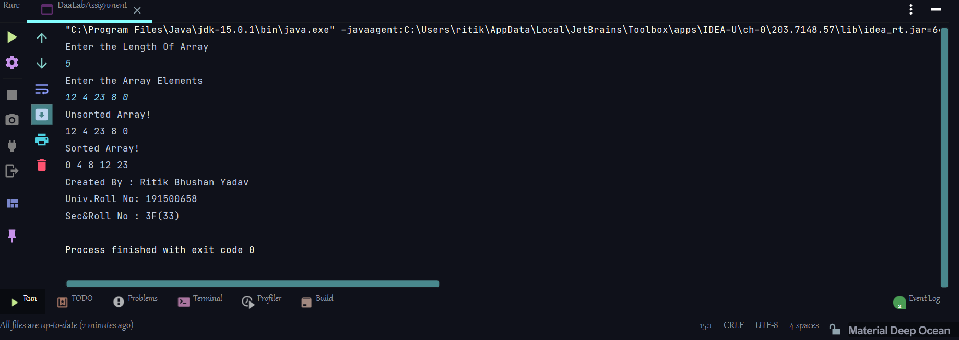

* Insertion Sort

*import* java.util.Scanner;  
*public class* DaaLabAssignment {  
 *static void* insertionSort(*int*[] arr)  
 {  
 *for*(*int* i = 1;i< arr.length;i++)  
 {  
 *int* key = arr[i];  
 *int* j = i-1;  
 *while*(j>=0 && arr[j]>key)  
 {  
 arr[j+1] = arr[j];  
 j-=1;  
 }  
 arr[j+1] = key;  
 }  
 }  
 *static void* displayArray(*int*[] arr,String msg)  
 {  
 System.*out*.println(msg);  
 *for* (*int* ele:  
 arr) {  
 System.*out*.print(ele+" ");  
 }  
 System.*out*.println();  
 }  
 *static void* detail()  
 {  
 System.*out*.println("Created By : Ritik Bhushan Yadav \nUniv.Roll No: 191500658\nSec&Roll No : 3F(33)");  
 }  
 *public static void* main(String[] args) {  
 Scanner scan = *new* Scanner(System.*in*);  
 System.*out*.println("Enter the Length Of Array");  
 *int* len = scan.nextInt();  
 *int*[] arr = *new int*[len];  
 System.*out*.println("Enter the Array Elements");  
 *for*(*int* index = 0;index<len;index++)  
 {  
 arr[index] = scan.nextInt();  
 }  
 *displayArray*(arr,"Unsorted Array!");  
 *insertionSort*(arr);  
 *displayArray*(arr,"Sorted Array!");  
 *detail*();  
 }  
}

* Output of Insertion sort

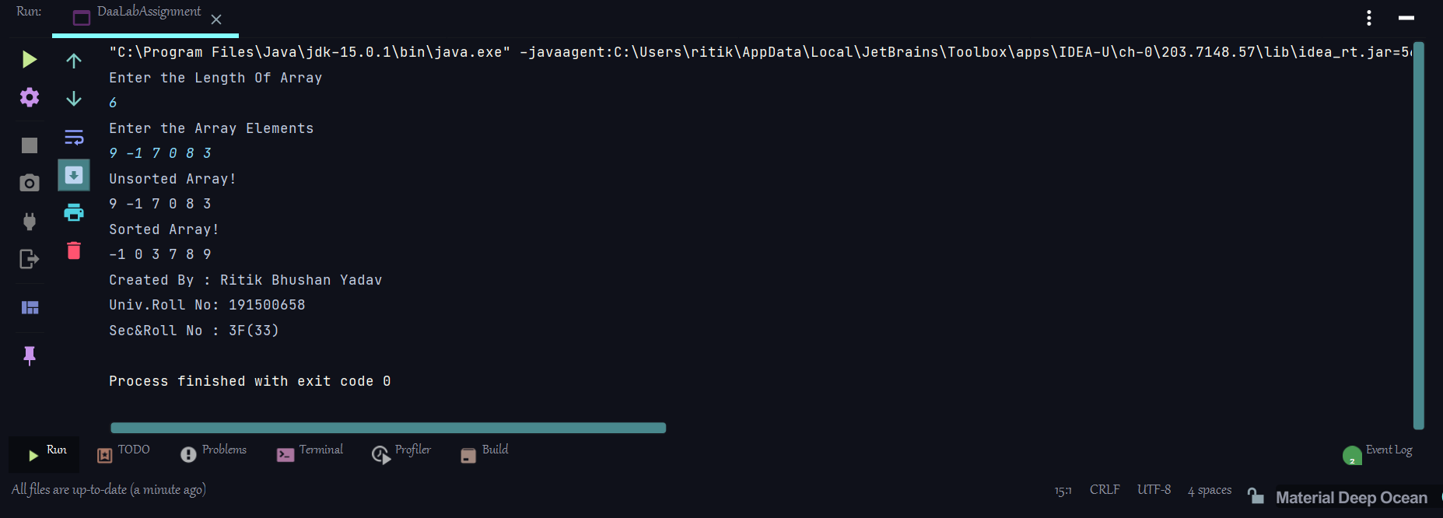

* Quick sort
* *import* java.util.Scanner;  
  *public class* DaaLabAssignment {  
   *static int* partition(*int*[] arr,*int* lowerIndex,*int* higherIndex)  
   {  
   *int* pivot = arr[(lowerIndex+higherIndex)/2];  
   *while*(lowerIndex<=higherIndex)  
   {  
   *while*(arr[lowerIndex]<pivot)  
   {  
   lowerIndex++;  
   }  
   *while*(arr[higherIndex]>pivot)  
   {  
   higherIndex--;  
   }  
   *if*(lowerIndex<=higherIndex)  
   {  
   *int* temp = arr[lowerIndex];  
   arr[lowerIndex] = arr[higherIndex];  
   arr[higherIndex] = temp;  
   lowerIndex++;  
   higherIndex--;  
   }  
   }  
   *return* lowerIndex;  
   }  
   *static void* quickSort(*int*[] arr,*int* lower,*int* higher)  
   {  
   *int* pi = *partition*(arr,lower,higher);  
   *if*(lower<pi-1){  
   *quickSort*(arr,lower,pi-1);  
   }  
   *if*(pi<higher)  
   {  
   *quickSort*(arr,pi,higher);  
   }  
   }  
   *static void* displayArray(*int*[] arr,String msg)  
   {  
   System.*out*.println(msg);  
   *for* (*int* ele:  
   arr) {  
   System.*out*.print(ele+" ");  
   }  
   System.*out*.println();  
   }  
   *static void* detail()  
   {  
   System.*out*.println("Created By : Ritik Bhushan Yadav \nUniv.Roll No: 191500658\nSec&Roll No : 3F(33)");  
   }  
   *public static void* main(String[] args) {  
   Scanner scan = *new* Scanner(System.*in*);  
   System.*out*.println("Enter the Length Of Array");  
   *int* len = scan.nextInt();  
   *int*[] arr = *new int*[len];  
   System.*out*.println("Enter the Array Elements");  
   *for*(*int* index = 0;index<len;index++)  
   {  
   arr[index] = scan.nextInt();  
   }  
   *displayArray*(arr,"Unsorted Array!");  
   *quickSort*(arr,0,arr.length-1);  
   *displayArray*(arr,"Sorted Array!");  
   *detail*();  
   }  
  }
* Output of QuickSort

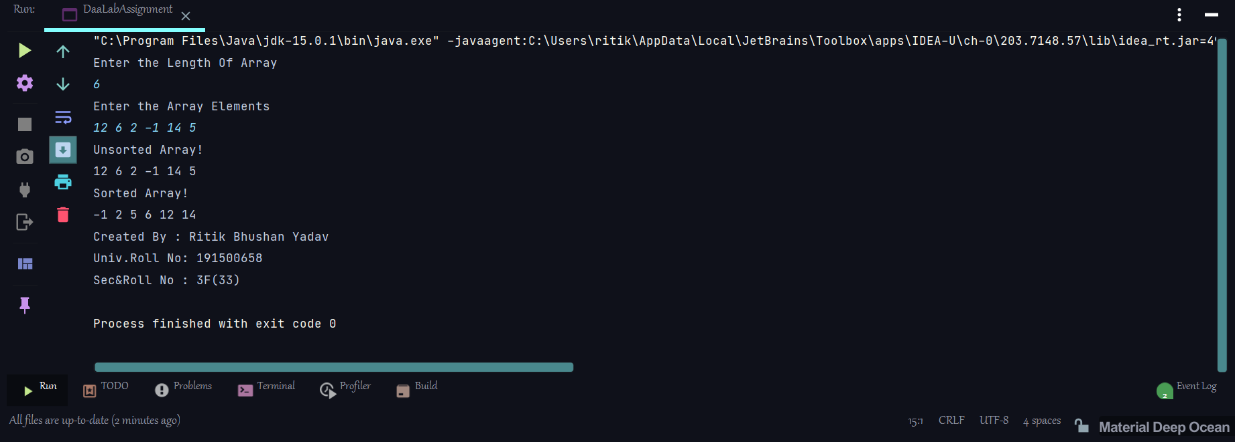

* Merge Sort
* *import* java.util.Scanner;  
  *public class* DaaLabAssignment {  
   *static void* mergeSort(*int*[] arr,*int* lowerIndex,*int* higherIndex)  
   {  
   *if*(lowerIndex<higherIndex)  
   {  
   *int* middleIndex = (lowerIndex+higherIndex)/2;  
   *mergeSort*(arr,lowerIndex,middleIndex);  
   *mergeSort*(arr,middleIndex+1,higherIndex);  
   *mergeArray*(arr,lowerIndex,middleIndex,higherIndex);  
   }  
   }  
   *static void* mergeArray(*int*[] arr,*int* lowerIndex,*int* middleIndex,*int* higherIndex)  
   {  
   *int* i,j,k;  
   *int* leftLen = (middleIndex-lowerIndex)+1;  
   *int* rightLen = (higherIndex-middleIndex);  
   k = lowerIndex;  
   *int*[] leftArr = *new int*[leftLen];  
   *int*[] rightArr = *new int*[rightLen];  
   *for*(i = 0;i<leftLen;i++)  
   {  
   leftArr[i] = arr[lowerIndex+i];  
   }  
   *for*(j = 0;j<rightLen;j++)  
   {  
   rightArr[j] = arr[middleIndex+1+j];  
   }  
   i = 0;j=0;  
   *while*(i<leftLen && j<rightLen)  
   {  
   *if*(leftArr[i]<=rightArr[j])  
   {  
   arr[k]=leftArr[i];  
   i++;  
   }*else*{  
   arr[k] = rightArr[j];  
   j++;  
   }  
   k++;  
   }  
   *if*(i<leftLen){  
   *while*(i<leftLen)  
   {  
   arr[k] = leftArr[i];  
   k++;  
   i++;  
   }  
   }  
   *else* {  
   *while*(j<rightLen)  
   {  
   arr[k] = rightArr[j];  
   k++;  
   j++;  
   }  
   }  
   }  
   *static void* displayArray(*int*[] arr,String msg)  
   {  
   System.*out*.println(msg);  
   *for* (*int* ele:  
   arr) {  
   System.*out*.print(ele+" ");  
   }  
   System.*out*.println();  
   }  
   *static void* detail()  
   {  
   System.*out*.println("Created By : Ritik Bhushan Yadav \nUniv.Roll No: 191500658\nSec&Roll No : 3F(33)");  
   }  
   *public static void* main(String[] args) {  
   Scanner scan = *new* Scanner(System.*in*);  
   System.*out*.println("Enter the Length Of Array");  
   *int* len = scan.nextInt();  
   *int*[] arr = *new int*[len];  
   System.*out*.println("Enter the Array Elements");  
   *for*(*int* index = 0;index<len;index++)  
   {  
   arr[index] = scan.nextInt();  
   }  
   *displayArray*(arr,"Unsorted Array!");  
   *mergeSort*(arr,0,arr.length-1);  
   *displayArray*(arr,"Sorted Array!");  
   *detail*();  
   }  
  }
* Output Of Merge Sort

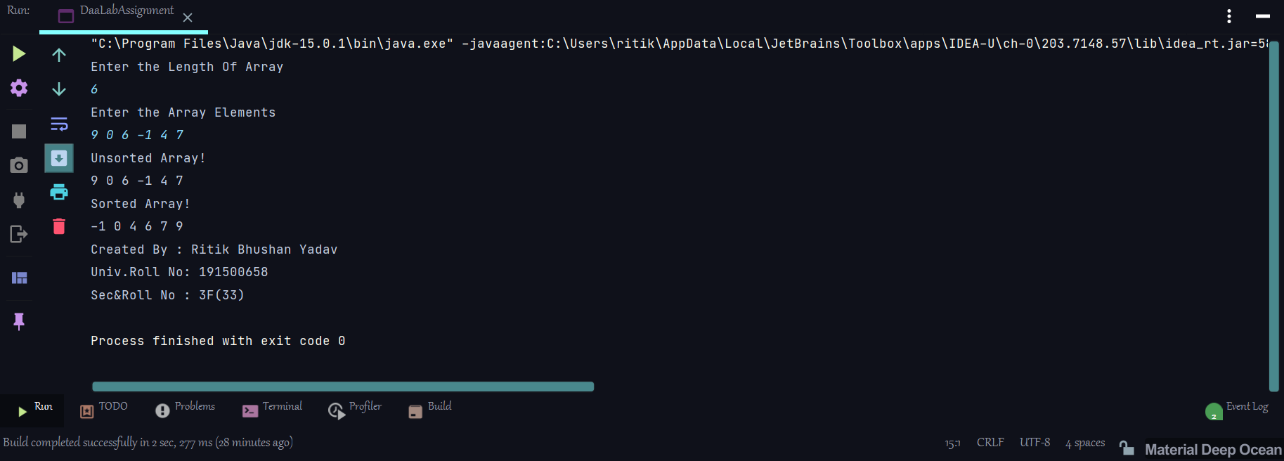

* Heap Sort

*import* java.util.Scanner;  
*public class* DaaLabAssignment {  
 *static void* heapify(*int* a[], *int* n, *int* i)  
 {  
 *int* largest = i;  
 *int* left = 2 * i + 1;  
 *int* right = 2 * i + 2;  
 *if* (left < n && a[left] > a[largest])  
 largest = left;  
 *if* (right < n && a[right] > a[largest])  
 largest = right;  
 *if* (largest != i) {  
 *int* temp = a[i];  
 a[i] = a[largest];  
 a[largest] = temp;  
  
 *heapify*(a, n, largest);  
 }  
 }  
 *static void* heapSort(*int* a[], *int* n)  
 {  
 *for* (*int* i = n / 2 - 1; i >= 0; i--)  
 *heapify*(a, n, i);  
 *for* (*int* i = n - 1; i >= 0; i--) {  
 *int* temp = a[0];  
 a[0] = a[i];  
 a[i] = temp;  
  
 *heapify*(a, i, 0);  
 }  
 }  
 *static void* displayArray(*int*[] arr,String msg)  
 {  
 System.*out*.println(msg);  
 *for* (*int* ele:  
 arr) {  
 System.*out*.print(ele+" ");  
 }  
 System.*out*.println();  
 }  
 *static void* detail()  
 {  
 System.*out*.println("Created By : Ritik Bhushan Yadav \nUniv.Roll No: 191500658\nSec&Roll No : 3F(33)");  
 }  
 *public static void* main(String[] args) {  
 Scanner scan = *new* Scanner(System.*in*);  
 System.*out*.println("Enter the Length Of Array");  
 *int* len = scan.nextInt();  
 *int*[] arr = *new int*[len];  
 System.*out*.println("Enter the Array Elements");  
 *for*(*int* index = 0;index<len;index++)  
 {  
 arr[index] = scan.nextInt();  
 }  
 *displayArray*(arr,"Unsorted Array!");  
 *heapSort*(arr,arr.length-1);  
 *displayArray*(arr,"Sorted Array!");  
 *detail*();  
 }  
}

* OutPut Of HeapSort



* Count Sort
* *import* java.util.Scanner;  
  *public class* DaaLabAssignment {  
   *static int* getMax(*int*[] a, *int* n) {  
   *int* max = a[0];  
   *for*(*int* i = 1; i<n; i++) {  
   *if*(a[i] > max)  
   max = a[i];  
   }  
   *return* max;  
   }  
    
   *static void* countSort(*int*[] a, *int* n)  
   {  
   *int*[] output = *new int* [n+1];  
   *int* max = *getMax*(a, n);  
   *int*[] count = *new int* [max+1];  
    
   *for* (*int* i = 0; i <= max; ++i)  
   {  
   count[i] = 0;  
   }  
    
   *for* (*int* i = 0; i < n; i++)  
   {  
   count[a[i]]++;  
   }  
    
   *for*(*int* i = 1; i<=max; i++)  
   count[i] += count[i-1];  
    
   *for* (*int* i = n - 1; i >= 0; i--) {  
   output[count[a[i]] - 1] = a[i];  
   count[a[i]]--;  
   }  
    
   *for*(*int* i = 0; i<n; i++) {  
   a[i] = output[i];  
   }  
   }  
   *static void* displayArray(*int*[] arr,String msg)  
   {  
   System.*out*.println(msg);  
   *for* (*int* ele:  
   arr) {  
   System.*out*.print(ele+" ");  
   }  
   System.*out*.println();  
   }  
   *static void* detail()  
   {  
   System.*out*.println("Created By : Ritik Bhushan Yadav \nUniv.Roll No: 191500658\nSec&Roll No : 3F(33)");  
   }  
   *public static void* main(String[] args) {  
   Scanner scan = *new* Scanner(System.*in*);  
   System.*out*.println("Enter the Length Of Array");  
   *int* len = scan.nextInt();  
   *int*[] arr = *new int*[len];  
   System.*out*.println("Enter the Array Elements");  
   *for*(*int* index = 0;index<len;index++)  
   {  
   arr[index] = scan.nextInt();  
   }  
   *displayArray*(arr,"Unsorted Array!");  
   *countSort*(arr,arr.length-1);  
   *displayArray*(arr,"Sorted Array!");  
   *detail*();  
   }  
  }
* Output



* Binary Search
* *import* java.lang.reflect.Array;  
  *import* java.util.Arrays;  
  *import* java.util.Scanner;  
  *public class* DaaLabAssignment {  
   *static int* binarySearch(*int*[] arr,*int* key)  
   {  
   *int* start = 0;  
   *int* end = arr.length-1;  
   *int* mid=(start+end)/2;  
   *int* index = -1;  
   *while*(start<=end)  
   {  
   *if*(arr[mid]==key)  
   {  
   index = mid;  
   *break*;  
   }  
   *else if*(key<arr[mid])  
   {  
   end = mid-1;  
   }*else* {  
   start = mid+1;  
   }  
   mid = (start+end)/2;  
   }  
   *return* index;  
   }  
    
   *static void* detail()  
   {  
   System.*out*.println("Created By : Ritik Bhushan Yadav \nUniv.Roll No: 191500658\nSec&Roll No : 3F(33)");  
   }  
   *public static void* main(String[] args) {  
   Scanner scan = *new* Scanner(System.*in*);  
   System.*out*.println("Enter the Length Of Array");  
   *int* len = scan.nextInt();  
   *int*[] arr = *new int*[len];  
   System.*out*.println("Enter the Array Elements");  
   *for*(*int* index = 0;index<len;index++)  
   {  
   arr[index] = scan.nextInt();  
   }  
   System.*out*.println("Enter the Key Value :");  
   *int* key = scan.nextInt();  
   Arrays.*sort*(arr);  
   System.*out*.println("After Sorting Array : "+ Arrays.*toString*(arr));  
   System.*out*.println(*binarySearch*(arr,key));  
   *detail*();  
   }  
  }
* OutPut Of Binary Search

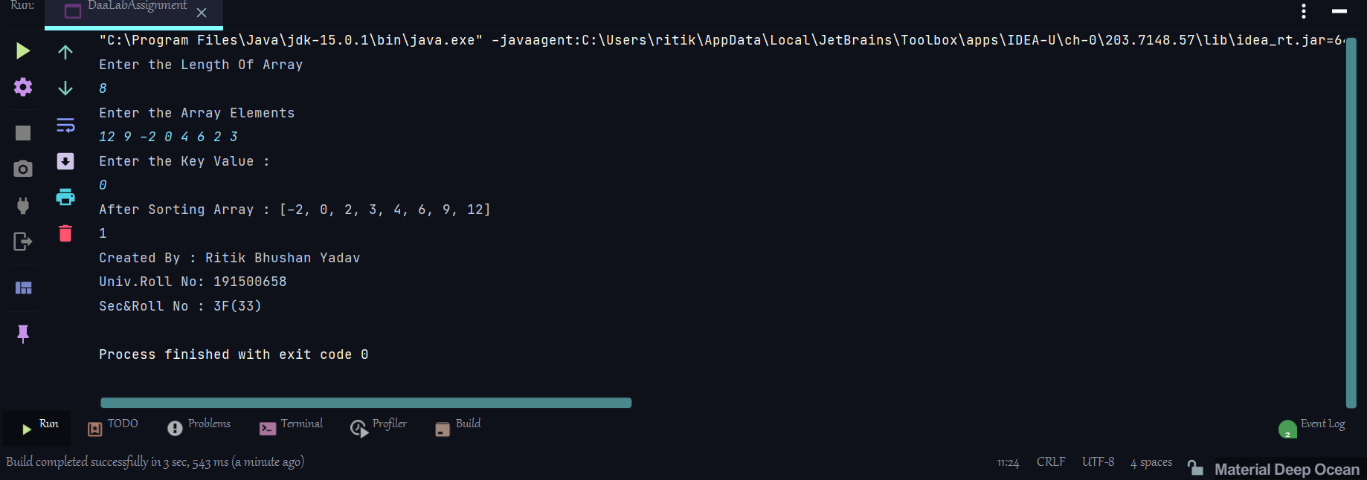

* Implement the Programme and Calculate and Print the Maximum Profit of Knapsack Problem (Knapsack Capacity (M) is 60) .

|  |  |  |  |  |
| --- | --- | --- | --- | --- |
| **Item** | **A** | **B** | **C** | **D** |
| Profit | 280 | 100 | 120 | 120 |
| Weight | 40 | 10 | 20 | 24 |

*import* java.lang.reflect.Array;  
*import* java.util.Arrays;  
*import* java.util.Scanner;  
*public class* DaaLabAssignment {  
  
 *static void* sortAll(*int*[] profit,*int*[] weight,*int*[] profit_weight)  
 {  
 *for*(*int* i = 0;i<profit.length;i++)  
 {  
 *int* min = i;  
 *for*(*int* j = i+1;j<profit.length;j++)  
 {  
 *if*(profit_weight[j]>profit_weight[min])  
 {  
 min = j;  
 }  
 }  
 *int* temp = profit_weight[i];  
 profit_weight[i] = profit_weight[min];  
 profit_weight[min] = temp;  
  
 *int* temp1 = profit[i];  
 profit[i] = profit[min];  
 profit[min] = temp1;  
  
 *int* temp3 = weight[i];  
 weight[i] = weight[min];  
 weight[min] = temp3;  
 }  
 }  
 *static int* getMaxProfit(*int*[] profit,*int*[] weight,*int*[] profit_weight,*int* capacity)  
 {  
 *int* res = 0,i;  
 *for*(i = 0;i<profit.length;i++)  
 {  
 *if*(capacity>0 && weight[i]<=capacity)  
 {  
 res+=profit[i];  
 capacity-=weight[i];  
 }*else*{  
 *break*;  
 }  
 }  
 *if*(capacity>0){  
 res = res+((profit[i]*capacity)/weight[i]);  
 }  
 *return* res;  
 }  
 *static void* detail()  
 {  
 System.*out*.println("Created By : Ritik Bhushan Yadav \nUniv.Roll No: 191500658\nSec&Roll No : 3F(33)");  
 }  
 *public static void* main(String[] args) {  
 *char*[] item = {'A','B','C','D'};  
 *int*[] profit = {280,100,120,120};  
 *int*[] weight = {40,10,20,24};  
 *int* capacity = 60;  
 *int*[] profit_weight = *new int*[profit.length];  
 *for*(*int* i = 0;i<profit.length;i++)  
 {  
 profit_weight[i] = (profit[i]/weight[i]);  
 }  
 *sortAll*(profit,weight,profit_weight);  
 System.*out*.println("Max Profit : "+*getMaxProfit*(profit,weight,profit_weight,capacity));  
 *detail*();  
 }  
}

* Output

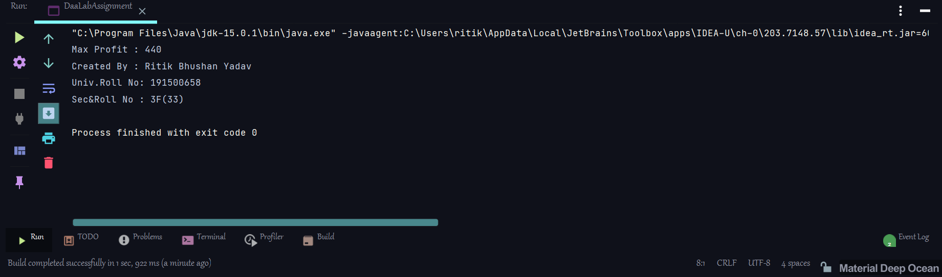

* Estimate the order of Activities Schedule in Activity Selection Problem

S = (A1 A2 A3 A4 A5 A6 A7 A8 A9 A10)

Si = (1,2,3,4,7,8,9,9,11,12)

fi = (3,5,4,7,10,9,11,13,12,14)

*public class* DaaLabAssignment {  
 *public static void* Activities(*int* s[], *int* f[])  
 {  
 *int* i, j;  
  
 System.*out*.print("Selected Activities: ");  
 i = 0;  
 System.*out*.print(i + " ");  
 *for* (j = 1; j < s.length; j++) {  
 *if* (s[j] >= f[i]) {  
 System.*out*.print(j + " ");  
 i = j;  
 }  
 }  
 System.*out*.println();  
 }  
  
 *static void* detail()  
 {  
 System.*out*.println("Created By : Ritik Bhushan Yadav \nUniv.Roll No: 191500658\nSec&Roll No : 3F(33)");  
 }  
 *public static void* main(String[] args) {  
 *int*[] s = {1,2,3,4,7,8,9,9,11,12};  
 *int*[] f = {3,5,4,7,10,9,11,13,12,14};  
 *Activities*(s,f);  
 *detail*();  
 }  
}

* OutPut

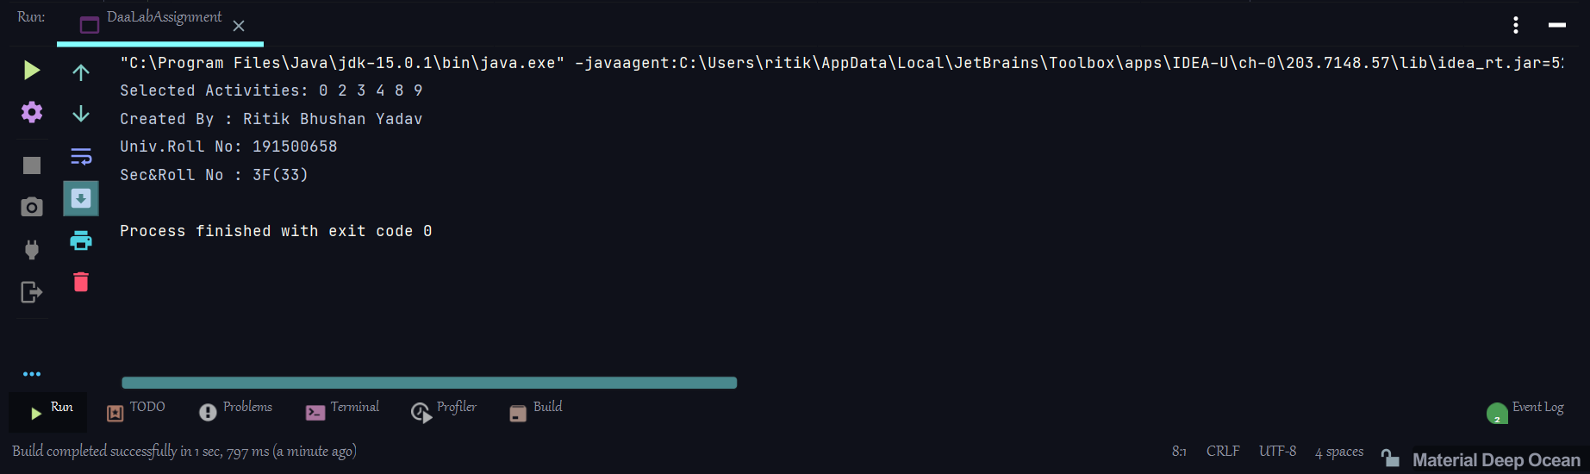

Thank You