An Internship Report
On

EXPENSO -- An Intelligent Python-Based Personal Finance & Expense Analytics Platform
at

CODEC TECHNOLOGIES PVT. LTD.
In association with the National Internship Portal (AICTE & ICAC Approved) and Google for Education

Submitted
To
School of Computer Science and Engineering
IILM University, Greater Noida, U.P.

In partial fulfilment of the requirement of degree of
B.Tech CSE

By
Roll Number of Student:- 25SCS1003004695
Name of Student: SHIVANSH UPADHYAY
Section: 1CSE23
Batch: 2026-27

2026-27

CANDIDATE'S DECLARATION
I, Shivansh Upadhyay, do hereby declare that the internship report titled “EXPENSO — An Intelligent Python-Based Personal Finance & Expense Analytics Platform at Codec Technologies Pvt. Ltd.” has been completed by me to fulfil the requirement for the award of the degree of Bachelor of Technology in Computer Science and Engineering. All the references have been quoted and I have not taken as such any material from any other source. I affirm to you that this report is my own and has not been submitted to any other institute for any degree/diploma requirement and further I shall be solely responsible for any kind of copyright violation in this regard.
Signature:-
Student Name: Shivansh Upadhyay
Roll No.: 25SCS1003004695

ACKNOWLEDGEMENT
I would like to express my sincere gratitude to Codec Technologies Pvt. Ltd. for providing me with the opportunity to undertake this internship under the National Internship Portal, in association with Google for Education. I am thankful to my mentor and the entire program team, especially Dr. Anurag Shrivastava, Program Manager, for their constant guidance, encouragement, and support throughout the internship. Their valuable suggestions, constructive feedback, and professional insights helped me gain practical knowledge in Python development and successfully complete the assigned work.
I also express my heartfelt gratitude to the faculty members of the School of Computer Science and Engineering, IILM University, Greater Noida, for their continuous support and motivation. Finally, I am deeply thankful to my parents for their encouragement, blessings, and unwavering support, which enabled me to complete this internship and prepare this report successfully.
Signature:
Student Name: Shivansh Upadhyay
Roll No.: 25SCS1003004695

3. INTERNSHIP COMPLETION CERTIFICATE

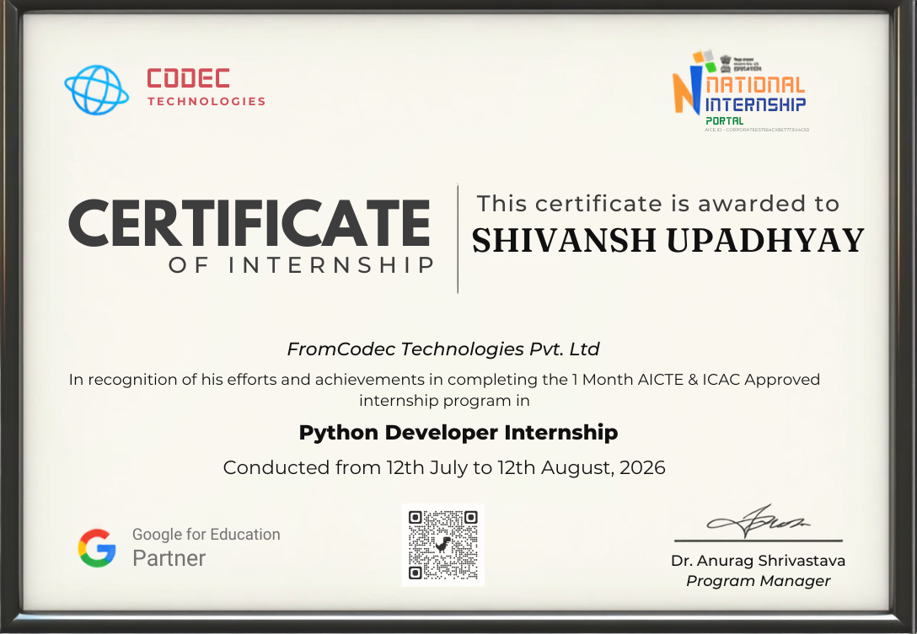

TABLE OF CONTENTS
Chapter No. | Chapter Name | Page No.
1. | Candidate's Declaration | i
2. | Acknowledgement | ii
3. | Internship Completion Certificate | iii
4. | Project Description
 | 4.1 Introduction | 1
 | 4.2 Organization Profile | 1
 | 4.3 Problem Statement | 2
 | 4.4 Project Objectives | 2
 | 4.5 Scope of the Project | 3
 | 4.6 Technologies and Tools Used | 3
 | 4.7 System Architecture | 4
 | 4.8 Methodology | 5
 | 4.9 Expected Outcomes | 5
 | 4.10 Certificates of Completion and Communication Proof | 6
5. | Bibliography/References | 6

4. PROJECT DESCRIPTION

4.1 Introduction
Internships are an integral part of professional education as they provide students with an opportunity to bridge the gap between theoretical knowledge and practical application. They enable students to gain real-world experience, understand workplace ethics, improve communication skills, and develop problem-solving abilities in a professional environment. For students pursuing a Bachelor of Technology (B.Tech) in Computer Science and Engineering, internships offer valuable exposure to applied software development, data-driven system design, and organizational workflows while preparing them for future career opportunities.
As a part of the academic curriculum, I successfully completed a one-month internship from 12th July 2026 to 12th August 2026 at Codec Technologies Pvt. Ltd., under the AICTE & ICAC approved National Internship Portal program, working remotely as a Python Developer Intern. During this internship, I contributed to the design and development of EXPENSO, an intelligent personal finance and expense analytics platform built in Python, which allows users to log expenses, automatically categorise spending, and receive data-driven summaries and insights into their financial habits. My responsibilities included designing the data-processing and analytics pipeline, building a rule-based categorisation engine, integrating the application with external data sources through REST APIs, and developing both a command-line and graphical interface for the platform. This internship enhanced my technical, analytical, and organizational skills while providing practical exposure to applied Python development, data engineering, and end-to-end application design.

4.2 Organization Profile
Codec Technologies Pvt. Ltd. is a technology training and product-engineering unit that develops student-facing and enterprise-grade learning solutions, operating in association with the National Internship Portal and recognised under AICTE & ICAC approval. The organization runs its internship programs under the vision of building industry-ready developers through structured, project-based learning rather than purely theoretical instruction, and delivers its Python Developer track in partnership with Google for Education.
The organization's core focus areas include Python Application Development, Data Analytics, Automation Engineering, and Applied Machine Learning, with a strong emphasis on hands-on project ownership for every intern. Each intern is assigned a capstone product to design, build, and deliver over the course of the internship, supported by weekly mentor reviews, structured learning modules, and a final evaluation and certification process.

4.3 Problem Statement
Most individuals track their personal expenses inconsistently, using scattered notes, generic spreadsheets, or nothing at all, which makes it difficult to understand spending patterns, identify unnecessary expenditure, or plan a monthly budget with any real accuracy. Existing expense-tracking solutions are often either too simplistic to offer meaningful insight or too complex and subscription-locked for everyday personal use, leaving a clear gap for a lightweight, transparent, and genuinely useful tool built with an ordinary user in mind.
The objective of this internship was to design and develop EXPENSO — a Python-based expense analytics platform that allows a user to log expenses quickly, automatically categorises and summarises that spending, and surfaces clear, actionable insights (category-wise trends, monthly comparisons, and overspending alerts) without requiring the user to manually build charts or perform any analysis themselves.

4.4 Project Objectives
- To understand the functioning and development workflow of a real, product-oriented Python engineering team.
- To design and build a robust data-processing pipeline capable of ingesting, cleaning, and structuring personal expense data.
- To develop a rule-based categorisation engine that automatically classifies expenses into logical spending categories.
- To build an analytics and reporting module that generates monthly summaries, category-wise breakdowns, and trend insights using Pandas and NumPy.
- To integrate the platform with an external currency-conversion REST API to support multi-currency expense logging.
- To design and develop both a command-line interface and a Tkinter-based graphical interface for the platform.
- To gain practical exposure to applied Python engineering, clean code practices, and collaborative development using Git & GitHub.

4.5 Scope of the Project
The scope of this internship was to support the design and development of EXPENSO, Codec Technologies' personal finance analytics platform, through the effective use of Python, data-processing libraries, and REST API integration. The internship involved contributing to the core data pipeline, the categorisation engine, the analytics and reporting module, and both user-facing interfaces to enhance the platform's overall usability and intelligence.
The project also provided an opportunity to gain practical experience in a structured, product-engineering environment while developing technical, analytical, and organizational skills. It demonstrated how thoughtful use of Python, data analysis, and automation can turn a routine, manual task — tracking personal expenses — into an intelligent, insight-driven experience for the end user.

4.6 Technologies and Tools Used
Core Language & Data Processing
- Python 3
- Pandas & NumPy
Analytics & Visualization
- Matplotlib for generating spending-trend charts
- Rule-based classification logic for expense categorisation
API & Integration
- REST APIs (Requests library)
- Postman for API testing
Interface Development
- Tkinter (Graphical User Interface)
- Command-Line Interface (CLI)
Data Storage
- CSV-based structured local storage
Collaboration
- Git & GitHub

4.7 System Architecture
Input Layer
(CLI menu and Tkinter form for expense entry)
↓
Data Processing Layer
(Cleaning, validation, and structuring of expense records using Pandas)
↓
Categorisation Engine
(Rule-based classification of expenses into spending categories)
↓
Analytics & Insights Layer
(Category-wise totals, monthly trends, and overspending alerts using Pandas & NumPy)
↓
Integration Layer
(REST API calls for real-time currency conversion)
↓
Presentation Layer
(CLI output and Tkinter dashboard with Matplotlib charts)
↓
Storage & Collaboration Layer
(CSV-based local storage; Git & GitHub version control)

4.8 Methodology
The internship was conducted using a structured and systematic approach over a period of four weeks. Each week focused on specific activities that contributed to the successful completion of the assigned responsibilities.
Week 1: Onboarding & Python Fundamentals
- Program induction, understanding the EXPENSO project vision, and a structured refresher on core Python — data structures, functions, file handling, and exception handling.
Week 2: Data Handling & Library Foundations
- Hands-on modules on NumPy and Pandas for data cleaning, filtering, and aggregation; introduction to the Requests library and REST API consumption.
Week 3: Core Feature Development
- Built the CSV-based data pipeline and command-line interface; developed the rule-based categorisation engine; integrated a public currency-conversion REST API.
Week 4: Analytics, GUI & Finalisation
- Built the analytics and reporting module using Pandas and NumPy; designed the Tkinter-based graphical interface with Matplotlib visualizations; conducted testing, debugging, documentation, and final submission with a recorded project walkthrough.

4.9 Expected Outcomes
- To gain practical exposure to the working environment of a structured Python product-engineering team.
- To enhance skills in applied Python development, data processing, and analytics using Pandas and NumPy.
- To develop proficiency in building and integrating REST API-based features into a Python application.
- To improve organizational, analytical, and problem-solving skills through practical, deadline-driven assignments.
- To understand the role of automated data analysis in transforming routine tasks into intelligent, insight-driven tools.
- To gain hands-on experience designing both command-line and graphical user interfaces in Python.
- To strengthen version control and collaborative development practices using Git & GitHub.
- To develop confidence in independently handling end-to-end feature development, from data pipeline to user interface.
- To apply academic knowledge in a real-world, product-oriented Python engineering environment.
- To improve overall professional and technical competencies for future career opportunities in software development.

4.10 Certificates of Completion and Communication Proof
This internship was conducted in remote mode with Codec Technologies Pvt. Ltd., in association with the National Internship Portal and Google for Education. Upon successful completion of the one-month AICTE & ICAC approved Python Developer Internship, a Certificate of Internship was issued by the organization, signed by Dr. Anurag Shrivastava, Program Manager, and verifiable through the QR code printed on the certificate. The certificate, presented in Section 3 of this report, serves as proof of successful completion of the internship and the assigned responsibilities.
Email confirmations and weekly task submission acknowledgements received from the program coordinators during the internship period are attached as supporting evidence in the appendix/annexure of this report.

5. BIBLIOGRAPHY/REFERENCES
1. Python Software Foundation. Official Website. https://www.python.org
2. GitHub. Official Website. https://www.github.com
3. Postman. Official Website. https://www.postman.com
4. Pandas Documentation. https://pandas.pydata.org/docs/
5. NumPy Documentation. https://numpy.org/doc/
6. Matplotlib Documentation. https://matplotlib.org/stable/
7. Codec Technologies Pvt. Ltd. — Python Developer Internship Program, National Internship Portal, 2026.

