In Previous Module we learnt HTTP very theoretically that we focused more on technicality and we got to know that :

HTTP Methods :as we got to know that http is nothing but a set of rule for client to communicate with server or backend(Hyper Text Transfer Protocol) just like how us Human communicate like we as Human when we want to communicate with each other

or Transfer our thoughts with each other we use language it can be english ,it can be hindi,it can be french ,it can be bengali etc so this language act as thought transfer protocol :

So using language we make ceratin sound and the travel across the air to the person we are trying to communicate

Person1->Hey------sounds travel through air->Person2

Person1<---Sound travel through air---Hi<--Person2

Similarly when computer want to talk to each other they need HTTP or Hyper Text Transfer Protocol

Comp1--->req[http followed]--->Comp2[Server]

[client]

Comp1<---[http followed]response---Comp2[Server]

[client]

But this is very technical way to describe http lets try a different approach to define http using a real world example:

Going To Doctor :

Doctors have a skill They have acquired that skill over years by studying medicine and human anatomy ,so that they provide service to other people who want to use their skill and who are in need of doctor

Now one thing to note is :Attending Patient is a single threaded process

That is doctor can attend or asses single patient at a time hence The doctor is single threaded

How to reach to a doctor :so doctor’s clinic will have some address that can be for example:India->delhi->Vasant Kunj->Sector 47->plot:320->clinic so the patient’s will visit this address that is they get doctor address and navigate to it

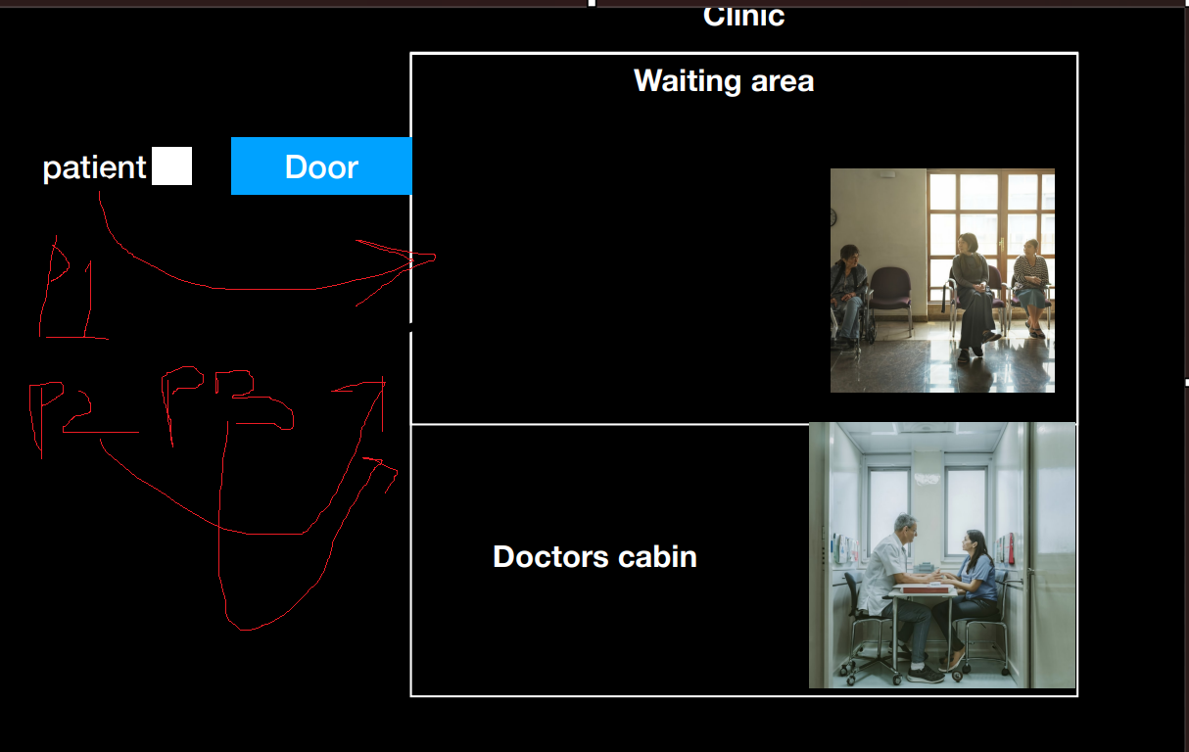

So Patient will enter the door one by one that p1 will enter than p2 will enter and so on

Now just after by entering through the door doctor wont meet them they will have to wait for there turn that is one by one so they will wait in waiting hall

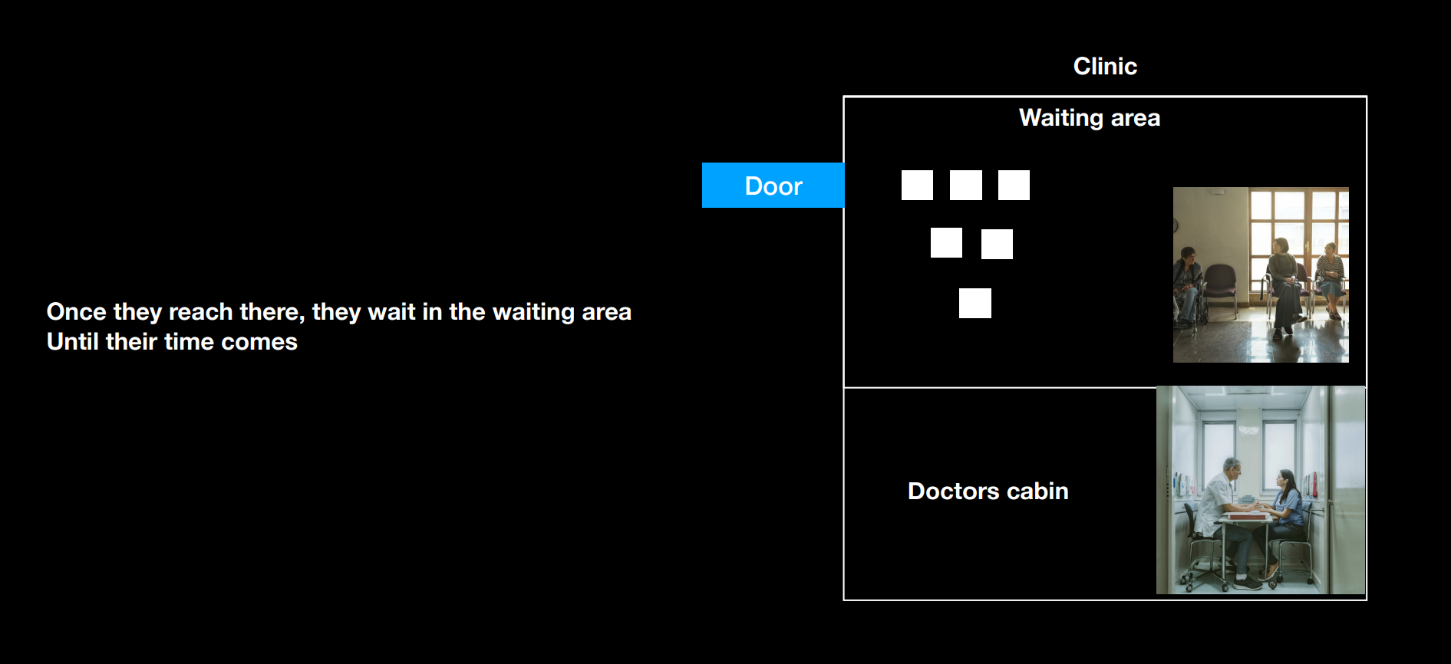

Then based on priority and who comes first ->Doctor will attend them one by one .

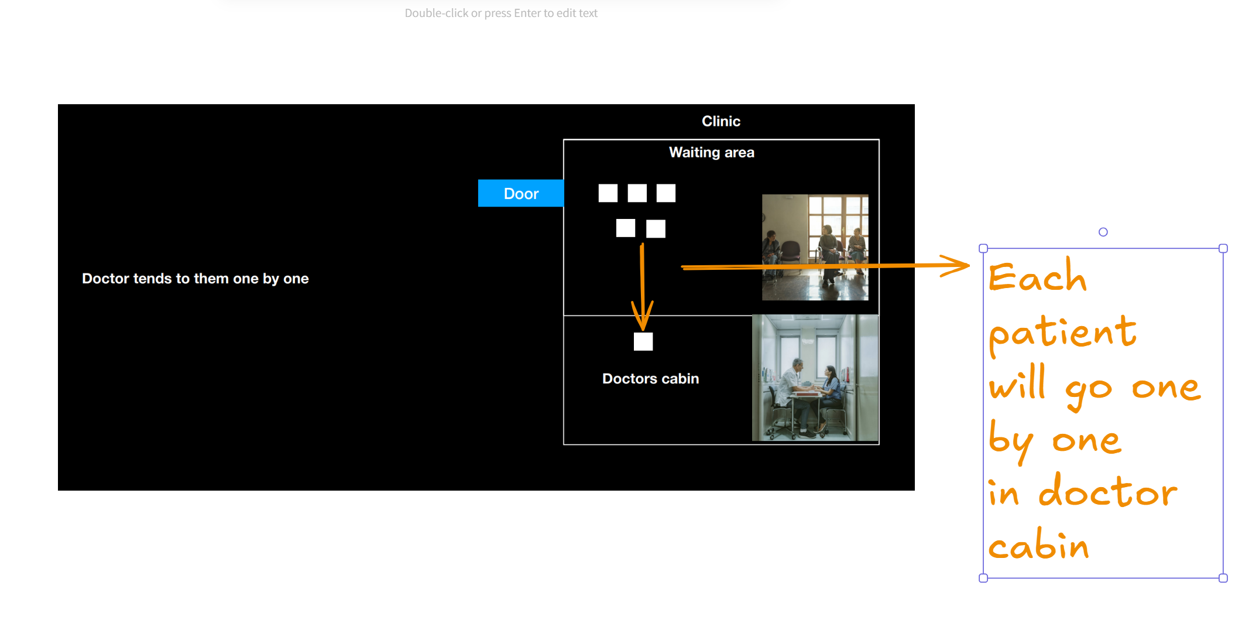

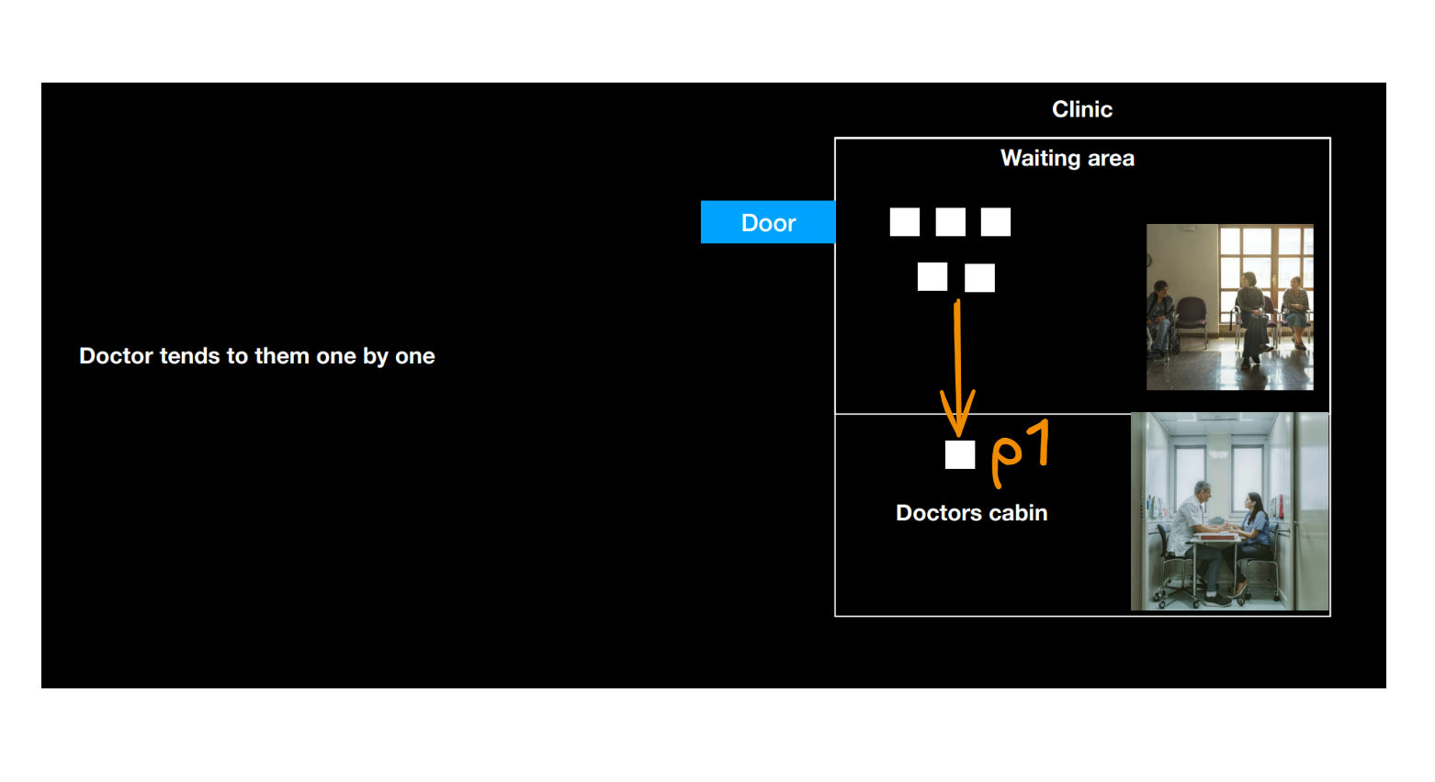

So suppose p1 got diagnosed like what doctor addressed what p1 is suffering from but there are test which needs to be done on p1 so doctor tell p1 ->fine go gets some medicine first which I prescribe and ones you are done taking medicine come back and wait in waiting room and then after some time I will call you for your test until then let me attend some other patients

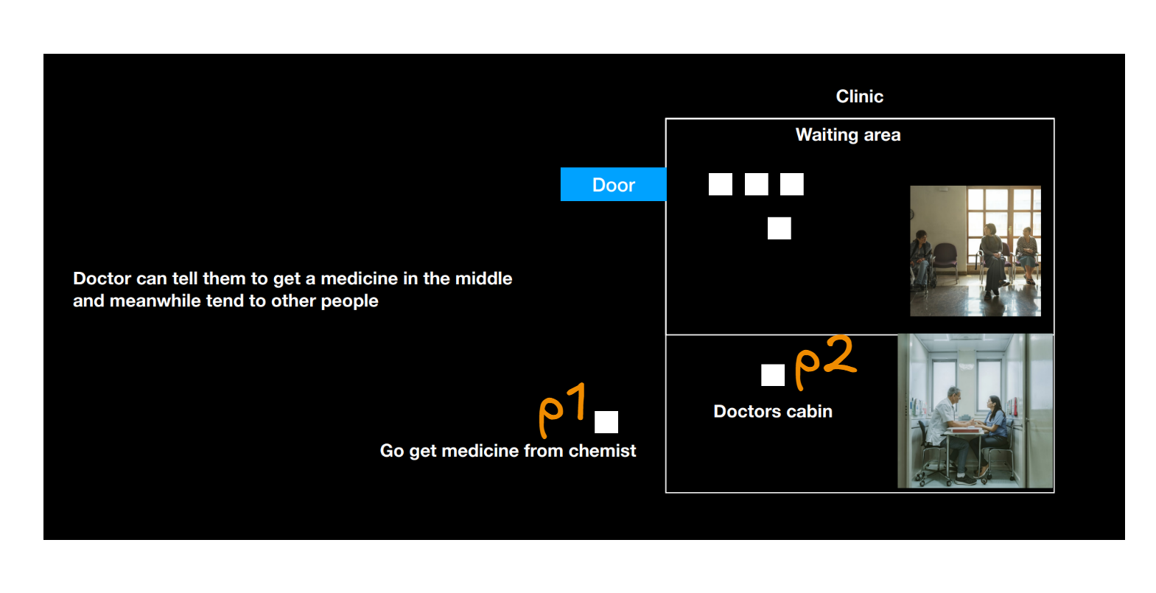

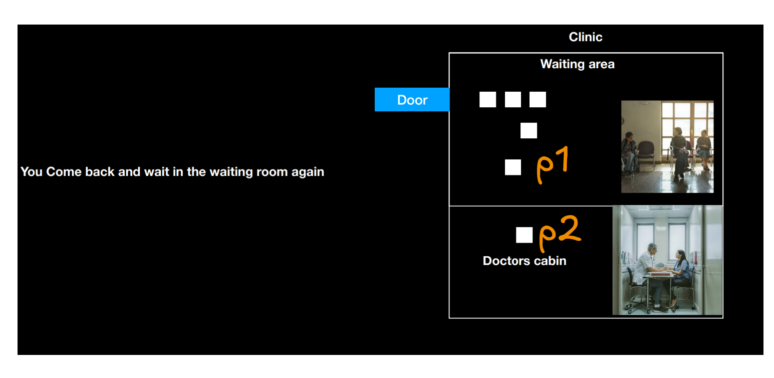

**This demonstrates JavaScript Async Process that is let Doctor be the runtime of js and p1 and p2 be the process 1 and 2 where p1 takes more time to get processed so we make it async and while the p1 is executing in background doctor/nodejs will attend p2**

**Now Having this real world example lets compare It with our code :**

**our logic is like a doctor that is**

